Parent Center Workspaces FAQs

What are the “Parent Center Workspaces”?
Workspaces are the places (Groups) where you can let your Parent Center colleagues know about activities and events that might be of interest (Calendars), share information or resources that you have found helpful, or pose a question or issue that you would like to have others with ideas or facing the same challenges chime in on (Forums). The “Workspaces” are just that, Spaces where you can get “Work” stuff done – collaboratively -- with others who share your interests or challenges.

I’m in the Parent Center Workspaces! Now what?

A. How can I find out about the Groups that I can join?
- Log-in to the Parent Center Workspaces.
- The names and descriptions of the Groups are listed below the banner that says “PARENT CENTER WORKSPACES”. Take a look at each Group’s descriptions and select the Group(s) you would like to join. Some groups are “Public” and you can join them right away by clicking on “Join Group.” Others are “Private” and, if you are interested in joining, click on “Request Membership.”
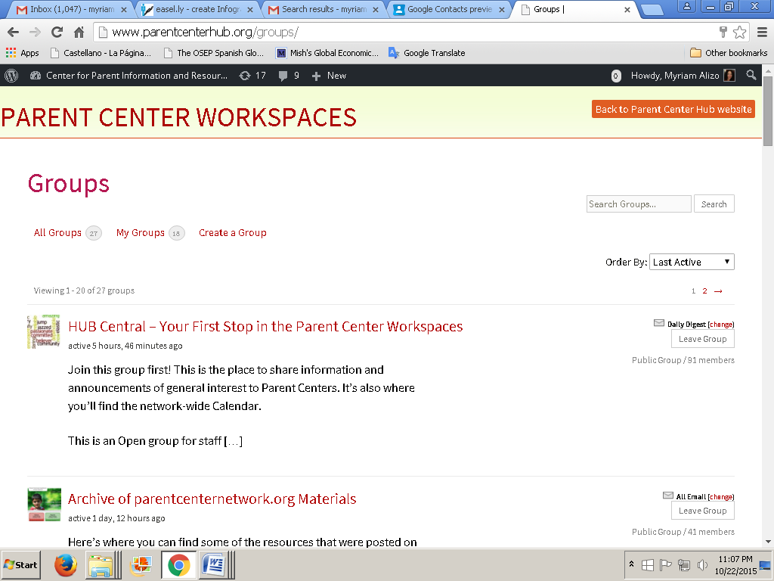

B. How can I find my Groups the next time I come to the Workspaces?
If you are already a user and you have joined one or more groups,
- Log-in to the Parent Center Workspaces.
- Click on “My Groups” below the “PARENT CENTER WORKSPACES” banner and you will see a list of the names and descriptions for your Groups.
You can also see your groups by going to the right hand corner of the black thin banner at the top of your screen.
- Go to “Howdy, (your name)” on the black banner. A drop-down menu will appear.
- Click on “Groups” and a list of all your Groups will be displayed.

C. How can I find out who else is a Member of my Groups?
- Once you have joined a Group you can see who else is there by clicking on Members

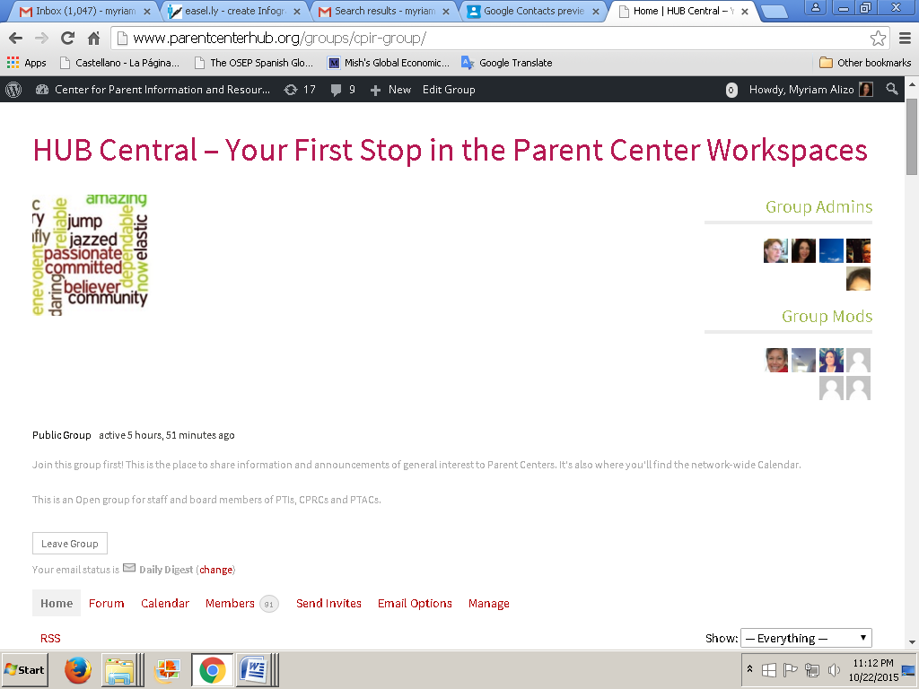

D. How can I change my e-mail notification options in each of my Groups?
Once you have joined a Group, you can customize the email notifications from that Group by clicking on “Email Options”

E. How can I share information?
There are several ways to share information or resources with your Parent Center colleagues on the Workspaces. Once you have joined a Group, you can:
- Post an announcement or comment related to Group’s topic in the “Home” section.
- Start or participate in a discussion on a sub-topic or specific project of your Group in its “Forum”.
- Share the date, time, place and other information about an event in the “Calendar” section of that Group.

F. How can I post in the Home section of Groups?
Every group has an area called “Home.” Post general comments or notifications related to the Group’s interests or activities to the members of the Group through the “Home” section. When posting:
- Make sure you click on the lower right corner of the box to expand it and see what you are about to post.
- Click on Post Update.
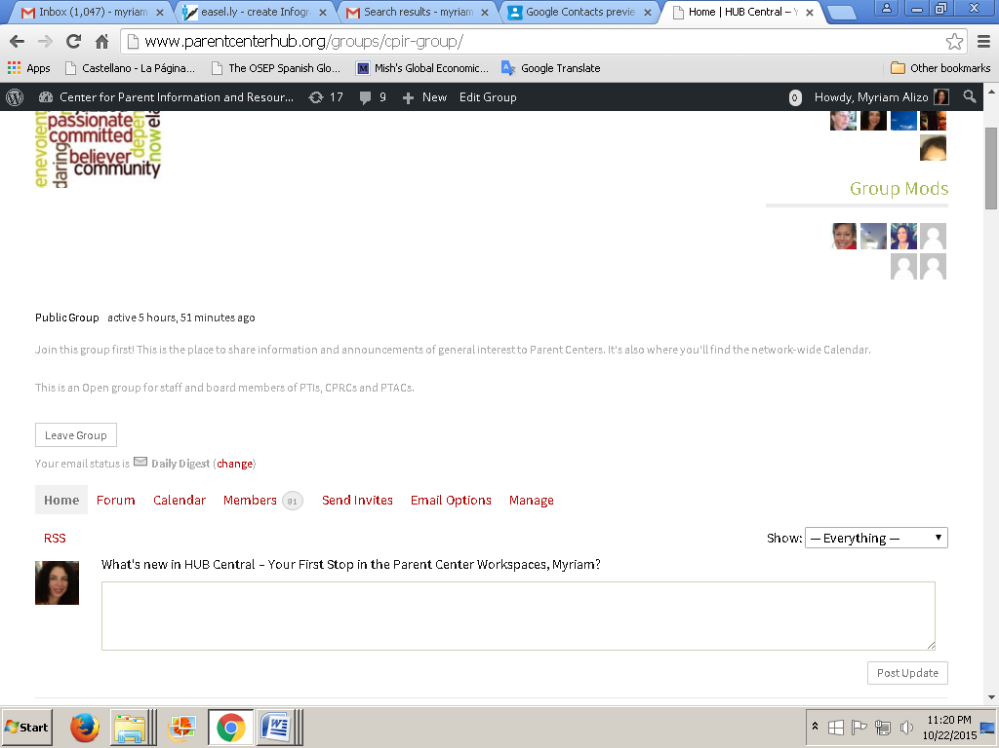

G. How can I share info on events in my Groups?
Every group has a Calendar section where users (depending on the configuration of the group) can post information about upcoming events. To post on the calendar:
- Go to the month of your event and click on the day.
- Proceed to “Create Event” and complete the indicated fields: Title, Date Time, Description and Location.
- Click on “Create Event”.
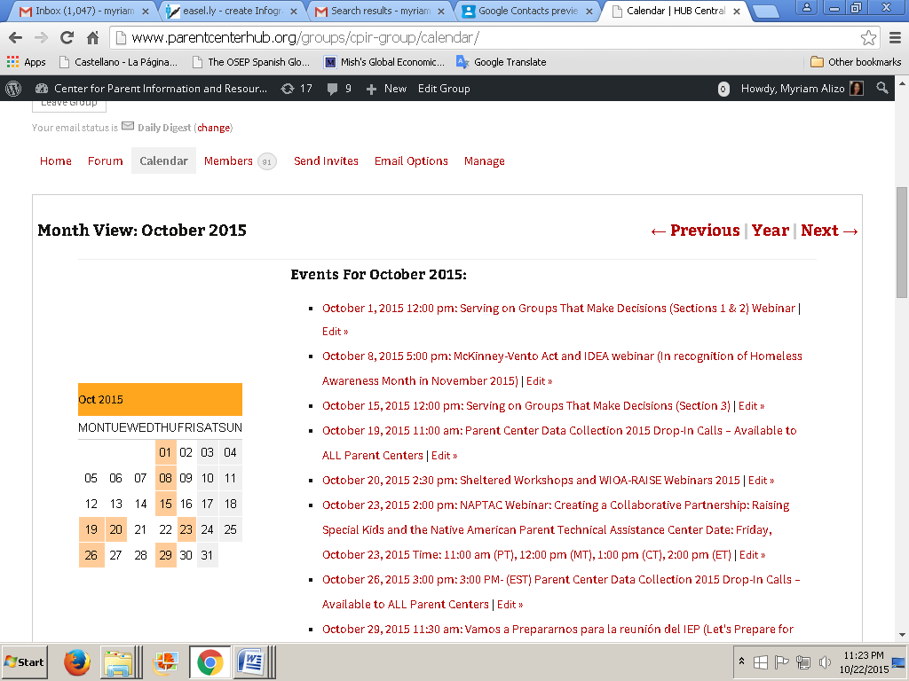

H. What can I share in the Forum section of Groups?
This is the place where you can share attachments.

I. Can I share an attachment in the Home section?
You cannot share attachments in the Home section. You can share attachments only in the Forum section.
J. How can I share an attachment in a Group?
- Every Group in the Workspaces can have a Forum.
- The Forum can have many Topics; each Topic can have many areas called Posts, and every Post can have several attachments.
- You can share on the Post area of an already existing Topic, or you can create a new Topic.
- You can only share 4 attachments at a time to a Post.
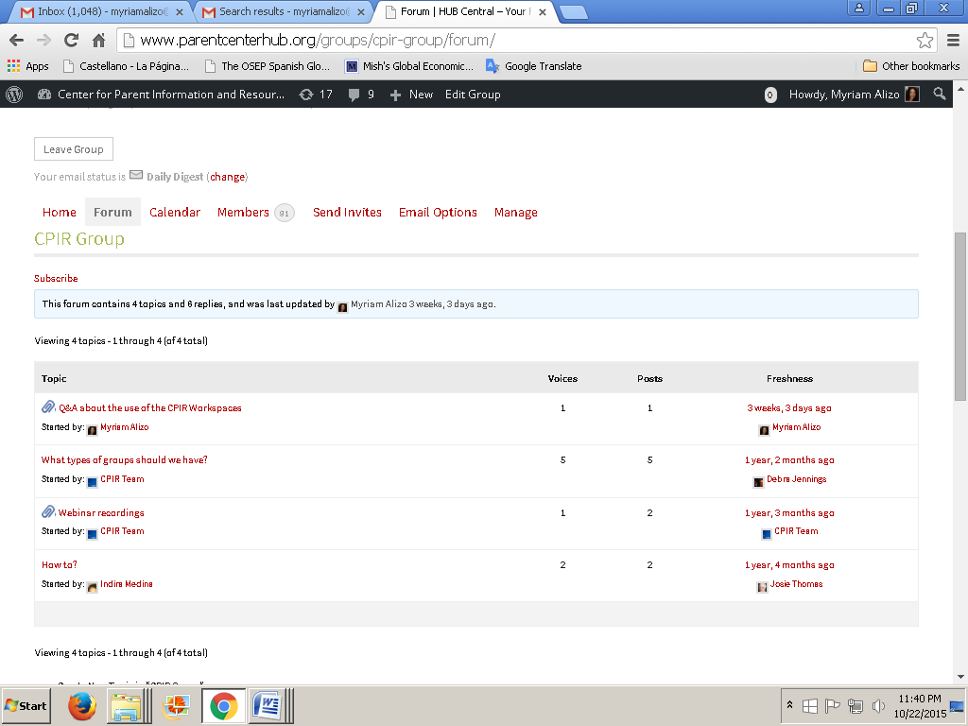

K. How can I share more than 4 attachments?
- Go to Forum
- Select the Topic where you would like to share the attachment.
- Select the Post where you would like to share the attachment(s).
- Go to edit on the right, and the system will let you share 4 more attachments at a time, and so forth.
- Every time you want to share an attachment to an old Post you need to go to edit, and proceed as indicated on 1.
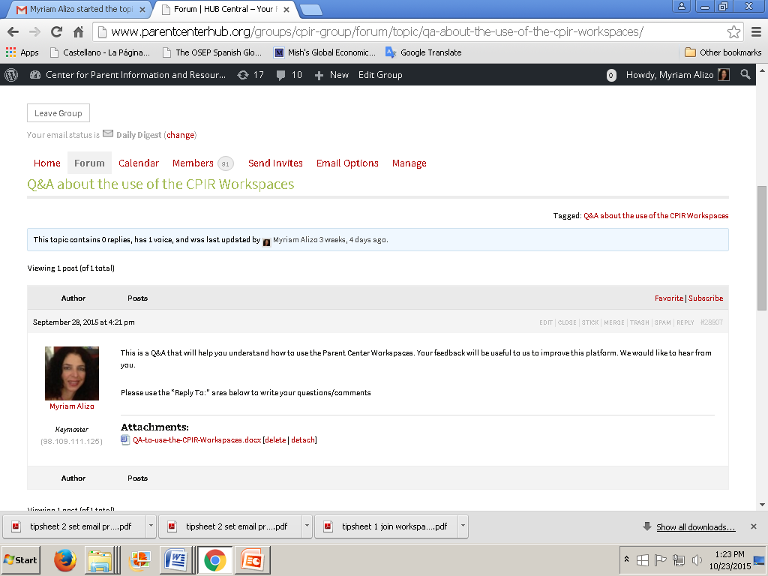

L. How can I create a Topic?
- Go to the Forum section of the Group where you want to create the new Topic
- Fill out the Topic Title area (give a title to your new Topic)
- Fill the description area. If you don’t fill this area, you won’t be able to post files, and you will get an error message like this:
ERROR: Your topic cannot be empty.
