Handout 10
Fun with Numbers: Calculating Risk Ratios

Your assignment | Calculate the likelihood (risk ratio) of Hispanic/Latino students with disabilities (ages 6-21) being identified as having a specific learning disability in State ABC.
What we know about State ABC | Here are data reported by the state both publicly and to OSEP. You can use them to complete your assignment.
- Total # of Hispanic/Latino students enrolled in schools in State ABC: 176,000
- # of Hispanic/Latino students identified as having a specific learning disability in State ABC: 7,000
- Total # of enrolled students from all other racial/ethnic groups in State ABC: 902,414
- # of students from all other ethnic groups identified as having a specific learning disability in State ABC: 23,417

First, calculate the risk of being identified with a specific learning disability if you are an Hispanic/Latino student in this state.
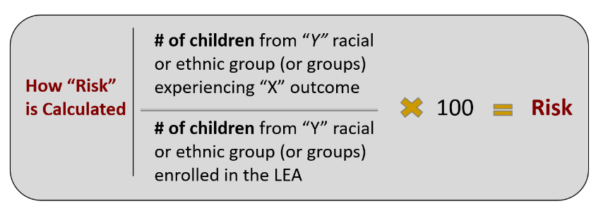

Second, calculate the risk of being identified as having a specific learning disability if you’re a student from any other racial/ethnic group (the comparison group).
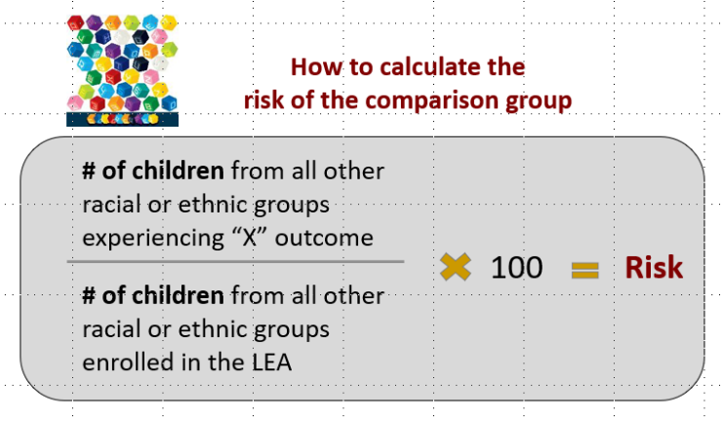
Finally, calculate the likelihood (risk ratio) of Hispanic/Latino students with disabilities (ages 6-21) being identified as having a specific learning disability in State ABC.
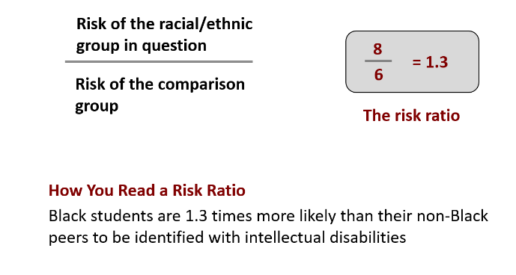
How would you describe your findings to others?

