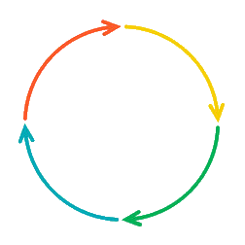

**Diversion Program:**

Youth is diverted away from court to a community-based program (i.e., community panel) – can occur any time before adjudication

Child remains detained

Released from Detention

Detained (detention center may be located in another county)

Released to Parent

**Detention / Probable  
Cause Hearing**(within 24-40 hours of detention)

INCIDENT

Youth Arrested

**Your State’s**

Arraignment

Adjudication

Residential Treatment

Department of Corrections

Other Services

Probation / Intensive Probation

Finding of Delinquency

Child Released to Parent

Child Placed / Remains in Detention

No Finding of Delinquency

Social Investigation Report

Disposition Hearing

(Child Sentenced)

Case Discharged upon successful (completion)

Motion to Expunge a juvenile’s record. (cannot be done prior to the juvenile turning 17)

**KEY**

**Court Proceedings**

**Child in Custody**

**Child out of Custody**

Aftercare services for youth who re-enter the community

Post-Dispositional Hearing / Appeal