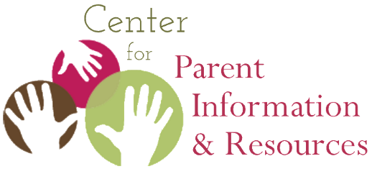

Parent Center Hub Resource Library Suggestions

If there is a good resource that isn't already in our Resource Library, let us know! Our team will check out the resource, consult with our Project Officer, and add resources that meet OSEP's criteria.
* Note: We link to external resources rather than recreating them, so the creating organization will receive the web traffic.

- Resource Title:
- Description:
- Format(s): [doc/pdf/presentation/website/web page/online module/trainer or facilitator guide/video/other]
- Language(s):
- Organization that created the resource:
- Link to resource:
- Please let us know why the resource is useful to your Parent Center so that we can help other centers benefit from it.
- Any addition information you’d like to share with the CPIR about this resource:

Thank you so much for sharing your knowledge and experience with us! Feel free to submit as many resources as you’d like to help us continue building a robust Resource Library for Parent Centers.
Fill out the above form and send the completed document to: malizo@spanadvocacy.org

