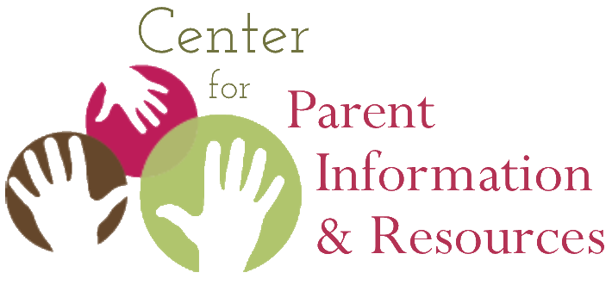
Great Things You Can Find on the Hub
The Center for Parent Information and Resources is honored to support Parent Centers in their heartfelt work with families of children with disabilities.
Visit CPIR’s website (the Hub) at: https://www.parentcenterhub.org/
______________________________________________________________________________ Sept. 2023

1. Resources Galore.
The CPIR Resource Library houses over 1,200 family- friendly materials on key topics for Parent Centers. This includes: fact sheets; IDEA training materials; explanations of early intervention and special education, the IFSP, the IEP, and transition planning; webinars on priority topics; and much more.
2. Buzz from the Hub.
CPIR’s bimonthly e-news highlights hot new resources, upcoming events, and materials you can share with families via social media, your website, or your own e-newsletter. The Buzz also spotlights a different key topic every month.
3. Facebook & Twitter Posts.
Follow the CPIR on social media for the latest disability-related resources that you can share with your own social media groups:
facebook.com/parentcenterhub
twitter.com/parentcenterhub
4. CentersConnect.
Engage with colleagues across the Parent Center network, exchange resources with other centers, discuss high-priority topics, and solve mutual challenges—all this and more when you join CentersConnect, a virtual platform exclusively for Parent Centers.
5. Central Event Calendar.
The Hub Event Calendar lists upcoming webinars and workshops of national TA centers, regional PTACs, and other Parent Centers. For your easy viewing, the calendar is right on the home page of the Hub, at the bottom left.
6. Who Knows What?
The Who Knows What? is an online database that houses profiles of Parent Center staff and serves as the network's very own “yellow pages.” Need to find someone at a Parent Center with experience on a given disability-related or management topic? Search the WKW, and find colleagues who can share their skills and knowledge.
7. Parent Center eLearning Hub.
The eLearning Hub provides key capacity-building resources for Parent Center staff via online self-paced training modules. Follow this link to sign up and see the course offerings. For Parent Centers only.
8. Survey Item Bank.
Want to know how well your trainings and services are addressing the info needs of families, youth, and funders? This database of 150⁺ ready-to-use questions in English and Spanish lets you quickly and easily survey participants accessing your programs and services.
9. Materials from Other Parent Centers.
Has your Center created resources that can be shared with other Parent Centers? Submit them to the Hub.

10. Recursos en español & the English Speakers’ Index to Resources in Spanish.
Ofrecemos muchos recursos en español que puede compartir con sus familias. The “Index to Resources in Spanish” helps English speakers easily find important information for the Spanish-speaking families you serve.

