The materials you will need to conduct the surveys.
- You will receive an e-mail message includes the following information:
  - The number of surveys that your center is to collect and submit.
  - An Excel document with your list in the order that you are to collect surveys from your parent contacts (codes).

- Next, you can download copies of the forms in English and Spanish to conduct your assigned surveys. These documents are also available in the Parent Center Workspace for Data Collection, or you can download the documents at:
  - In English:
  - In Spanish:

Conducting the Surveys. Using your randomized list, you will start in the first row to reach out to contacts to conduct surveys. You must collect surveys in the prescribed order. However, as mentioned, we know that some of your contacts may not be available or willing to complete the survey. So you will continue down the list until you have obtained enough surveys to fulfill your assigned number.

Here are a couple of ways in which you might approach the randomized list.

Example 1: You are assigned to collect 10 surveys from your contact list. Call or send surveys to the first 10 contacts listed (shared in green). But you are only able to get complete responses from 6 of the 10 needed. So you reach out to the next 4 contacts (shaded in blue) and the next ones and the next ones, until you reach your total of 10 assigned.
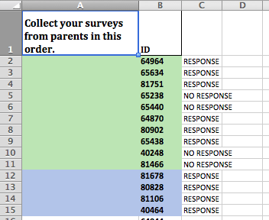

Example 2: You are assigned to collect 10 surveys. You want to send the survey to a larger number of contacts on your list so that you will have some extra information for your center to use. You send out 50 surveys and receive 25 responses. You will submit responses only for the first 10 respondents that appear on your list, (i.e., ID numbers 64964, 65634, 81751, 64870, 80902, 65438, 81678, 80828, 81106, 40464). Thus, it’s important to make sure you can connect respondents to the code you assigned to them, so you know which respondents are in your original random sample group.

When conducting the surveys, do not change the wording of any of the survey questions. The scripts, on the other hand, are provided as examples of ways you can communicate information about the survey to your parent contacts, either in writing or orally. You can adapt or adopt these scripts based on your center’s cultural context or communication style. However, the survey questions themselves must be asked just as they are given.

Tallying The Results. We have developed a worksheet you can use to tally the results of your assigned respondents. After completing surveys for the parent contacts assigned to your Parent Center, use this worksheet to record the numbers of parent answers for each question. As you can see below, you will only need to add up your responses. There is no need to calculate totals and percentages.
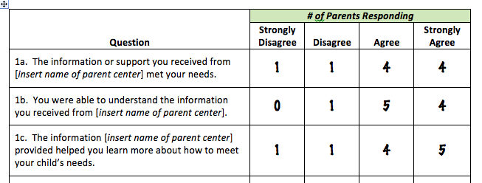

Remember that you are to only submit the assigned number of responses from contacts as prescribed in your randomized list.

Online Submission of Results by December 2nd. Please submit your survey results via the SmartSheet form that can be found online at: http://tinyurl.com/parentprogram-survey-2016

Submit your survey results by December 2, 2016.

If you have any questions or need further assistance, please contact Maria Rodriguez at mrodriguez@spannj.org or (862) 214-2813.

