Disproportionality
in Special Education:
A Trainer’s Guide

A training guide developed for Parent Centers by the
Center for Parent Information and Resources (CPIR)
http://www.parentcenterhub.org
November 2020
_____________________________________________________________________________________
This trainer’s guide is… | One part of a training module developed for Parent Centers to use in staff development and board training on disproportionality in special education, as well as in training sessions about disproportionality conducted for families and professionals.
The complete training module on disproportionality includes… | Two trainer’s guides that go with two separate PowerPoint slideshows, and handouts for participants. Feel free to adapt the slideshows and handouts to include information specific to your state or especially relevant to your audience. The two slideshows are designed to address the different information needs of specific audiences:
- Slideshow 1 (26 slides) | Provides an overview of disproportionality and key aspects of the final regulations on disproportionality published in December 2016. Parent Centers can use this presentation as part of staff development, to inform their Advisory Boards about disproportionality issues nationally and within their state, and to enlist community groups and others in local and state efforts to address disproportionality in special education. Slideshow 1 is intended primarily for use with general audiences with little prior or in-depth knowledge of disproportionality as a national, state, and local concern.
- Slideshow 2 (29 slides) | Focuses on how disproportionality is measured via risk-ratios and what the Individuals with Disabilities Education Act (IDEA) requires when states identify any of their school districts or local educational agencies (LEAs) with significant disproportionality in special education based on race or ethnicity. Technical! Use this slideshow with participants who are already knowledgeable about disproportionality as a concern and who now want or need to know more about what corrective actions are required under the regulations.
Download the training materials | This training module and its component parts can be downloaded from the CPIR Hub, at: https://www.parentcenterhub.org/disproportionality-in-special-education/
The trainer’s guide, slideshows, and handouts are a 2020 revision of…| The training module produced in 2007 by the National Dissemination Center for Children with Disabilities (NICHCY) at the request of the Office of Special Education Programs (OSEP) at the U.S. Department of Education.

How this guide is organized | The trainer’s guide begins with an overview of:
- what disproportionality is in the context of IDEA;
- its history as an ongoing concern in special education and where we stand today;
- the 2016 publication of final IDEA regulations that change how states identify and address disproportionality within their school districts and schools; and
- the influential role that Parent Centers, parent leadership groups, and community organizations can play in the process.
After the overview, the guide will take care of “housekeeping” details—such as what files you’ll need to download and from where; what handouts are available for training participants; and how to interpret references to IDEA and its sections. This section of the trainer’s guide will close with the credits and thank you’s to the authors, editors, and contributors to this revised training module.
The guide will then move through Slideshow 1, slide by slide, explaining the content, offering suggestions for trainers, and describing how the handouts might be used with or adapted for training participants. The trainer’s guide for Slideshow 2 is separate document that follows the same pattern of moving slide by slide through the content.

Overview of Disproportionality
Defining disproportionality | In the context of IDEA, the nation’s special education law, disproportionality refers to findings that students from certain racial and ethnic groups may have a greater (or lesser) likelihood than students from other groups of:
- being identified as a child with a disability who needs special education and related services;
- being identified as having a particular disability (e.g., autism, intellectual disabilities);
- receiving their special education services in settings that are more separated or restrictive;
- receiving harsher, more exclusionary discipline, including suspension and expulsion.
When specific racial or ethnic groups are more likely (or less likely) than others to have any of these outcomes, it’s cause for concern and deeper investigation. In some cases, the percentage of a racial or ethnic group in special education may be less than what is found in the student minority population in general. In this case, the group may be described as underrepresented in special education. In contrast, when a specific racial or ethnic group is represented in special education at a greater rate than the student minority population in general, that group is said to be overrepresented.
This training module will focus primarily on the issue of overrepresentation in special education, as does IDEA itself.

Is Disproportionality Something New?
No. In fact, the need to address the disproportionate representation of specific racial or ethnic groups in special education has been evident for several decades. Consider that Congress has twice commissioned the National Academy of Sciences (NAS) to study the issue—in 1982 and again in 2002. When IDEA was reauthorized in 2004, Congress drew express attention to the issue, stating as part of its findings that:
- Greater efforts were needed to prevent the intensification of problems connected with mislabeling minority children with disabilities.
- More minority children had been, and were continuing to be, served in special education than would be expected from the percentage of minority students in the general school population.
- African-American children were identified as having intellectual disabilities and emotional disturbance at rates greater than their White counterparts.
- Studies had found that, in schools with predominately White students and teachers, disproportionately high numbers of minority students were being placed in special education. [20 U.S.C. 1400(c)(12)]
IDEA 2004 made many changes in how States and LEAs were to address disproportionality in special education. Congress was sufficiently concerned about the disproportionate representation of minority children in special education, and how they were categorized and placed, that disproportionality became one of three areas it established as a monitoring priority to the extent that such “representation is the result of inappropriate identification.”
Yet here we are today, more than a decade and a half later, having made little progress in addressing disproportionality. According to a 2013 report from the U.S. Government Accountability Office (GAO), it continues still, in:
- how minority children are identified as having a disability (and which disability);
- where they are placed to receive special education and related services (e.g., in more restrictive or segregated environments); and
- how they are disproportionately disciplined by schools for behavior or other infractions.
GAO’s recommendation? That the U.S. Department of Education (ED) “should develop a standard approach for defining significant disproportionality to be used by all states. This approach should allow flexibility to account for state differences and specify when exceptions can be made.”
Which is exactly what ED did.
Note to Trainers

Several slides in the slideshow provide details of recent research, allowing you to discuss with the audience some of the root causes of disproportionality and many of its potential consequences.

IDEA 2016 Regulations on Disproportionality
On December 12, 2016, the U.S. Department of Education released final regulations under Part B of IDEA, aimed at promoting equity by targeting widespread disparities in the treatment of students of color with disabilities. These regulations address a number of issues related to significant disproportionality in the identification, placement, and discipline of students with disabilities based on race or ethnicity. At the same time, the Department also released a new Dear Colleague Letter addressing racial discrimination and a fact sheet on Equity in IDEA.
You can connect with these resources at:
http://www.parentcenterhub.org/final-idea-rule-on-disproportionality/
Suggestions | Resources from ED are authoritative sources of information on disproportionality—its history as a Congressional concern, the research base that has fueled that concern, and the road forward from here under the 2016 regulations. Use ED’s resources in professional development activities within your Parent Centers, adapt them as handouts to inform families or your Advisory Board, and share them with colleagues. Especially take advantage of the places where stakeholder input is required—be informed and be involved!

“Housekeeping” Details
Files You'll Need for Training Sessions Conducted with Slideshow 1
https://www.parentcenterhub.org/disproportionality-in-special-education
Trainer’s Guide for Slideshow 1 (this document) (as an adaptable Word file or as a PDF)
Slideshow 1 in PowerPoint (as an adaptable PowerPoint or as a PDF)
Handouts for Participants (as adaptable Word files or as PDFs)
Handout 1: Sketching Out the Scene | Opening Activity
Handout 2: Congressional Findings (1 page, optional)
Handout 3: Final IDEA Regulations on Disproportionality (§300.646 and §300.647)
Handout 4: Action Steps for Parents of Children with Disabilities (4 pages)
Handout 5: Action Steps for Parent Leadership Groups and Community Organizations (2 pages)
Handout 6: Action Steps for Educators and School Administrators (2 pages)
Handout 7: Circle-Square-Triangle (2 pages)
Handout 8: Resources of More Information

Finding Specific Sections of the Regulations: 34 CFR
As you read the explanations about the final regulations on disproportionality, you will find references to specific sections, such as §300.647. (The symbol § means “Section.”) These references can be used to locate the precise sections in the federal regulations that address the issue being discussed. In most instances, we’ve also provided the verbatim text of the IDEA regulations so that you don’t have to go looking for them.
However, be aware that all final Part B regulations are codified in Title 34 of the Code of Federal Regulations. This is more commonly referred to as 34 CFR or 34 C.F.R. It’s not unusual to see references to specific sections of IDEA’s regulations include this—such as 34 CFR §300.646. We have omitted the 34 CFR in this training curriculum for ease of reading.
Finding the Most Current Version of IDEA’s Regulations
The most update-to-date version of the regulations can be found in the e-CRF, which stands for the Electronic Code of Federal Regulations. The e-CRF is available online at:
https://www.ecfr.gov/cgi-bin/ECFR?page=browse
Just below, we provide screenshots of what you’ll see when you visit the e-CRF and what links you should choose to work your way to IDEA’s regulations. You may never have a reason to access the e-CFR, but it can be very useful if you want to verify the exact language of the law at some future point in time.
Exhibits 1 and 2
Screenshots from the e-CFR and How to Navigate to IDEA’s Regulations

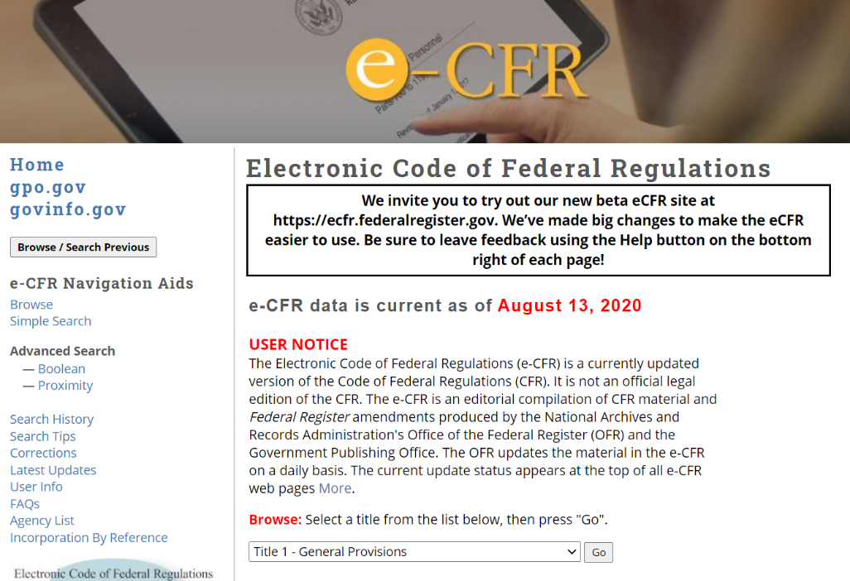

The date of its currency
is given in red.

See this drop-down menu?
Scroll down and select
“Title 34—Education.”
Then hit GO.

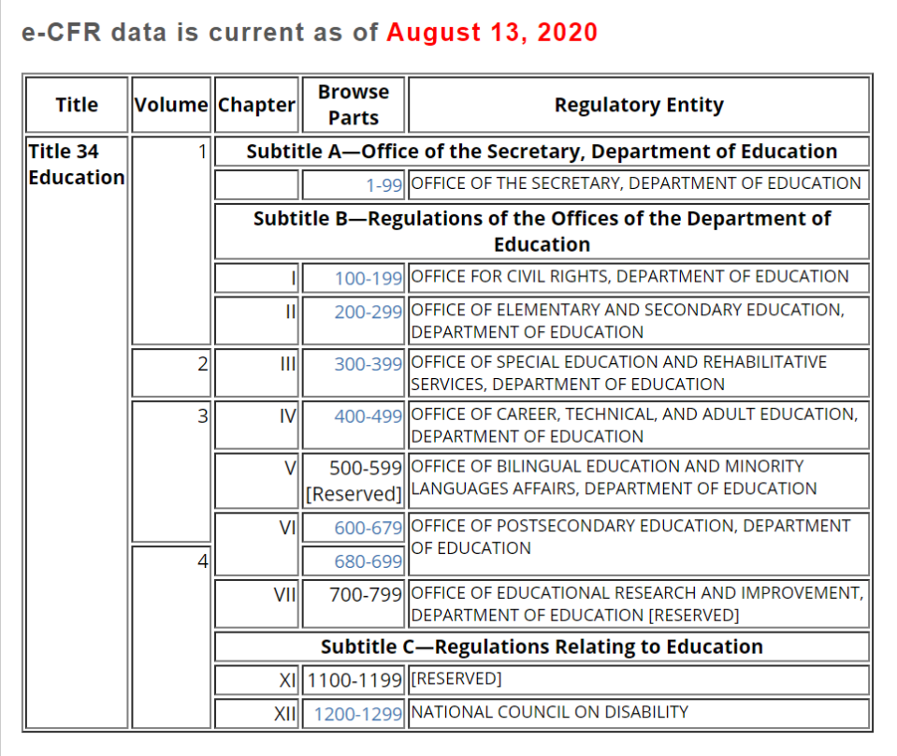
Select the blue
“300-399” link. That’s where IDEA’s regulations are codified.

Citing the Regulations in This Trainer’s Guide
You’ll be seeing a lot of citations in this trainer’s guide that look similar to this: 81 Fed. Reg. at 92389
This means that whatever is being quoted can be found in the Federal Register (Fed. Reg.) published on December 19, 2016—Volume 81, Number 243, to be precise. The number at the end of the citation (in our example, 92389) refers to the page number on which the quotation appears in that volume.
When people quote from something published in the Federal Register, this is the typical citation style they’ll use: Volume Number of the Federal Register in which the cited words appeared, at such-and-such page #.
How does information about how we’ve cited regulations in this guide relate to the final regulations on disproportionality? Most of the regulations cited in this guide refer to the recent final regulations on disproportionality, which were published in 81 Fed. Reg. at 92463-92464.
The final regulations on disproportionality are just two pages long? Yes. Two pages, neat and tidy. However…
If you download a copy of those regulations (see below), they come with 87 pages of analysis and discussion of the comments received from the public during the public comment period following the release of proposed regulations by the Department (known as the Notice of Public Rulemaking, or the NPRM).
The Analysis of Comments and Changes can give you a fascinating window into the depths and details of IDEA as well as what’s happening in the field and in people’s genuine experience. That’s why, when appropriate, we’ve included snippets from that discussion in this trainer’s guide.
To download a copy of the disproportionality regulations | View or download a copy from the Federal Register website. The first 87 pages will be, as we’ve said, the Analysis of Comments and Changes. You’ll find the two pages of the regulations at the very end (pages 92463-92464).
PDF version (547 KB) | https://www.gpo.gov/fdsys/pkg/FR-2016-12-19/pdf/2016-30190.pdf
HTML version | https://www.gpo.gov/fdsys/pkg/FR-2016-12-19/html/2016-30190.htm
Note to Trainers | We’ve provided only the final regulations on disproportionality (as printed in the Federal Register) on Handout 3.

Thank You’s and Acknowledgements
The Center for Parent Information and Resources (CPIR) would like to express its deep appreciation for the hard work and expertise of:
- Perry Williams, Ph.D., Office of Special Education Programs, U.S. Department of Education, who was the primary original author of this module and who continues to be closely involved in addressing disproportionality in special education;
- Carmen Sánchez, Office of Special Education Programs, U.S. Department of Education, who is the federal project officer for CPIR and many Parent Center programs and who has been a sharp-eyed reviewer and advisor during the module’s development; and
- CPIR’s Significant Disproportionality Advisory Committee that has guided development of these materials all along the way, sharing their Parent Center perspectives and commitment to this topic—namely, Kanika Littleton (Michigan Alliance for Families), Barb Koumjian (The Branch Military PTAC), and Paula Wills (Family Resource Center on Disabilities, serving Chicago, IL).

Now… Let’s Dig In!
Here ends Part 1 of this Trainer’s Guide. The remainder of the guide is devoted to describing the slides in Slideshow 1. We’ll move slide by slide, giving you a thumbnail picture of the slide, a detailed discussion of its content, the relevant regulations (if any), possible handouts or activities that can be used with the slide, tidbits of information you may wish to share with your audience, and helpful resources you might consult for your own learning or find appropriate to share with the audience.

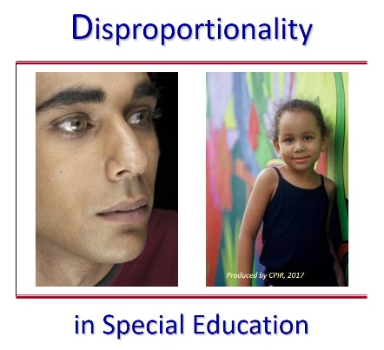
Slide 1 / Title Slide
Suggested handout: Handout 1, Sketching out the Scene
Use Slide 1 to orient your audience to this training. Just as the title of the slide indicates, the topic under the microscope will be Disproportionality in Special Education.
The module begins with an activity designed to have participants focus on the racial and ethnic elements in their own community, school, or school system. By starting off with their personal context, which is more familiar to them than anything else, the topic of this training session is made immediately personal.
The activity sheet for participants is Handout 1, Sketching out the Scene. The activity itself is described between the lines below.
Opening Activity
Purpose | To have participants reflect on the racial/ethnic profile of their school or school system.
Total Time Activity Takes | 10 minutes.
Group Size | Individually to complete handout. Large group to discuss.
Materials | Handout 1, Sketching out the Scene
Instructions
- Refer participants to Handout 1. Indicate that this is the activity sheet they each have to complete. There are no right or wrong answers, only what they know or would presume. They will have 5 minutes.
- Give participants the allotted 5 minutes to work alone. Then call them back to the large group.
- Take 5 minutes to do a rough scan of how participants answered. Question 1...show of hands, for example. Ask for more detail from participants, especially about the diversity of their student population and whether they believe that differences exist between the educational experience of different ethnic or racial groups. What about differences in how they are disciplined at school (e.g., referrals to the office, suspensions, expulsions)?
Possible Prompts
- How many of you answered thinking of a school where the majority of students are White? African American? Hispanic? Asian?
- Does anyone know their school/system’s dropout rate for these ethnic groups?
- Let’s list a few ways that leaders might demonstrate their commitment to students who are racially or ethnically diverse.
When you’ve heard from a few participants, summarize their comments as appropriate, and use that summary as the segue into the module on disproportionality.

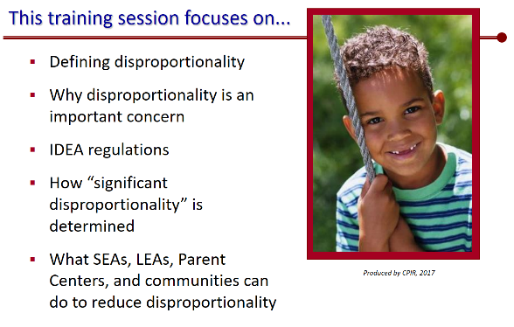
Slide 2 / Agenda Slide
Slide 2 is an advance organizer for the audience regarding the content treated in this slideshow. The slide loads completely, headers, bullets, and photo.
Using the Slide to Activate Knowledge and Focus Attention
Each of the bulleted items on the slide allows you to solicit a smattering of remarks from your audience, as time permits. The interaction you have with the audience—or more precisely, their participation in the interaction—activates their knowledge base and attention, and allows other participants to absorb that knowledge and interest.
Suggestions:
Bullet 1: Defining disproportionality. Ask the group how they would define it. What’s their understanding of this term?
Bullet 2: Why disproportionality is an important concern. Does anyone in the audience care to comment on why disproportionality is a concern? Are participants aware that it is a concern and has been for quite some time? If not, then you’ll tell them all about it.
Bullet 3: IDEA’s regulations. Can anyone in the audience summarize what IDEA has required in the past regarding disproportionality (under IDEA 2004)? How much do trainees know about 2016 provisions? Show of hands—would they rate their knowledge as “I know it all,” “I know a little bit,” or “I know nothing.”
Bullet 4: How “significant disproportionality” is determined. What might “significant disproportionality” be? Would anyone hazard a guess, or a knowledgeable statement?
Bullet 5: What SEAs, LEAs, Parent Centers, and communities can do. Let the audience know that you have lots of goodies for them in terms of resources on disproportionality in special education, which they can use when they finish this training session and return to their “regularly scheduled programming.”

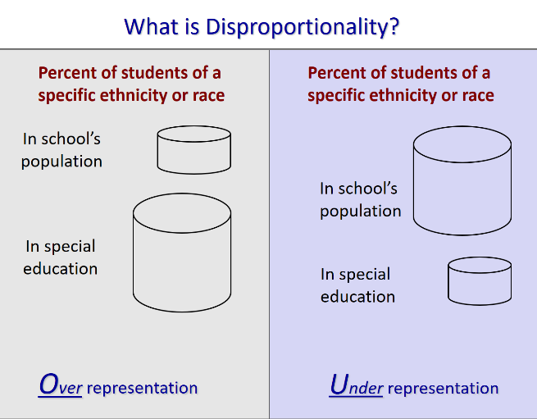
Slide 3 / What is Disproportionality?
Suggested handout: Handout 2, Congressional Concerns: Excerpts from Findings in IDEA 2004’s Statute
Slide 3 focuses on defining disproproportionality, both overrepresentation and underrepresentation. Both situations are graphically depicted on the slide by the cylinders of different sizes.
Suggestions for Trainers
This slide lays the foundation for talking about disproportionality throughout this training session. The concept of disproportionality is relatively easy to explain, but describing how it is determined is much more complicated. This slide will help you do that.
- Use the graphics of the cylinders to explain what over- and under-representation are. These will help most participants grasp the concept of “over” (too many) and “under” (too few), and will be particularly helpful to visual learners in the audience.
- Take advantage of what participants may have shared in the opening activity (Handout 1, Sketching out the Scene) about their own schools and possible disproportionalities.
- Share information about the history of Congressional concern over disproportionality in special education and how that concern has resulted in concrete legislative action, most notably through the IDEA statute. You may wish to share Handout 2 with participants, so they can see exactly what Congress expressed as “findings” that must be addressed.
- Remind everyone that determining disproportionality requires data analysis. Real numbers must be crunched and compared. What may appear to be unequal practices in special education toward some racial or ethnic groups can only be verified by looking at school data. Participants will hear more about what data need to be analyzed in upcoming slides.
Background and Supporting Information
What is Disproportionality?
Within the context of this training session, disproportionality refers to situations when the percentage of students from a specific racial or ethnic group in special education programs or specific special education categories is noticeably greater than (or markedly less than) the percentage of their enrollment in a school’s general student population or in comparison with other racial or ethnic groups in the school.
Overrepresentation | The left side of the slide shows the situation of overrepresentation—where the percentage of students from a specific racial or ethnic group (e.g., Native Americans) is greater in special education than in the school’s population. We see this graphically depicted by the two cylinders on the left. The cylinder at the bottom left (percentage of such students in special education) is much bigger than the cylinder at the top left (their percentage in the school’s student population).
It is well known that children of some racial or ethnic groups are overrepresented in some categories of special education. For example, research data show that the problem of disproportionality is especially apparent for African-American males in high-incidence categories such as intellectual disability and emotional disturbance. Upcoming slides will take a deeper look at that research data.
Over the last 30 or more years, overrepresentation has been the focus of much discussion and action—including research into what is causing it and how to take direct action against it. This truth can be seen in many provisions of IDEA over the years, especially in IDEA 97, IDEA 2004, and the IDEA regulations published in 2016.
Underrepresentation | As everyone can see, the right side of the slide appears nearly identical to the left; both include the same examination of what percent of children of a specific race or ethnic group are represented in special education versus in the school’s population. What’s different is the size of the cylinders shown. The cylinders on the right are the visual opposite of those on the left, graphically depicting a situation where there are markedly fewer children of that race or ethnicity in special education than in the school population. This is a case of underrepresentation.
Although this training session focuses primarily on the overrepresentation of students of particular racial or ethnic groups in special education, it’s important for the audience to understand that underrepresentation of a particular racial/ethnic group is also a disproportionate representation and therefore a cause for concern and action. Several studies of disproportionality have revealed the underrepresentation of children from particular racial or ethnic groups in programs for the gifted and talented and in special education classes. However, this will not be discussed in any detail in this module. This is consistent with what the U.S. Department of Education asserts has been its long-standing interpretation of original Congressional intent, which was to require states to address overrepresentation, not underidentification or underrepresentation. As the Department states in its Analysis of Comments and Changes:
The basis for congressional action was largely due to a concern that students of color were being identified too often for special education services, and placed too frequently in segregated settings, in ways that were detrimental to their education.
Congressional Concern
Trainers may find it appropriate to share Congress’s concern here as foundational. The Congress has expressed its concern about this issue over the years and taken action to investigate and ameliorate it. For example:
- IDEA 97 mandated new state reporting requirements concerning enrollment by race and ethnicity in special education.
- IDEA 2004, passed by Congress in December 2004, opened with a list of findings that specifically identify disproportionality as an issue to be addressed. Those findings are presented below and on Handout 2, if you’d like to share them with the audience. As you can see, they are quite extensive. They also remain relevant today as we examine the 2016 revision of IDEA’s disproportionality regulations.

Excerpts from Findings in IDEA 2004’s Statute
‘‘(10)(A) The Federal Government must be responsive to the growing needs of an increasingly diverse society.
‘‘(B) America’s ethnic profile is rapidly changing. In 2000, 1 of every 3 persons in the United States was a member of a minority group or was limited English proficient.
‘‘(C) Minority children comprise an increasing percentage of public school students.
‘‘(D) With such changing demographics, recruitment efforts for special education personnel should focus on increasing the participation of minorities in the teaching profession in order to provide appropriate role models with sufficient knowledge to address the special education needs of these students.
‘‘(11)(A) The limited English proficient population is the fastest growing in our Nation, and the growth is occurring in many parts of our Nation.
‘‘(B) Studies have documented apparent discrepancies in the levels of referral and placement of limited English proficient children in special education.
‘‘(C) Such discrepancies pose a special challenge for special education in the referral of, assessment of, and provision of services for, our Nation’s students from non-English language backgrounds.
‘‘(12)(A) Greater efforts are needed to prevent the intensification of problems connected with mislabeling and high dropout rates among minority children with disabilities.
‘‘(B) More minority children continue to be served in special education than would be expected from the percentage of minority students in the general school population.
‘‘(C) African-American children are identified as having mental retardation and emotional disturbance at rates greater than their White counterparts.
‘‘(D) In the 1998–1999 school year, African-American children represented just 14.8 percent of the population aged 6 through 21, but comprised 20.2 percent of all children with disabilities.
‘‘(E) Studies have found that schools with predominately White students and teachers have placed disproportionately high numbers of their minority students into special education.”
Public Law 108-446
Section 601(c), Findings.

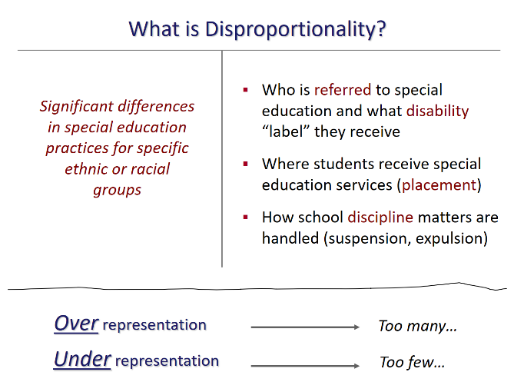
Slide 4 / What is Disproportionality?
Slide 4 sharpens the discussion of disproportionality in special education to the three distinct areas addressed in the 2016 disproportionality regulations and requirements. As shown on the slide, these three areas of inquiry and monitoring are:
- Who is referred to special education and what disability “label” they receive after evaluation;
- Where students receive special education services (i.e., their placement); and
- How school disciplinary matters are handled.
These three threads will run through this entire training module. They serve as the current frame through which states, school districts, and schools must examine their special education data and practices, as well as:
- How they will reach determinations of “significant disproportionality” in any of their local education agencies (LEAs) and school districts;
- What remedial actions must be taken, if required; and
- What information they must report (e.g., findings and any resultant actions to be taken) to the public and to the U.S. Department of Education.
Discussing the Slide
- Go over the points on the slide. Be sure to stress that the audience take special note of these areas, because they do serve as the frame for how the educational system will identify and address disproportionate practices in special education.
- Note that participants will hear more about each of these areas during the training session and that the action steps suggested near the end of the session will harken back to these important areas.
- Note as well that, prior to the reauthorization of IDEA in 2004, disproportionality monitoring focused on identification and placement. Examining disciplinary data to see if there are significant differences between how one racial/ethnic minority group was disciplined versus another was added to §300.646 in IDEA 2004. The 2016 revision of IDEA 2004’s reauthorization of disproportionality has reinforced discipline as an area of concern.
- Indicate that each area stands alone as its own line of state and local inquiry and monitoring. Together, they constitute what areas states must address when determining if significant disproportionality exists at the state level and within its LEAs.

Moving on to the Next Slide
Let’s get into some examples of why these three areas are of particular concern when talking about disproportionality in special education. What does the research reveal?
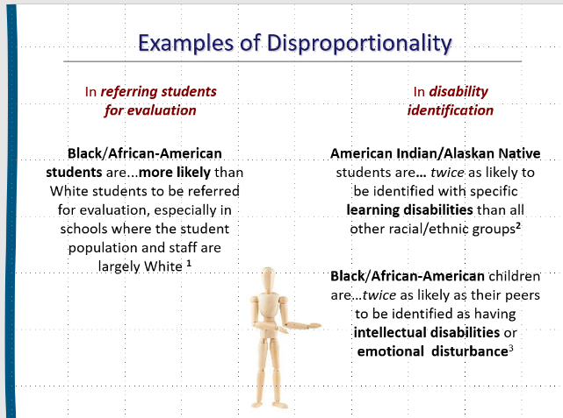
Slide 5 / Examples of Disproportionality
Slide 5 begins a series of slides on what we know from research about disproportionate practices. This slide looks at the first area of concern. Specifically, are students from a given racial or ethnic group more (or less) likely than others to be:
- Referred for evaluation to see if they have a disability; and/or
- Identified as having a particular disability?
Note to Trainers! | As a trainer, you are at liberty to decide how much time you will spend with the audience on this (or any) slide. How much does the audience already know about how students are referred for special education evaluation or how they are identified as having a disability? If not much, then you may wish to share some of the overview information we’ve provided under the “Background and Supporting Information” section of this slide’s discussion.
If the audience is already well-versed in these two facets of the special education system, focus on the research findings, sum them up quickly, and move on to Slide 6.
Disproportionality in Referrals
As the slide (left column) indicates:
“Black/African-American students are...more likely than White students to be referred for evaluation, especially in schools where the student population and staff are largely White”
The bullet is footnoted, with the research citation for the statement appearing in the speaker notes section below the PowerPoint slide. Participants will not be able to see the citation. Should they ask, or should you wish to share where this information comes from, we’ve provided the citation at the end of this slide’s discussion.
This is but one example from the research literature as to which students are more likely to be referred for evaluation than would be expected from their numbers in the school population (or compared to how often students from other minority groups are referred for evaluation).
Disproportionality in Disability Identification
As the slide (right column) indicates:
Native American students are…twice as likely to be identified with specific learning disabilities than all other racial/ethnic groups
Black/African-American children are…twice as likely as their peers to be identified as having intellectual disabilities or emotional disturbance
What these statistics tell us is that there’s disproportionality in how specific racial or ethnic groups are being “assigned” to disability categories, which will have a significant impact on the education and support services these children receive.
These two research findings are footnoted on the slide and come from the sources identified at the end of this slide’s discussion. The findings are among the most-often mentioned when disproportionality in special education is discussed.
Background and Supporting Information
Quick Overview of Referral | Given that referral for evaluation is an area where disproportionate practices have been found, you may need to take the audience through a quick “tour” of the referral process in general. You can share this information with the audience or discuss what participants already know about the referral process, as you deem necessary. It’s always good to be clear about what’s being discussed. You might mention:
- There are a number of paths by which students may come to receive an evaluation for disability, including at the request of parents or the school system itself. General education teachers often refer students for evaluation based on poor academic performance or behavior in class.
- Upon receiving a referral, the school system must promptly provide parents with prior written notice about its proposal to evaluate their child, ask for and obtain parents’ written consent, and conduct the evaluation in keeping with IDEA’s timeframe requirements (60 days from receiving parental permission, or within the timeframe set by the state).
- Parents must give their informed consent before the school may evaluate their child for a disability.
State-Specific Practices, Policies, and Procedures | The referral process may be affected by a number of state-specific policies (described below). If any of these are used in your state, you may wish to mention them in any overview about referral you offer.
- Many states have a pre-referral process or team designed to determine if a referral for special education evaluation is really necessary or appropriate. If your state has such a process, you’ll want to mention it to the audience.
- Many states also provide what’s known as early intervening services (EIS) before evaluating a child. With EIS, assistance is given to children who have not yet been identified as eligible for special education and related services under IDEA but who need extra help and support to progress in the general education environment. Is this approach relevant in your state? If so, it may need to be mentioned, because it affects the referral process.
- Many schools also use a response-to-intervention (RTI) or similar approach as a step before actual evaluation for specific learning disabilities. One of RTI’s underlying premises is the possibility that a child’s struggles may be due to inadequacies in instruction or in the curriculum either in use at the moment or in the child’s past. Is this relevant to your audience?
If so, you may wish to explain briefly that an RTI approach is designed to see if the student in question responds to a program of high-quality, evidence-based instruction with ongoing progress monitoring. RTI typically has several tiers where intervention becomes steadily more intensive and targeted. If a student’s academics or behavior does not improve at a lower tier, he or she may move up to a more intensive tier of intervention.
- It’s important to note that, at any time during an RTI approach, parents have the right to ask that their child be evaluated to see if he or she has a disability. If they do request such an evaluation, the school must promptly ask for parents’ written consent and conduct the evaluation in keeping with IDEA’s timeframe requirements (60 days from receiving parental permission, or within the timeframe set by the state).
Disability Identification: Insights from the Literature | The professional literature distinguishes between judgmental or high-incidence and nonjudgmental or low-incidence disability categories. Nonjudgmental categories relate to children who are deaf and blind or have orthopedic impairments or severe intellectual disabilities. In contrast, diagnoses for categories such as mild intellectual disability, emotional disturbance, or specific learning disabilities (SLD) rest on the “art” of professional judgment in that referral for special education evaluation and diagnoses involve school personnel’s subjective opinions, which can cause inconsistencies in identification.
It is for this reason that we need to pay greater attention to the general education world where the problem of disproportionate representation often begins. The problem of disproportionality can no longer be viewed solely as a special education issue.
Citations for the Research Findings Noted on the Slide
For Referral Reference
Woodson, L., & Harris, S.M. (2018). Teacher and student demographic variables which predict teacher referrals of males for special education evaluation. Journal of At-Risk Issues, 21(1), 32-43.
For Identification References
- Re: Native Americans (i.e., American Indians/Alaska Natives)
Harper, C. (2017, January). 5 things to know about racial and ethnic disparities in special education (Child Trends 5). Online at: https://www.childtrends.org/child-trends-5/5-things-know-racial-ethnic-disparities-special-education
- Re: Blacks/African-Americans
81 Fed. Reg. at 92380 (The Analysis of Comments and Changes, which accompanied the publication of the final disproportionality regulations in December 2016).

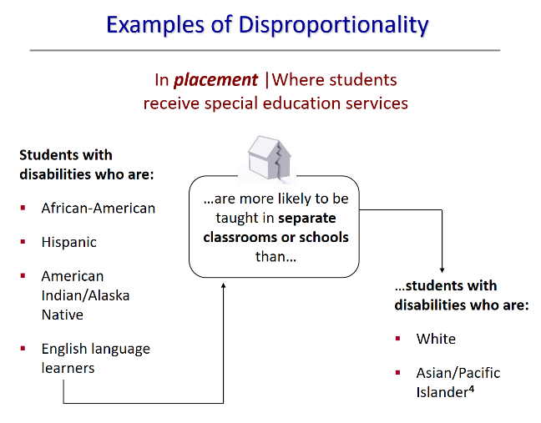
Slide 6 / Examples of Disproportionality
Slide 6 continues the brief look at examples of disproportionality—this time capturing what research says about disproportionality in special education placement.
As the slide indicates, students with disabilities who are African-American, Hispanic, American Indian/Alaska Native, or English language learners are more than likely to be taught in separate classrooms or schools than students with disabilities who are White or Asian/Pacific Islanders.
As with the previous slide, the research is footnoted in the speaker notes area of the slide. For your information, that citation is:
National Council on Disability. (2018, February). IDEA series: The segregation of students with disabilities. Washington, DC: Author. Online at: https://ncd.gov/sites/default/files/NCD_Segregation-SWD_508.pdf
Talking about the Slide: Covering the Basics of Placement First
What’s placement? | For clarity’s sake, start by stating what “placement” means, something simply put as “Placement is where students with disabilities receive their special education and related services.”
Ask the audience to name a few possible placements | The slide uses the phrase “more likely to be taught in separate classrooms or schools.” What other placements might there be? Possible answers you may hear: in a resource room; in a pull-out program; in a class only for students with disabilities; at home; in a special school.
Note to Trainers: Need More
Info on Placement?

Depending on the familiarity of the audience with placement, you may find they need a brief overview of the subject.
Refer to the Background and Supporting Information section of this slide’s discussion for key information such as: Who decides a child’s placement? What are the options, according to IDEA? How do IDEA’s least restrictive environment (LRE) provisions guide placement decisions?
What’s so terrible about being taught in a separate class? | While participants may not voice this question aloud, some might be wondering it. It will be important to address the question whether it’s voiced or not.
The answer is complicated, but it’s directly tied to the requirements of IDEA regarding placement (discussed more fully in the Background and Supporting Information section of this slide’s discussion). Briefly here, you may wish to make the following points:
- In and of itself, receiving special education services in a separate classroom is not “terrible” or necessarily “wrong.” IDEA itself requires each public agency (e.g., school district, LEA) to ensure that a continuum of alternative placements is available to meet the needs of children with disabilities for special education and related services. That continuum includes making instruction in special classes or in special schools available as a placement option.
- However, as the Department states and IDEA’s provisions make clear, “The overriding rule is that placement decisions must be determined on an individual, case-by-case basis, depending on each child’s unique needs and circumstances and, in most cases, based on the child’s IEP.”
Placement Info You Can Share
with Families

Looking for an easy-to-read explanation of placement to share with the families you serve? Try these:
Placement, Short-and-Sweet
https://www.parentcenterhub.org/
placement-overview/
Determinando la Ubicación del Niño
https://www.parentcenterhub.org/
ubicacion/

- Moreover, IDEA has always required that placement decisions be made in keeping with the law’s least restrictive environment (LRE) provisions, which include the following:
(2) Each public agency must ensure that—
(i) To the maximum extent appropriate, children with disabilities, including children in public or private institutions or other care facilities, are educated with children who are nondisabled; and
(ii) Special classes, separate schooling, or other removal of children with disabilities from the regular educational environment occurs only if the nature or severity of the disability is such that education in regular classes with the use of supplementary aids and services cannot be achieved satisfactorily.
- Especially note the strength of the wording in IDEA’s LRE provisions: “To the maximum extent appropriate” | “…occurs only if…”
- Parents have the right to be part of any group that decides their child’s placement.
The decades-long concern over disproportionality in placement decisions, therefore, is not about the quality of special education services that children with disabilities receive in separated environments as opposed to services they might receive in the general education setting. Rather, the concern is that children with disabilities of certain racial or ethnic groups are more likely—often much more likely—to be placed in segregated, more restrictive environments. This is one of the reasons why IDEA requires that LEAs examine their placement data by race and ethnicity to identify if they are placing disproportionately higher percentages of students from certain racial or ethnic groups in separated, more restrictive settings.

Discussing the Example of Disproportionality Given on the Slide
Research findings that children with disabilities from specific minority groups are more likely to be placed in a separated setting than children with disabilities from other groups have definitely been an impetus for Congress to take legislative action. There may be many reasons behind this disproportionality (some will be discussed under Slide 14), but the data reveal a consistent pattern of placement disproportionality based on race and ethnicity.
Let’s move on to our last research-based example of disproportionality—this time with regard to disciplinary action.

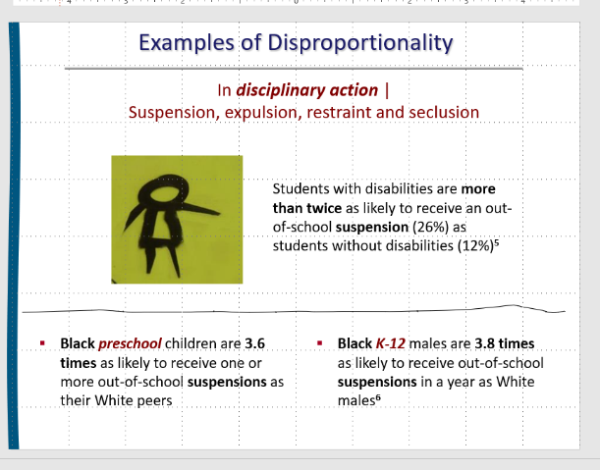
Slide 7 / Examples of Disproportionality
Note to Trainers | The slide will display all graphics and text fully and automatically, without you having to click to advance the elements. However, the slide is set to display slowly, not all at once, so be patient as each piece presents itself! (The slow display makes it easier for participants to absorb each individual element.)
Slide 7 wraps up this series of disproportionality examples drawn from the research. Three research findings are mentioned; all relate to the ways in which students with disabilities receive disciplinary actions such as suspension, expulsion, or restraint/seclusion.
- Students with disabilities are more than twice as likely to receive an out-of-school suspension (26%) as students without disabilities (12%)
- Black preschool children are 3.6 times more likely to receive one or more out-of-school suspensions as their White peers
- Black K-12 males are 3.8 times more likely to receive one or more out-of-school suspensions in a year as White males
As with previous slides, each of these findings are footnoted in the speaker notes area of the slide. For your convenience, we provide those citations at the end of this slide’s discussion.
Finding 1 | The first finding simply compares the likelihood of receiving an out-of-school suspension between two groups: students with disabilities and students without disabilities. Clearly, students with disabilities are more than twice as likely to be suspended from school (K-12) than are students without disabilities.
Findings 2 and 3 | Here, research reveals that Black students are much more likely than their White peers to receive an out-of-school suspension (especially males). Truly disturbing is the number of Black children who are suspended from preschool! We don’t normally think of preschoolers being suspended, but the data tell a different reality. In addition to what’s listed on the slide, you might mention several of the alarming statistics below, all of which come from the Office for Civil Rights at the U.S. Department of Education.
- Black children represent 19% of preschool enrollment, but 47% of preschool children receiving one or more out-of-school suspensions. In comparison, White children represent 41% of preschool enrollment, but 28% of preschool children receiving one or more out-of-school suspensions.
- Black boys represent 19% of male preschool enrollment, but 45% of male preschool children receiving one or more out-of-school suspensions.
- Black girls represent 20% of female preschool enrollment, but 54% of female preschool children receiving one or more out-of-school suspensions.
There’s also a disparity in suspension rates by gender: Most of the public preschool children suspended are boys. While boys represent 54% of preschool enrollment, they represent 78% of preschool children receiving one or more out-of-school suspensions. Interestingly, at the preschool level, children with disabilities and English learners are not disproportionately suspended.
Nationally, school children collectively lost over 11 million days of instruction (11,360,004) as a result of out-of-school suspension. Black students lost disproportionately more instructional days than any other racial/ethnic group (an estimated 66 days, as contrasted with 31 days for Native Americans, 30 for Pacific Islanders, and 17 for Latinos). The suspension rate of students with disabilities varies noticeably by race and ethnicity. More than 1 out of 5 American Indian or Alaska Native (23%), Native Hawaiian or other Pacific Islander (23%), Black (25%), and multiracial (27%) boys with disabilities served by IDEA received one or more out-of-school suspensions, compared to 1 out of 10 White (10%) boys with disabilities served by IDEA. As the Office for Civil Rights summarizes:
The Civil Rights Data Collection (CRDC) reveals that students of certain racial or ethnic groups and students with disabilities are disciplined at far higher rates than their peers, beginning in preschool. The CRDC data also show that an increasing number of students are losing important instructional time due to exclusionary discipline.
Beyond Suspension
Out-of-school suspensions are only one form of disciplinary action used by schools. Others include referral to the principal's office or detention, in-school suspensions, restraint and seclusion, expulsion, alternative placements, referral to law enforcement agencies, and arrest. Here are some data you can share with participants about these other forms of discipline. They all shed light on the serious and ongoing inequity in how some students are disciplined at school.
- Students with disabilities represent 28% of the students who are referred to law enforcement or subjected to school-related arrests, while representing just 12% of the student population.
- Data on referrals to law enforcement and school-based arrests indicate that the majority of suspensions and expulsions resulted from only trivial infractions of school rules or offenses, not from offenses that endangered the physical well-being of other students.
- Up to 85% of youth in juvenile detention facilities have disabilities that make them eligible for special education services, yet only 37% receive these services while in school. Black students with disabilities represent 18.7% of the IDEA population, but 49.9% of IDEA students in correctional facilities. This has become known as the “school-to-prison pipeline.
- Students with disabilities served by IDEA represent 12% of students enrolled in public schools, but represent 71% of all students subjected to physical restraint during school and 66% of all subjected to seclusion.
- Black students represent 19% of students with disabilities served by IDEA, but 36% of those students who are subject to mechanical restraint.
Enough said? Not quite yet. IDEA 2004’s discipline rules are complex and sometimes hard to understand, yet they play an important role in how students with disabilities are disciplined for behavior or other infractions of the student code of conduct. We’ve listed several resources below that your audience may find helpful now or in the future.
Brief Listing of Resources on Discipline for Families, Staff, and Others
Placement and School Discipline
This article takes a not-so-brief look at how a student placement can be affected by disciplinary actions at school.
https://www.parentcenterhub.org/disciplineplacements/
On the Legal Limits of Using Restraint or Seclusion
This suite of resources comes from the Office for Civil Rights at the U.S. Department of Education.
https://www.parentcenterhub.org/restraint-seclusion-ed2016/
Webinar | IDEA Behavioral Support and Discipline
In this CPIR webinar, Renee Bradley, of OSEP, is joined by representatives from Parent Centers, protection and advocacy agencies, and state directors of special education to unpack an important “Dear Colleague” letter released by OSEP regarding behavior and school discipline, and discuss its impact on the field.
https://www.parentcenterhub.org/webinar-oser-dcl-idea-behavioral-support-and-discipline/
School Climate and Discipline
This page of resources at the U.S. Department of Education is really a suite of resources that connects you with the latest data and thinking on suspension and expulsion of students from school. The basic message is “Rethinking Discipline” in order to create safe and positive school climates.
http://www2.ed.gov/policy/gen/guid/school-discipline/index.html
School Discipline Laws and Regulations by Category and State
See what school discipline laws your state has on the books.
https://safesupportivelearning.ed.gov/node/3510

Citations for the Research Findings Noted on the Slide
Finding at the Top of the Slide
U.S. Department of Education, Office for Civil Rights. (2019, May). Data highlights on school climate and safety (2015-2016 Civil Rights Data Collection). Washington, DC: Author. Online at: https://www2.ed.gov/about/offices/list/ocr/docs/school-climate-and-safety.pdf
Left and Right Findings
Rafa, A. (2018, January). Suspension and expulsion: What is the issue and why does it matter? (Policy Snapshot). Denver, CO: Education Commission of the States. Online at: https://eric.ed.gov/?id=ED581500
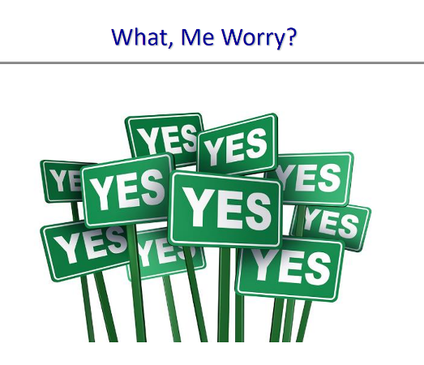
Slide 8 / What, Me Worry?
Slide 8 is meant to be a quick, wry slide. After having presented a handful of sobering findings from research, it’s clear why Congress was worried about disproportionality—and why we should be, too.
The “What, Me Worry?” title on the slide should call to mind Alfred E. Neuman of Mad Magazine, who made the statement famous. Anyone in the audience recognize it?

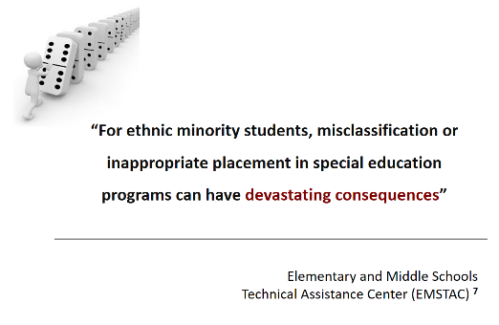
Slide 9 / Devastating Consequences
Slide 9 presents a quote from the Elementary and Middle School Technical Assistance Center (EMSTAC), a project formerly funded by OSEP.
“For ethnic minority students, misclassification or inappropriate placement in special education programs can have devastating consequences.”
EMSTAC is no longer in operation, but this quote captures an ongoing reality. We use it now as both a summative statement of the research review just presented (“What, Me Worry?”) and the lead-in to the next slide, which looks at some of the very real consequences of misclassifying or inappropriately placing ethnic minority students in special education. The graphic on this slide (top left) shows a row of dominos about to go down.
Read the quote aloud, then ask the audience if they can project what some in-school consequences might be (Slide 13 will address post-school consequences). Let participants name several possible in-school repercussions. Then move on to Slide 10 and explore with the audience what research has to contribute to our deeper awareness of how damaging disproportionality in special education can be for many minority students with disabilities.

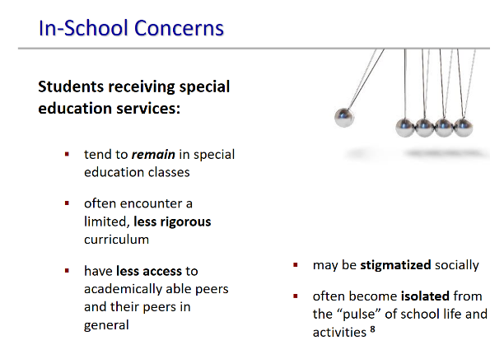
Slide 10 / In-School Consequences
Slide 10 takes a research-based look at the consequences that misidentification, inappropriate placement, and discriminatory disciplinary actions can have on special education students, especially those from minority backgrounds. As the slide states:
Students receiving special education services:
- tend to remain in special education classes once they are “placed” there
- often encounter a limited, less rigorous curriculum with limited access to the curriculum used in general education
- have less access to academically able peers and their peers in general
- may be stigmatized socially
- often become isolated from the “pulse” of school life and activities
These findings come from multiple research studies, which are extensively discussed in:
Losen, D.J., & Whitaker, A. (n.d.). 11 million days lost: Race, discipline, and safety at U.S. public schools (Part 1). New York, NY: American Civil Liberties Union. Online at: https://www.aclu.org/report/11-million-days-lost-race-discipline-and-safety-us-public-schools-part-1
National Council on Disability. (2018, February). IDEA series: The segregation of students with disabilities. Washington, DC: Author. Online at: https://ncd.gov/sites/default/files/NCD_Segregation-SWD_508.pdf
Raj, C. (2016). The misidentification of children with disabilities: A harm with no foul. Arizona State Law Journal, 373-437. Online at: https://scholarcommons.sc.edu/cgi/viewcontent.cgi?article=2068&context=law_facpub
Did anyone in the audience notice how frequently these in-school consequences include words that convey isolation from and limited access to the normal life of students within a school?
When you consider that many students (especially those from minority groups) have been misidentified as having a particular disability and then provided with services appropriate for a disability they don’t have, sometimes in settings that are unjustifiably separated from their peers, these consequences are not all that surprising. Even in this day of state standards for learning and IEP development that ties student goals to those standards, these consequences accumulate, slowly and steadily. What is surprising is that so many students of color are being educated in more restrictive environments when IDEA’s LRE provisions explicitly state that “special classes, separate schooling, or other removal of children with disabilities from the regular educational environment occurs only if the nature or severity of the disability is such that education in regular classes with the use of supplementary aids and services cannot be achieved satisfactorily” [§300.114(a)(2)].
And these aren’t the only negative consequences that can occur. Slide 11 describes yet more—consequences largely associated with being suspended or expelled from school.

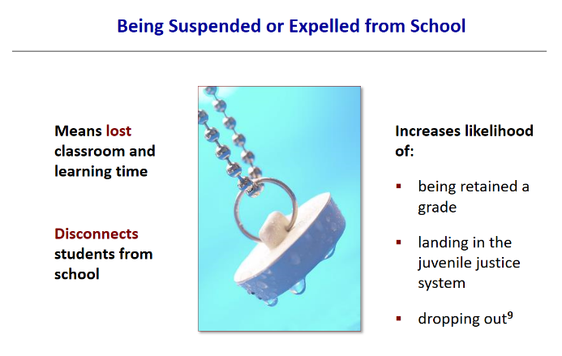
Slide 11 / Being Suspended or Expelled from School
Slide 11 focuses on the consequences associated with the third strand of disproportionality that states must attend to—namely, disciplinary practices that disproportionately affect students from specific racial or ethnic groups.
The consequences of being suspended or expelled from school are many, and they are all negative. As the slide captures, being suspended or expelled from school:
- Means lost classroom and learning time
- Disconnects students from school
- Increases likelihood of:
- being retained a grade
- landing in the juvenile justice system
- dropping out
Many researchers and concerned professional groups have noted these consequences, including the one that’s cited in the speaker notes area below the slide:
Rafa, A. (2018, January). Suspension and expulsion: What is the issue and why does it matter? (Policy Snapshot). Denver, CO: Education Commission of the States. Online at: https://eric.ed.gov/?id=ED581500
Discussing the “Costs” of Suspension or Expulsion
In this section, you’ll find more detail about several items on the slide. This background and supporting information are primarily intended to add to your knowledge base as a trainer and equip you with specifics to back up the summative statements on the slide. Any of this information can be shared or discussed with the audience, as a way of stimulating conversation and exchange, or to provide participants with the sharp-edged details of the bigger picture at hand (i.e., what suspension or expulsion from school can mean for too many minority students with and without disabilities).
Lost Instructional Time | Removing students with disabilities from school via suspension or expulsion not only means lost instructional and learning time, but obviously can undermine students’ academic achievement. As mentioned under Slide 10, the loss of instructional time can be quite substantial and lead to a multitude of spin-off impacts—lower scores on national assessments, increased risk of dropping out, lower graduation rates, and increased likelihood of arrest and involvement in the juvenile justice system.
Involvement in Juvenile Justice System | Of definite concern is the greater likelihood of becoming involved with the juvenile justice system for students with disabilities (especially those who are from minority populations) who have one or more suspensions in a school year or outright expulsion from school. The issue will also be addressed in the Slide 13, so you might put off discussing it right here.
This issue has become known as the “school-to-prison pipeline.” It doesn’t just apply to those with disabilities, however. The school-to-prison pipeline is a serious reality for youth of color in general and has spawned a wide array of federal and state initiatives intended to reduce the risk of juvenile justice involvement for youth of color and youth with disabilities.
The audience may or may not be familiar with some of those initiatives (which include laws), so let us list a few examples that trainers might mention:
- My Brother’s Keeper initiative, launched under the Obama administration, addresses persistent opportunity gaps faced by boys and young men of color. It’s now called MBK Alliance.
https://www.obama.org/mbka/
- Juvenile Justice and Delinquency Prevention Act (JJDPA), originally passed in 1974 and most recently reauthorized by Congress in 2018, offers core protections to youth (including those with disabilities) involved in the juvenile justice system. Among those protections:
  - The “Deinstitutionalization of Status Offenders” requirements that states and territories must follow. (More information about “status offenses” is provided in the box on the next page, because status offenses are relevant to exclusionary school disciplinary decisions.)
http://www.act4jj.org/what-jjdpa
  - The “Racial and Ethnic Disparities” provisions (formerly called Disproportionate Minority Contact) require states to collect and analyze data on racial and ethnic disparities at decision points in state, local, or tribal juvenile justice systems to determine which points create racial and ethnic disparities (RED) among youth who come into contact with the juvenile justice system. States must then establish a plan to address RED.
- Office of Juvenile Justice and Delinquency Prevention (OJJDP) is a federal office within the Department of Justice. Its charge is “to support local and state efforts to prevent delinquency and improve the juvenile justice system.” Lots of good resources here for Parent Centers, families, advocates, and others alarmed by the school-to-prison pipeline for youth of color, including those who have disabilities. Check out OJJDP’s State Contacts page, to identify JJ contacts in your state, at: https://ojjdp.ojp.gov/states
More about Status Offenses | “Status offenses are offenses that only apply to minors whose actions would not be considered offenses if they were adults. The most common are skipping school, running away, breaking curfew, and possession or use of alcohol.”
The Deinstitutionalization of Status Offenders (DSO) provision “seeks to ensure that status offenders who have not committed a criminal offense are not held in secure juvenile facilities for extended periods of time or in secure adult facilities for any length of time. These children, instead, should receive community-based services, such as day treatment or residential home treatment, counseling, mentoring, family support, and alternative education.”
Dropping Out of School | Students who are expelled from school are far more likely to drop out of school. Research shows that being suspended even once in ninth grade is associated with a two-fold increase in the likelihood of dropping out.
While the high school graduation rate of racial/ethnic minority students has significantly increased in the last 10 years, the connection remains evident between in-school disciplinary actions and the increased likelihood of a student dropping out of school. This brief section reviews current data that you can share with the audience as you wish or have time to include.
- High school graduation rates for: Asian students (91%); Whites (89%); Hispanic/Latino students (80%); African American students (78%); and American Indian/Alaska Native students (72%) .
- The percentage of 16- to 24-year-olds who are not enrolled in school and have not earned a high school credential is known as the status dropout rate. In 2017 there were approximately 2.1 million such youth, with disparities by race and ethnicity: American Indian/Alaska Native youth had the highest dropout rate (10.1%), followed by Hispanic youth (8.2%); Black youth (6.5%); White youth (4.3%); Pacific Islander (4.9%); and Asian youth (2.1%).
- Dropouts are 3.5 times more likely to be arrested than high school graduates. Many so-called dropouts who end up in jail are actually push-outs. Under the guise of zero tolerance, initiated after Columbine, students are often asked to leave school as a first response rather than a last resort.
- The graduation rate for students with disabilities hit 67.1% in 2016-17, which is still nearly 20 points behind the national average of 84.6%.
- Want to find out your state’s graduation rate? Have a look at Figure 1 in The Condition of Education 2019, online at: https://nces.ed.gov/programs/coe/pdf/coe_coi.pdf

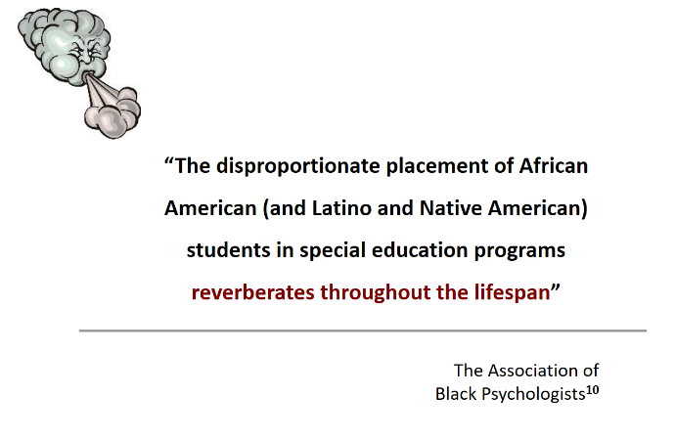
Slide 12 / Lifetime Reverberations
Slide 12 is meant to be quickly covered. It serves as a steppingstone from earlier slides of in-school consequences of disproportionality to the next slide, which identifies post-school consequences of note. The quote on the slide says:
“The disproportionate placement of African American (and Latino and Native American) students in special education programs reverberates throughout the lifespan.”
The citation associated with this quote is provided in the speaker notes box below the slide (which the audience cannot see). Here it is, should you wish to share that information:
Codrington, J., & Fairchild, H.H. (2012, February). Special education and the mis-education of African American children: A call to action (p. 5). Ft. Washington, MD: The Association of Black Psychologists. Online at: http://www.abpsi.org/pdf/specialedpositionpaper021312.pdf
Suggestion to Trainer
Read the quote aloud, then ask the audience if they can project what some post-school consequences might be. Let participants name several possible repercussions. Then move on to Slide 13 and explore with the audience what research reveals are some of the real-life and lifelong consequences.
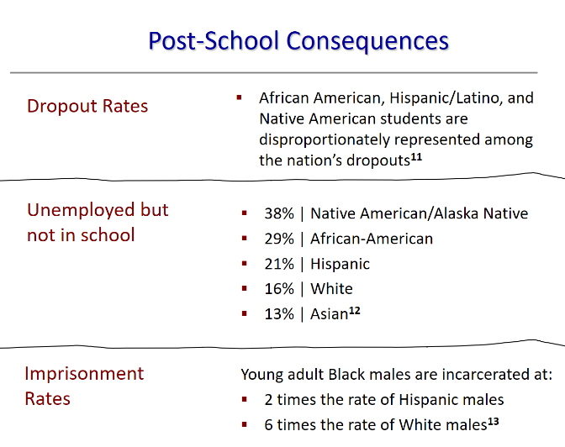
Slide 13 / Post-School Consequences
Slide 13 takes us to “What happens afterwards?” What are the longer-term, perhaps lifelong, consequences of disproportionality in special education for students from minority backgrounds?
Three areas are addressed: dropout rates; percent of those who are unemployed but not in school; and imprisonment rates. You may have mentioned some of these areas of consequence as you moved through Slides 10 to 12.
Discussion of the Slide
Dropout rates | Students with disabilities drop out of high school at a significantly higher rate than students without disabilities. As the slide indicates, disproportionate percentages of African-American, Hispanic/Latino, and Native American students are among those who drop out of high school. American Indian/Alaska Native youth (ages 16-24) had the highest dropout rate (9.5%), followed by Pacific Islanders (8.1%); Hispanic youth (8.0%); Black youth (6.4%); White youth (4.2%); and Asian youth (1.9%).
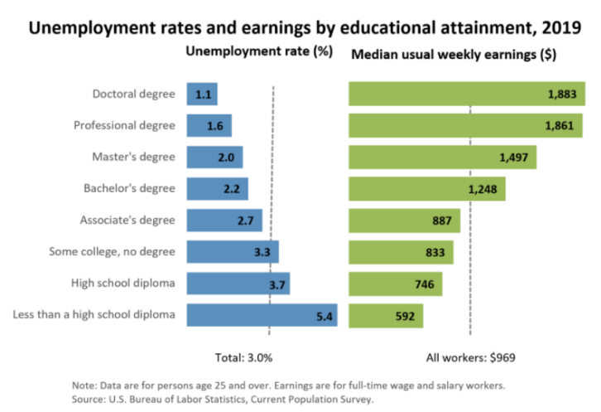
Employment | Given the statistics shown on the slide, it’s clear that, even after many ethnic/racial minorities exit school (for whatever reason), the pattern of negative consequences comes with them and contributes to their disproportionate numbers among the unemployed. Consider this chart from the Bureau of Labor Statistics at the U.S. Department of Labor. It shows how dramatically levels of education can affect future employment and wages. The lower the educational attainment of an individual, the lower his or her projected earnings will be.

Imprisonment rates | The school-to-prison pipeline has been mentioned several times in this trainer’s guide. Refer to the discussion under Slide 11 for more statistical information about the disproportionate numbers of ethnic/racial minorities who are incarcerated. The data cited on this slide come from:
The Sentencing Project. (2018, April). Report of The Sentencing Project to the United Nations Special Rapporteur on contemporary forms of racism, racial discrimination, xenophobia, and related intolerance: Regarding racial disparities in the United States criminal justice system. Washington, DC: Author. Online at: https://www.sentencingproject.org/publications/un-report-on-racial-disparities/
In sum | The overall post-school outcomes for ethnic/racial minority youth, including those with disabilities, depict a difficult life ahead, with “higher incarceration rates, lower college attendance, blunted employment opportunities, lower socio-economic well-being, more dire health statistics, and lower life expectancies.”
All of this begs the question, Why? The next slide looks at some hypotheses about the roots of disproportionality in special education.
You may wish to pause here (on this slide) and talk with the audience about what they think might be possible causes or roots of the problem. If you have time, have the audience break into small groups of 2-4 to discuss this question and list what they think is causing or contributing to disproportionality in special education based on race or ethnicity. Have the small groups report back as part of the post-activity debriefing.
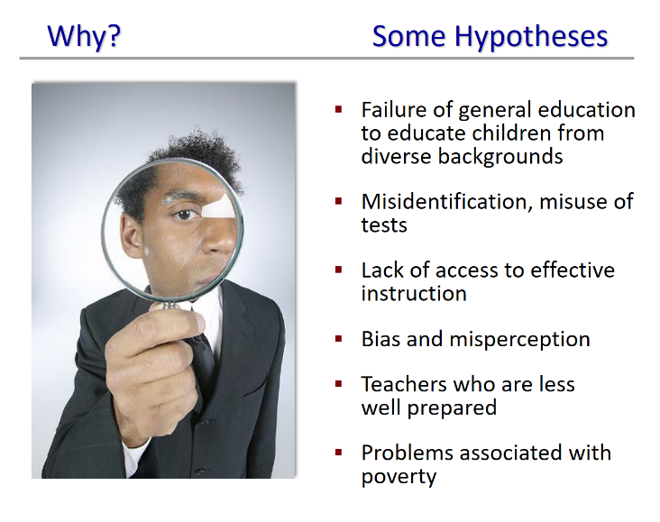
Slide 14 / Why? Some Hypotheses
Slide 14 brings us to the obvious question that most of the audience is probably asking: What in the world?! What is causing or contributing to the disproportionality of racial/ethnic minority students in special education?
Some possibilities are given on the slide:
- Failure of general education to educate children from diverse backgrounds
- Misidentification, misuse of tests
- Lack of access to effective instruction
- Bias and misperception
- Teachers who are less well prepared
- Problems associated with poverty
Associated with these possibilities comes a plethora of research and speculation. Certainly, the role that discrimination or implicit bias might play has been more than substantively discussed and has many dimensions. Have a look at this resource for a deeper exploration of eight possible root causes.
Identifying the Root Causes of Disproportionality | From the New York University Technical Assistance Center on Disproportionality. This 13-page guide is hands-on, with tips for guiding local discussions about this complicated and sensitive issue. Possible causes explored: (1) discipline policies and practices, (2) interventions and referrals, (3) instruction and assessment, (4) differential access to educational opportunity, (5) family and community partnerships, (6) teacher expectations and misconceptions, (7) cultural dissonance, and (8) district socio-demographics. Online at: https://steinhardt.nyu.edu/scmsAdmin/media/users/ll81/Identifying_the_Root_Causes_of_Disproportionality.pdf
This slide ends Section 1 of the slideshow, which looked at what we know about disproportionality in special education. The next slide opens Section 2 of the slideshow---what is being done to address this issue?
Slide 15 / December 2016
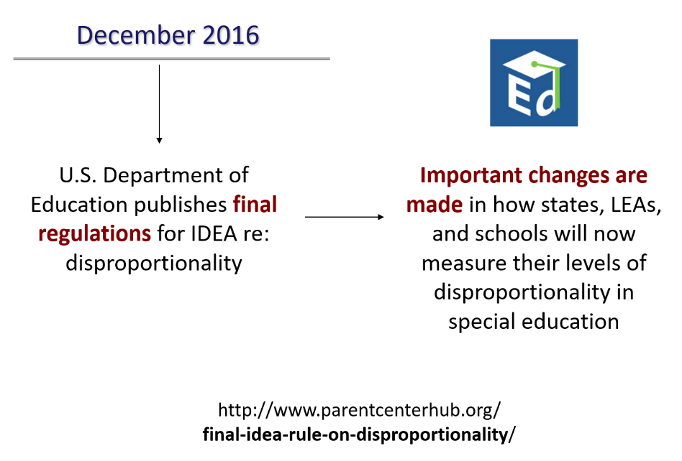
Slide 15 takes us out of the realm of background information (albeit reality) and into the realm of action. The remaining slides in this presentation briefly introduce the final IDEA regulations on disproportionality that were published by the U.S. Department of Education in December 2016.
As the Slide 15 indicates, the new final IDEA regulations on disproportionality bring important changes in how states, LEAs, and schools will now measure their levels of disproportionality in special education.
The final rule on disproportionality, plus | At the same time that ED released IDEA’s 2016 final regulation on disproportionality, it also published a fact sheet on equity and announced a Dear Colleague Letter (DCL) on Racial Discrimination from the Office for Civil Rights. All (the final rule, the fact sheet, and the DCL) can be accessed at the URL address given at the bottom of the slide:
https://www.parentcenterhub.org/final-idea-rule-on-disproportionality/
We highly recommend reading and sharing the Dear Colleague Letter on Racial Discrimination. It’s 25 pages long, but is an excellent and authoritative resource on the obligation of states, districts, and public schools (including charter schools) not to discriminate on the basis of race, color, or national origin in the administration of special education or related aids and services. Several federal laws are discussed: IDEA, Section 504 of the Rehabilitation Act of 1973, and Title II of the Americans with Disabilities Act of 1990.
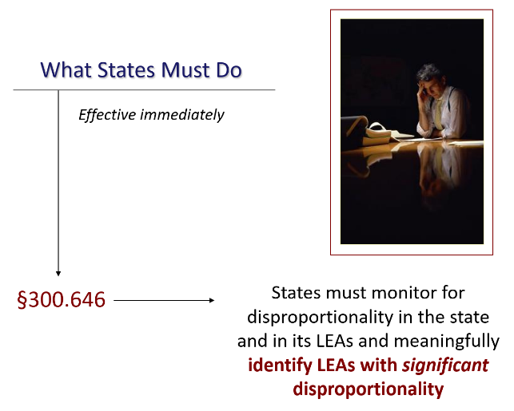
Slide 16 / What States Must Do
Suggested handout: Handout 3, IDEA Final Regulations on Disproportionality (6 pages)
Slide 16 captures in brief what states must do under the 2016 final regulations (beginning at §300.646). States must monitor for disproportionality in the state itself (as a whole) and in its LEAs and meaningfully identify those with significant disproportionality.
These requirements raise several immediate questions:
- What must states monitor for, specifically?
- What does the word “meaningfully” mean?
- What is significant disproportionality, and how does it differ from disproportionality as discussed to date in this slideshow? Are they the same thing?
These questions will be answered within this series of slides on the requirements of the 2016 disproportionality regulations. You might ask the audience to brainstorm some possible answers. Given what’s been said thus far, they should have a fairly concrete notion of the basic strands or threads of student data that states must monitor (e.g., referral and disability identification, placement, discipline).
How much information does your audience need about what states are required to do? | Some audiences may not require or want detailed information about the regulations. This may be especially so for families or stakeholders not steeped in prior knowledge about disproportionality. If you’re trying to raise general awareness of disproportionality, you may wish to move quickly through the next slides, so that audience members “get” the broad picture of what is now required of states. They may appreciate receiving Handout 3 for later reference, but whether or not you share the handout is up to you.
If, however, you are training colleagues or stakeholders likely to get involved in addressing disproportionality at the systems level, then you will want to share Handout 3, letting participants know that you will be referring to it as you go through the upcoming slides. These federal regulations are important. They provide states, LEAs, and stakeholders with critical definitions and rules for identifying and addressing disproportionate representation in special education based on race/ethnicity, as well as state reporting requirements to the federal government and to the public.

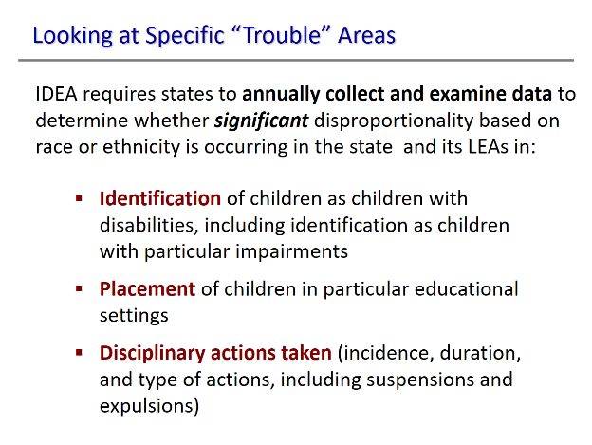
Slide 17 / Looking at Specific “Trouble” Areas
Slide 17 answers one aspect of the question raised on Slide 16: What must states monitor for, specifically?
As might be expected, given the information provided already in this slideshow, states must now collect and examine data every year to determine if any of their LEAs have significant disproportionality based on race or ethnicity in how children with disabilities are:
- Identified as having a disability, including which disability;
- Placed in specific educational settings; and
- Disciplined at school (i.e., the incidence, duration, and type of disciplinary actions taken, including suspension and expulsion).
These three areas have been mentioned multiple times, and now we see them as part of IDEA-required monitoring by states.
If you’ve shared Handout 3 with the audience, refer them to the very beginning of the disproportionality regulations—§300.646(a), to be precise, which reads as follows:
Sec. 300.646 Disproportionality.
(a) General. Each State that receives assistance under Part B of the Act, and the Secretary of the Interior, must provide for the collection and examination of data to determine if significant disproportionality based on race and ethnicity is occurring in the State and the LEAs of the State with respect to--
(1) The identification of children as children with disabilities, including the identification of children as children with disabilities in accordance with a particular impairment described in section 602(3) of the Act;
(2) The placement in particular educational settings of these children; and
(3) The incidence, duration, and type of disciplinary removals from placement, including suspensions and expulsions.

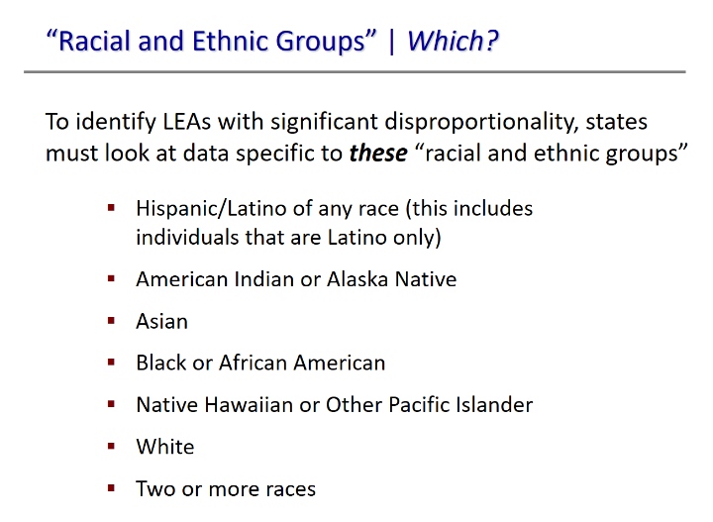
Slide 18 / Looking at Specific “Trouble” Areas
Slide 18 answers another aspect of the question posed on Slide 16: What must state monitor for, specifically? If significant disproportionality is occurring based on race and ethnicity—which racial and ethnic groups are we talking about?
The regulations make it very clear which racial and ethnic groups are the focal point of interest in the state’s monitoring efforts. So does the slide, which lists IDEA’s requirements. These are found on page 4 of Handout 3, at §300. 647(b)(2), and read as follows:
(2) The State must apply the risk ratio threshold or thresholds determined in paragraph (b)(1) of this section to risk ratios or alternate risk ratios, as appropriate, in each category described in paragraphs (b)(3) and (4) of this section and the following racial and ethnic groups:
(i) Hispanic/Latino of any race; and, for individuals who are non-Hispanic/Latino only;
(ii) American Indian or Alaska Native;
(iii) Asian;
(iv) Black or African American;
(v) Native Hawaiian or Other Pacific Islander;
(vi) White; and
(vii) Two or more races. [§300. 647(b)(2)]

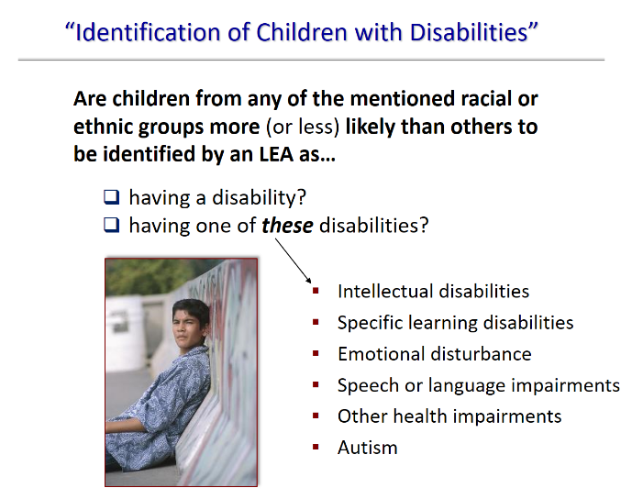
Slide 19 / “Identification of Children with Disabilities”
Slide 19 provides detail about what states must monitor for in the identification of children as having a disability. (This issue was discussed under Slide 5.) States must also monitor to see if there is racial or ethnic disproportionality in what disabilities children are identified as having. This corresponds to the findings of research that students of color are more likely to be identified with intellectual or emotional disabilities, and that students from other racial or ethnic groups are more likely to be identified as having, for example, specific learning disabilities.
Here, succinctly enumerated on the slide and in regulation, are the disability categories on which states must focus their monitoring when they look at an LEA’s data on students with disabilities who come from specific racial or ethnic groups. If you shared Handout 3 with participants, direct their attention to IDEA’s pertinent regulations on page 4, at §300.647(b)(3):
(3) Except as provided in paragraphs (b)(5) and (c) of this section, the State must calculate the risk ratio for each LEA, for each racial and ethnic group in paragraph (b)(2) of this section with respect to:
(i) The identification of children ages 3 through 21 as children with disabilities; and
(ii) The identification of children ages 3 through 21 as children with the following impairments:
(A) Intellectual disabilities;
(B) Specific learning disabilities;
(C) Emotional disturbance;
(D) Speech or language impairments;
(E) Other health impairments; and
(F) Autism.
What does “except as provided in paragraphs (b)(5) and (c) of this section” refer to? | This phrase offers two exceptions to the just-stated requirements. Both exceptions need not be explained to general audiences, only to those audiences who need to know the particulars of the regulations because they expect to be involved in providing stakeholder input or advocacy work at a systems level. Even with well-informed audiences, there’s no need to explain the exceptions in this slideshow. They are exactly what they seem to be—exceptions to the rule.
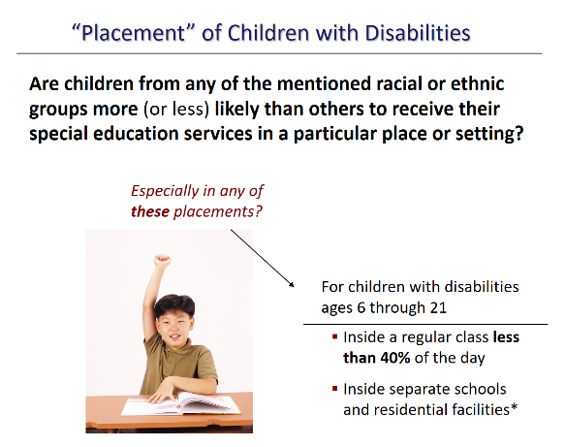
Slide 20 / “Placement” of Children with Disabilities
Slide 20 is one of two about what states must monitor for with respect to significant disproportionality in placement—where children with disabilities from the ethnic/racial groups identified on Slide 19 receive special education and related services.
The regulations associated with this slide can be found at the top of page 5 of Handout 3 (if you shared it), at §300.647(b)(4). They read as follows:
(4) Except as provided in paragraphs (b)(5) and (c) of this section, the State must calculate the risk ratio for each LEA, for each racial and ethnic group in paragraph (b)(2) of this section with respect to the following placements into particular educational settings, including disciplinary removals:
(i) For children with disabilities ages 6 through 21, inside a regular class less than 40 percent of the day;
(ii) For children with disabilities ages 6 through 21, inside separate schools and residential facilities, not including homebound or hospital settings, correctional facilities, or private schools…
Discussing the Regulations
It’s important to let participants know that what’s on this slide represents only part of what’s required by the regulations in terms of monitoring placements. The next slide will focus on the remainder of what’s required. We’ve broken the requirements into two parts for your ease of presentation and discussion, not to mention participant understanding. Breaking the discussion into two parts makes logical sense, too, when you consider the nature of what’s being monitored about placement.
- Restrictiveness of placement: Slide 20 (this slide) describes the required monitoring of placements for children with disabilities ages 6 to 21 (especially within the specified racial/ethnic groups) in more restrictive settings (i.e., inside a regular class less than 40% of the day; inside separate schools and residential facilities); and
- Placement affected by disciplinary actions: Slide 21 focuses on the monitoring of disciplinary actions taken with children with disabilities ages 3 to 21 (especially within the specified racial/ethnic groups), including out-of-school suspensions and expulsions, in-school suspensions and expulsions, and total number of disciplinary removals.
What does the asterisk on Slide 20 refer to? | See that * (asterisk) after the last bullet on the slide (which says “inside separate schools and residential facilities”)? It’s meant to indicate that “inside separate schools and residential facilities” does not include “homebound or hospital settings, correctional facilities, or private schools.”
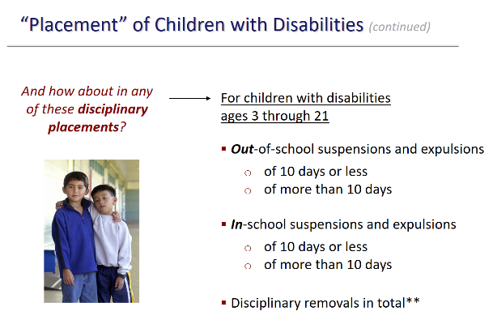
Slide 21 / “Placement” of Children with Disabilities
Slide 21 is the second of two about what states must monitor with respect to significant disproportionality in placement. It completes the story begun in the previous slide, and shows what must be monitored with respect to disciplinary placements.
The Regulations, Verbatim
Slide 20 provided the beginning of the verbatim regulations at §300.647(b)(4). The current slide provides the remainder of those regulations, which read as follows:
(4) Except as provided in paragraphs (b)(5) and (c) of this section, the State must calculate the risk ratio for each LEA, for each racial and ethnic group in paragraph (b)(2) of this section with respect to the following placements into particular educational settings, including disciplinary removals:
(i) ….
(ii)…
(iii) For children with disabilities ages 3 through 21, out-of-school suspensions and expulsions of 10 days or fewer;
(iv) For children with disabilities ages 3 through 21, out-of-school suspensions and expulsions of more than 10 days;
(v) For children with disabilities ages 3 through 21, in-school suspensions of 10 days or fewer;
(vi) For children with disabilities ages 3 through 21, in-school suspensions of more than 10 days; and
(vii) For children with disabilities ages 3 through 21, disciplinary removals in total, including in-school and out-of-school suspensions, expulsions, removals by school personnel to an interim alternative education setting, and removals by a hearing officer.
Discussing the Slide
You may wish to make several points about this slide, such as:
- Obviously, these IDEA requirements address the third strand of concern discussed throughout this slideshow—whether disciplinary actions taken with minority children with disabilities are disproportionately harsher and more exclusionary than actions taken with other groups of students.
- The double asterisk (**) after “disciplinary removals in total” indicates that the regulations contain additional information about this category—namely, the category includes in-school and out-of-school suspensions, expulsions, removals by school personnel to an interim alternative education setting, and removals by a hearing officer. Participants can see this additional regulatory detail on Handout 3 at §300.646(b)(4)(vii). It also appears in the verbatim regulations cited above—in that last line.
- Most audiences will not need this level of detail about what states must monitor about placements. Participants have heard (on Slide 17) that the monitoring of disciplinary actions within an LEA must include the “incidence, duration, and type of disciplinary removals from placement” [§300.646(a)(3)]. Suffice it to say that the regulations now require states to monitor for disproportionality in placements, including (as this slide shows) when disciplinary actions remove students from their placement and exclude them from regular school activities, even from the building itself.
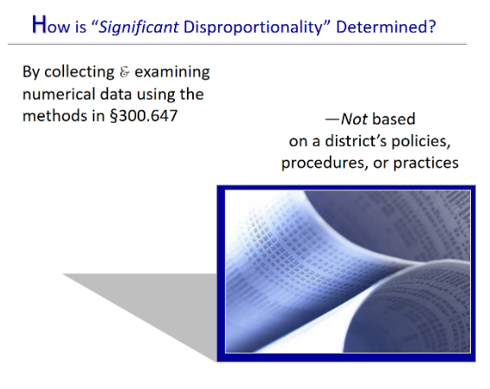
Slide 22 / How is “Significant Disproportionality” Determined?
Slide 22 addresses a critical point about monitoring for disproportionality based on race and ethnicity. The regulations require states to collect and examine data, data, data, and identify significant disproportionalities in the state and in its LEAs. What is “significant”? When does disproportionality rise to a level considered “significant”? What is that level?
Discussing the Slide
- The first element to point out to the audience is that disproportionality determinations are made based on data. Hard data. Numerical data. Determinations are not made by looking at a district’s policies, practices, or procedures—that scrutiny happens after a finding of significant disproportionality.
- The 2016 regulations do not define the term “significant disproportionality.” This is something that the state must define for itself, with input from stakeholders, including its State Advisory Panel. However, the regulations [at §300.647(b)] do describe the method by which the state reaches a determination of significant disproportionality in an LEA or in the state itself. That will be the focus of the next slide.
- Considering the audience | As we’ve said before, the amount of detail that audience members might need about the subject at hand will vary greatly from audience to audience. If you are making this presentation to a general audience, limit how much terminology you throw at them (e.g., risk ratio, risk ratio threshold, minimum cell size). These may be the nuts-and-bolts of how a state defines and determines significant disproportionality, but this slideshow is not the place to explore what such terms mean. Slideshow 2 pursues that purpose, for those who need to know what’s involved in calculating risk, risk ratios, and so on.
- The term significant disproportionality isn’t difficult to define in general, lay terms. You might describe, for example, a pot on the stove reaching the boiling point. What degree of disproportionality in special education is too much? Where’s the cut-off point, the limit, the “it’s-gone-over-the-threshold” point? That is what the state must decide, with stakeholders weighing in.
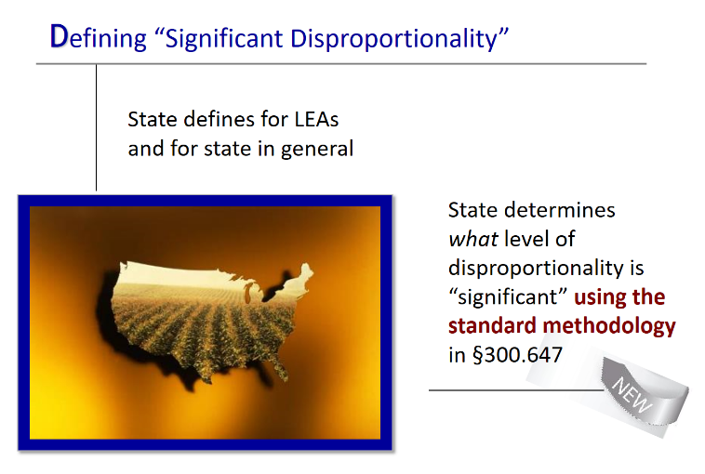
Slide 23 / Defining “Significant Disproportionality”
Slide 23 points out that it is the state that defines the term “significant disproportionality” for the state itself and for its LEAs. The regulations require that states use what is referred to as the “standard methodology” described at §300.647.
Again, it’s best to limit how deeply you delve into this subject with a general audience. It’s sufficient for most introductory audiences to understand that:
- Each state defines this important term (and several others such as risk ratio), with input from stakeholders, including the State Advisory Panel. This means that everyone has a role to play in the process, should they care to. More information about stakeholder involvement is provided under Slide 24 and on Handouts 4, 5, and 6: Action Steps You Can Take.
- The regulations published in 2016 require all states to use the same approach when defining and calculating significant disproportionality. This is the first time that IDEA requires all states to use the same approach—the standard methodology referred to on the slide in bold. According to the Department, standardizing the methodology used by states:
“…will provide clarity to the public, increase comparability of data across States, and improve upon current policy, which has resulted in State definitions which vary widely and may prevent States from identifying the magnitude of racial and ethnic overrepresentation in special education.”
A summary of the standard methodology is provided on the next slide.

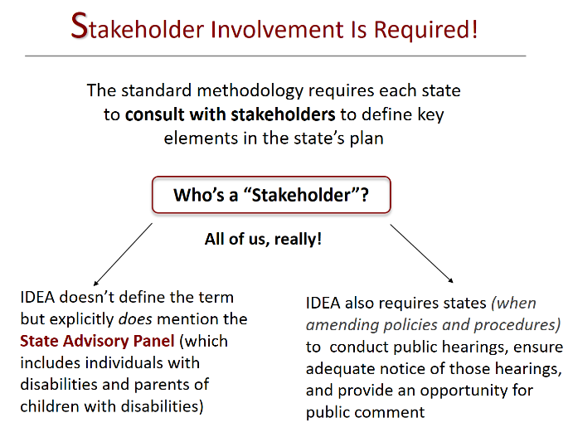
Slide 24 / Stakeholder Involvement
Suggested Handouts
- Handout 4: Action Steps for Parents of Children with Disabilities
- Handout 5: Action Steps for Parents, Parent Leadership Groups, and Community Organizations
- Handout 6: Action Steps for Educators and Administrators
Slide 24 takes a summary look at the role of input from stakeholders plays in implementing the regulations on disproportionality at the state level. Here, it’s important to let your general audience know that IDEA does require states to involve stakeholders in deciding and defining key elements of its state approach to disproportionality.
Defining “Stakeholder”
The regulations do not define the term, any more than it’s defined in other parts of IDEA. As the slide indicates, IDEA only specifically mentions that “advice from stakeholders” includes input from the State Advisory Panel.
Who’s on the State Advisory Panel?
The required membership of the State Advisory Panel is described elsewhere in IDEA [(§300.168(a)]. In general, the Panel members are appointed by the Governor (or any other official authorized under State law to make such appointments) and must “be representative of the State population and be composed of individuals involved in, or concerned with the education of children with disabilities.” State Advisory Panels must include parents of children with disabilities and individuals with disabilities. In fact, by special rule, “A majority of the members of the panel must be individuals with disabilities or parents of children with disabilities (ages birth through 26).”
What about Requirements for Public Input?
Yes, this, too, is mentioned on the slide. It’s a general requirement of IDEA and has been for a long time. When a state is revising any of its policies and procedures, it is required to do so with public input. That means holding public meetings, informing the public of those meetings with sufficient lead-time to allow them to attend, and receiving public comment. This requirement appears at §300.165(a) and reads:
- Prior to the adoption of any policies and procedures needed to comply with this section (including any amendments to such policies and procedures), the State ensures that there are public hearings, adequate notice of the hearings, and an opportunity for comment available to the general public, including individuals with disabilities and parents of children with disabilities.

How Else Might People Become Involved?
This training session is accompanied by 3 separate handouts listing action steps that people can take to become part of resolving issues of disproportionality. Depending on your audience, you might share one or another.
- Handout 4: Action Steps for Parents of Children with Disabilities
- Handout 5: Action Steps for Parents, Parent Leadership Groups, and Community Organizations
- Handout 6: Action Steps for Educators and Administrators
Activity Suggestion
Also depending upon the audience, you might delay sharing the handout in favor of having participants first get into small groups and brainstorm action steps of their own. What can they reasonably see themselves as doing? What might they do at their child’s school, or in the neighborhood, or in the classroom (depending on who they are).
Close the activity with a full-group discussion and sharing of potential action steps. Then share the appropriate handout with participants, if it seems appropriate.

Slide 25 / Wrapping It All Up
Suggested Handouts:
- Handout 7, Circle-Square-Triangle
- Handout 8, Resources of More Information
Final activity! You’re nearly done. To wrap up the session, pass out Handout 7, which engages participants in the “round-up” activity described below.
Closing Activity
Purpose | To have participants consider their own learning in this training session.
Total Time Activity Takes | 10-20 minutes.
Group Size | Participants complete the handout individually. You might then have them pair-up to compare their answers. Large group to discuss.
Materials | Handout 7, Circle-Square-Triangle
Description of Handout | The handout has 3 figures: a circle, a square, and a triangle. Within the circle are these questions to be answered: What’s still going around in your head? What do you still not understand? Within the square are these questions: What’s squared away? What do you really understand? Within the triangle? What 3 things are you “taking away” from today’s session about disproportionality? How will you use these take-aways?
Instructions
- Refer participants to Handout 7. Indicate that this is the activity sheet they will complete alone. They will have 10 minutes.
- Give participants the allotted 10 minutes to fill in the circle, square, and triangle, according to the questions inside those figures. Then either let them discuss their answers in pairs, or call them back to the large group.
- Take 5 minutes to do a scan of how participants answered. Focus in particular on what they listed in the circle and in the triangle. Wrap up the activity by answering any questions. Make sure you give Handout 8 to participants for later reference, which lists resources of additional information on disproportionality.
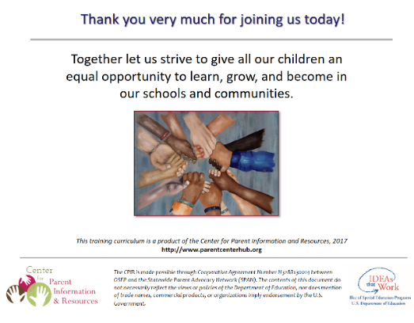
Slide 26 / Final Slide and Thank You

Final slide! You’re done. Thank the audience for joining the session, and definitely make sure that you invite them to call or email your Parent Center or organization about issues involving children with disabilities and their families.

Center for Parent Information and Resources
SPAN | 35 Halsey Street, Suite 400, Newark, NJ 07102-3047 | www.parentcenterhub.org
The Center for Parent Information and Resources (CPIR) is funded by the U.S. Department of Education, Office of Special Education Programs, under Cooperative Agreement Number H328R180005. The views expressed herein do not necessarily represent the positions or policies of the Department of Education. No official endorsement by the U.S. Department of Education of any product, commodity, service, or enterprise mentioned herein is intended or should be inferred.

This product is in the public domain. Authorization to reproduce it in whole or in part is granted. While permission to photocopy this material is not necessary, the citation should be:

Küpper, L. (Ed.) (2020, Nov). Disproportionality in special education: Trainer’s guide for slideshow 1. Newark, NJ: Center for Parent Information and Resources.

References

Section 616(a)(3) of Public Law 108-446, Individuals with Disabilities Education Act of 2004. Online at CPIR, at: http://www.parentcenterhub.org/wp-content/uploads/repo_items/PL108-446.pdf
U.S. Government Accountability Office. (2013). INDIVIDUALS WITH DISABILITIES EDUCATION ACT—Standards Needed to Improve Identification of Racial and Ethnic Overrepresentation in Special Education (GAO–13–137). Washington, DC: Author. Retrieved from www.gao.gov/products/GAO-13-137
Office of Special Education Programs. (2011). 30th Annual report to Congress on the implementation of the Individuals with Disabilities Education Act, 2008. Washington D.C.: U.S Department of Education.
Morgan, P.L., Farkas, G., Hillemeier, M.M., Mattison, R. Maczuga, S., Li, Hui, & Cook, M. (2015, June). Minorities are disproportionately underrepresented in special education: Longitudinal evidence across five disability conditions. Educational Researcher, (44)5, 278–292. DOI: 10.3102/0013189X15591157. Online at: http://www.aera.net/Newsroom/News-Releases-and-Statements/Study-Finds-Minority-Students-Are-Underrepresented-in-Special-Education
81 Fed. Reg. at 92381.
Section 601(c) of Public Law 108-446, Individuals with Disabilities Education Act of 2004, Findings. Online at: http://www.parentcenterhub.org/wp-content/uploads/repo_items/PL108-446.pdf
§300.301(b)—Initial evaluations: Request for initial evaluation.
§300.301(c)(1)—Initial evaluations: Procedures for initial evaluation.
§ 300.300 (a)—Parental consent: Parental consent for initial evaluation.
§300.226(a)—Early intervening services: General.
RTI Action Network. (n.d.). What is RTI? Retrieved from the RTI Action Network’s website, August 24, 2020 from: http://www.rtinetwork.org/learn/what/whatisrti
§300.311(a)(7)(ii)(C)—Specific documentation for the eligibility determination.
§300.301(c)(1)—Initial evaluations: Procedures for initial evaluation.
O’Connor, C., & DeLuca Fernandez, S. (2006). Race, class, and disproportionality: Reevaluating the relationship between poverty and special education placement. Educational Researcher, 35(6), 6-11.
Niedenfuer, J.D. (2015). The overrepresentation of African American students in special education: A review of the literature. Culminating Projects in Special Education (Paper 3), 1-47. St. Cloud, MN: St. Cloud State University. Online at: http://repository.stcloudstate.edu/cgi/viewcontent.cgi?article=1002&context=sped_etds
§300.115(a)—Continuum of alternative placements. (See these regulations online at: http://www.parentcenterhub.org/partb-subpartb/#300.115)
81 Fed. Reg. at 92393.
§300.114(a)(2)—LRE requirements: General.
§300.116(a)—Placement.
U.S. Department of Education, Office for Civil Rights. (2016, October). A first look: Key data highlights on equity and opportunity gaps in our nation's public schools (2013-2014 Civil Rights Data Collection). Washington, DC: Author. Online at: https://www2.ed.gov/about/offices/list/ocr/docs/2013-14-first-look.pdf
Ibid.
Losen, D.J., & Whitaker, A. (n.d.). 11 million days lost: Race, discipline, and safety at U.S. public schools (Part 1). New York, NY: American Civil Liberties Union. Online at: https://www.aclu.org/report/11-million-days-lost-race-discipline-and-safety-us-public-schools-part-1
U.S. Department of Education, Office for Civil Rights. (2016, October). A first look: Key data highlights on equity and opportunity gaps in our nation's public schools (2013-2014 Civil Rights Data Collection). Washington, DC: Author. Online at: https://www2.ed.gov/about/offices/list/ocr/docs/2013-14-first-look.pdf
U.S. Department of Education, Office for Civil Rights. (2014, March). Data snapshot: School discipline. Issue Brief 1, 1-24. (Quotation from page 2.) Online at: https://www2.ed.gov/about/offices/list/ocr/docs/crdc-discipline-snapshot.pdf
Balingit, M. (2018, April 24). Racial disparities in school discipline are growing, federal data show. The Washington Post (April 24, 2018). Online at: https://www.washingtonpost.com/local/education/racial-disparities-in-school-discipline-are-growing-federal-data-shows/2018/04/24/67b5d2b8-47e4-11e8-827e-190efaf1f1ee_story.html
Redfield, S.E., & Nance, J.P (2016, February). School-to-prison pipeline: Preliminary report. Washington, DC: American Bar Association, Joint Task Force on Reversing the School-to-Prison Pipeline. Online at: http://jjie.org/wp-content/uploads/2016/02/School-to-Prison-Pipeline-Preliminary-Report-Complete-Final.pdf
National Council on Disability. (2015, June). Breaking the school-to-prison pipeline for students with disabilities. Washington, DC: Author. Online at: https://ncd.gov/publications/2015/06182015
U.S. Department of Education, Office for Civil Rights. (2019, May). Data highlights on school climate and safety (2015-2016 Civil Rights Data Collection). Washington, DC: Author. Online at: https://www2.ed.gov/about/offices/list/ocr/docs/school-climate-and-safety.pdf
U.S. Department of Education, Office for Civil Rights. (2014, March). Data snapshot: School discipline. Issue Brief 1, 1-24. Online at: https://www2.ed.gov/about/offices/list/ocr/docs/crdc-discipline-snapshot.pdf
Sweet, S. (2016, March 3). A boy with no birthday turns sixty: The long and tangled history of Alfred E. Neuman. The Paris Review. New York, NY: Author. Online at: https://www.theparisreview.org/blog/2016/03/03/a-boy-with-no-birthday-turns-sixty/
Elementary and Middle Schools Technical Assistance Center (EMSTAC). (n.d.) Disproportionality: Frequently asked questions. Washington, DC: Author. (No longer available online.)
Losen, D.J., & Whitaker, A. (n.d.). 11 million days lost: Race, discipline, and safety at U.S. public schools (Part 1). New York, NY: American Civil Liberties Union. Online at: https://www.aclu.org/report/11-million-days-lost-race-discipline-and-safety-us-public-schools-part-1
Sawyer, W. (2019, December). Youth confinement: The whole pie 2019. Northampton, MA: Prison Policy Initiative. Online at: https://www.prisonpolicy.org/reports/youth2019.html
Act 4 Juvenile Justice.org. (2019, February). Core protections: Racial and ethnic disparities (Juvenile Justice and Delinquency Prevention Act Fact Sheet Series). Washington, DC: Author. Online at: http://www.act4jj.org/sites/default/files/resource-files/Racial%20and%20Ethnic%20Disparities%20Fact%20Sheet.pdf
Office of Juvenile Justice and Delinquency Prevention. (n.d.). About OJJDP. Washington, DC: Author. Online at: https://ojjdp.ojp.gov/about
Quotation from Core Requirements on the website of Act 4 Juvenile Justice website: http://www.act4jj.org/what-jjdpa/core-requirements
Quotation from Core Requirements on the website of Act 4 Juvenile Justice website: http://www.act4jj.org/what-jjdpa/core-requirements
Jones, E.P. (2018, September). The link between suspensions, expulsions, and dropout rates. Washington, DC: America's Promise Alliance. Online at: https://www.americaspromise.org/opinion/link-between-suspensions-expulsions-and-dropout-rates
National Center for Education Statistics. (2019, May). Public high school graduation rates. The Condition of Education (Indicator 1.17, p. 122). Washington, DC: Author. Online at: https://nces.ed.gov/programs/coe/indicator_coi.asp
National Center for Education Statistics. (2019, May). Status dropout rates. The Condition of Education (Indicator 1.18, p. 130). Washington, DC: Author. Online at: https://nces.ed.gov/programs/coe/indicator_coj.asp
Hanson, K., & Stipek, D. (2014, May 16). Schools v. prisons: Education's the way to cut prison population. San Jose, CA: San Jose Mercury News. Online at: http://www.mercurynews.com/2014/05/15/schools-v-prisons-educations-the-way-to-cut-prison-population/
Atwell, M.N., Balfanz, R., Bridgeland, J., & Ingram, E. (2019). Building a grad nation: Progress and challenge in raising high school graduation rates (Annual Update 2019). Washington, DC: America’s Promise Alliance. Online at: https://www.americaspromise.org/2019-building-grad-nation-report
Grady, M., & Bost, L. W. (Eds.). (2014). Decreasing dropout rates for minority male youth with disabilities from culturally and ethnically diverse backgrounds. Clemson, SC: National Dropout Prevention Center for Students with Disabilities. Online at: https://eric.ed.gov/?id=ED575729
National Center for Education Statistics. Status dropout rates 2018. The Condition of Education 2020. Washington, DC: Author. Online at: https://nces.ed.gov/programs/coe/indicator_coj.asp
Bureau of Labor Statistics. (2019, September). Unemployment rates and earnings by educational attainment: 2019. Washington, DC: U.S. Department of Labor. Online at: https://www.bls.gov/emp/chart-unemployment-earnings-education.htm
Codrington, J., & Fairchild, H.H. (2012, February). Special education and the mis-education of African American children: A call to action (p. 5). Ft. Washington, MD: The Association of Black Psychologists. Online at: http://www.abpsi.org/pdf/specialedpositionpaper021312.pdf
81 Fed. Reg. at 92377.
§300.168(b)—Membership: Special rule.

