Disproportionality
in Special Education:
Trainer’s Guide 2

A training guide developed for Parent Centers by the
Center for Parent Information and Resources (CPIR)
http://www.parentcenterhub.org
November 2020
_____________________________________________________________________________________
This trainer’s guide explains… | …the content of Slideshow 2 in CPIR’s training module series called Disproportionality in Special Education. The series was developed for Parent Centers to use in staff development and board training on disproportionality in special education, as well as in training sessions about disproportionality conducted for families and professionals.
Download the training materials | This training module and its component parts can be downloaded from the CPIR Hub, at: https://www.parentcenterhub.org/disproportionality-in-special-education/
The complete training module on disproportionality includes… | Two trainer’s guides that go with two separate PowerPoint slideshows, and handouts for participants. Feel free to adapt the slideshows and handouts to include information specific to your state or especially relevant to your audience. The two slideshows are designed to address the different information needs of specific audiences:
Slideshow 1 (28 slides)
Provides an overview of disproportionality as a national concern; key aspects of the final regulations on disproportionality published in December 2016; and the obligations that states and public schools have to report and address disproportionality in special education.
Parent Centers can use Slideshow 1 as part of staff development, to inform their Advisory Boards about disproportionality issues nationally and within their state, and to enlist community groups and others in local and state efforts to address disproportionality in special education.
Slideshow 1 is intended primarily for use with general audiences with little prior or in-depth knowledge of disproportionality as a national, state, and local concern. Note that Slideshow 1 can be paired with Slideshow 2 to create a mini-training series.
Slideshow 2 (29 slides)
Slideshow 2 picks up where Slideshow 1 left off, with a brief recap of the disproportionality regulations released by the Department in December 2016. The slideshow then looks closely at what the regulations require states to monitor and report every year to the U.S. Department of Education, how disproportionality is to be measured by states (via risk ratio analysis using the standard methodology set forth in the 2016 regulations), and what happens if a state finds significant disproportionality in its own special education practices or in any of its LEAs.
Technical! Use this slideshow with participants who are already knowledgeable about disproportionality as a concern but who need to have a deeper understanding of how disproportionality is determined and what must be done upon findings of significant disproportionality.
The trainer guides, slideshows, and handouts are a 2020 revision of…| (a) the training module released by CPIR in its 2017 Boot Camp for Parent Centers, which itself was a revision of (b) the training module produced in 2007 by the National Dissemination Center for Children with Disabilities (NICHCY) at the request of the Office of Special Education Programs (OSEP) at the U.S. Department of Education.
How this guide is organized | Trainer’s Guide 2 presents all the slides in Slideshow 2, moving one by one through the slides and explaining their content. Basic background information about disproportionality (who is affected? why is it a concern? what are some of its consequences?) has been provided in Trainer’s Guide 1 and in Slideshow 1 and will not be repeated here.

“Housekeeping” Details
Files You'll Need for This Training Session
All available at: https://www.parentcenterhub.org/disproportionality-in-special-education
Trainer’s Guide for Slideshow 2 (this document)
Slideshow 2 in PowerPoint or PDF
Handouts for Participants
Handout 3: IDEA’s Final Regulations on Disproportionality (published in December 2016, 6 pages)
Handout 8: Resources of More Information (Also a handout in Slideshow 1)
Handout 9 (optional): Let’s Recap (Review of the content in Slideshow 1)
Handout 10 (optional): Calculating Risk Ratios
Handout 11: Circle-Square-Triangle Redux (2 pages, not the same as Handout 7!)
Finding Specific Sections of the Regulations: 34 CFR
As you read the explanations about the final regulations on disproportionality, you will find references to specific sections, such as §300.647. (The symbol § means “Section.”) These references can be used to locate the precise sections in the federal regulations that address the issue being discussed. In most instances, we’ve also provided the verbatim text of the IDEA regulations so that you don’t have to go looking for them.
However, be aware that all final Part B regulations are codified in Title 34 of the Code of Federal Regulations. This is more commonly referred to as 34 CFR or 34 C.F.R. It’s not unusual to see references to specific sections of IDEA’s regulations include this—such as 34 CFR §300.646. For the most part, we have omitted the 34 CFR in this training curriculum for ease of reading.
Citing the Regulations in This Trainer’s Guide
You’ll be seeing citations in this trainer’s guide that look similar to this: 81 Fed. Reg. at 92389
This means that whatever is being quoted can be found in the Federal Register (Fed. Reg.) published on December 19, 2016—Volume 81, Number 243, to be precise. The number at the end of the citation (in our example, 92389) refers to the page number on which the quotation appears in that volume.
When people quote from something published in the Federal Register, this is the typical citation style they’ll use: Volume Number of the Federal Register in which the cited words appeared, at such-and-such page #.
How does information about how we’ve cited regulations in this guide relate to the final regulations on disproportionality? Most of the regulations cited in this guide refer to the recent final regulations on disproportionality, which were published in 81 Fed. Reg. at 92463- 92464. They are also available in a more readable form on Handout 3.
The new final regulations are just two pages long? Yes. Two pages, neat and tidy and using incredibly small print. (Handout 3 is easier on the eyes, at 6 pages.) However…
If you download a copy of those regulations (see below), they come with 87 pages of analysis and discussion of the comments received from the public during the public comment period following the release of proposed regulations by the Department (known as the Notice of Public Rule Making, or the NPRM). The Analysis of Comments and Changes can give you a fascinating window into the depths and details of IDEA as well as what’s happening in the field and in people’s genuine experience. That’s why, when appropriate, we’ve included snippets from that discussion in this trainer’s guide.
To download a copy of the disproportionality regulations | View or download a copy from the Federal Register website, at the links given below. The first 87 pages will be, as we’ve said, the Analysis of Comments and Changes. You’ll find the two pages of the regulations at the very end (pages 92463-92464).
PDF version (547 KB) | https://www.gpo.gov/fdsys/pkg/FR-2016-12-19/pdf/2016-30190.pdf
HTML version | https://www.gpo.gov/fdsys/pkg/FR-2016-12-19/html/2016-30190.htm

Now… Let’s Dig In!
Here ends Part 1 of the Trainer’s Guide 2. The remainder of the guide is devoted to the slideshow itself. We’ll move slide by slide, giving you a thumbnail picture of the slide, a detailed discussion of its content, the relevant regulations (if any), possible handouts or activities that can be used with the slide, tidbits of information you may wish to share with your audience, and helpful resources you might consult for your own learning or find appropriate to share with the audience.
We again alert you to the technical nature of the information that’s shared. This is not suitable for general audiences, only to audiences that will be or are involved in policy development and decision making with respect to disproportionality in special education.

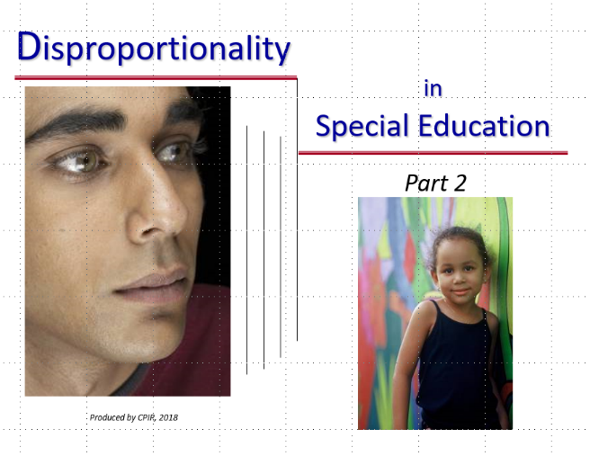
Slide 1 / Title Slide and Context-Setter
Handout: Handout 9, Let’s Recap

Current Context
Let’s say you’ve completed Slideshow 1 with a group of individuals—maybe staff of your Parent Center, perhaps your Board, or parents in your community, region, or state. Slideshow 1 can also be a good tool for introducing community organizations, civil rights groups, and potential partners with a vested interest in knowing about disproportionality in special education.
Slideshow 1 was designed as an introduction to this most important topic. It did not address the data-related details of:
- how states and schools monitor for disproportionality in special education;
- how the 2016 regulations on disproportionality standardize (as much as possible) the way that schools and states calculate disproportionality;
- the standard methodology to be used; or
- what states and schools are required to do upon a finding of significant disproportionality in their special education practices associated with identification of children as having a disability, where students are “placed” to receive their special education services, or how they are disciplined.
Slideshow 2—this slideshow—picks up where the first slideshow left off. It’s far more technical than slideshow 1 and is meant for informed audiences who are likely to be involved in some aspect of addressing disproportionality in their school, community, or state.
First, A Review
On this title slide, before moving into the slideshow proper and its new content, you may wish to spend a few minutes reviewing the information presented in Slideshow 1 (optional Handout 9 can help you with this, or a review activity of your own creation). Especially revisit:
- Which racial/ethnic groups appear to be most affected by disproportionality? Which 7 groups are identified in the regulations as being required areas of monitoring for disproportionality in special education? (Hispanic/Latino of any race; and, for individuals who are non-Hispanic/Latino only; American Indian or Alaska Native; Asian; Black or African American; Native Hawaiian or Other Pacific Islander; White; and two or more races)
- What are the 3 strands of required monitoring for disproportionality in special education based on race or ethnicity?
- Identification of children as having a disability, and also their identification as having a particular disability. Which categories of disability are of interest? Can the audience recall the 6 named in the regulations? (Intellectual disabilities; specific learning disabilities; emotional disturbance; speech or language impairments; other health impairments; and autism).
- Placement of students with disabilities (of specific racial or ethnic groups) in particular educational settings, especially settings that are more restrictive or exclusionary.
- Disciplinary actions taken with students (of specific racial or ethnic groups), including the incidence, duration, and type of disciplinary removals from placement, including suspensions and expulsions.
- How is disproportionality defined? Who defines it? (Bit of a trick question here! “Disproportionality” is defined by the state for itself and for its LEAs. Stakeholder input into that definition—e.g., at what threshold does disproportionality become “significant”—is a required part of the process.)
Slide 2 / Get Ready… Set…
This is a quick slide intended to shift from “what is already known” to presenting new content—which (as you can tell by the picture on the slide) is going to involve some heavy lifting of data.
You can present this as an “fair warning” that math and data crunching will be involved, and perhaps ask the audience to roll up their sleeves, resurrect their math skills and mind-set, and get ready to enjoy working with lovely, lovely numbers!
Let’s go!

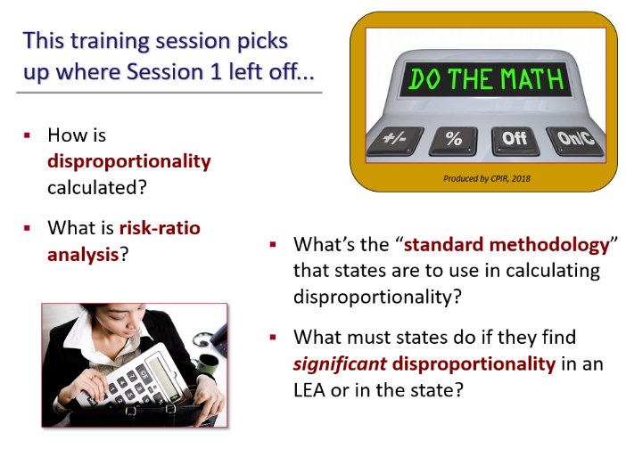
Slide 3 / Agenda
What numbers do we need to gather and crunch to answer the central questions associated with disproportionality?
This slide shows the agenda for the session, the questions to be asked and answered, and relevant vocabulary such as “risk ratio” and “standard methodology.”
Discussing the Slide
Obviously, mention that this slide provides an overview of the content to be covered. None of this information was presented in Slideshow 1, so it’s okay if participants don’t know much (if anything) about the content they see listed on the agenda.
You might ask for a show of hands (and limited comments) to gauge the background knowledge that participants already possess, asking questions such as:
- Who knows, more or less, how states and LEAs calculate for disproportionate practices in their special education programs?
- Who’s heard of “risk ratio” or “risk ratio analysis”?
- Slideshow 1 mentioned that the 2016 regulations included a new method for monitoring and calculating disproportionality: the standard methodology. Anyone know what that methodology is? Why would we need a standard way to determine disproportionality?
- The regulations also talk about significant disproportionality. How many of you know something about what this term means, or how it differs from plain old disproportionality?
When you’re gotten a preliminary idea of how much prior knowledge your audience has of the subjects to be covered, move to the next slide, where we’ll delve into how disproportionality is calculated.

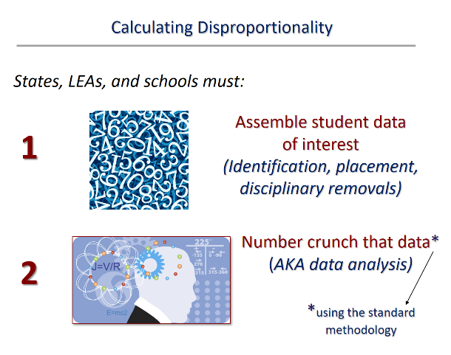
Slide 4 / Calculating Disproportionality
Suggested Handout: Handout 3, IDEA’s Regulations on Disproportionality
This can be presented as a quick slide, or you can go into some of the details presented under Discussing the Slide.
Participants will recognize the common sense of the first two steps in calculating disproportionality:
- getting together all the student/school data of interest (discussed in some detail in Slideshow 1), and
- number-crunching that data to see what they reveal.
Discussing the Slide
Using the standard methodology is required | Point out the asterisk on Step 2 and the arrow leading down to what the asterisk means: When number crunching the data (also known as data analysis), states are required to use the standard methodology that’s new in IDEA’s regulations. Refer participants to Handout 3, as appropriate, and point out §300.646(b) in the regulations (partway down page 1 of the handout), which reads:
(b) Methodology. The State must apply the methods in Sec. 300.647 to determine if significant disproportionality based on race and ethnicity is occurring in the State and the LEAs of the State under paragraph (a) of this section.
Upcoming terms | No need to go into the standard methodology described in §300.647 just yet! A quick glance at that section of the regulations (beginning at the top of page 3 of Handout 3) shows that the methodology is largely described through key terms that we’ll cover in the next few slides—terms such as risk, risk ratio, risk ratio analysis, and risk ratio threshold.
Where does the state find all the data it needs to analyze? | For the most part, states already have the data they need to analyze. This fact was certainly mentioned in Slideshow 1, but it bears repeating here. As the Department notes in the Analysis of Comments and Changes that accompanies the 2016 final regulations:
The Department made a concerted effort, both in our prior guidance and in these final regulations, to ensure that States were only required to collect and examine data that they, and their LEAs, are otherwise obligated to collect and report to the Department and the public under IDEA section 618(a).
Further:
Under the Department’s current information collection (OMB Control No. 1875–0240), States are required to submit counts of children with disabilities, by race, who are (1) identified with a particular impairment, (2) placed in particular educational settings, and (3) subjected to disciplinary removals.
Further still, states are required to report specific data to the U.S. Department of Education as part of their Annual Performance Report (APR), such as:
- Rates of suspension and expulsion (in the reporting process, known as Indicator 4)
- Disproportionate representation in special education resulting from inappropriate identification (Indicator 9), and
- Disproportionate representation in specific disability categories resulting from inappropriate identification (Indicator 10).
Many provisions in IDEA relate to data reporting, but perhaps the most central is Section 618 of IDEA’s statute. While you, as trainer, might not want to share this information with the audience, we include excerpts from Section 618 of the statute further below, for it really does:
- illuminate the scope of a state’s data reporting obligations, and
- illustrate why states generally already have the data they need to identify disproportionality and significant disproportionality.
If you’re interested in seeing your state’s APR, as filed with the U.S. Department of Education, visit the Department online, where you’ll also find OSEP’s State Determination Letters. These latter are issued after OSEP reviews the state’s APR and makes a determination as to how the state is progressing in its implementation of IDEA.
- Find your state’s APR and OSEP’s State Determination Letter for your state | https://sites.ed.gov/idea/spp-apr-letters

[Repeated from Slideshow 1 Trainer’s Guide, for your convenience]
Online at: https://sites.ed.gov/idea/statute-chapter-33/subchapter-II/1418
Section 618 of IDEA’s Statute

Section 618 <<NOTE: 20 USC 1418.>> PROGRAM INFORMATION.
(a) In General.—Each State that receives assistance under this part, and the Secretary of the Interior, shall provide data each year to the Secretary of Education and the public on the following:
(1)(A) The number and percentage of children with disabilities, by race, ethnicity, limited English proficiency status, gender, and disability category, who are in each of the following separate categories:
(i) Receiving a free appropriate public education.
(ii) Participating in regular education.
(iii) In separate classes, separate schools or facilities, or public or private residential facilities.
(iv) For each year of age from age 14 through 21, stopped receiving special education and related services because of program completion (including graduation with a regular secondary school diploma), or other reasons, and the reasons why those children stopped receiving special education and related services.
(v)(I) Removed to an interim alternative educational setting under section 615(k)(1).
(II) The acts or items precipitating those removals.
(III) The number of children with disabilities who are subject to long-term suspensions or expulsions.
(B) The number and percentage of children with disabilities, by race, gender, and ethnicity, who are receiving early intervention services.
(C) The number and percentage of children with disabilities, by race, gender, and ethnicity, who, from birth through age 2, stopped receiving early intervention services because of program completion or for other reasons.
(D) The incidence and duration of disciplinary actions by race, ethnicity, limited English proficiency status, gender, and disability category, of children with disabilities, including suspensions of 1 day or more.
(E) The number and percentage of children with disabilities who are removed to alternative educational settings or expelled as compared to children without disabilities who are removed to alternative educational settings or expelled.
(F) The number of due process complaints filed under section 615 and the number of hearings conducted.
(G) The number of hearings requested under section 615(k) and the number of changes in placements ordered as a result of those hearings.
(H) The number of mediations held and the number of settlement agreements reached through such mediations.
(2) The number and percentage of infants and toddlers, by race, and ethnicity, who are at risk of having substantial developmental delays (as defined in section 632), and who are receiving early intervention services under part C.
(3) Any other information that may be required by the Secretary.
(b) Data Reporting…
(c) Technical Assistance…
(d) Disproportionality.—
(1) In general.—Each State that receives assistance under this part, and the Secretary of the Interior, shall provide for the collection and examination of data to determine if significant disproportionality based on race and ethnicity is occurring in the State and the local educational agencies of the State with respect to—
(A) the identification of children as children with disabilities, including the identification of children as children with disabilities in accordance with a particular impairment described in section 602(3);
(B) the placement in particular educational settings of such children; and
(C) the incidence, duration, and type of disciplinary actions, including suspensions and expulsions.
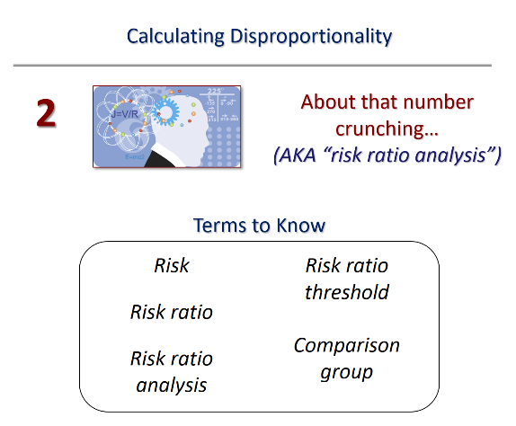
Slide 5 / Calculating Disproportionality (continued)
Let’s focus in for a brief time on “that number crunching.” In IDEA’s terms, it’s called “risk ratio analysis.” The next slide will take a deeper look at risk ratio analysis and how it is commonly used in the world. As you’ll see, it’s not something OSEP invented and decided to require as part of the new standard methodology.
There are several other terms that are helpful to know. These are shown in the box on the slide.
Discussing the Slide
- You might approach this slide as a quick “heads-up” to the audience of terms that are important to know and that upcoming slides will briefly explore.
- Alternatively, you might take a moment and ask the audience what they already know about any of these terms, in any context (not just special education). Don’t correct any suggested information.
Okay, everyone ready for diving deeper? Off the cliff we go.

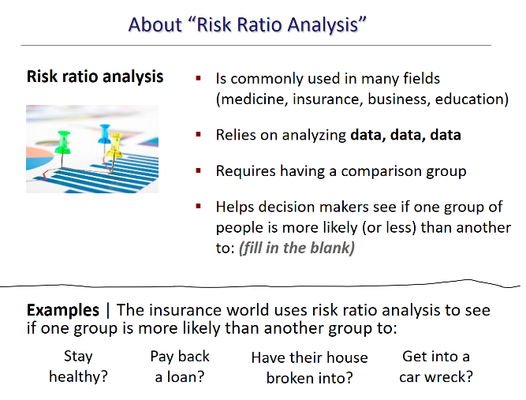
Slide 6 / About Risk Ratio Analysis
This slide takes a real-world perspective on “risk ratio analysis.” Within the context of special education, it’s a required part of using the standard methodology to calculate disproportionality and significant disproportionality. How is it used elsewhere to make important decisions?
Top Part of the Slide
The upper part of the slide gives some ways in which risk ratio analysis is used in businesses and industries around us. As the slide indicates, risk ratio analysis:
- is commonly used in many fields (medicine, insurance, business, education)
- relies on analyzing data, data, data
- requires having a comparison group
- helps decision makers see if one group of people is more likely (or less) than another to: (fill in the blank)
Important points to make:
- As has been said, data, data, data are crucial to calculating risk. That’s why it’s also a crucial element in identifying disproportionality in special education based on race or ethnicity.
- Data alone are insufficient, however. You need a comparison group—another group of people to serve in realistic contrast. In many cases, Whites are considered the comparison group against which other racial or ethnic groups’ risks (for whatever) can be determined. In the case of the standard methodology and IDEA’s 2016 regulations, however, Whites are not the comparison group to be used. Rather:
Comparison group consists of the children in all other racial or ethnic groups within an LEA or within the State, when reviewing a particular racial or ethnic group within an LEA for significant disproportionality. [§300.647(a)(2)]
Participants can see this definition of comparison group on Handout 3 (top of page 3). Definitely make a point of this.

Bottom Part of Slide
Here, everyone can find examples of how insurance companies use risk ratio analysis to decide which group of people are a better “risk” (or poorer risk) for coverage. The audience will surely recognize these examples.
- Are you more likely than, say, someone younger to stay healthy? (Don’t even THINK to mention the current health care situation with COVID-19!)
- At your age (or ethnicity, or educational level, or home neighborhood, or “fill in the blank”), are you more likely to get your house broken into than your friend who lives across town (is a different ethnicity, didn’t graduate high school)? Which of the two are of you are more (or less) likely to pay back a loan?
It’s easy to see how this works, because risk ratio analysis is used every day to make decisions like who gets a loan or not. We were fascinated, we must admit, by the analysis associated with car insurance. Anyone want to guess which drivers are MOST likely to have a car accident and who, as a consequence, pays the highest car insurance rates? Obviously, driving under the influence is going to be at the top of any list. But we’ve put some additional “fun” facts in the box (on the next page) that you can share with the audience.

Example: Risk ratio analysis and Car Insurance
What are some factors that can affect your car insurance costs?
Age (Who pays more?)
Drivers over 65 and drivers under 26
New drivers (The rate of accident-related deaths per mile among 16 to 19 years old is 3 times higher than for drivers over 20 years old.)
Marriage | Someone who is married is LESS likely to be in an accident than someone who is not married.
Gender | Women are less likely as a group to get into a car accident. The difference in the risk assessment between men and women between 16 and 24 years old is so big that it accounts for most of the lifetime difference in insurance costs between men and women.
Occupation | If you have a high-risk occupation, you’ll pay more. What’s considered a high-risk occupation? Doctors, lawyers, real estate brokers, business owners and executives, architects, and salespeople. (Who would have thought?!)

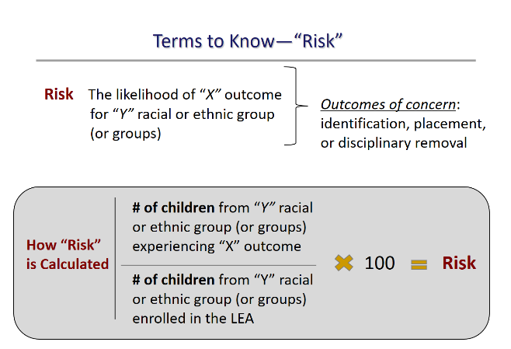
Slide 7 / Terms to Know: Risk
Suggested Handout: Handout 3, IDEA’s Regulations on Disproportionality
Is the audience ready to run through key terms that are important to know? Explain that you’re first going to give the definition of a term (like “risk”), then show how it is calculated, and then (in the separate slide) provide a real-world example. Here goes.
Dissecting the Top of the Slide, Piece by Piece
This slide focuses on the first key term to know—risk. Everyone can see the definition of “risk” on the slide: “The likelihood of “X” outcome for “Y” racial or ethnic group (or groups).”
That might sound like a mish-mash of meaningless words (or algebra class) at first, so break it down for your participants or have them break it down for you. They no doubt understand the meaning of the likelihood of something happening. In this case, we’re talking about the likelihood of “X” outcome happening. On the right, you’ll see the outcomes of concern identified in the regulations: identification, placement, or disciplinary removal. These outcomes have been discussed in this slideshow (and in Slideshow 1) as “strands of concern.” The audience should recognize them.
Now, the likelihood of any of those outcomes happening to “Y” racial or ethnic group or groups? Let the audience tell you which racial or ethnic groups are to be considered as the “Y.”
Everybody clear? What’s the X referring to? (Could be one of the outcomes shown on the right.) What is the Y referring to? (Each of the minority groups of concern.)
How do the regulations define “risk”? | Naturally, the regulations [at §300.647(a)(5)] provide an official definition of risk. Here’s how it begins:
(5) Risk is the likelihood of a particular outcome (identification, placement, or disciplinary removal) for a specified racial or ethnic group (or groups), calculated by…
First, you’ll want to note that the slide language closely mirrors the language of the regulations. Second, you’ll definitely notice that we’ve cut off the rest of IDEA’s definition, because that part refers to how “risk” is calculated. And that’s the bottom part of the slide! So here it comes.
Dissecting the Bottom of the Slide, Piece by Piece
(5) Risk is the likelihood of a particular outcome (identification, placement, or disciplinary removal) for a specified racial or ethnic group (or groups), calculated by dividing the number of children from a specified racial or ethnic group (or groups) experiencing that outcome by the total number of children from that racial or ethnic group or groups enrolled in the LEA.
Words are not nearly as effective here as the actual mathematical equation that’s being described. So, the slide uses the math format to depict how “risk” is calculated.
We won’t repeat the words or the equation, but talk with participants to ensure that they understand that this is a division problem, then a multiplication problem, as shown. The final answer to the math problem is the “risk” of the “Y” racial/ethnic group experiencing “X” outcome.
But nothing speaks louder than an example, so move on to Slide 8 and show the audience one example of how “risk” is calculated, with real people, real outcomes, and real numbers.
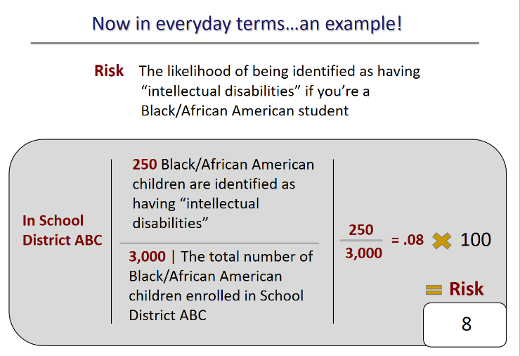
Slide 8 / Risk Example
Here, we have the same set-up of the slide’s format but have substituted in specific information for the vagueness of variables in the previous slide.
This time, we’re looking at: “The likelihood of being identified as having “intellectual disabilities” if you’re a Black/African American student.”
Clearly, a real-world calculation to be made in every state! The audience has already heard (in Slideshow 1) that the likelihood of this “outcome” (being identified as having intellectual disabilities) is often greater for students with disabilities who are Black/African American.
Calculating the Risk of This Outcome for Black/African American Students
School District ABC needs to determine if it has a disproportionality in its identification of children with disabilities, particularly this disability. To calculate risk, it uses the total number of Black/African American students identified with intellectual disabilities, divided by the total number of all Black/African American children enrolled in the district. These are data that are already readily available in School District ABC, because it has to report such data to the State.
Again, we have a division problem, then a multiplication problem, all of which yields the risk for Black/African American students of being identified as having intellectual disabilities. Here, in this example, the risk is 8.
What does this number indicate? | Frankly, the number “8” alone tells us nothing. It must be viewed in the context of the comparison group to have any substantive meaning or interpretation. So, what’s the risk of being identified as intellectual disabilities for students in the comparison group? Let’s find out. Time for Slide 9.

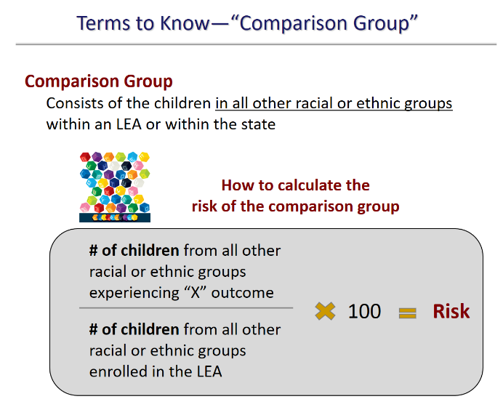
Slide 9 / Terms to Know: Comparison Group
Same format for the slide, but this time we’re looking at the likelihood (risk) of children in the comparison group being identified as having intellectual disabilities.
Discussing the Slide
In order to make the necessary calculations about one group’s risk of (fill in the blank), you need a comparison group to serve in contrast. As mentioned on Slide 6, IDEA’s regulations provide a definition of comparison group. For disproportionality calculations, the comparison group will always be “children in all other racial or ethnic groups” within the LEA (or the state, if the calculation is being made to determine disproportionality statewide). We reiterate that definition at the top of the slide.
Calculating the risk of the comparison group | Risk for the comparison group is calculated in the same way as it is calculated for a specific racial or ethnic group. It’s first a division problem, then a multiplication problem, then the answer—the risk. Again, data, data, data. How many children from all other racial/ethnic groups have been identified as having intellectual disabilities? How many children from all other racial/ethnic groups are enrolled in the LEA (or state)? These are data the LEA and state already have, to meet annual reporting requirements.
Can participants see the parallels in how making risk calculations for different groups begin? What information goes in the numerator (above the division line)? What information goes in the denominator (what’s below the division line)?
Let’s have an example with real numbers, now | Move on to Slide 10.
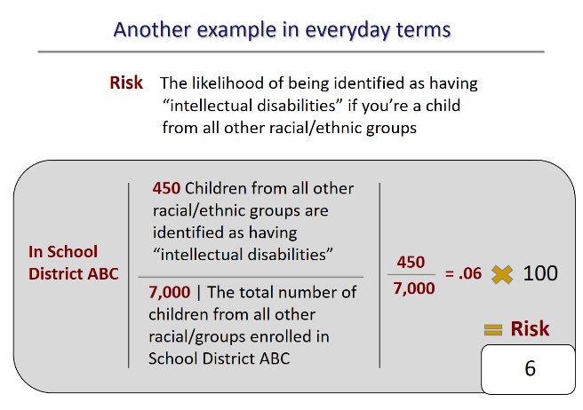
Slide 10 / Another Example
So, here we have numbers substituted into the various parts of the equation, to determine: The likelihood of being identified as having “intellectual disabilities” if you’re a child from all other racial/ethnic groups.”
- As everyone can see, there are 450 children from all other racial/ethnic groups who’ve been identified as having intellectual disabilities.
- The total enrollment of students from all those other racial/ethnic groups is 7,000.
- As in our previous examples, the division-then-multiply formula results in a risk of 6.
Key Points to Make
Reminder List | The Racial/Ethnic Groups of Concern

Hispanic/Latino of any race; and, for individuals who are non-Hispanic/ Latino only
American Indian or Alaska Native
Asian
Black or African American
Native Hawaiian or Other Pacific Islander
White
Two or more races

Recognizable pattern | Hopefully, the audience now sees the consistent pattern (call it a formula, if you will) in how an LEA or state determines risk for a given group. This will be the same pattern/approach used when determining risk for American Indians/Alaska Natives, for Hispanics/Latinos, for each of the racial or ethnic groups specifically mentioned in the regulations (see “Reminder List” in the box).
We’re not done yet | It’s not enough to know that, in these examples, Black/African American students have a “risk” of 8, while students from all other racial/ethnic groups have a “risk” of 6. Believe it or not, that still tells us nothing—or at least not what we want to know.
The number we’re really aiming for is called the risk ratio—which compares the risk of one group to the risk of another. Risk ratio and how to calculate it are the focus of the next slide. Let’s see what it involves.

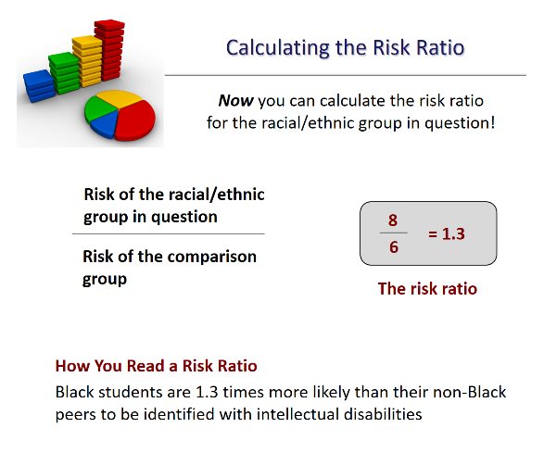
Slide 11 / Calculating the Risk Ratio
The IDEA regulations describe risk ratio at §300.647(a)(6) as follows:
(6) Risk ratio is a calculation performed by dividing the risk of a particular outcome for children in one racial or ethnic group within an LEA by the risk for children in all other racial and ethnic groups within the LEA.
Another division problem! This one, however, yields a number of critical importance in determining whether an LEA has a disproportionality in special education with respect to identifying Black/African American students with intellectual disabilities (which has been used in this cluster of slides as our working example).
Discussing the Slide
- Go over the “formula” for calculating risk ratio. Point out that it brings together the racial/ethnic group in question and the comparison group.
- Indicate that, according to the Department, most states already use some version of this approach (calculating each racial/ethnic group’s risk ratio for various outcomes) as part of identifying LEAs with significant disproportionalities.
- Limitations and benefits of risk ratio analysis | There are some limitations to using risk ratio analysis to identify disproportionality. For example, “LEAs with small populations or small populations of specific racial or ethnic subgroups with disabilities, such as those in small rural or charter schools, could potentially produce risk ratios that are misleading due to volatility associated with calculating risk ratios for small numbers of children.” However, “risk ratios are sufficient to determine whether an LEA has sufficiently large disparities to determine whether significant disproportionality is occurring.”
- Risk ratio analysis does not identify the causes of disproportionality, only that it is occurring. That finding triggers deeper investigation into what is causing the disparities identified.
- There is also a point beyond which a disproportionality becomes significant—meaning that some threshold of acceptability has been crossed. That point is known as the risk ratio threshold, and is the subject of the next slide.

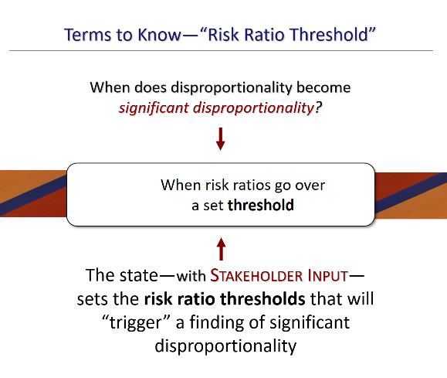
Slide 12 / Risk Ratio Threshold
This slide poses a simple but must-be-answered question: When does disproportionality become significant disproportionality?
Basic Background for This Slide
As odd as it may strike some, the two terms (disproportionality and significant disproportionality) are not the same thing. At least not with respect to the 2016 or prior IDEA regulations. There’s a threshold at which a disproportionality becomes a significant disproportionality, as the definition of risk ratio threshold makes clear:
Risk ratio threshold is a threshold, determined by the State, over which disproportionality based on race or ethnicity is significant under Sec. 300.646(a) and (b).
Is there only one threshold? | No, actually there may be many thresholds to set. Consider the number of different racial/ethnic groups specifically named in the regulations. Consider the three main strands of concern, which break down into multiple sub-questions. Consider the disability categories to be monitored. Altogether, there are a lot of calculations to be made, a lot of risk ratios to examine (more on this in a moment). As the Department notes:
The standard methodology uses risk ratios to analyze disparities for seven racial or ethnic groups, comparing each to all other children within the LEA in 14 different categories of analysis. States determine the thresholds above which the risk ratio in each category of analysis indicates significant disproportionality.
Discussing the Slide
Centrality of the risk ratios | Basically, the driving question becomes: How high does a group’s risk ratio have to be for any of the concern areas (identification, placement, discipline) before it’s too high? Before it represents too much risk or probability of an undesirable outcome for that group? Is there a boiling point, a cut-off threshold?
Yes, indeed | Participants can see by the slide that there is indeed a cut-off point called the risk ratio threshold. If you wish, share IDEA’s definition of the term (cited above, for your convenience; also on page 3 of Handout 3). Going over the set threshold indicates that an LEA now has a significant disproportionality.
Who sets the threshold? | The ultimate responsibility for setting the risk ratio thresholds rests with the state, but the state doesn’t decide the thresholds alone. It must gather stakeholder input to decide what the thresholds will be. This includes input from the State Advisory Panel. This requirement opens the door wide for all stakeholders to take part in the process.
The threshold must be reasonable | Obviously, if the risk ratio threshold is set too high, fewer instances of disproportionality will be found. On the other hand, if the threshold is set too low, then many more findings of disproportionality will be triggered—perhaps mistakenly. Therefore, it’s very important that the threshold set by the state with input from stakeholders be reasonable. According to the Department:
“Reasonable” means a sound judgment in light of all of the facts and circumstances that bear upon the choice. When choosing a risk ratio threshold, a State may consider its unique characteristics, such as the racial and ethnic composition of the State and LEAs, enrollment demographics, and factors correlated with various disabilities or disability categories. States should not set risk ratio thresholds for the purpose of identifying no LEAs with significant disproportionality.
Must states report their risk ratio thresholds to the Department? | Yes, they must. They must also demonstrate that the thresholds are reasonable and include the rationales for each.
More on Risk Ratio Thresholds
It’s a bit daunting to realize the number of risk ratio thresholds the state (with stakeholder input) must set. We provide this information below for trainer’s information (TMI?), which you may share as you deem relevant to your audience. From the Department’s Significant Disproportionality: Essential Questions and Answers:
Question B-3-4: How many risk ratio thresholds must each State set?
Answer B-3-4: Fourteen, one for each category of analysis. [§300.647(b)(2)] However, States may set the same threshold for multiple categories of analysis (e.g., a State could set a risk ratio threshold of 2.5 for identification of children as children with disabilities and for identification of children as children with emotional disturbance).
_________
Question B-3-5: May States set different risk ratio thresholds for different categories of analysis?
Answer B-3-5: Yes. States may need to set different risk ratio thresholds in order to reasonably identify significant disproportionality for categories with different degrees of incidence rates, and, therefore, different degrees of disparity, such as children identified with autism, on the one hand, and children placed in a regular classroom less than 40 percent of the day on the other. [§300.647(b)(1)(ii)]
_________
Question B-3-6: May States set different risk ratio thresholds for different racial and ethnic groups?
Answer B-3-6: No. The use of different risk ratio thresholds, by race or ethnicity within the same category of analysis would be unlikely to meet constitutional scrutiny. The risk ratio thresholds developed for each category of analysis must be the same for each racial and ethnic group. [§300.647(b)(2)]
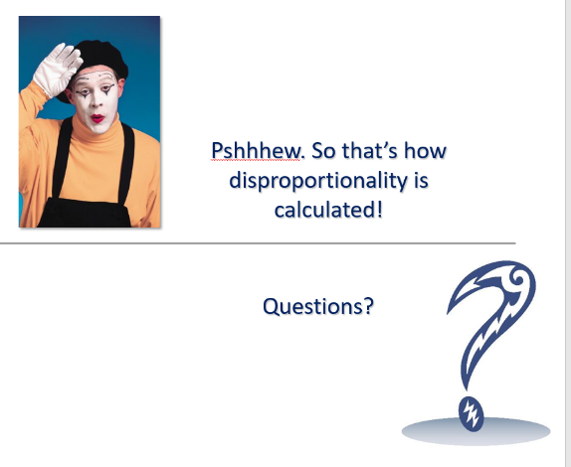
Slide 13 / Relief! Maybe Time for an Activity?
Optional Handout: Handout 10, Calculating Risk Ratios
Congratulations on getting through some of the data crunching that must be done in order to monitor for disproportionality. Hopefully, the audience understood the basics of how these calculations are done.
If you feel that the group would appreciate getting hands-on with the actual number crunching, as a way of practice or deepening their familiarity with the process, we’ve designed an optional handout—Handout 9—that you can use as an activity. We describe the activity below.
You can also skip this optional activity and move on to the next slide, which will bring us back on course to answer the question posed on Slide 3—What happens if there’s a determination
of significant disproportionality?
Optional Practice Activity
Purpose | To have participants work with real student numbers to make risk-ratio calculations.
Total Time Activity Takes | 15 minutes.
Group Size | In pairs to complete handout. Large group to discuss.
Materials | Handout 10, Calculating Risk Ratios
Instructions
- Refer participants to Handout 10. Indicate that this is the activity sheet they will complete in pairs. They will have 10 minutes.
- Give participants the allotted 10 minutes to work in pairs. Then call them back to the large group.
- Take 5 minutes to do a scan of how participants answered. Explain any miscalculations made—not the math per se, but how the pairs set up their equations. Did they put the correct number in the numerator? In the denominator?
- Wrap up the activity by answering questions and then segue into the 2nd half of this training session—which focuses on our starting question: “What happens if there’s a determination of significant disproportionality?”
Answers
- Calculating the risk for Hispanic/Latino students of being identified as having a specific learning disability | 7,000 divided by 176,000 = .039 x 100 = 3.9
- Calculating the risk of comparison group | 23,417 divided by 902,414 = .026 x 100 = 2.6
- Calculating the risk ratio of Hispanic/Latino students being identified as having a specific learning disability | 3.9 divided by 2.6 = 1.5
- How to read this risk ratio | Hispanic/Latino students are 1-½ times more likely to be identified as having a specific learning disability than students from all other racial/ethnic groups.

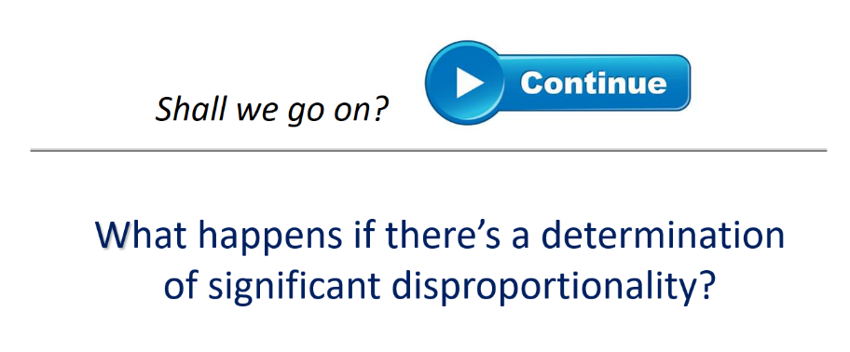
Slide 14 / Segue Slide
This slide signals the end of the 1st half of this training session (what’s involved in the number crunching) and the beginning of the 2nd half.
Use it as a way to step back into the question originally posed at the beginning of this slideshow, which again appears on the slide.

Slide 15 / For Determinations of Significant Disproportionality
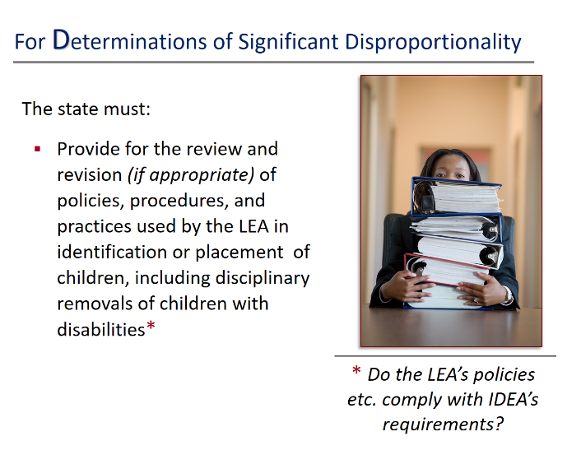
Suggested Handout: Handout 3, IDEA’s Regulations on Disproportionality
Let the audience know that the next several slides will explain what a state must do upon determining that disproportionality in special education (based on race or ethnicity) is occurring in the state or in any of its LEAs. Refer participants (as appropriate) to Handout 3 for the verbatim IDEA regulations.
The regulations associated with this slide can be found at §300.646(c)(1), which appear on page 1 of the handout and read as follows:
(c) Review and revision of policies, practices, and procedures. In the case of a determination of significant disproportionality with respect to the identification of children as children with disabilities or the placement in particular educational settings, including disciplinary removals of such children, in accordance with paragraphs (a) and (b) of this section, the State or the Secretary of the Interior must—
(1) Provide for the annual review and, if appropriate, revision of the policies, practices, and procedures used in identification or placement in particular education settings, including disciplinary removals, to ensure that the policies, practices, and procedures comply with the requirements of the Act.
Discussion of the Slide
As you can see, the text on the slide mirrors the verbatim language of the regulations. Upon making a determination that an LEA has a significant disproportionality in any of the to-be-monitored areas, the state must take corrective action. This slide looks at the state’s obligation to see that a review is conducted of the LEA’s policies, procedures, and practices in the area where the significant disproportionality has been identified. That may be in one or more of these areas:
- identification of children with disabilities (including which disabilities they are identified as having),
- their placement in particular educational settings, and
- removals from their placement or school as a result of a disciplinary action taken by the LEA.
What the state is looking for is whether the LEA’s policies are in keeping with what IDEA requires in the strand where the disproportionality was found. This review of policies, practices, and procedures must occur in every year in which an LEA is identified with significant disproportionality [§ 300.646(c)(1) and (2)]. If the review process reveals that the LEA’s policies, procedures, and practices are not in compliance with IDEA, then the state must see that those policies etc. are revised.
What IDEA requires in these areas was discussed as part of Slideshow 1, but reiterate for the audience (or have them recall aloud as a group) that IDEA spells out requirements as to:
- what evaluation of children for disability involves;
- how the eligibility determination is made (and by whom);
- what placement options must be made available to students with disabilities;
- how placement is decided (and by whom);
- the role that IDEA’s LRE provisions play in placement decisions; and
- disciplinary actions that may and may not be taken when a student with disabilities violates a school code of conduct.
IDEA’s regulations on the use of disciplinary actions (what is permissible, what is not) are as extensive as they are complicated. This is a difficult area to summarize in brief. Some aspects you might mention can be found in:
Placement and School Discipline
https://www.parentcenterhub.org/disciplineplacements/
Points of Note
Consequence | It’s important to recognize that this review of practices, procedures, and policies does not occur before a finding of significant disproportionality is made. Rather, as the Department notes, it “is a consequence of, not a part of, a determination of significant disproportionality” (emphasis added).
Who conducts the review? | The regulations require that the “state (or the Secretary of the Interior) provide for the annual review…”. This means that the state itself doesn’t necessarily have to be the entity that conducts the review; it must merely ensure that the review is conducted. As the Department notes, “the State may select another entity, such as the LEA, to actually conduct the review.”
Scope of review | A finding of significant disproportionality in one area of concern (e.g., identification of children or their placement) brings on the review of the LEA’s policies, practices, and procedures in that area, not necessarily all other areas of concern. This may not be immediately obvious in a reading of the regulations. But note the use of the word “OR” in the regulations. Point this out to the audience and have them underline or highlight it. Specifically, we’re talking about:
“In the case of a determination of significant disproportionality with respect to the identification of children as children with disabilities or the placement…” [§300.646(c)]
“Provide for the annual review and, if appropriate, revision of the policies, practices, and procedures used in identification or placement…” [§300.646(c)(1)]
In the Analysis of Comments and Changes accompanying the 2016 final regulations, the Department illustrates this point well, stating at some length:
For example, in an LEA identified with significant disproportionality with respect to identification, the State must provide for the review of policies, practices, and procedures used in identification. This should include a review of child find and evaluation policies, practices, and procedures to ensure they comply with IDEA.
Consider that LEA Y has a risk ratio for identification of white students as students with autism that exceeds the State-defined risk ratio threshold. As a result, the State identifies LEA Y as having significant disproportionality and provides for a review of the LEA’s policies, procedures, and practices as required by IDEA section 618(d)(2)(A). This review results in the LEA identifying that it has a long-standing practice of requiring students to have a medical diagnosis of autism in order to receive special education services as a child with autism. However, minority students in LEA Y were much less likely to be able to obtain such a diagnosis for a number of reasons, including a lack of consistent care and early screening and referral conducted by health professionals.
Given that LEAs are not allowed, under the IDEA, to set eligibility criteria for special education and related services absent a State-wide requirement or criteria that is consistent with the IDEA (i.e., the child’s parent does not incur a cost for the medical diagnosis and the requirement does not result in a delay in the special education and related services that are required for a child to receive a free appropriate public education) and the fact that the State where LEA Y is located does not require a medical diagnosis for autism, the LEA’s practice is inconsistent with IDEA.
So, what might this LEA do, to remedy this inconsistency? The Department suggests:
“…[T]he LEA must eliminate or revise its practice of requiring students to have a medical diagnosis of autism in order to receive special education services. In addition, the LEA could address the impact of that criteria by using funds reserved for comprehensive CEIS to increase developmental screenings” [that would identify minority children with possible autism and then help those children and their families] “secure diagnostic testing.”
Want another example from the Analysis of Comments and Changes? Sure, you do! This one is much shorter, but it’s also in the strand of discipline, which is helpful. The Department shares:
Similarly, for an LEA identified with significant disproportionality with respect to discipline, the State must provide for the review of policies, practices, and procedures used in the discipline of children with disabilities. This should include a review of the LEA’s polices, practices, and procedures related to manifestation determinations, functional behavioral assessments, or behavioral intervention plans or schoolwide discipline rules to ensure they comply with IDEA.
In Summary
To close this slide’s discussion, we’d like to provide one more observation from the Department’s Analysis of Comments and Changes. It puts the required review of an LEA’s practices, policies, and procedures in perspective.
The Department understands that not all factors contributing to a determination of significant disproportionality can be remedied through a review of policies, practices, and procedures. However, when aligned with the other remedies required in final §300.646(c) and (d), we believe that the review of policies, practices, and procedures can be a valuable tool to LEAs when addressing significant disproportionality.

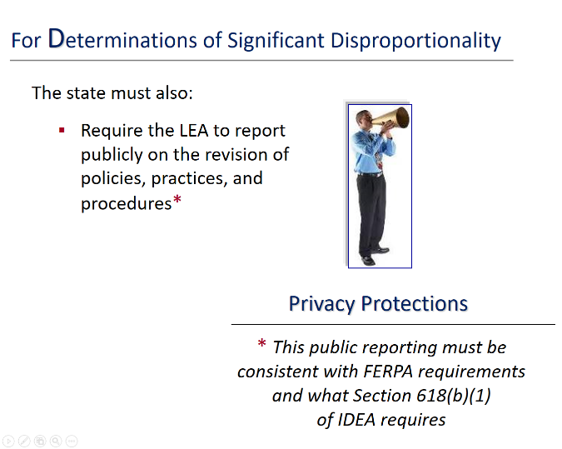
Slide 16 / For Determinations of Significant Disproportionality (continued)
Suggested Handout: Handout 3, IDEA’s Regulations on Disproportionality
This slide is the 2nd in the series of what is required when the state finds that it or one of its LEAs has a significant disproportionality in special education. This slide might be subtitled: Reporting Obligations.
The regulations associated with this slide can again be found on Handout 3, page 1, at the very bottom. The audience just covered part of the regulations (you’ll see these below, dimmed to gray), and the part you’ll want to focus on [§300.646(c)(2)] is presented in bold.
(c) Review and revision of policies, practices, and procedures. In the case of a determination of significant disproportionality with respect to the identification of children as children with disabilities or the placement in particular educational settings, including disciplinary removals of such children, in accordance with paragraphs (a) and (b) of this section, the State or the Secretary of the Interior must--
(1) Provide for the annual review and, if appropriate, revision of the policies, practices, and procedures used in identification or placement in particular education settings, including disciplinary removals, to ensure that the policies, practices, and procedures comply with the requirements of the Act.
(2) Require the LEA to publicly report on the revision of policies, practices, and procedures described under paragraph (c)(1) of this section consistent with the requirements of the Family Educational Rights and Privacy Act, its implementing regulations in 34 CFR part 99, and Section 618(b)(1) of the Act.
Discussing the Slide
The slide is very straightforward, even as it nearly replicates the language of the regulations. There should be little confusion here, only a few extra points to make for clarity (as appropriate for your audience, and as you have time).
- Hear Ye! | Reporting to the public is a common requirement in many laws and regulations. Here, it’s the LEA that is required to report publicly on the revision of policies, practices, and procedures—presumably what was revised, where, and why. In reporting to the public, the LEA must not ignore the privacy protections of FERPA (The Family Educational Rights and Privacy Act), nor those in Section 618(b)(1) of IDEA. (More on FERPA in a second.)
- No personally identifiable information | Speaking generally, Section 618 of IDEA requires that each state submit data to the Secretary of Education about the infants and toddlers, birth through age 2, who receive early intervention services under Part C of IDEA and children with disabilities, ages 3 through 21, who receive special education and related services under Part B of IDEA. Section 618(b)(1) is as follows:
(b) Data Reporting.
(1) Protection of identifiable data.—The data described in subsection (a) shall be publicly reported by each State in a manner that does not result in the disclosure of data identifiable to individual children.
- FERPA | FERPA is a crucial law focused on protecting the confidentiality of personal information in education. For a “primer” on FERPA, you might suggest (as necessary) that the audience visit the site called Protecting Student Privacy. Courtesy of the U.S. Department of Education, the site provides official guidance on FERPA, technical best practices, and the answers to Frequently Asked Questions. Right on the home page is the 4-minute video about FERPA for parents and students.
https://studentprivacy.ed.gov/
- The dovetailing of FERPA and IDEA | There are many deliberate consistencies between the confidentiality provisions of FERPA and IDEA. In fact, in June of 2014, OSERS and the Family Policy Compliance Office (FPCO) released IDEA and FERPA Confidentiality Provisions Crosswalk. This document is a side-by-side comparison of the primary legal provisions and definitions in IDEA Part B, IDEA Part C, and FERPA that relate to protecting the confidentiality of personally identifiable information of students and children served under the IDEA. To learn more about how the laws address the same issues, see:
https://www2.ed.gov/policy/gen/guid/ptac/pdf/idea-ferpa.pdf
- Knowing what’s changed | This public reporting ought to provide stakeholders with valuable information about the state (or LEA’s) efforts to reduce disproportionality in special education. It will also be important for Parent Centers, school systems in the LEA, and others to understand what changes or revisions are made, because these may affect the information they share with others, especially families, about key processes in special education (e.g., identification, placement, discipline).
Example: Consider for a moment the example from the Department shared on the last slide—an LEA that required a medical diagnosis for identifying a child as having autism. If the LEA changed that approach, it would be essential for Parent Centers and others to know and incorporate the new approach into their materials and what they share with families.
- Final question | Must an LEA report to the public if, after review of its policies, practices, and procedures, it concludes that no changes are necessary? According to the Department, the answer is: “No, an LEA is not required to publicly report if no revisions to its policies, practices, or procedures are necessary.” However, “LEAs are encouraged to report that information to stakeholders, including the State Advisory Panel” (emphasis added).
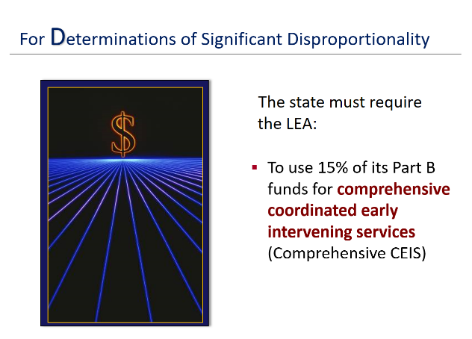
Slide 17 / For Determinations of Significant Disproportionality (continued)
Suggested Handout: Handout 3, IDEA’s Regulations on Disproportionality
Note to Trainers | This slide is the 3rd (and last) in the series of what is required when the state finds that it or one of its LEAs has a significant disproportionality in special education. This slide might be subtitled: Mandatory CEIS. (Note that there will be several slides on CEIS. Focus here on its use as a mandatory requirement upon a finding of significant disproportionality.)
This is the 3rd corrective action that states must take upon identifying an LEA with a significant disproportionality in special education based on race or ethnicity. As IDEA’s regulations indicate, the LEA must reserve the maximum amount of funds under section 613(f) of IDEA to provide comprehensive coordinated early intervening services to address factors contributing to the significant disproportionality. This regulation is found on Handout 3, at the top of page 2, at: §300.646(d), and reads as follows:
“(d) Comprehensive coordinated early intervening services. Except as provided in paragraph (e) of this section, the State or the Secretary of the Interior shall require any LEA identified under paragraphs (a) and (b) of this section to reserve the maximum amount of funds under section 613(f) of the Act to provide comprehensive coordinated early intervening services to address factors contributing to the significant disproportionality.”
Discussing the Slide
This slide is sure to evoke several immediate questions: What are comprehensive coordinated early intervening services? Are they the same thing as early intervention? What are their differences? What’s the exception noted in paragraph (e)? What does Section 613(f) say?
p.s. to Trainers | For an excellent description of the differences between these sets of services, refer to the IDEA Data Center’s comparison, online at: https://ideadata.org/sites/default/files/media/documents/2018-01/51322_IDC_CEIS_vs_CCEIS_Chart_0.pdf
So, let’s answer those questions in order.
What are comprehensive CEIS? | These services will be discussed in more detail on the next slide, so you don’t have to offer much explanation here. Definitely offer background information, such as:
“Before we can talk about comprehensive coordinated early intervening services and what they are, let’s talk about early intervening services (EIS) in general. These services are about catching problems early in school-aged children. It’s about identifying when children are struggling to learn—especially apparent in the early grades and in tasks like reading and math—and quickly intervening to provide support. Under IDEA 2004, school districts may use up to 15% of their Part B funds (the maximum amount allowed) to develop and provide EIS to children who are not children with disabilities but who need academic or behavioral support to succeed in a general education environment. EIS are for children in kindergarten through grade 12 (with a particular emphasis on students in kindergarten through grade three).”
May v. Must | Notice that school districts may voluntarily set aside or use 15% of their Part B funds to design and deliver these services. That “may” becomes a MUST upon a finding of significant disproportionality. Such a finding triggers the mandatory use of comprehensive coordinated early intervening services in an LEA, with the purpose of addressing factors contributing to the significant disproportionality.
What’s the difference between comprehensive CEIS and coordinated early intervening services? Or are they the same thing? | The main difference between these two similar-sounding sets of services is that the former (Comprehensive CEIS) is a mandatory use of 15% of an LEA’s Part B funds to address findings of disproportionality. The latter (CEIS without the “Comprehensive”) is a voluntary use of those funds to help struggling learners who do not have disabilities.
Are comprehensive CEIS the same thing as early intervention? | No, they are not the same thing as early intervention services. These are two very different initiatives, although, to be fair, both are about intervening early. Early intervention is for infants and toddlers with disabilities and is often referred to as Part C of IDEA. Early intervening services are about catching problems early in school-aged children.
What’s the exception noted in paragraph (e)? | Refer participants to Handout 3, as necessary. It’s easy to explain, however, that the exception being made is that a state may not require an LEA to reserve funds for providing comprehensive CEIS, if that LEA serves only children with disabilities. The verbatim regulation at 300.646(e) reads as follows:
“The State or the Secretary of the Interior shall not require any LEA that serves only children with disabilities identified under paragraphs (a) and (b) of this section to reserve funds to provide comprehensive coordinated early intervening services.”
What does Section 613(f) say? | In general, Section 613 has to do with “Local Educational Agency Eligibility”—what an LEA must do to be eligible to receive IDEA funds under Part B. The part being referenced here (paragraph f) relates specifically to early intervening services—what they are, how the funds may be used (what’s permitted, what’s not), and who their intended recipients are: “children who have not been identified as needing special education or related services but who need additional academic and behavioral support to succeed in a general education environment.”
Let’s move on to the next slide and see what comprehensive CEIS (i.e., mandatory) involves and how the funds allocated for them may be used.
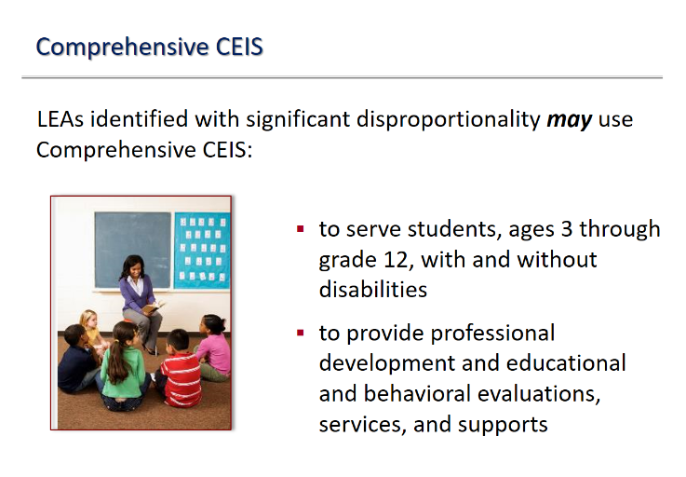
Slide 18 / Comprehensive CEIS
Suggested Handout: Handout 3, IDEA’s Regulations on Disproportionality
This slide is 1 of 3 on comprehensive CEIS. IDEA’s regulations related to comprehensive CEIS are found on Handout 3 (page 2), at §300.646(d). They describe permissible uses of the funds, two of which are captured on the slide in more everyday language.
The regulations beginning at §300.646(d) that are associated with this slide read:
(d) Comprehensive coordinated early intervening services. Except as provided in paragraph (e) of this section, the State or the Secretary of the Interior shall require any LEA identified under paragraphs (a) and (b) of this section to reserve the maximum amount of funds under section 613(f) of the Act to provide comprehensive coordinated early intervening services to address factors contributing to the significant disproportionality.
(1) In implementing comprehensive coordinated early intervening services an LEA—
(i) May carry out activities that include professional development and educational and behavioral evaluations, services, and supports.
Discussing the Slide
In short, LEAs may use these funds to serve students with and without disabilities (ages 3 to grade 12). Although not shown on the slide, §300.646(d)(3) adds that these funds may be used by the LEA to serve children with disabilities “particularly, but not exclusively, children in those groups that were significantly overidentified.” You should emphasize, however, the requirement that comprehensive CEIS are intended to be used with students without disabilities, not just those who have a disability. It is not permissible for an LEA to limit its provision of comprehensive CEIS to only children with disabilities.
Important! | One aspect of using comprehensive CEIS that may not be immediately apparent is that those funds are to be used “to address factors contributing to the significant disproportionality” [§300.646(d)]. This aspect is more thoroughly explored on the next slide, but here it’s worth pointing out that a link must clearly exist between what an LEA chooses to do with its comprehensive CEIS funds AND the factors that have contributed to the significant disproportionality in the first place. Let the audience know that you’ll get to the importance of that link-connection on the next slide.
What might an LEA do with these funds? | As the slide indicates (and the regulations as well), funds may be used to “carry out activities that include professional development and educational and behavioral evaluations, services, and supports.” Within the Analysis of Comments and Changes, there is a vigorous exchange between commenters and the Department of Education about possible ways that an LEA might legitimately use the 15% of Part B funds that IDEA requires upon a finding of significant disproportionality. We’ll include some of these comments under the next slide; they are quite illuminating.
Activity Suggestion | If you have time or want to engage the audience a sharing activity, take a few moments to either break the audience in small discussion groups or continue as a whole group to answer questions such as:
- What do the regulations include as possible uses of the comprehensive CEIS funds? (professional development and educational and behavioral evaluations, services, and supports)
- What other uses might there be? Can you name a few? Think of your own school and experience. What comes to mind? (Answers will vary but might include: implementing a schoolwide program of behavior support; improving general education teacher skills about behavior management; implementing social-emotional development programs in the early grades)
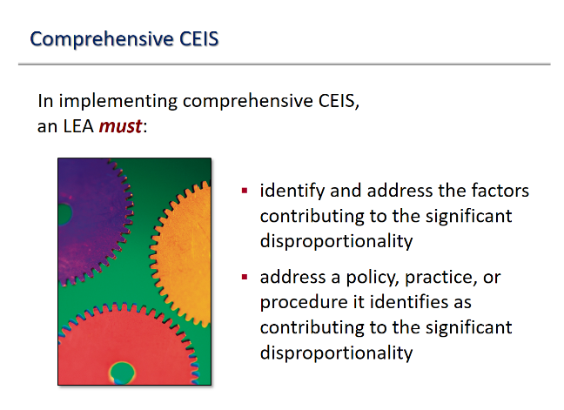
Slide 19 / Comprehensive CEIS (continued)
Suggested Handout: Handout 3, IDEA’s Regulations on Disproportionality
This slide is the 2nd of 3 on comprehensive CEIS. It looks more closely at IDEA’s regulations at §300.646(d)(1) and picks up where the last slide left off. As participants can see if they refer to Handout 3, the slide abbreviates the actual regulations to make them manageably fit in the space!
Here’s what the regulations say:
(1) In implementing comprehensive coordinated early intervening services an LEA—
(i)…
(ii) Must identify and address the factors contributing to the significant disproportionality, which may include, among other identified factors, a lack of access to scientifically based instruction; economic, cultural, or linguistic barriers to appropriate identification or placement in particular educational settings; inappropriate use of disciplinary removals; lack of access to appropriate diagnostic screenings; differences in academic achievement levels; and policies, practices, or procedures that contribute to the significant disproportionality.
(iii) Must address a policy, practice, or procedure it identifies as contributing to the significant disproportionality, including a policy, practice or procedure that results in a failure to identify, or the inappropriate identification of, a racial or ethnic group (or groups).
Boiling the Regulations Down
Bullet 1 | The first bullet on the slide states simply that, in implementing comprehensive CEIS, an LEA MUST “identify and address the factors contributing to the significant disproportionality.” The regulations also say that, but go on to offer several examples of factors that might be found to contribute to the significant disproportionality—stating that such factors may include, among other identified factors:
- a lack of access to scientifically based instruction;
- economic, cultural, or linguistic barriers to appropriate identification or placement in particular educational settings;
- inappropriate use of disciplinary removals;
- lack of access to appropriate diagnostic screenings;
- differences in academic achievement levels; and
- policies, practices, or procedures that contribute to the significant disproportionality.
The audience may find it helpful to go through this list and consider how the possible factors mentioned relate to everything that’s been discussed thus far about disproportionality in special education.
Bullet 2 | Again, the regulations provide extra information about a possible policy, practice, or procedures that could be contributing to the LEA’s significant disproportionality, “including a policy, practice or procedure that results in a failure to identify, or the inappropriate identification of, a racial or ethnic group (or groups).”
Identifying the factors contributing to a significant disproportionality is a critical step in addressing that disproportionality. We’ve discussed several possible root causes of disproportionality. Ask the audience to reiterate a few of the possible root causes mentioned in this training session (especially during Slideshow 1).
Examples | As was mentioned on the previous slide, use of comprehensive CEIS funds must be directed toward correcting whatever significant disproportionality was found. This slide makes that very clear. So, what are some examples of how comprehensive CEIS funds might be used to address identified concerns? The Analysis of Comments and Changes offers many possibilities, several of which we share below. Keep in mind that comprehensive CEIS funds cannot be used solely for the benefit of children with disabilities. They are also intended to address catching academic and behavioral problems early, before a child has been identified as having a disability.
- Identification | Providing comprehensive CEIS to preschool children may help LEAs to address significant disproportionality in identification by allowing funds reserved for comprehensive CEIS to be used to provide more timely supports and services to younger children.
- Identification | An LEA identified with significant disproportionality might use IDEA Part B funds reserved for comprehensive CEIS to implement universal screening to better identify and support children with developmental delays before they enter kindergarten.
- These activities will also assist in ensuring that children with disabilities in the LEA are appropriately identified.
- Placement and Discipline | Providing comprehensive CEIS to children with disabilities is more likely to address significant disproportionality in placement and discipline by allowing LEAs to directly improve the supplementary aids and services and positive behavioral interventions and supports provided to children with disabilities.
- Discipline | LEAs can use IDEA Part B funds reserved for comprehensive CEIS to implement a schoolwide program to address problems in discipline and serve both children with and without disabilities.
- Placement | An LEA may provide professional development to regular education teachers on the supports they can provide to enable a child with a disability to be educated in the regular class and participate in extracurricular and other nonacademic activities with nondisabled children.
- Each LEA, in implementing comprehensive CEIS, may carry out activities that include professional development, behavioral evaluations, hiring reading or math specialists, or providing other supports and services that the LEA has determined will address the factors contributing to the significant disproportionality.
- Training and professional development on effective FBAs and BIPs, a review of behavioral intervention and supports included in IEPs, positive behavioral interventions and supports, multi-tiered systems of supports are all permitted... to the extent that they address factors that the LEA has identified as contributing to the significant disproportionality identified in the LEA.

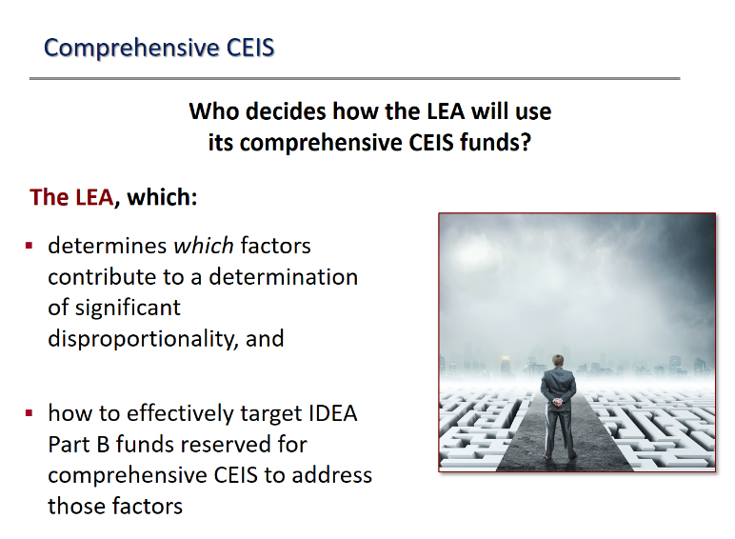
Slide 20 / Comprehensive CEIS (continued)
Suggested Handout: Handout 3, IDEA’s Regulations on Disproportionality
This slide is the 3rd of 3 on comprehensive CEIS and answers the question, “Who decides how the LEA will use its comprehensive CEIS funds?”
The answer is given in the two bullets, but—in short—it is the LEA that decides. The regulations do not explicitly say this; rather, it’s embedded in the regulations at §300.646(d), which refers only to what the LEA must do, may do, and may not do when it implements comprehensive CEIS.
The Department of Education is more overt in stating that such decisions fall to the LEA. In its Analysis of Comments and Changes, for example, the Department writes:
- Section 300.646(d) underscores the importance of allowing an LEA to determine which factors contribute to a determination of significant disproportionality and how to effectively target IDEA Part B funds reserved for comprehensive CEIS to address those factors.
- We emphasize that the LEA has the flexibility to determine, based on its identification of factors contributing to the significant disproportionality identified in the LEA, which activities will be funded using IDEA Part B funds reserved for comprehensive CEIS.
- An LEA does have flexibility in how these funds are allocated within the LEA and how these funds are expended.

Additional Information
Participants may appreciate knowing any of the following nuggets of information about the use of comprehensive CEIS funds to address identified significant disproportionalities.
- There are no requirements for the process an LEA must use when deciding how to allocate those funds if they choose to do so.
- Under 34 CFR 76.731, an LEA must keep records to show its compliance with program requirements. Therefore, an LEA must maintain documentation to demonstrate that it expended IDEA Part B funds reserved for comprehensive CEIS in accordance with final §300.646(d).

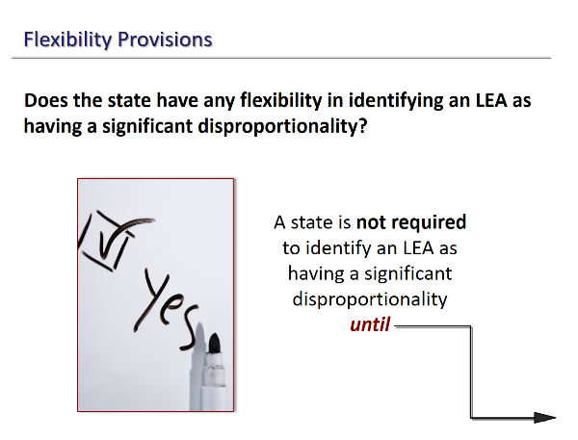
Slide 21 / Flexibility
This slide begins a series of 5 on the flexibility provisions in the 2016 regulations on disproportionality (one of those slides is intended to give the audience a good laugh!). Here, we set the stage with the question, “Does the state have any flexibility in identifying an LEA as having a significant disproportionality?”
The answer is yes, as the graphic indicates. Under these regulations a state is not required to identify an LEA as having a significant disproportionality until…
Until what? Slide 22 completes the sentence.
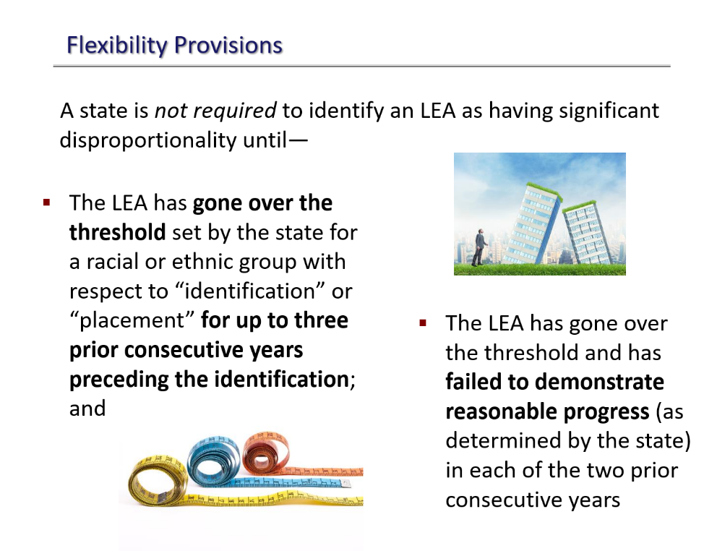
Slide 22 / Flexibility
(continued)
Note to Trainers! This slide is purposefully designed to be a bit of an “information-eyeball overload.” You will not seriously discuss this slide (that opportunity comes on Slides 24 and 25). For now, display the slide and let the audience absorb all those words. You might even read them aloud.
Then say, “Hmmm.” And move on to Slide 23, which will hopefully make your audience smile. Then you can get down to business again with Slide 24.

Slide 23 / Flexibility
(continued)
So, which of the pictures best captures each participant’s reaction to all those words and details in the flexibility provisions shown on Slide 22? Ask them. You might ask for a show of hands as you go through the pictures.
For example, you might say:
- Are you the man whose head is hurting?
- Or maybe you feel like a firehose of TMI (too much information) just got you in the face?
- Who wants to run out of this room as fast as they can?
- Or perhaps you’re just thinking, HUH? Like the lady on the bottom left. She’s still game for the answer but not sure she’s ready to hear it right this moment.
- Is your ESCape ESCape ESCape button flashing?
- Or maybe you’re like this llama, who doesn’t know or care what the explanation is. At the very least, he’s stoic in the face of what’s coming.
So, let’s be stoic, too. We’re almost done here today, and we’ve saved the best for last.

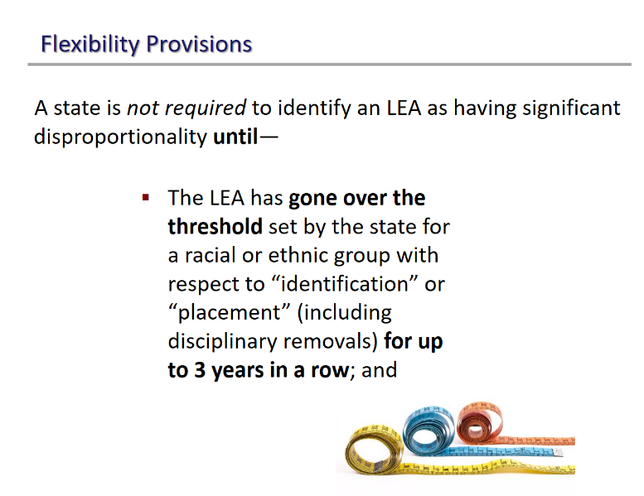
Slide 24 / Flexibility Provisions (continued)
Suggested Handout: Handout 3, IDEA’s Regulations on Disproportionality
Say something along the lines of: “Let’s start over and take these flexibility provisions one by one. They sound complicated, but they are actually pretty straightforward.”
Refer participants to the last page (page 6) of Handout 3, which is where the flexibility provisions appear. These read:
(d) Flexibility. A State is not required to identify an LEA as having significant disproportionality based on race or ethnicity under Sec. 300.646(a) and (b) until--
(1) The LEA has exceeded a risk ratio threshold set by the State for a racial or ethnic group in a category described in paragraph (b)(3) or (4) of this section for up to three prior consecutive years preceding the identification; and
(2) The LEA has exceeded the risk ratio threshold and has failed to demonstrate reasonable progress, as determined by the State, in lowering the risk ratio or alternate risk ratio for the group and category in each of the two prior consecutive years.
We’ve bolded the parts that will be covered in this slide.
Being Clear About the Language Used on the Slide
As everyone can see, the words on the slide are not the exact words used in the regulations. To be specific:
- The regulations use the term risk ratio threshold, for example, which (admittedly) has been covered in this slideshow. We’ve used only the word “threshold” to save space on the slide, given that the full term is a concept that participants should now be familiar with.
- The regulations also refer to various sections or paragraphs, and we’ve substituted in what those references mean. For example, “a category described in paragraph (b)(3) or (4)” refers to:
—the identification of children, ages 3 through 21, as having a disability or as having one of the disabilities of special concern (e.g., intellectual disabilities, autism);
— the placement of children with disabilities into particular educational settings, including disciplinary removals.
The slide highlights the three key words—identification or placement (including disciplinary removals)—instead of “paragraph (b)(3) or (4).”
- Last but not least, there is the regulatory phrase “up to three prior consecutive years preceding the identification.” Yikes! We substituted a shorter phrase (“for up to 3 years in a row”), drawing from the Department’s own words (“for up to three years”) in the Analysis of Comments and Changes.
Why all this concern about language? you may wonder. Well, it’s important to be precise when you’re talking—or training others—about IDEA’s statute or regulations. There’s no need to share nitpicky points with the audience, but we wanted to make sure we shared them with you, the trainer.
Discussing the Slide
There are several points you can make about this first flexibility provision, depending on the needs and interests of your audience.
Why the delay in identifying an LEA as having a significant disproportionality? | Three years may strike the audience as a delay in taking action. However, there are sound reasons why the regulations provide states with this flexibility. The Department’s thorough discussion of the matter in the Analysis of Comments and Changes is helpful, so we’ve included several excerpts below. The Department writes:
- Using three consecutive years of data was the most common approach to identifying significant disproportionality among the States in 2012–2013. Of the 23 States that reported using multiple years of data in the SY 2012–2013 State Supplement Survey (SSS), 13 States required an LEA to exceed the threshold for three consecutive years before finding significant disproportionality, while 9 States required 2 consecutive years.
- Allowing States to take into consideration the data of up to three consecutive years provides an opportunity for the States to focus their efforts on LEAs with consistently high risk ratios year over year, rather than only those with a single year of a high risk ratio.
- To the extent States need to amend their policies and procedures to comply with these regulations, States will also need time to conduct public hearings, ensure adequate notice of those hearings, and provide an opportunity for public comment.
- [A]ny determination of significant disproportionality uses the most recent year for which data are available and up to two previous consecutive years of data.
- The flexibility to determine significant disproportionality after one, two, or three consecutive years was designed to account for volatility—small changes in data from year to year that may cause large changes in a risk ratio and cause an LEA to be identified with significant disproportionality.
Examples are helpful, too! | The Analysis of Comments and Changes includes this example.
For example, if a State is making a determination in the 2018–2019 school year, it can rely on up to three years of data to make its determinations (e.g., 2015–2016, 2016–2017, and 2017– 2018).
If an LEA exceeds the risk ratio threshold for a particular racial or ethnic group for a particular category of analysis in each of those years, the State must identify that LEA as having significant disproportionality. The fact that the determination made in 2018– 2019 is based, in part, on data from 2015–2016 does not constitute a delay of four years to make a determination, but is a result of data lags that occur regardless of how many prior years of data a State analyzes (e.g., 2018–2019 child count, placement, and discipline data are not typically available in time for States’ determinations in the 2018– 2019 school year).
Does a state have to wait three years to make a determination of significant disproportionality? No. The state does not have to wait through three years, each year examining an LEA’s data, before it may determine that the LEA has a significant disproportionality based on race or ethnicity. The flexibility provisions give the state that option, yes, if the state so chooses, but, as the Department states:
[T]he Department does not want to require States to wait an additional year, or an additional two years, to make an identification of significant disproportionality when they have confidence that the racial and ethnic disparities within an LEA require more immediate intervention.
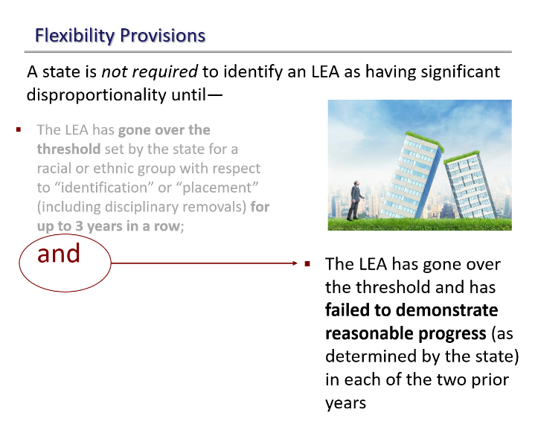
Slide 25 / Flexibility Provisions (continued)
Suggested Handout: Handout 3, IDEA’s Regulations on Disproportionality
Refer participants to the last page (page 6) of Handout 3, which is where the second flexibility provision appears. Again, we’ll bold the part covered in this slide. This provision says:
(d) Flexibility. A State is not required to identify an LEA as having significant disproportionality based on race or ethnicity under Sec. 300.646(a) and (b) until--
(1) The LEA has exceeded a risk ratio threshold set by the State for a racial or ethnic group in a category described in paragraph (b)(3) or (4) of this section for up to three prior consecutive years preceding the identification; and
(2) The LEA has exceeded the risk ratio threshold and has failed to demonstrate reasonable progress, as determined by the State, in lowering the risk ratio or alternate risk ratio for the group and category in each of the two prior consecutive years.
You’ll notice that the word “and” (after the dimmed first bullet) is circled on the slide, appears in red, bold face, and is much bigger in size. This is to emphasize that, if a state decides to adopt the flexibility provisions, BOTH situations must occur in order before the state is required to identify an LEA as having significant disproportionality based on race or ethnicity. In other words, the LEA must have:
- exceeded the threshold set by the state in one of the categories of interest for three years in a row (Slide 24); and
- not shown reasonable progress in lowering the disproportionality in EACH of the two previous years (this slide).

Discussing the Slide
- Point out the meaning of that bolded “and” (with arrow) on the slide. The provision the audience just heard about on Slide 24 is only ½ of the trigger point that compels the state to identify an LEA as having a significant disproportionality. Here (this slide) is the other half of that trigger point.
- What is “reasonable progress” and who determines it? | The state sets the “standard for measuring reasonable progress” for itself and its LEAs, if it uses these flexibility provisions. Setting the standard must be done with stakeholder input, including from the State Advisory Panel.
- “Reasonable progress” is only one of the terms that the state must define with stakeholder input. Others include minimum cell size, reasonable n-size, and the risk ratio threshold.
- The standard for reasonable progress may vary, depending on the category of concern (identification, placement, disciplinary removals). In other words, each of the categories of concern may have a different standard set for measuring reasonable progress. The regulations express this possibility at §300.647(b)(ii), which reads:
The State may, but is not required to, set the standards set forth in paragraph (b)(1)(i) of this section at different levels for each of the categories described in paragraphs (b)(3) and (4) of this section.
Clarifications from the Department
Ever useful, the Analysis of Comments and Changes helps illuminate the finer points of the flexibility provision discussed on this slide. We include some of that discussion below as an FYI for trainers, bolding key elements. Now, this is the Department speaking:
- We believe it is important to allow States the flexibility to not identify LEAs with significant disproportionality if, for example, a prior review and revision of policies, practices, and procedures and effective use of funds for comprehensive CEIS has resulted in a reasonable reduction in risk ratios in each of the two prior consecutive years. In such an LEA, a continued finding of significant disproportionality, including an ongoing annual review of policies, practices, and procedures, may actually divert State attention from LEAs in which substantial problems continue to occur and are not improving.
- LEAs must be making reasonable progress in lowering the risk ratio or alternate risk ratio for the group and category for each of the two prior consecutive years, rather than the immediate preceding year... if an LEA is not reducing risk ratios over each of the two prior consecutive years, a State cannot exercise this flexibility (emphasis added).
- [T]he State’s standard for reasonable progress, under § 300.647(d)(2), is subject to the Department’s monitoring and enforcement for reasonableness.
Slide 26 / Questions?
We are near the end of this training session, with only a few slides left. Now is a good time to take questions from the audience and clear up whatever confusions they have, as best you can. This slideshow has covered a lot of ground, so you may wish to devote a chunk of time here.
Possible Activity | Alternatively, you might have the audience break into small groups and list their own questions, discuss as best they can the answers to those questions, and then check back with you in a full-group debrief.

Slide 27 / Resources of More Information and Technical Assistance
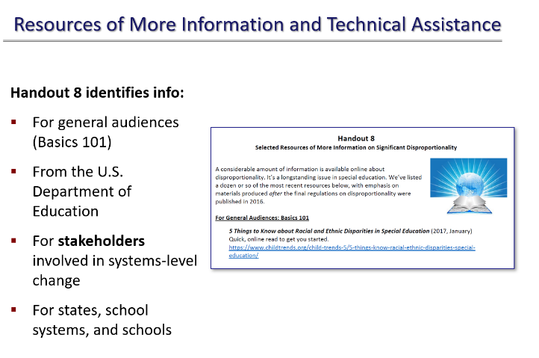
Suggested Handout: Handout 8, Resources of More Information and Technical Assistance
Without a doubt, significant disproportionality in special education is a serious subject, with serious consequences, and with mandated activities and actions resulting from it. More information on the subject is available. Handout 8 may have been shared as part of Slideshow 1, but feel free to share it again with the audience. The handout identifies information:
- For general audiences (disproportionality basics 101, shall we say?)
- From the U.S. Department of Education
- For stakeholders involved in systems-level change
- For states, school systems, and schools.
The handout includes videos, basic reads, complicated how-to manuals, and materials in English and Spanish. Short descriptions of the resources are included, to help people decide which resources might suit their needs best.

Slide 28 / Wrapping It All Up
Suggested Handout: Handout 11, Circle-Square-Triangle
Final activity! You’re nearly done. To wrap up the session, pass out Handout 11, which engages participants in the “round-up” activity described below. This round-up format was also used in Slideshow 1 (as Handout 7), but the questions and answers on Handout 11 are related to the content of Slideshow 2, this one about to end.
Closing Activity
Purpose | To have participants consider their own learning in this training session.
Total Time Activity Takes | 10-20 minutes.
Group Size | Participants complete the handout individually. You might then have them pair-up to compare their answers. Large group to discuss.
Materials | Handout 11, Circle-Square-Triangle
Description of Handout | The handout has 3 figures: a circle, a square, and a triangle. Within the circle are these questions to be answered: What’s still going around in your head? What do you still not understand? Within the square are these questions: What’s squared away? What do you really understand? Within the triangle? What 3 things are you “taking away” from today’s session about disproportionality? How will you use these take-aways?
Instructions
- Refer participants to Handout 11. Indicate that this is the activity sheet they will complete alone. They will have 10 minutes.
- Give participants the allotted 10 minutes to fill in the circle, square, and triangle, according to the questions inside those figures. Then either let them discuss their answers in pairs, or call them back to the large group.
- Take 5 minutes to do a scan of how participants answered. Focus in particular on what they listed in the circle and in the triangle. Wrap up the activity by answering any questions.

Slide 29 / Final Slide and Thank You

Final slide! You’re done. Thank the audience for joining the session, and definitely make sure that you invite them to call or email your Parent Center or organization about issues involving children with disabilities and their families.

This training curriculum is a product of the Center for Parent Information and Resources, 2020
https://www.parentcenterhub.org

The CPIR is made possible through Cooperative Agreement Number H328R130014 between OSEP and the Statewide Parent Advocacy Network (SPAN). The contents of this document do not necessarily reflect the views or policies of the Department of Education, nor does mention of trade names, commercial products, or organizations imply endorsement by the U.S. Government.
This product is in the public domain. Authorization to reproduce it in whole or in part is granted. While permission to photocopy this material is not necessary, the citation should be:
Küpper, L. (Ed.) (2020, November). Disproportionality in special education: Trainer’s guide for slideshow 2. Newark, NJ: Center for Parent Information and Resources.

References

81 Fed. Reg. at 92389.
81 Fed. Reg. at 92389.
DMV.org. (n.d.). How age affects auto insurance rates. Online at: https://www.dmv.org/insurance/how-age-affects-auto-insurance-rates.php
DMV.org. (n.d.). How marital status affects auto insurance rates. Online at: https://www.dmv.org/insurance/how-marital-status-affects-auto-insurance-rates.php
DMV.org. (n.d.). How gender affects auto insurance rates. Online at: https://www.dmv.org/insurance/how-gender-affects-auto-insurance-rates.php
DMV.org. (n.d.). How occupation affects auto insurance rates. Online at: https://www.dmv.org/insurance/how-occupation-affects-auto-insurance-rates.php
81 Fed. Reg. at 92398.
81 Fed. Reg. at 92403.
81 Fed. Reg. at 92405.
§300.647(a)(7)—Determining significant disproportionality: Risk ratio threshold.
U.S. Department of Education, Office of Special Education Programs. (2017, March). Significant disproportionality: Essential questions and answers (p. 3). Washington, DC: Author. Online at: https://sites.ed.gov/idea/files/significant-disproportionality-qa-03-08-17-1.pdf
U.S. Department of Education, Office of Special Education Programs. (2017, March). Significant disproportionality: Essential questions and answers (p. 5). Washington, DC: Author. Online at: https://sites.ed.gov/idea/files/significant-disproportionality-qa-03-08-17-1.pdf
§300.647(b)(7)—Significant disproportionality determinations.
U.S. Department of Education, Office of Special Education Programs. (2017, March). Significant disproportionality: Essential questions and answers (pp. 5-6). Washington, DC: Author. Online at: https://sites.ed.gov/idea/files/significant-disproportionality-qa-03-08-17-1.pdf
81 Fed. Reg. at 92396.
81 Fed. Reg. at 92445.
81 Fed. Reg. at 92444.
81 Fed. Reg. at 92444.
81 Fed. Reg. at 92444.
81 Fed. Reg. at 92444.
81 Fed. Reg. at 92444-92445.
U.S. Department of Education, Office of Special Education Programs. (2017, March). Significant disproportionality: Essential questions and answers (p. 19). Washington, DC: Author. Online at: https://sites.ed.gov/idea/files/significant-disproportionality-qa-03-08-17-1.pdf
§300.646(d)(3)—Disproportionality.
See 81 Fed. Reg. at 92446-92450.
81 Fed. Reg. at 92447.
81 Fed. Reg. at 92448.
81 Fed. Reg. at 92449.
81 Fed. Reg. at 92449.
81 Fed. Reg. at 92449. Note: 34 CFR 76.731 refers “Records related to compliance” and reads “A State and a subgrantee shall keep records to show its compliance with program requirements.” Online at: https://www.law.cornell.edu/cfr/text/34/76.731
81 Fed. Reg. at 92397.
81 Fed. Reg. at 92438.
81 Fed. Reg. at 92438-92439.
81 Fed. Reg. at 92392.
81 Fed. Reg. at 92438.
81 Fed. Reg. at 92438.
81 Fed. Reg. at 92438.
81 Fed. Reg. at 92438.
81 Fed. Reg. at 92439.
81 Fed. Reg. at 92439.
81 Fed. Reg. at 92439.

