Handout 1
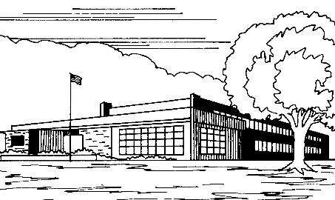
Sketching Out the Scene

Answer the following questions about the school or school system in which you work or are involved. If you have several you can choose from, just pick the one that comes to mind first. It’s OK to guess if you have to.

1. This school/school system is in ___________.
- a rural area
- a suburban community
- an inner-city community

2. I’d describe this school/school system as:
- Small, not many students
- Medium-sized
- Large
- Very large

3. About what percentage of students have disabilities?
- 0-5%
- 6-10%
- More than 10%

4. Which of the following would you see in this school/school system? (Check all that apply.)
- White students
- Black or African-American students
- Hispanic students
- Students who are Asian/Pacific Islanders
- Students who are American Indians/Alaska Natives

5. Are there differences in educational performance or disciplinary challenges among these racial/ethnic groups?
- Yes
- No
- Don’t know

6. If yes, describe your impressions or knowledge of those differences in educational performance or disciplinary challenges.

