NICHCY's Building the Legacy for Our Youngest Children with Disabilities
A Training Curriculum on Part C of IDEA 2004

Module 1:
The Basics of Early Intervention
Trainer’s Guide

This module was developed in collaboration by:
- The U.S. Department of Education, Office of Special Education and Rehabilitative Services (OSERS), Office of Special Education Programs (OSEP) | Virginia Sheppard
- OSERS’ Office of Policy and Planning | Mary Louise Dirrigl and Jessica Spataro
- The U.S. Department of Education, Office of the General Counsel | Kala Surprenant
- The National Dissemination Center for Children with Disabilities (NICHCY) | Lisa Küpper

Copyright free. You’re welcome to share this module far and wide. Please do give credit to its producer, the National Dissemination Center for Children with Disabilities.
Suggested citation: Küpper, L. (Ed.). (2012, October). The basics of early intervention (Module 1). Building the legacy for our youngest children with disabilities: A training curriculum on Part C of IDEA 2004. Washington, DC: National Dissemination Center for Children with Disabilities. Available online at: http://nichcy.org/laws/idea/legacy/partc/module1

This module is part of a training package on the Part C regulations of the Individuals with Disabilities Education Act, as amended in 2004. This training curriculum provides a detailed discussion of the Part C regulations as published in the Federal Register on September 28, 2011. The curriculum is entitled Building the Legacy for Our Youngest Children; this module is entitled The Basics of Early Intervention and is the first module in the curriculum. The information in the module is not a substitute for the requirements reflected in the IDEA statute and Part C regulations.

Welcome to Part C of IDEA and to Early Intervention!
Thanks to a powerful and important federal law called the Individuals with Disabilities Education Act, or IDEA, 336,895 eligible infants and toddlers birth through age 2 received early intervention services in 2011 under Part C of IDEA.
Early intervention services are concerned with all the basic and brand-new developmental skills that babies typically develop during the first three years of life, such as:
- physical (reaching, rolling, crawling, and walking);
- cognitive (thinking, learning, solving problems);
- communication (talking, listening, understanding);
- social/emotional (playing, feeling secure and happy); or
- adaptive behavior (eating, dressing).
Early intervention services are designed to meet the needs of eligible infants and toddlers who have a developmental delay or disability. Services may also address the needs and priorities of each child’s family, to help family members understand the special needs of the child and how to enhance his or her development.
A Wee Bit of History
Congress established the program of early intervention for infants and toddlers with disabilities in 1986 in recognition of “an urgent and substantial need” to:
- to enhance the development of handicapped infants and toddlers and to minimize their potential for developmental delay,
- to reduce the educational costs to our society, including our Nation’s schools, by minimizing the need for special education and related services after handicapped infants and toddlers reach school age,
- to minimize the likelihood of institutionalization of handicapped individuals and maximize the potential for their independent living in society, and
- to enhance the capacity of families to meet the special needs of their infants and toddlers with handicaps.
We’ve come a long way since 1986. We no longer use the term “handicapped” in IDEA, but it’s startling to see how virtually unchanged the findings of Congress are in the most current authorization of IDEA—passed in 2004 as Public Law 108-446. The only differences between the Congressional findings of 1986 and those in 2004 are that the current law expressly acknowledges “the significant brain development that occurs during a child’s first 3 years of life” and has added one finding, which reads:
- to enhance the capacity of State and local agencies and service providers to identify, evaluate, and meet the needs of all children, particularly minority, low-income, inner city, and rural children, and infants and toddlers in foster care.
As first authorized in 1986, the early intervention program was known as Part H of IDEA. It became Part C with the reauthorization of IDEA in 1997. It continues today as a federal grant program that helps states set up and operate a comprehensive statewide system of early intervention services for eligible infants and toddlers with disabilities, ages birth to the third birthday, and their families.
Meeting Basic Requirements
The current statute for IDEA and the regulations for Part C contain many requirements that States have to meet in order to participate in the Part C program. These include but aren’t limited to:
- assuring that early intervention will be available to every eligible infant or toddler in the State and those children’s families;
- designating a lead agency (a duty of the Governor) to receive the grant and administer the program; and
- appointing an Interagency Coordinating Council (ICC) that includes, among others, parents of young children with disabilities, to advise and assist the lead agency; and
- specifying the minimum components of the comprehensive Statewide early intervention system to be implemented.
States have flexibility in the criteria they set for child eligibility, but must establish a rigorous definition of the term “developmental delay” and specify how it will be measured. States also have the option of serving at-risk children in Part C programs. New to States is the Part C extension option, which allows them to continue providing Part C services to children past their third birthday (traditionally, Part C has addressed the developmental needs of children up to but not beyond their third birthday). As a result, definitions of eligibility for Part C differ widely from State to State. States also differ concerning which state agency has been designated "lead agency" for the Part C program. In fact, notes the National Early Childhood Technical Assistance Center (NECTAC), statewide early intervention systems differ in many ways from State to State.
Currently, all states and eligible territories are participating in the Part C program. Annual funding to each state is based upon census figures of the number of children, birth through 2, in the general population.
To say that Part C of IDEA has a huge impact on early childhood policy and practice is to understate the reality. IDEA’s Part C regulations provide States with extensive guidelines and requirements in how to design and implement early intervention system for infants and toddlers with disabilities and their families, including federal fiscal support via formula grants to States exceeding $438.5 million annually.
This Module in Time and Space
This module on The Basics of Early Intervention falls within the umbrella topic of Theme A, Welcome to IDEA. There are two modules under that umbrella, as follows:
- The Basics of Early Intervention (this module) is divided into three sections: (1) the eight steps involved in accessing early intervention services for infants and toddlers with disabilities; (2) seven acronyms commonly used in early intervention; and (3) nine key definitions in Part C of IDEA that everyone should know.
- Overview of Key Changes in Part C takes a brief and summarizing look at what’s new and different in the law and regulations for Part C of IDEA 2004.
For Whom Is This Module Designed?
This module opens the Building the Legacy for Our Youngest Children with Disabilities training curriculum and serves as the introduction to Part C of IDEA. It is primarily intended for trainers to use with audiences who are newcomers to the law and the early intervention process. This includes:
- parents and family members of an infant or toddler who has, or is suspected to have, a developmental delay or a disability;
- early childhood candidates who are learning about the developmental needs of babies and toddlers (with and without disabilities) and the availability of Part C early intervention programs to address those needs; and
- new staff, advocates, policy makers, administrators, and early childhood specialists who will be working with either the Part C system or with infants and toddlers who have disabilities and their families, but who have little prior knowledge of disability or early intervention.
How This Discussion Section is Organized
As with the other modules in this curriculum, this discussion section is organized by slide. A thumbnail picture of each slide is presented, along with brief instructions as to how the slide operates. This is followed by a discussion intended to provide trainers with background information about what’s on the slide. Any or all of this information might be appropriate to share with an audience, but that decision is left up to trainers.
Organization of the Module
This module is divided into three sections:
- Section 1: the 8 steps involved in the early intervention process as prescribed by the Part C regulations of IDEA;
- Section 2: the 7 acronyms frequently heard (and used) in early intervention; and
- Section 3: 9 key terms that are defined within the Part C regulations and applied in our statewide systems of early intervention every day, thousands upon thousands of times.
Each slideshow is provided in a separate file, as is the trainer guide for that slideshow. Handouts for Participants are also in stand-alone files so that you can download and print only those you need for a particular training session.
Note to Trainers | The last section—9 key terms defined—is intended for the hardiest and most deeply involved of trainee participants. Not all trainees will need to look in such depth at the key terms the last section addresses (e.g., infant or toddler with a disability, developmental delay, service coordination services). Trainers can make that judgment on their own, using what they know about their audience in a given training session.
Files You’ll Need in Each Section of This Module
Module 1 includes the following components provided in separate files that align with the three distinct sections of the module. If you plan to provide training on a given section, be sure to download each of the components of that section in either Word® or PDF format.
All files are available on NICHCY’s website at: http://nichcy.org/laws/idea/legacy/partc/module1

Section 1: The 8 basic steps in EI
- 1a-trainerguide
- 1a-slideshow
- activity1
- activity2
- handout1
- handout3
- handout7
- handout8
Section 2: 7 acronyms to know in EI
- 1b-trainerguide
- 1b-slideshow
- activity3
- handout10

Section 3: 9 key definitions in EI
- 1c-trainerguide
- 1c-slideshow
- activity1
- activity4
- handout2
- handout 3
Trainer’s Guide Discussion. The Trainer’s Guide for each section (e.g., what you’re reading right now for Section 1 of the module) describes how the slides operate and explains the content of each slide, including relevant requirements of the statute passed by Congress in December 2004 and the final regulations for Part C published in September 2011.
Because there are three sections in Module 1, the three trainer guides are provided in files that are consecutively numbered as 1a, 1b, and 1c to make it clear which slideshow they go with. Each of the guides is available in PDF and Word® formats.
PowerPoint® Slideshow. NICHCY is pleased to provide slideshows (produced in PowerPoint®) around which trainers can frame their presentations and training on the basics of early intervention.
Important note: You do NOT need the PowerPoint® software to use these slide shows. It’s set to display, regardless, because the PowerPoint Viewer® is included. (You may be asked to agree to Viewer’s licensing terms when you first open the slideshow.)
Handouts for Participants. The handouts for this module are also provided in individual files in PDF and Word formats. The PDF versions are designed to share with participants. The Word versions are made available for those participants who need or request accessible materials.
Activity Sheets. Most modules in the Part C curriculum come with one or two activity sheets that are designed to engage participants actively in the learning process. Trainers have the option to use these activity sheets if they wish. They may also wish to design activities of their own.
Looking for IDEA 2004?

The Statute (the law passed by Congress)
PDF | http://www.nichcy.org/wp-content/uploads/docs/PL108-446.pdf
HTML | http://frwebgate.access.gpo.gov/cgi-bin/getdoc.cgi?dbname=108_cong_public_laws&docid=f:publ446.108
Part C Regulations (published by the U.S. Department of Education on September 28, 2011)
PDF | http://www.gpo.gov/fdsys/pkg/FR-2011-09-28/pdf/2011-22783.pdf
Word document | http://idea.ed.gov/part-c/downloads/IDEA-Regulations.doc
Part B Regulations (published by the U.S. Department of Education on August 14, 2006)
PDF | http://nichcy.org/wp-content/uploads/docs/IDEA2004regulations.pdf
HTML | http://tinyurl.com/cvx6ko3

Finding Specific Sections of the Regulations: 34 CFR
As you read the explanations about the Part C regulations, you will find references to specific sections, such as §303.21. (The symbol § means “Section.”) These references can be used to locate the precise sections in the Part C regulations that address the issue being discussed. In most instances, we’ve also provided the verbatim text of the Part C regulations so that you don’t have to go looking for them.
The Part C regulations will be codified in Title 34 of the Code of Federal Regulations. This is more commonly referred to as 34 CFR or 34 C.F.R. It’s not unusual to see references to specific sections of IDEA’s regulations include this—such as 34 CFR §303.21, which is where you’d find Part C’s definition of “infant or toddler with a disability.” We have omitted the 34 CFR in this training curriculum for ease of reading.
Citing the Regulations in This Training Curriculum
You’ll be seeing a lot of citations in this module—and all the other modules, too!—that look like this: 76 Fed. Reg. at 60250
This means that whatever is being quoted may be found in the Federal Register published on September 28, 2011—Volume 76, Number 188, to be precise. The number at the end of the citation (in our example, 60250) refers to the page number on which the quotation appears in that volume. Where can you find Volume 76 of the Federal Register? At this address:
http://www.gpo.gov/fdsys/pkg/FR-2011-09-28/pdf/2011-22783.pdf

Slide 1 / Operation and Discussion: Title Slide
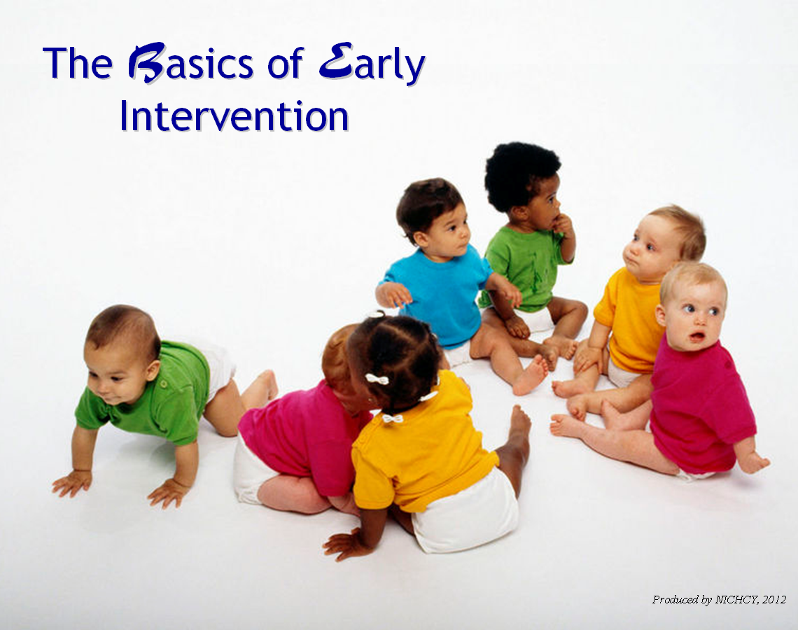
Text of slide……………………….
The Basics of Early Intervention

End of slide……………………….

Slide operation: The slide loads completely.
No clicks are necessary except to advance to the next slide.

Slide 1 is the title slide for this module. In addition to the title “The Basics of Early Intervention,” the slide sports a small gaggle of babies busy crawling, looking around, puzzling, and working on their “sitting-up” skills.
You don’t really need to say much about the slide—it’s meant to orient the audience to the training session you’re about to present. But you may wish to engage participants in a brief discussion of your own choosing or an opening activity, as best fits the needs and prior knowledge of your particular participants.
Suggestion
Focus the discussion on the types of learning tasks that babies typically engage in. Early intervention is all about helping babies and toddlers with developmental delays or disabilities develop necessary, important skills across one or more of five developmental areas (physical, cognitive, communication, social/emotional, and adaptive). Ask prompting questions such as:
- What do you see going on in that group of babies on the screen?
- What are the things you might typically see babies do at 6 months….a year….various early stages? (rolling over, sitting up, crawling, looking at their feet or hands, babbling)
- What do you do if a baby doesn’t seem to be learning a particular skill by the time you’d expect most babies to have learned it?

Slide 2 / Operation and Discussion: Warm-up and Context-Setting

Slide operation: The slide looks like this when it loads.


Click 1: TV logo lifts away. These two views of the slide come up automatically.
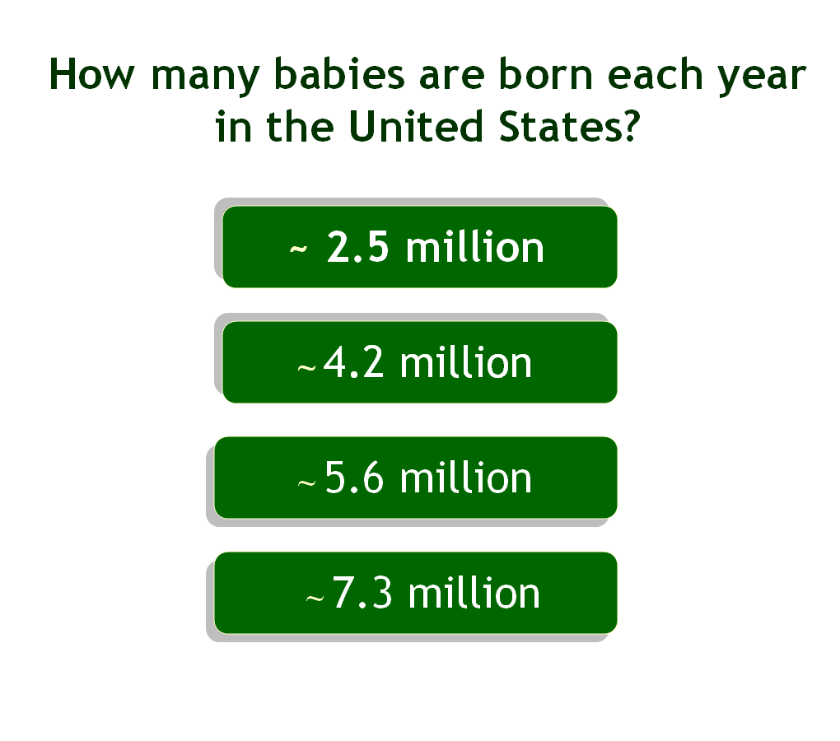
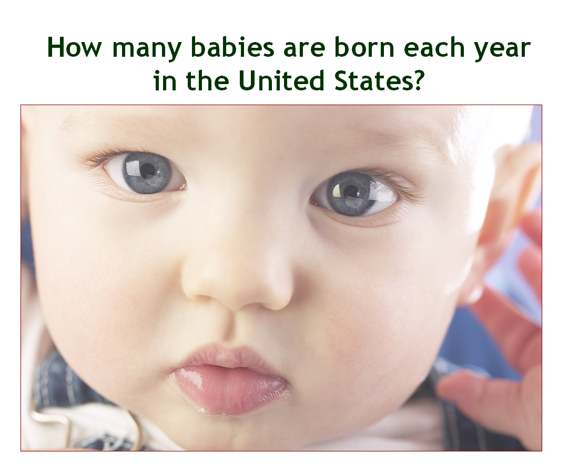

Click 2: The correct answer (~4.2 million) blicks on and off,on and off.

Click again to advance to the next slide.

Text of slide……………………….
[Logo of the TV Show Are You Smarter Than a 5th Grader?]

How many babies are born each year in the United States?

- ~ 2.5 million
- ~ 4.2 million
- ~ 5.6 million
- ~ 7.3 million

End of slide……………………….
Slides 2, 3, 4, and 5 are quick warm-up slides that help create both a relaxed training atmosphere and the context for why early intervention services exist. All four slides are built around familiar game show formats. This one uses “Are You Smarter Than a 5th Grader?”—the logo of which appears as the slide loads.
The question that is posed on Slide 2 is, “How many babies are born each year in the United States?” Four possible answers are given. The correct answer is “B, approximately 4.2 million.” This answer isn’t identified on the screen until you click to make the number pulse (as close as we could come to how the correct answer is shown on the actual show!). So let the audience call out their guesses for a brief time, then click to reveal the correct answer.
You’ll notice that each possible answer begins with the symbol ~. That means “approximately.” The precise number of live births, in fact, as reported by the Centers for Disease Control and Prevention (the CDC) for the year 2008 was 4,247,694.
Other Statistics of Note
You don’t have to mention any of the statistics below unless you’d like to elaborate on how this slide relates to early intervention. The stats below all relate to the conditions of babies at their birth, some of which include known risk factors for later developmental delay or disability (e.g., low birthweight).
- Low birthweight | Percent of births with low birthweight (less than 5.5 pounds) | 8.2%
- Fetal alcohol spectrum disorders | For every 1,000 births, one or two babies are born with fetal alcohol syndrome. Combining this number with the number of live births per year indicates that somewhere between 4,200 and 8,400 babies are born each year with marked exposure to alcohol during pregnancy.
According to the CDC, “Fetal alcohol spectrum disorders (FASDs) are a group of conditions that can occur in a person whose mother drank alcohol during pregnancy. These effects can include physical problems and problems with behavior and learning.”
- Birth defects | The CDC states that 1 of every 33 babies is born with a birth defect. The term “birth defect” includes conditions such as congenital heart defects, cleft palate, Down syndrome, and spina bifida. Combining these statistics with the number of live births per year indicates that approximately 128,000 babies are born each year with a birth defect.
Slide 3 / Operation and Discussion: Warm-up and Context-Setting (cont.)

Slide operation: The slide looks like this when it loads.


Click 1: Millionaire logo lifts away, and the question comes up. So do the possible answers.
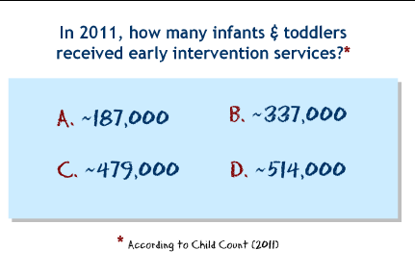

Click 2: The correct answer (B. ~337,000) flutters on the screen.

Click again to advance to the next slide.

Text of slide……………………….
[Logo of the TV Show Who Wants to Be a Millionaire?]

In 2011, how many infants and toddlers received early intervention services?*

A. ~ 187,000
B. ~ 337,000
C. ~ 479,000
D. ~ 514

* According to Child Count (2011)

End of slide……………………….
Slide 3 picks up where Slide 2 left off in the warm-up and context-setting. This time the question-and-answer slide is modeled upon “Who Wants to be a Millionaire?” The logo of the show appears first. Click to make it disappear, which automatically causes the question (and possible answers) to appear.
What do your participants think is the correct answer? Let them guess!
Click again to reveal the answer: B. ~ 337,000
That’s approximately how many children, ages birth to the third birthday, received early intervention under Part C in 2011 (the most recent year of data available as of this writing).
Extra Info You Can Offer
The precise number of infants and toddlers receiving early intervention services under Part C of IDEA in 2011 was | 336,895. This number is for all 50 states and the outlying areas of American Samoa, Guam, the Northern Mariana Islands, and the U.S. Virgin Islands.
If you need to make a summary statement about “early intervention,” just to be clear (helpful to participants with little prior knowledge or experience with early intervention), you might say something along the lines of: “Part C of IDEA provides early intervention (EI) services to infants and toddlers ages birth to the third birthday with developmental delays or a medical condition likely to lead to a developmental delay.”
Slide 4 / Operation and Discussion: Warm-up and Context-Setting (cont.)

Text of slide……………………….
[Logo of the TV Show Jeopardy!]

Federal Legislation

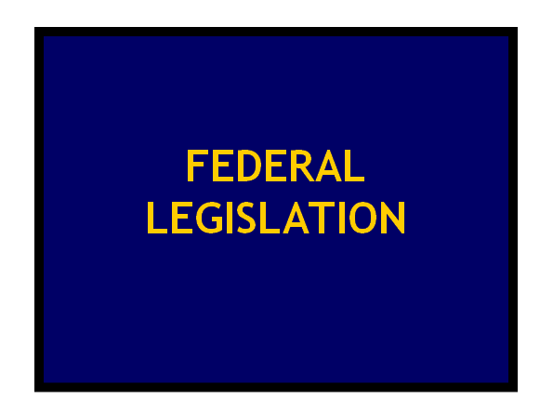
End of slide……………………….

Slide operation: The slide loads automatically. No clicks are necessary except to advance to the next slide.

Slides 4 and 5 are designed in the manner of Jeopardy! and, together, close out the context-setting warm-up. In keeping with Jeopardy’s format of having different categories, this slide presents OUR category: Federal Legislation.
Where’s This Going?
Just where you suspect. Slides 4 and 5—especially 5—are vehicles for introducing IDEA. Slide 5 will quote from the findings of Congress that have compelled the creation of the Part C program for infants and toddlers with disabilities.
Back to Jeopardy
For those who aren’t familiar with Jeopardy’s format as a quiz show, explain briefly that the slide identifies the category to which the question-answer will relate. Have the audience think of federal legislation they know and guess what federal legislation might be the focus of this Jeopardy challenge. They probably won’t have much trouble guessing, given the topic of this training!
Also explain that, on Jeopardy, the answer is given first. That’s what they’ll see next (when you click). They have to come up with the question that would have prompted that answer.
Before clicking to advance the slide, remind participants that the category is…federal legislation and that, in true Jeopardy form, they will have to write a question—and to make sure it’s in the form of a question—that would prompt the answer they’ll now see.
Slide 5 / Operation and Discussion: Warm-up and Context-Setting (cont.)
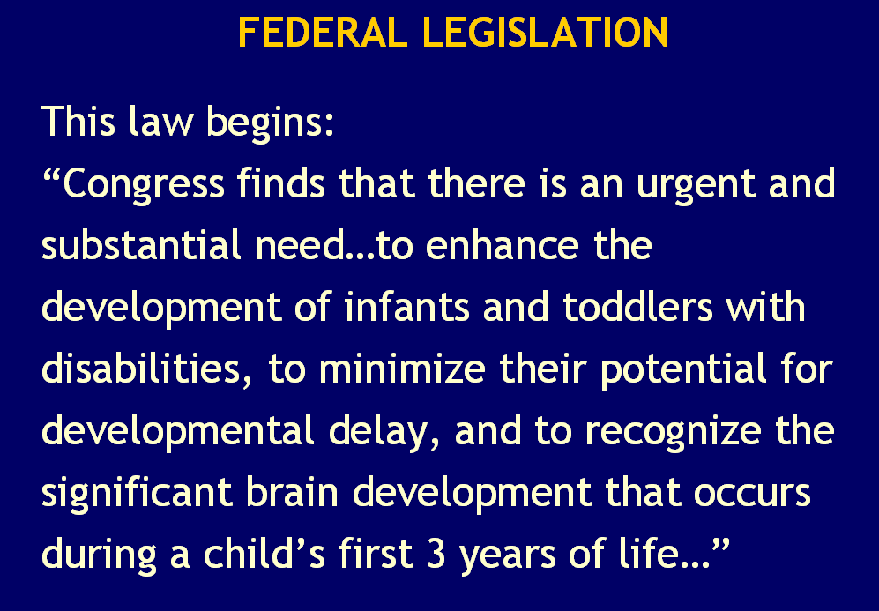
Text of slide……………………….
[Logo of the TV Show Jeopardy!]

Federal Legislation

This law begins:
“Congress finds that there is an urgent and substantial need…to enhance the development of infants and toddlers with disabilities, to minimize their potential for developmental delay, and to
recognize the significant brain development that occurs during a child’s first 3 years of life…”

End of slide……………………….

Slide operation: The slide loads automatically. No clicks are necessary except to advance to the next slide.

Now everyone can see the answer that begs the question (again, the Jeopardy approach to quiz shows). And that’s:
This law begins:
“Congress finds that there is an urgent and substantial need…to enhance the development of infants and toddlers with disabilities, to minimize their potential for developmental delay, and to recognize the significant brain development that occurs during a child’s first three years of life…”
To stay in the Jeopardy format, say, “Contestants, you have 30 seconds.”
Give the audience much less than 30 seconds to write their answer—which must be in the form of a question. Suggested question: What is IDEA? or What is the Individuals with Disabilities Education Act? or What is Part C of IDEA?
With that segue, you’re ready to move into the training proper.

Slide 6 / Operation and Discussion: Agenda
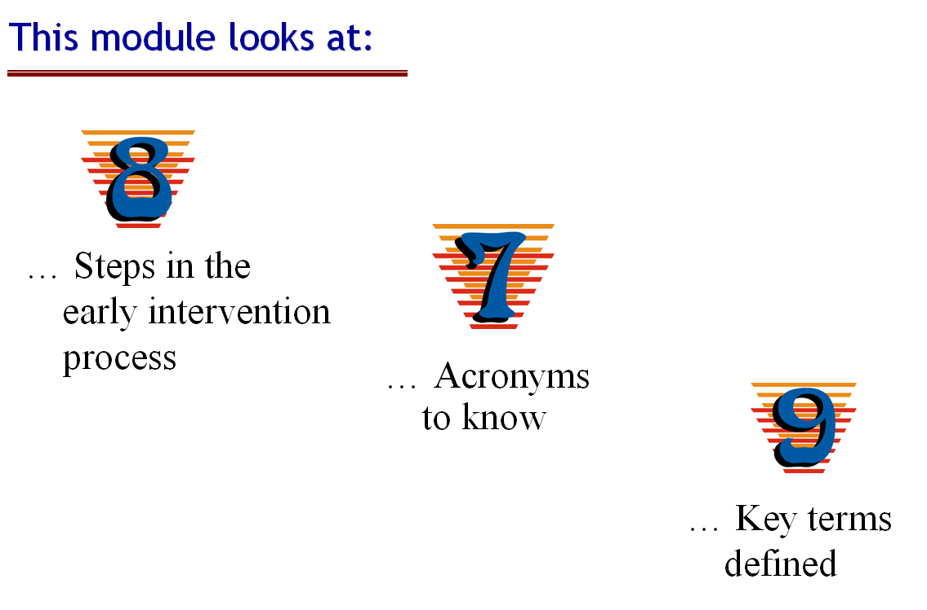
Text of slide……………………….
This module looks at...

- 8 steps in the early intervention process
- 7 acronyms to know
- 9 key terms defined
End of slide……………………….

Slide operation: The slide loads automatically. No clicks are necessary except to advance to the next slide.

Slide 6 is an advance organizer for participants, to alert them to the areas covered in the full training module.
Are You Going to Go Through All Three Slideshows?
As the slide indicates, Module 1 is divided into three separate sections. Each has its own slideshow (see discussion in the introduction to this Trainer’s Guide). If you’re not intending to go through all three presentations, indicate to participants which part(s) you are going to be looking at with them.
You can talk with the audience about what they think each of these elements will involve or what they hope they’ll learn about each, adjusting your questions to reflect the actual slideshows you intend to use with the audience. Ask questions such as:
- What steps might you guess would be involved in accessing early intervention services for a baby or toddler with a disability?
- What acronyms have you heard that made you wonder, huh? What does that mean?
- Have you ever had an experience with an acronym—in early intervention or otherwise—where knowing what the acronym meant made all the difference in the world?
- What key terms might you expect to hear defined here? Any wild guesses?

Slide 7 / Operation and Discussion: Step 1 (Slide 1 of 2)

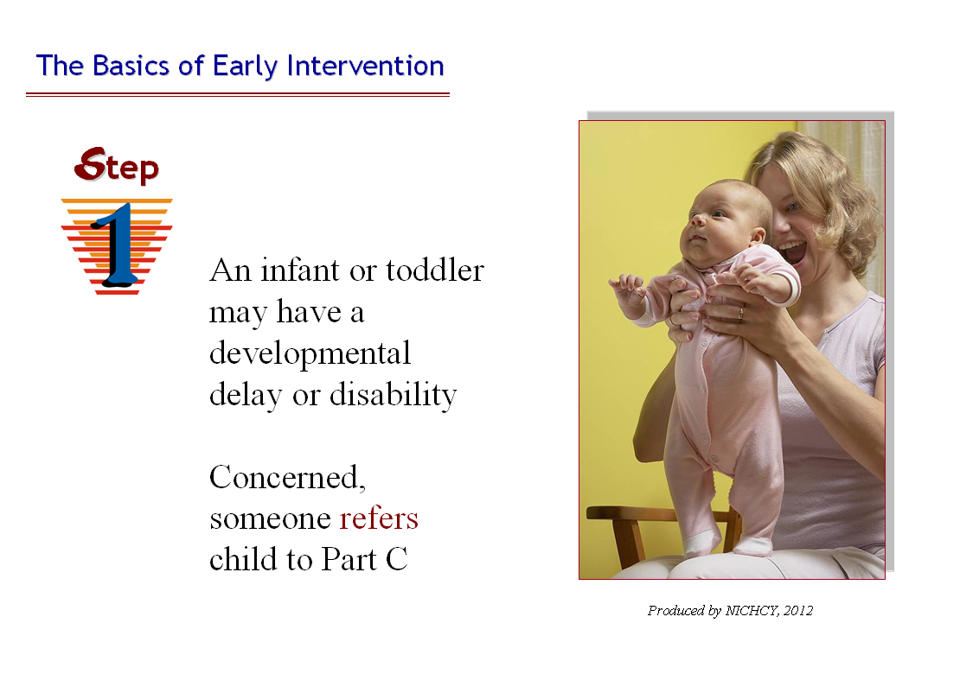
Text of slide……………………….
The Basics of Early Intervention
Step 1
An infant or toddler may have a
developmental delay or disability

Concerned, someone refers child to
Part C

End of slide……………………….

Slide operation: The slide loads automatically. No clicks are necessary except to advance to the next slide.

Pertinent Handouts:
- Handout 1, Basics of the Early Intervention Process under Part C of IDEA
- Examples of public awareness materials disseminated by your State’s lead agency

The first section of this training session is meant for greenhorns to early intervention and Part C. It focuses on the eight basic steps involved in the early intervention process. Participants will find the eight steps depicted on Handout 1.
Trainer Note
Handout 1 will also serve you well if you have only a short amount of time available for this training session and need to present the eight steps in their barest bones.
If that’s not the case, much additional information is provided below to flesh out those bones and offer participants a more substantial look at each step, as your training agenda permits.
Bare Bones of Step 1
Step 1 in the early intervention process corresponds to someone noticing that a baby or toddler seems to have a developmental delay of some sort, a disability, or a diagnosed physical or mental condition. That person needs to refer the child to the State’s early intervention system, which can evaluate the child and determine if he or she does, in fact, have a developmental delay or disability.
“Someone noticing” and “referring” the child and family to the early intervention system may happen at birth. Often this is so for children who are diagnosed at birth with a specific condition or who experience significant prematurity, very low birth weight, illness, or surgery soon after being born. Even before heading home from the hospital, this child’s parents may be given a referral to their local early intervention office.
Other children have a relatively routine entry into the world, but may develop more slowly than others, experience set backs, or develop in ways that seem very different from their peers. For these children, a visit with a developmental pediatrician may lead to an early intervention referral. Or perhaps the referral comes from a childcare provider, nurse, family member, or friend who notices that the child isn’t meeting the normal “baby” milestones such as rolling over by a certain age, or sitting up, crawling, speaking, and so forth.
However the referral to early intervention happens, for children found eligible for services under Part C, early intervention can provide the vital support they need to learn critical developmental skills.
Where Do You Call?
IDEA requires that each State have a statewide early intervention system that includes well-advertised processes for finding, referring, and (as appropriate) evaluating babies and toddlers suspected of having (or known to have) a developmental delay or disability. The system includes:
- operating a public awareness program so that residents of the State know that early intervention services are available to help eligible infants and toddlers with developmental delays or disabilities; and
- providing referral procedures by which children may be referred to the Part C system for evaluation.
About the Public Awareness Program
The purpose of the public awareness program is to let residents in the State know:
- that early intervention services are available to eligible infants and toddlers with disabilities;
- how to connect with the EI system to have an infant or toddler evaluated; and
- how to make a referral to the EI system regarding a child potentially in need of EI services.
End result of the public awareness program | The early identification of infants and toddlers with disabilities
Show and tell | Do you have some public awareness materials used in your State or locale—a few brochures, say? Show them to your participants. Ask them what type of information would be important for the brochure (or whatever) to include, given its purpose to raise awareness and stimulate people to action when a baby or toddler is suspected of having a delay or disability. Find that information on the brochure (or whatever).
Note to Trainers:
IDEA requires that public awareness materials include certain information, which you can highlight in this show-and-tell: (a) a description of the availability of early intervention services; (b) a description of the child find system and how to refer a child under the age of three for an evaluation or early intervention services; and (c) a central directory that identifies resources, experts, and EI service providers.
About Referral
Each State has an affirmative obligation to ensure that all infants and toddlers with disabilities in the State who are eligible for early intervention services under Part C are identified, located, and evaluated. As part of fulfilling that obligation, the State operates a child find system, which must include procedures for referring a child to early intervention. The referral system must enable referrals in particular from what IDEA calls primary referral sources (e.g., parents, physicians, hospital staff). These are the individuals who are most likely to be interacting with very young children; they are in a position to notice that a child may have a developmental delay or disability and to make a referral to the Part C system. The list of primary referral sources in the box below comes directly from the Part C regulations.
------ in a box-----------
Primary Referral Sources
listed at §303.303(c)
Primary referral sources include:
- hospitals (including prenatal and postnatal care facilities)
- physicians
- parents (especially parents with premature infants or infants with other physical risk factors associated with learning or developmental complications)
- child care & early learning programs
- local educational agencies (LEAs)
- public health facilities
- social service agencies
- clinics or health care providers
- child welfare agencies
- homeless & domestic violence shelters
------end box-----------
IDEA’s list of primary referral sources isn’t meant to be exhaustive, despite its length. Other sources of referral may be included in a State’s child find system. The bottom line is that “primary referral sources” are possible observers of a delay or disability in a baby or toddler. All must be well informed as to the availability of the Part C system and the procedures to use when referring an infant or toddler to the system.
Need More Detail?
This module focuses on providing an overview of the early intervention process. As such, it’s limited in giving or discussing IDEA’s precise details and requirements. Other modules in this training curriculum are devoted to examining and explaining the basic steps summarized in this module. Indepth discussion of public awareness, child find, and referral processes can be found in Module 3 (Pre-Referral Activities) and Module 4 (Referral to Part C).
Feel free to borrow liberally from either module’s substance to add more depth to this overview or to tailor the content you present to address the needs of your audience.

Slide 8 / Operation and Discussion: Step 1 cont. (Slide 2 of 2)

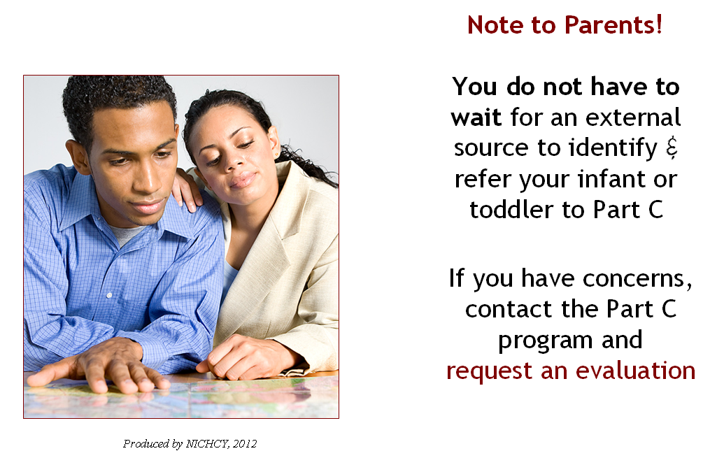
Text of slide……………………………………….
Note to Parents!

You do not have to wait for an external source to identify & refer your infant or toddler to Part C

If you have concerns, contact the Part C program and request an evaluation
End of slide……………………………………………………………

Slide operation: The slide loads automatically. No clicks are necessary except to advance to the next slide.

Pertinent Handouts: None

The slide answers a question that many parents may have—may I contact the Part C system directly and ask that my child be evaluated? Or do I have to wait until someone refers my child?
Simple answer: If parents have concerns about their child’s development, they don’t have to wait for someone else to notice and refer the child. Parents themselves are considered a primary referral source. They may contact the Part C system directly, explain their concerns, and ask that their little one be evaluated. The Part C system will respond according to its particular State policies and guide parents, given those policies.
Which raises another question—how do parents find their Part C program?
There are multiple ways, of course, including asking the neonatal unit at the local hospital or their child’s pediatrician. Parents can also visit the website of the National Early Childhood Technical Assistance Center—known as NECTAC—which maintains a list of current Part C coordinators by State. Contacting the State lead agency office is an excellent way to be put in touch with your local EI program.
Additional Resources for Parents
If there are many parents in your audience, you may wish to mention several resources of particular helpfulness to families in understanding the early intervention process.
National Early Childhood Technical Assistance Center | Just mentioned! NECTAC offers a wealth of information about early intervention on its website, at: http://www.nectac.org
The State’s PTI or CPRC | One terrific resource for parents is their State’s Parent Training and Information Center—referred to as the PTI. Every State has at least one PTI that helps parents understand IDEA’s provisions, access systems of help for infants and toddlers under Part C or school-aged children under Part B (including preschoolers), and much more. PTIs regularly provide trainings to parents on key IDEA-related subjects.
Your State’s PTI will have the contact information for the State’s early intervention system. So will the CPRC, which stands for Community Parent Resource Center. Not all States have CPRCs, but many do. CPRCs typically focus on providing services in a specific area of the State (perhaps a particular county or city) or to a specific population (such as Spanish-speaking or low-income families).
Parents can locate their PTI or CPRC by visiting: http://www.parentcenterhub.org/find-your-center/

Slide 9 / Operation and Discussion: Step 2 (Slide 1 of 6)
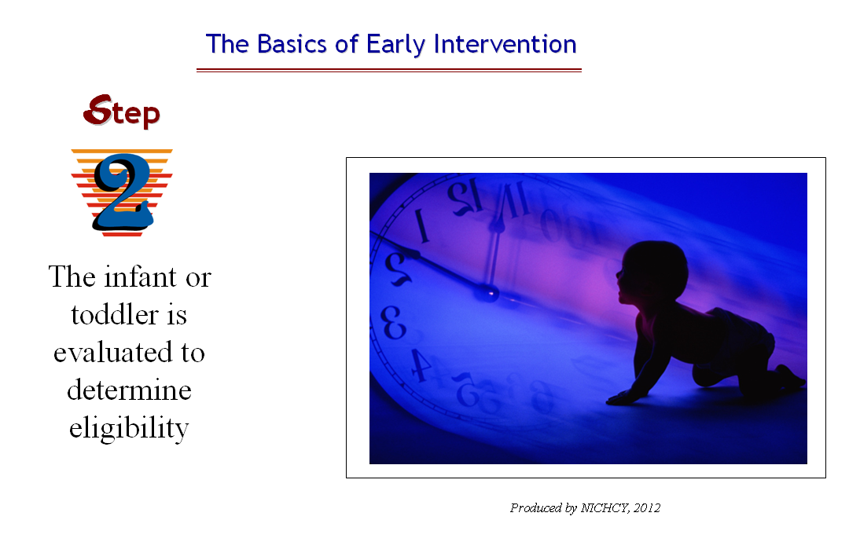
Text of slide ………………………………….
Step 2
The infant or toddler is evaluated to determine eligibility
End of slide ……………………………

Slide operation: The slide loads automatically. No clicks are necessary except to advance to the next slide.

Pertinent Handouts: Handout 1, Basics of the Early Intervention Process under Part C of IDEA

Okay, time for Step 2. It’s a big step, with details spread across six slides. Slide 9 (this one) acts as an advance organizer for the audience, with two keys words to note:
- evaluated
- eligibility

The upcoming slides will focus upon what’s involved in a child’s evaluation, the need for prior written notice and parental consent, the definition of “developmental delay,” the role that definition plays in how eligibility for Part C is determined, and what happens next, depending on whether a child is felt eligible for Part C or not.

Slide 10 / Operation and Discussion: Step 2 cont. (Slide 2 of 6)
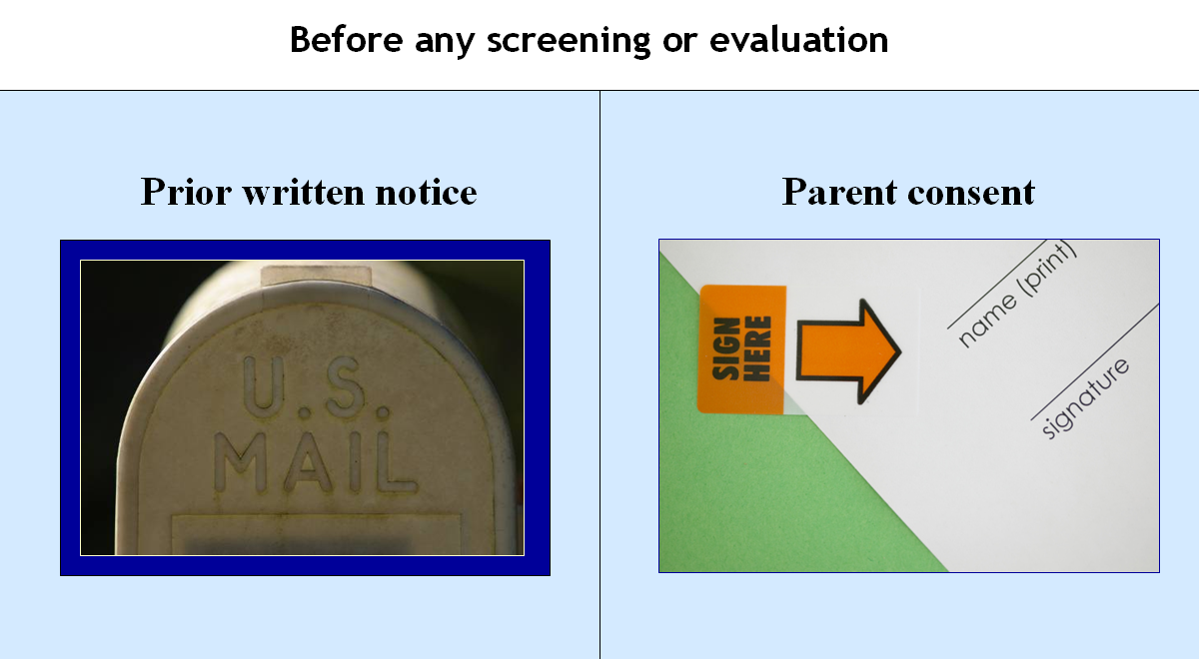
Text of slide ……………………………………….
Before any screening or evaluation…

- Prior written notice
- Parent consent
End of slide …………………………

Slide operation: The slide loads automatically. No clicks are necessary except to advance to the next slide.

Pertinent Handouts
- Handout 1, Basics of the Early Intervention Process under Part C of IDEA
- Handout 7, Parent Notification and Parent Consent

Slide 10 introduces two very important aspects in early intervention: the need to fully inform parents via prior written notice and the need for parental consent before any evaluation procedures may be conducted. These two elements will also be pertinent at other points in the early intervention process, as participants will see in upcoming steps.
Refer participants to Handout 7, as appropriate to your pace, where they’ll find the Part C regulations verbatim regarding parent notification and parent consent.
Note to Trainers:
Prior written notice is covered in detail in Module 14, Introduction to Procedural Safeguards, but here, in this training, you’ll want to indicate its importance within the early intervention system and give your participants a quick summary of what prior written notice is, when it must be provided to parents, and what type of information the lead agency or EIS provider is required to include in the notice.
Prior Written Notice
Prior written notice refers to the notification that must be provided to parents a reasonable time before the lead agency or an EIS provider proposes (or refuses) to “initiate or change the identification, evaluation, or placement of their infant or toddler, or the provision of early intervention services to the infant or toddler with a disability” and his or her family. The notice must be in sufficient detail to inform parents about—
- the action that is being proposed or refused;
- the reasons for taking the action; and
- all procedural safeguards that are available to parents (e.g., mediation, filing a State complaint or a due process complaint, relevant timelines).
Native language | To ensure that a parent can understand the notice, it must be written in a language understandable to the general public and provided in the parent’s native language (or other mode of communication), unless it is clearly not feasible to do so. If the parent’s language is not a written one, the lead agency or EIS provider must ensure that the prior written notice is translated orally to the parent, that the parent understands the notice, and that there is written evidence that these requirements have been met.
In the context of Step 2, parents would be provided with prior written notice describing in detail what will be involved in the evaluation process. This information is intended to help parents understand what’s going to happen and decide whether or not to proceed.
Parental Consent
Consent within IDEA has a very specific meaning that is closely tied to prior written notice. Consent, in IDEA, means informed written consent. Prior written notice comprehensively describes a proposed or refused action and is intended to inform parents fully about a specific issue. Only by building that foundation of understanding can informed consent be given.
Consider the definition of consent in the Part C regulations (provided on Handout 7):
§303.7 Consent.
Consent means that—
(a) The parent has been fully informed of all information relevant to the activity for which consent is sought, in the parent’s native language, as defined in §303.25;
(b) The parent understands and agrees in writing to the carrying out of the activity for which the parent’s consent is sought, and the consent form describes that activity and lists the early intervention records (if any) that will be released and to whom they will be released; and
(c)(1) The parent understands that the granting of consent is voluntary on the part of the parent and may be revoked at any time.
(2) If a parent revokes consent, that revocation is not retroactive (i.e., it does not apply to an action that occurred before the consent was revoked).
The right to give or refuse consent for pivotal activities is an important procedural safeguard for parents and recognizes their authority and responsibility in making decisions about their child’s involvement in early intervention, and the family’s.
When Prior Written Notice & Parental Consent Are Required in Evaluation
It will come as no surprise that both prior written notice and parental consent are required repeatedly throughout the evaluation process. Depicted below in chart-form, these times are:
Activity | Is Prior Written Notice required? | Is Parental Consent Required?
Before administering screening procedures to see if an infant or toddler is suspected of having a disability | Yes | Yes
Before conducting evaluation of the infant or toddler to determine eligibility for Part C | Yes | Yes
Before conducting all assessments of the infant or toddler | Yes | Yes

There are notable other times when prior written notice and/or parental consent are required by the Part C regulations, but at this moment the spotlight is on what’s required during Step 2, evaluating the child to determine his or her eligibility for Part C.

Slide 11 / Operation and Discussion: Step 2 (cont.) (Slide 3 of 6)

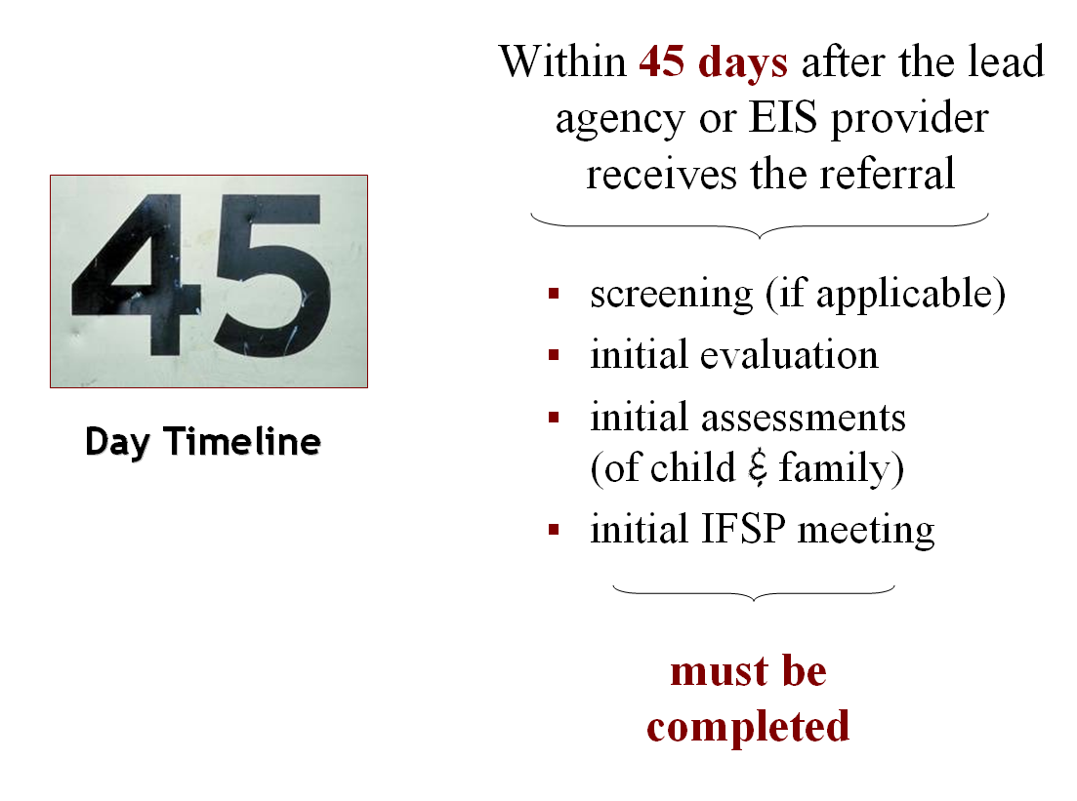
Text of slide………………………
Step 2 (continued)

45-Day Timeline

Within 45 days after the lead agency or EIS provider receives the referral:

- screening (if applicable)
- initial evaluation
- initial assessments (of child & family)
- initial IFSP meeting

must be completed
End of slide……………………………………………………………

Slide operation: The slide loads automatically. No clicks are necessary except to advance to the next slide.

Pertinent Handouts
- Handout 1, Basics of the Early Intervention Process under Part C of IDEA

Now that we have prior written notice and parent consent out of the way, it’s time to look at the timeframe in which all evaluation of the child must be completed. As the slide clearly shows via the large picture of the number “45”, that’s the timeline. Section 303.310 requires that, within 45 days after the lead agency or EIS provider receives a referral of a child, the screening (if applicable), initial evaluation, initial assessments (of the child and family), and the initial IFSP meeting for that child must be completed.
Screening
States now have the option of adopting procedures to screen children under the age of three who have been referred to the Part C program to determine whether they are suspected of having a disability. Screening activities are carried out by, or under the supervision of, the lead agency or EIS provider to identify infants and toddlers suspected of having a disability and in need of early intervention services. Screening activities also include the administration of appropriate instruments by personnel trained to administer those instruments.
Prior written notice and parental consent are required if a State chooses to screen a child to determine whether the child is suspected of having a disability. Both are important elements in protecting the rights of parents to be informed decision makers with respect to the Part C system’s involvement with their child.
Results of the screening are used to determine next steps in the early intervention process.
Yes, the screening indicates that the child is suspected of having a developmental delay | In this case, the next step is to conduct an evaluation and assessment of the child. Before the State may do so, however, it must again give parents prior written notice and obtain their consent.
No, the screening indicates that the child is not suspected of having a developmental delay | The agency must inform parents of that determination (via prior written notice) and let parents know that they still may request an evaluation of their child.
Important! If, at any time during the screening process, the parent requests and consents to an evaluation, then an evaluation must be conducted, even if the lead agency or EIS provider has determined that the child is not suspected of having a disability. Additionally, if the parent does not consent to the screening but, rather, requests and consents to an evaluation, then an evaluation must be conducted.
Initial Evaluation
After providing parents with prior written notice and obtaining parental consent to proceed, the State will conduct a timely, comprehensive, multidisciplinary evaluation of an infant or toddler to determine his or her eligibility for Part C services. Note that an evaluation is not necessary if the infant or toddler is deemed eligible due to a diagnosed physical or mental condition that has a high probability of resulting in a developmental delay.
In conducting an evaluation, no single procedure may be used as the sole criterion for determining an infant or toddler’s eligibility for early intervention services under Part C. Procedures must include:
- administering an evaluation instrument;
- taking the infant or toddler’s history (including interviewing the parent);
- identifying the infant or toddler’s level of functioning in the five developmental areas (discussed on the next slide);
- gathering information from other sources such as family members, other caregivers, medical providers, social workers, and educators, if necessary, to understand the full scope of the infant or toddler’s unique strengths and needs; and
- reviewing medical, educational, or other records.
Evaluation of the child and family (and assessments, too, discussed further below) must be conducted by qualified personnel, in a nondiscriminatory manner, and selected and administered so as not to be racially or culturally discriminatory. The regulations also specify that, during evaluations and assessments, native language is the language normally used by the child (not the parent, note the difference), if doing so is developmentally appropriate for the child, as determined by the qualified personnel who are conducting the evaluation or assessment.
Initial Assessment of the Child and Family
If the child is determined eligible as an infant or toddler with a disability, qualified personnel must conduct:
- a multidisciplinary assessment of the child; and
- a family-directed assessment.
The multidisciplinary assessment of the child focuses on identifying the infant or toddler’s unique strengths and needs and the early intervention services appropriate to meet those needs. Parents must be provided with prior written notice and must give their written consent before any assessment of the child may be conducted. The assessment must include:
- a review of the results of the evaluation conducted,
- personal observations of the child, and
- identification of the child’s needs in each of the developmental areas.
The family-directed assessment focuses on the resources, priorities, and concerns of the family and on identifying the supports and services necessary to enhance the family's capacity to meet the developmental needs of their child. Also conducted by qualified personnel, the family-directed assessment must be voluntary on the part of each family member participating in the assessment and be based on information obtained through an assessment tool and also through an interview with those family members who elect to participate.
Initial IFSP Meeting
The initial IFSP meeting and the writing of the initial IFSP for a child will only occur if the child is found eligible for Part C services. If so, then the IFSP must be completed within the 45-day timeline shown on the slide.
Note: Meeting to write the IFSP is the primary focus of Step 3, which begins on Slide 15.

Slide 12 / Operation and Discussion: Step 2 cont. (Slide 4 of 6)

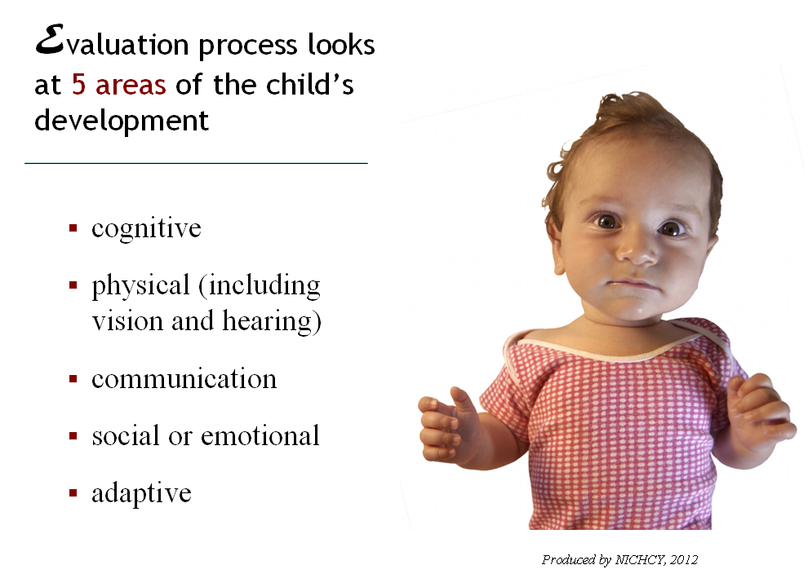
Text of slide…………………………………………………………….
Evaluation process looks at 5 areas of the child’s development
- cognitive
- physical (including vision and hearing)
- communication
- social or emotional
- adaptive
End of slide………………………………

Slide operation: The slide loads automatically. No clicks are necessary except to advance to the next slide.

Pertinent Handouts
- Handout 1, Basics of the Early Intervention Process under Part C of IDEA

Now that we’ve covered the 45-day timeline in which the evaluation process must be completed, it’s time to look at the scope of the evaluation. As the slide indicates, there are five areas of childhood development examined in each evaluation of an infant or toddler suspected of having a developmental delay or disability.
You don’t need to say much, the slide is pretty self-explanatory, but you may wish to add some examples of skills involved in each of the developmental areas. Depending on the amount of time you have and the needs of your audience, consider having participants brainstorm (either individually, in pairs, or as a large group) a list of the kinds of skills each area might involve.
For your training convenience, we’ve provided additional information further below about each development area.
How Are These Areas Evaluated?
Good question, and one that participants may very well ask, considering we’re talking about evaluating babies and toddlers! The answer is that practices and evaluation tools vary from State to State. Under the Part C regulations, each State defines the term “developmental delay” (as discussed on the next slide) and describes the evaluation and assessment procedures that will be used to measure a child’s development in each of the five developmental areas. The State must also specify the level of developmental delay in functioning (or other comparable criteria) that constitutes a developmental delay in one or more of the developmental areas.
But, as we said, the State-specific nature of the evaluation process will be treated on the next slide. So if participants ask how programs measure a child’s development in each of the five areas…simply indicate you’ll be talking about that in a moment.
Now, as promised, more details about the five developmental areas of interest when Part C programs evaluate infants and toddlers.
Cognitive Development
Cognitive development refers to children’s ability to learn and solve problems, which typically grows dramatically between birth and three years old as children begin to make sense of the world around them. Developmental milestones of cognitive development include:
- paying attention to faces and recognizing familiar people (2 months);
- showing curiosity and trying to get to objects that are out of reach (6 months);
- knowing what ordinary things are for (e.g., spoon, toothbrush, comb) and being able to follow one-step commands (such as “sit down”) (18 months).
Physical Development
Physical development includes a child’s gross motor skills, fine motor skills, and sensory and perceptual abilities.
- Fine motor skills include the child’s ability to use small muscles, specifically in the hands and fingers, to pick up small objects, hold a spoon, turn pages in a book, or use a crayon to draw.
- Gross motor skills refer to the child’s ability to use large muscles. Large muscle development will help a baby learn to sit up without support, crawl or roll from one place to another, and pull up to a stand by holding onto furniture.
- Sensory and perceptual abilities include vision and hearing, as mentioned on the slide.
Interestingly, motor skills development in children generally progresses from head to toe, with babies usually gaining control of their body parts in the following order:
- head and neck at about 2 months of age;
- arms and hands, with grasping at about 3 months;
- trunk, with sitting well by about 8 months;
- legs and feet, with most children walking by 14 or 15 months.
Communication Development
At issue in this developmental area is the child’s ability to both understand and use language to communicate with people and express his or her own emotions. Typical milestone behaviors at different ages include:
- babbling (4 months);
- responding to sounds by making sounds and responding to own name (6 months);
- copying actions that others make, such as shaking the head to indicate “no” or waving “bye-bye” (9 months), and
- using a few simple words (18 months).
By age 3, a child may know as many as 900 words.
Social or Emotional Development
Zero to Three gives an excellent summary of the social-emotional domain, as follows:
Making friends. Showing anger in a healthy way. Figuring out conflicts peacefully. Taking care of someone who has been hurt. Waiting patiently. Following rules. Enjoying the company of others. All of these qualities, and more, describe the arc of healthy social-emotional development. Like any skill, young children develop these abilities in small steps over time.
Examples of typical milestones of social-emotional development include:
- smiling spontaneously, especially at people (4 months);
- clinging to familiar adults and perhaps being afraid of strangers (9 months);
- having temper tantrums (18 months); and
- playing mainly beside other children, but beginning to include other children, such as in chase games (2 years).
Adaptive Development
The ability to adapt to changing circumstances and take care of oneself is a vital skill in life, to be sure. For babies and toddlers, adaptive development includes learning the self-help skills involved in daily living—to eat independently (with fingers at first, then with a spoon), to get dressed, use the toilet, and see to basic hygiene and grooming. Not surprisingly, as children acquire more adaptive skills, they become more independent.

Slide 13 / Operation and Discussion: Step 2 (cont.) (Slide 5 of 6)

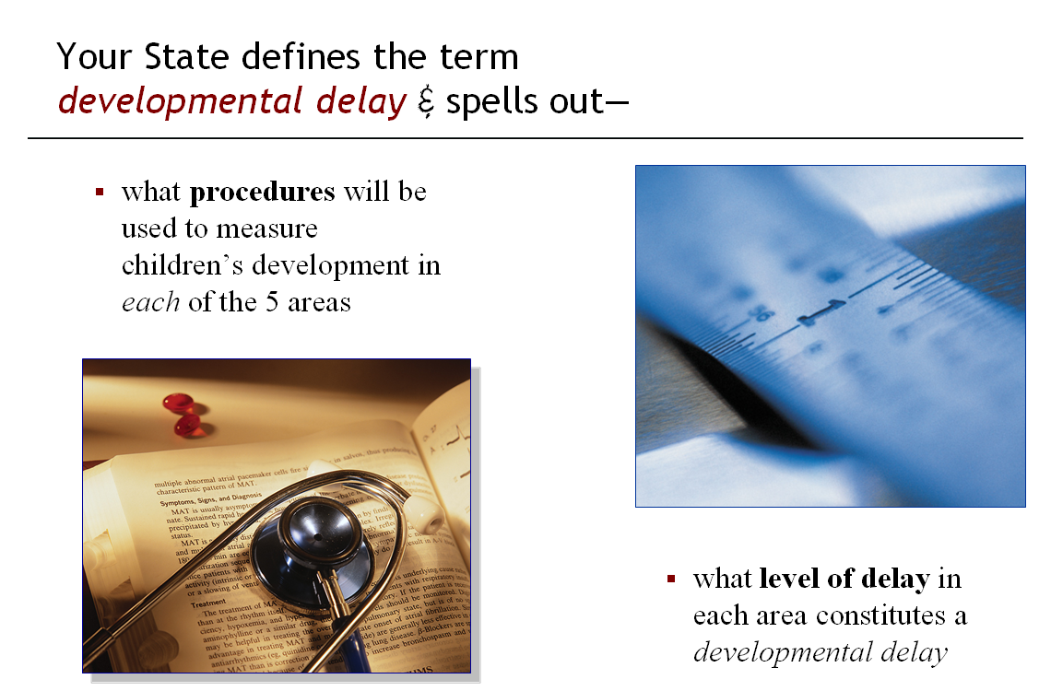
Text of slide……………………………….
Your State defines the term developmental delay & spells out—

- what procedures will be used to measure children’s development in each of the 5 areas
- what level of delay in each area constitutes a developmental delay

End of slide…………………………

Slide operation: The slide loads automatically. No clicks are necessary except to advance to the next slide.

Pertinent Handouts: none

Early intervention is intended to help infants and toddlers with developmental delays or disabilities. So it’s time to get down to the meaning of those terms. What’s a developmental delay? What’s a disability?
Discussing the Slide in Brief
You can quickly summarize the point of this slide, which is that the term developmental delay is defined by each State. The State also specifies how each child’s development will be measured in each developmental area (e.g., cognitive, physical). And the State spells out how big the delay in any one area of functioning has to be to meet the State’s definition of developmental delay.
Children’s evaluations for Part C—and the determination of their eligibility for Part C services—will be very much based upon these State definitions and procedures.
How Does Your State Define Developmental Delay?
Obviously, it’s very important to know your State’s policies, especially its definition of developmental delay. Don’t know? Get in touch with your State’s lead agency for Part C. The information should be readily available.
Trainer Note
Share your State’s policies and definition with the audience. Include both as a handout that participants can refer to now and later, if that information would be valuable to them. If you have time available and would like to give partipants an opportunity to move around and interact, consider using the handout as part of an activity or guided discussion.
What about Disability?
Yes, we did say this slide would also look at the meaning of the term disability. IDEA defines the term infant and toddler with a disability at §303.21. There are two parts of the definition quite pertinent to this “basics” module. They are that the term means infants or toddlers who have either:
- a developmental delay; or
- a diagnosed physical or mental condition that has a high probability of resulting in developmental delay.
We’ve just covered developmental delay. What about the diagnosed physical or mental condition? What might that be? The best way to see is to look at the exact words of the Part C regulations. Here they are, with the relevant part bolded for emphasis.

§303.21 Infant or toddler with a disability.
(a) Infant or toddler with a disability means an individual under three years of age who needs early intervention services because the individual—
(1) Is experiencing a developmental delay, as measured by appropriate diagnostic instruments and procedures, in one or more of the following areas:
(i) Cognitive development.
(ii) Physical development, including vision and hearing.
(iii) Communication development.
(iv) Social or emotional development.
(v) Adaptive development; or
(2) Has a diagnosed physical or mental condition that—
(i) Has a high probability of resulting in developmental delay; and
(ii) Includes conditions such as chromosomal abnormalities; genetic or congenital disorders; sensory impairments; inborn errors of metabolism; disorders reflecting disturbance of the development of the nervous system; congenital infections; severe attachment disorders; and disorders secondary to exposure to toxic substances, including fetal alcohol syndrome.
All this is to say, an infant or toddler with a diagnosed condition such as what’s bolded above would be considered an infant or toddler with a disability under the Part C regulations. These conditions are considered “conditions of established risk.” Children in this category are eligible for services under Part C of IDEA by virtue of their diagnosis, regardless of whether a measurable delay is present.
Other conditions possible | The regulations use the word “includes” before the list of conditions—which means that the conditions listed aren’t necessarily the only ones. States may include additional conditions in their definition of “diagnosed physical or mental condition” and provide EI services to eligible children with those conditions. As NECTAC observes:
Although many states have mirrored the Part C regulatory language in listing diagnosed conditions in their eligibility definitions, several states have included many other conditions in their eligibility definitions... Accompanying their list of diagnosed conditions, many states use the phrase “but is not limited to the following” to allow flexibility for other conditions to be accepted for eligibility.
State policy may also break down the broad categories given in the regulations (e.g., chromosomal abnormalities, genetic or congenital disorders) and specify what types of conditions will automatically qualify a baby or toddler for Part C. We’ve included an example from the State of Missouri in the box below, to give you a flavor of just how specific States can get.
------in a box-------
The Genetic Conditions Specified by the State of Missouri
Genetic Conditions known to be associated with mental retardation or developmental disabilities including but not limited to:
- Down Syndrome
- Cri-du-Chat Syndrome
- Klinefelter's Syndrome
- Trisomy 18 (Edward's Syndrome)
- Trisomy 13 (Patau's Syndrome)
- Turner's Syndrome
- Triple-X Syndrome
- Fragile X Syndrome
- Prader-Willi Syndrome
- Pierre Robin
Additional conditions known to be associated with mental retardation or developmental disabilities including but not limited to:
- Hypoxic-Ischemic Encephalopathy (HIE) and at term (36 weeks gestation or more)
- Cranio-facial anomalies (i.e., cleft palate, etc.)
- Epilepsy/Seizure Disorder
- Spina Bifida
- Blindness, including visual impairments
- Macro/Microcephalus, including Hydrocephalus
- Deafness, including hearing impairments
- Fetal Alcohol Syndrome
- Cyanotic Congenital Heart Disease
- PKU (phenylketonuria)
- Cerebral Palsy
- Viruses/bacteria (Herpes, syphilis, cytomegalovirus, toxoplasmosis, and rubella)
- Acquired Immune Deficiency Syndrome (AIDS
- Autism Spectrum Disorders
----end of box-----

Slide 14 / Operation and Discussion: Step 2 (cont.) (Slide 6 of 6)

Slide operation: The slide looks like this when it loads:
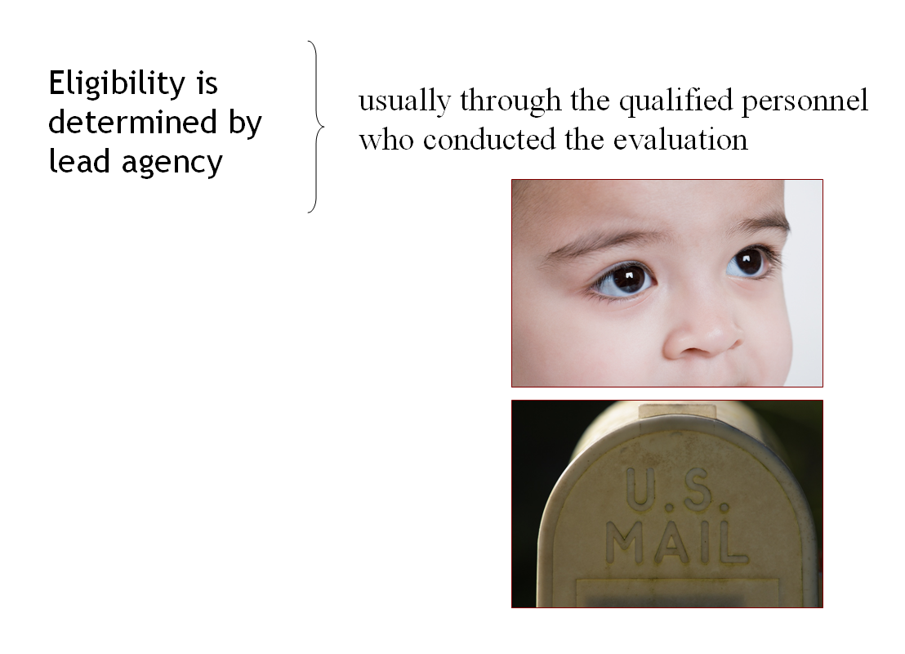

Click 1: “Yes, the child is eligible for Part C services” displays and one picture lifts away.
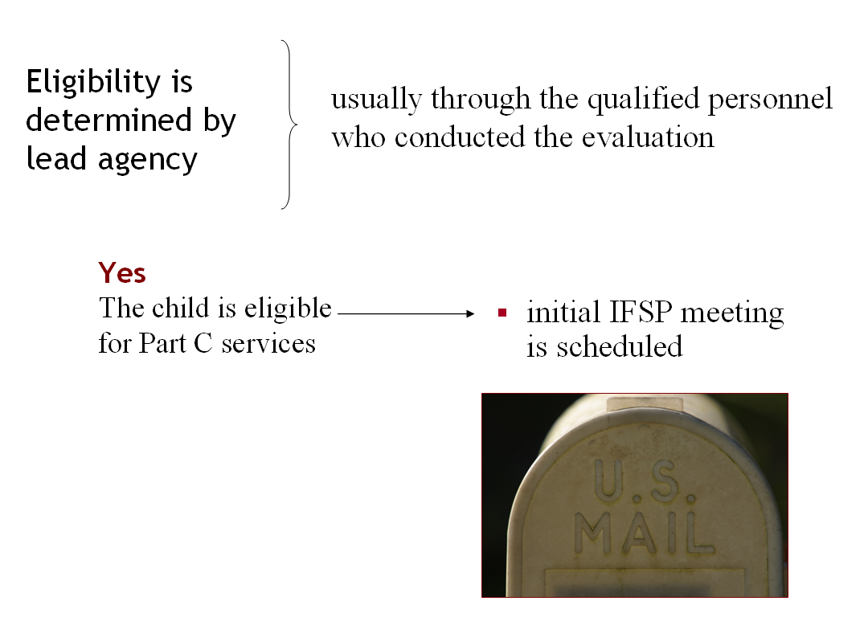

Click 2: “No, the child is not eligible” displays and the 2nd picture lifts away.
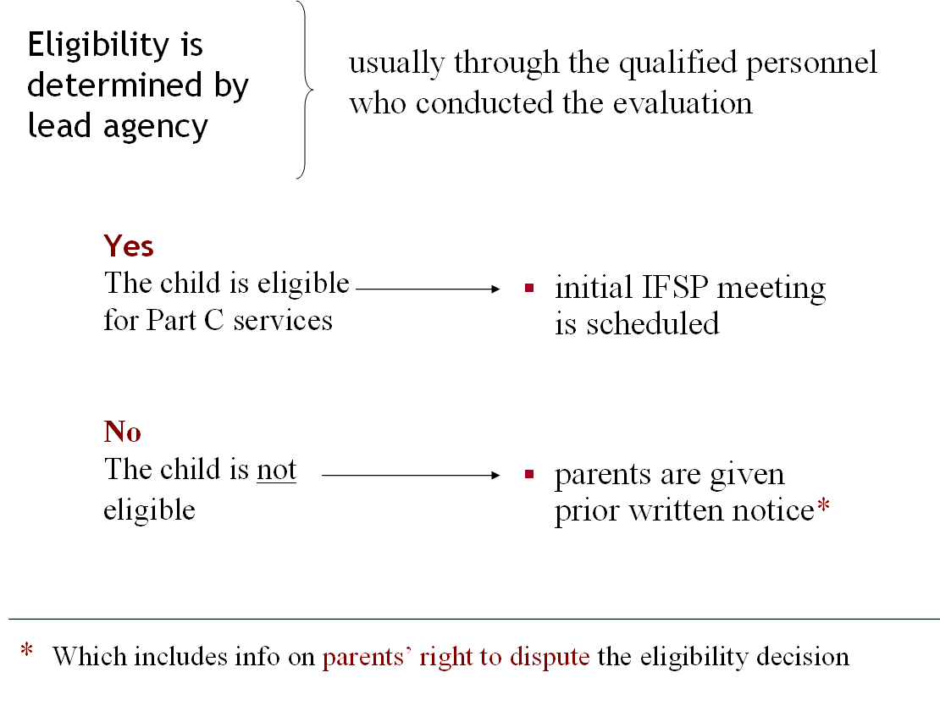

Click again to advance to the next slide.

Text of slide…………………………………………………………….
Eligibility is determined by lead agency--
usually through the qualified personnel who conducted the evaluation

Yes | The child is eligible for Part C services
- initial IFSP meeting is scheduled

No | The child is not eligible
- parents are given prior written notice*

*Which includes info on parents’ right to dispute the eligibility decision
End of slide……………………………………………………………
Pertinent Handouts: none

Slide 14 summarizes the yes/no nature of eligibility determinations and what happens next. It is designed so you can move ahead quickly, if you’re pressed for time. Key points to make:

The lead agency determines a child’s eligibility for early intervention services.

- If the determination is “yes, the child is eligible,” then an initial IFSP meeting is immediately scheduled.

- If the determination is “no, the child is not eligible,” then the lead agency must inform parents of that determination using prior written notice, and it must include information on parents’ right to disagree with the “no” determination.

Remember that the 45-day timeline is still running. This means that eligibility determinations must occur within the 45-day limit. Enough time must also be left in the 45-day timeline to go to next steps for children found eligible—namely, to schedule the IFSP meeting for those children and write their IFSPs (Step 3).
Trainer Note
Detailed information on parents’ right to disagree with the eligibility decision made by the lead agency is available in this training curriculum’s Module 17, Options for Dispute Resolution.

This is the last slide treating Step 2. The next three slides will deal with Step 3 in the early intervention process.

One final observation of potential interest to your audience, depending on their roles in the Part C system: What part does “informed clinical opinion” play in making eligibility determinations?

The Role of Informed Clinical Opinion
When conducting an evaluation of the child, qualified personnel must use informed clinical opinion. The lead agency must ensure that informed clinical opinion may be used as an independent basis to establish a child’s eligibility under Part C, even when other instruments do not establish eligibility. However, in no event may informed clinical opinion be used to negate the results of evaluation instruments used to establish eligibility.
The Part C regulations do not include a definition of “informed clinical opinion.” However, the Department’s comments on the subject are illuminating. They are as follows:
The use of informed clinical opinion by qualified personnel is neither an objective criterion nor a separate assessment strategy. Rather, informed clinical opinion is the way in which qualified personnel utilize their cumulative knowledge and experience in evaluating and assessing a child and in interpreting the results of evaluation and assessment instruments….
[A]ll States must allow qualified personnel, when conducting evaluations, to use their informed clinical opinion to determine whether the child meets the State’s definition of developmental delay. Given the Department’s monitoring experience in States where qualified personnel are not permitted to use their informed clinical opinion as a separate basis to establish eligibility, we have set forth in new § 303.321(a)(3)(ii) that such personnel must be able to use informed clinical opinion as an alternate basis for establishing eligibility. Permitting informed clinical opinion to serve as a separate basis to establish a child’s eligibility under part C of the Act is important given that standardized instruments may not capture the extent of a child’s delay. The purpose of new [requirement] is to alleviate the confusion and to expressly permit qualified personnel to use their informed clinical opinion to establish a child’s eligibility for early intervention services under part C of the Act, even when other istruments fail to identify or confirm the level of developmental delay to establish part C eligibility.
Slide 15 / Operation and Discussion: Step 3 (Slide 1 of 3)
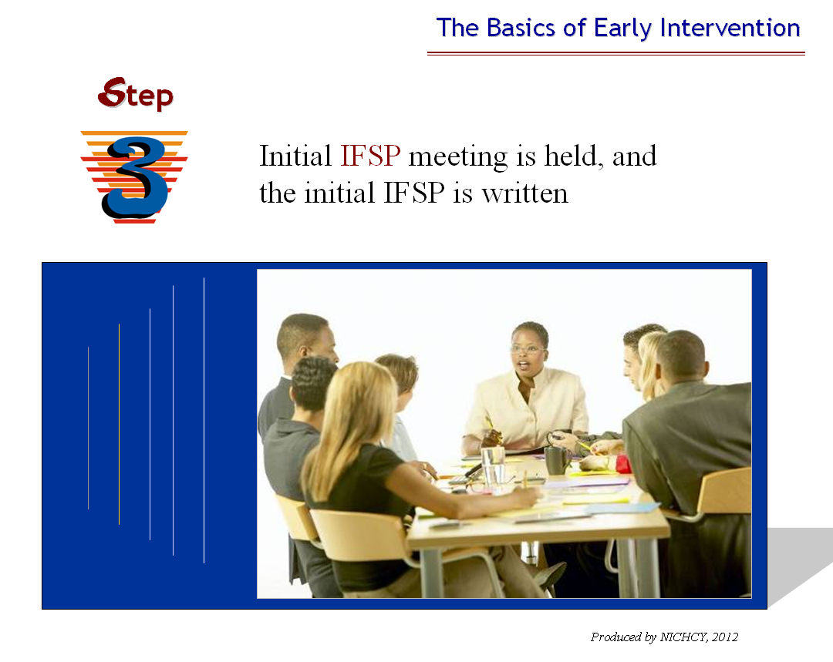
Text of slide……………………………….
Step 3. IFSP meeting is held & the IFSP is written
End of slide……………………

Slide operation: The slide loads automatically. No clicks are necessary except to advance to the next slide.

Pertinent Handouts: Handout 1, Basics of the Early Intervention Process under Part C of IDEA

Ahhhh, it’s time for three slides on the IFSP and Step 3 in our sequence of 8 basic steps in early intervention.

As you undoubtedly could say in your sleep, the IFSP stands for the Individualized Family Service Plan. The slide gives you the opportunity to introduce that acronym, the full name that’s long been used to refer to this important document, and to spend a few moments, as you wish, on seeing how much your audience already knows about the IFSP and the meeting where it’s developed. Suggestions for prompting questions:

- What does IFSP stand for?
- Who develops the IFSP?
- What kind of topics would you expect IFSP teams to talk about?
- Ever participated in developing an IFSP? What was your role there? What was the experience like?
- What happens after the IFSP is developed?

45-Day Timeline Applies
Remind participants that development of the IFSP is included in the 45-day timeline already discussed (see Slide 11). The Part C regulations state this at §303.342, as follows:

(a) Meeting to develop initial IFSP—timelines. For a child referred to the Part C program and determined to be eligible under this part as an infant or toddler with a disability, a meeting to develop the initial IFSP must be conducted within the 45-day time period described in §303.310.
Okay, let’s see what the Part C regulations have to say about the IFSP and the meeting that’s held to write the IFSP of an infant or toddler with a disability found eligible for Part C services.

Slide 16 / Operation and Discussion: Step 3 (cont.) (Slide 2 of 3)

Slide operation: The slide looks like this when it loads:
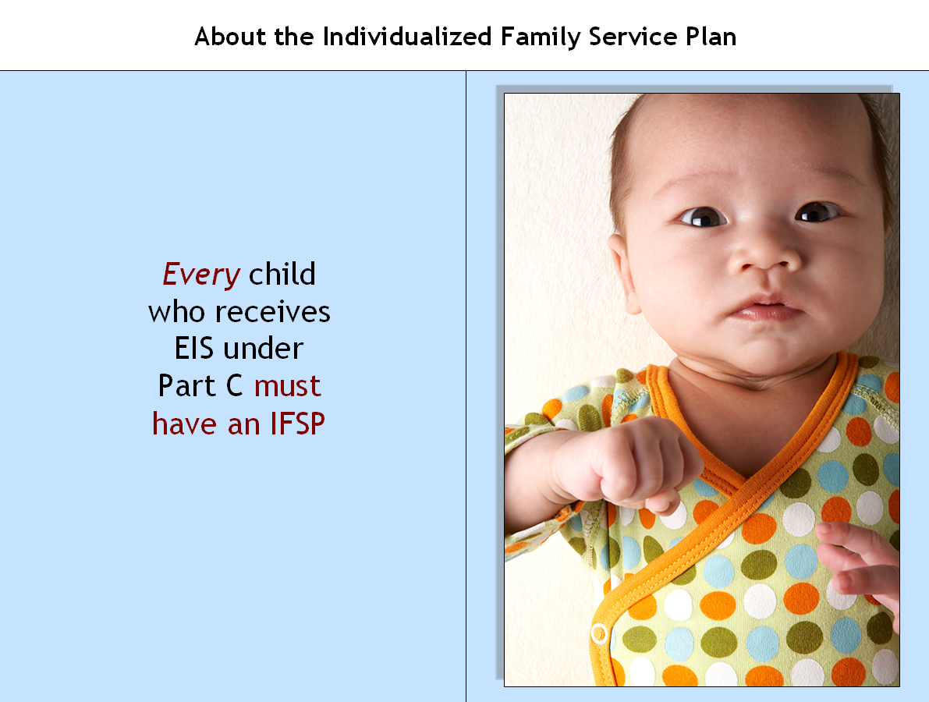

Click 1: Picture of baby lifts away and the text beneath is displayed.
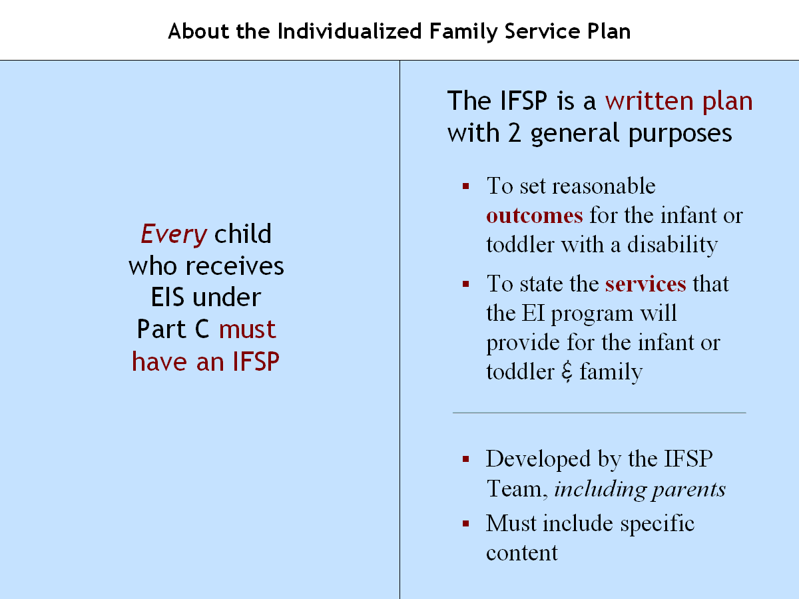

Click again to advance to the next slide.
Text of slide…………………………….
Every infant & toddler with a disability who receives EIS under Part C must have an IFSP

The IFSP is a written plan with 2 general purposes
- To set reasonable outcomes for the infant or toddler with a disability
- To state the services the EI program will provide for the infant or toddler & family

IFSP is developed by the IFSP team, including parents
IFSP must include specific content
End of slide……………………………………………………………

Pertinent Handouts | Handout 8, The Individualized Family Service Plan (optional)

The slide is designed to touch on key points about the IFSP and give you, as the trainer, the leeway to provide whatever level of additional detail fits your particular session, audience, and allotted time. The extensive discussion below is provided to give you details to choose from.
Even if you keep the discussion here brief, consider providing participants with Handout 8 for their future reference. The handout provides the Part C regulations describing:
- the contents of the IFSP,
- the membership of the IFSP Team, and
- the process by which the IFSP is developed and reviewed.
Who Must Have an IFSP?
As the slide states: Every infant or toddler with a disability who receives early intervention services under Part C of IDEA must have an IFSP. The pertinent regulation can be found at §303.340 and begins:

§303.340 Individualized family service plan—general.
For each infant or toddler with a disability, the lead agency must ensure the development, review, and implementation of an individualized family service plan or IFSP developed by a multidisciplinary team, which includes the parent…
Definition of the IFSP
In brief, an IFSP is a written plan for providing early intervention services to an infant or toddler with a disability and that child’s family. As the slide indicates, the two general purposes of the IFSP are to set reasonable outcomes for the child and state the services that will be provided for the child and family.

You’ll find the IFSP provisions from §§303.340—303.346 (refer participants to Handout 8), and the actual definition of the IFSP at §303.20. That definition reads:

§303.20 Individualized family service plan.
Individualized family service plan or IFSP means a written plan for providing early intervention services to an infant or toddler with a disability under this part and the infant’s or toddler’s family that—
(a) Is based on the evaluation and assessment described in §303.321;
(b) Includes the content specified in §303.344;
(c) Is implemented as soon as possible once parental consent for the early intervention services in the IFSP is obtained (consistent with §303.420); and
(d) Is developed in accordance with the IFSP procedures in §§303.342, 303.343, and 303.345.

Clearly, the main definition of IFSP refers to several other significant provisions in the Part C regulations. We’ve already talked about the “evaluation and assessment described in §303.321” (see Slides 9-13, Step 2). As used in the regulation above, this means that the IFSP must be based on the data gathered about the child and family during the evaluation process, which includes the child and family assessments.

Who Develops the IFSP?
This vital document is developed by a team of individuals, including the parents. The slide gives you this brief summary, upon which you can elaborate as you wish. The regulations cited below provide the list of who’s a member of the IFSP Team.

§303.343 IFSP Team meeting and periodic review.
(a) Initial and annual IFSP Team meeting. (1) Each initial meeting and each annual IFSP Team meeting to evaluate the IFSP must include the following participants:
(i) The parent or parents of the child.
(ii) Other family members, as requested by the parent, if feasible to do so.
(iii) An advocate or person outside of the family, if the parent requests that the person participate.
(iv) The service coordinator designated by the public agency to be responsible for implementing the IFSP.
(v) A person or persons directly involved in conducting the evaluations and assessments in §303.321.
(vi) As appropriate, persons who will be providing early intervention services under this part to the child or family.
Trainer Note
Additional information about the IFSP team is available in Module 9 | The IFSP Team: Who Is A Member?

What Information Does an IFSP Contain?
The last point on the slide states that the “IFSP must include specific content.” Brief, yes, as befits a slide, but notably nonspecific. This may be one area where the audience might appreciate a bit more detail.

What “specific content” must a child’s IFSP include? The exacting wording of the Part C regulations with respect to the content of the IFSP can be found at §303.344 (see page 2 of Handout 8). Summarized, the IFSP must include:

- information about the child’s developmental status;
- the resources, priorities, and concerns of the family, provided voluntarily;
- results or outcomes to be gained;
- the early intervention services to be provided (including the length, duration, frequency, intensity, and method of delivering each of those services);
- medical and other services the infant or toddler and the family may need or are receiving but which are not required under Part C of IDEA;
- the name of the service coordinator who will be responsible for implementation of the IFSP; and
- steps and services to be taken to support the toddler’s transition from Part C services.

There may be other required content, depending on the State’s or lead agency’s policies.

Trainer Note
Additional information about the content required in the IFSP is available in Module 10 | Content of the IFSP.

Slide 17 / Operation and Discussion: Step 5 cont. (Slide 3 of 3)
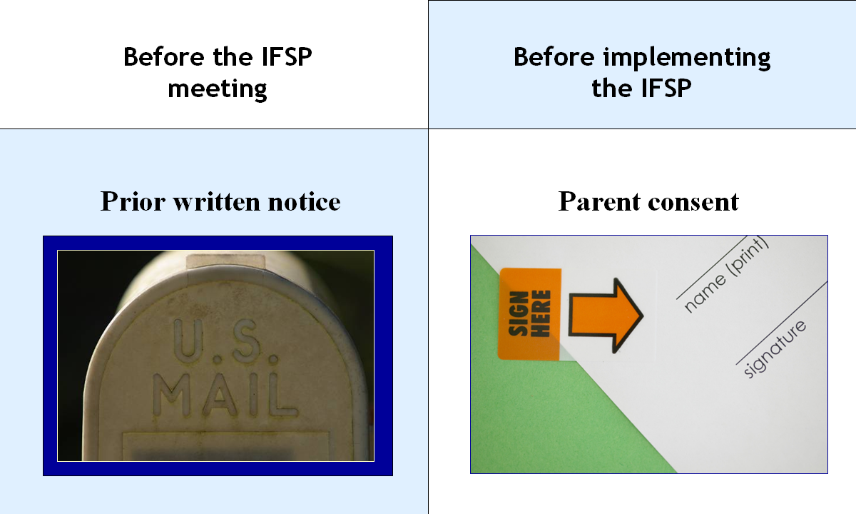
Text of slide………………….
Before the IFSP meeting
Prior written notice

Before implementing the IFSP
Parent consent
End of slide………………

Slide operation: The slide loads automatically.
No clicks are necessary except to advance to the next slide.

Pertinent Handouts:
- Handout 7, Parent Notification and Consent (optional)
- Handout 8, IFSP (optional)

Does this slide look familiar? It should!
Under Slide 10, the subjects of prior written notice and parental consent were discussed. There, the focus was on evaluation. Here, on Slide 17, prior written notice and parental consent come up again, this time with respect to the IFSP. As the slide indicates:
- prior written notice must be given to parents before the IFSP meeting, and
- parental consent is needed before the IFSP may be implemented.
Parental Consent
The information about parental consent presented under Slide 10 needs a bit of expansion in the context of the IFSP. Parental consent at this time is for the provision of the early intervention services listed in the child’s IFSP. The regulations at §303.420 (presented on Handout 7, page 2) make it clear that parents have the right to give or refuse consent for each service (one by one) and to revoke consent at any time for any service. Make sure that you draw participants’ attention to §303.420(d), where this is made clear:
(d) The parents of an infant or toddler with a disability—
(1) Determine whether they, their infant or toddler with a disability, or other family members will accept or decline any early intervention service under this part at any time, in accordance with State law; and
(2) May decline a service after first accepting it, without jeopardizing other early intervention services under this part.

If you’ve shared Handout 8 with participants, you might also refer the audience to the parental consent provisions at §303.340(e) that appear on page 2 of the handout. These read:
(e) Parental consent. The contents of the IFSP must be fully explained to the parents and informed written consent, as described in §303.7, must be obtained, as required in §303.420(a)(3), prior to the provision of early intervention services described in the IFSP. Each early intervention service must be provided as soon as possible after the parent provides consent for that service, as required in §303.344(f)(1).
Note that, to ensure parents can provide informed written consent, the contents of the IFSP must be fully explained to them. IFSP meetings must be conducted in the family’s native language, unless it’s clearly not feasible to do so.
Discussing the Slide
Because you’ve already talked about prior written notice and parent consent with the audience, this is a good time for a quick review. Ask participants questions such as the ones suggested below and have them answer in the large group.

Questions you might ask with respect to prior written notice before the IFSP meeting
- Why is prior written notice important in early intervention? (it ensures that parents are informed as to what the lead agency proposes or refuses to do)
- Why does prior written notice have to be provided to parents before an IFSP meeting? (To ensure that parents know about the IFSP meeting in advance, so they can make arrangements to attend)
- What kind of information would the notice include? (meeting time and location, that the purpose of the meeting is to develop the child’s IFSP, parents’ procedural safeguards)
- Must the notice be in the native language or mode of communication of the parents? (yes, unless it is clearly not feasible to do so)
- Can parents ask that an interpreter be present at the IFSP meeting? (yes)
Questions you might ask with respect to parent consent before the IFSP may be implemented
- What is the parent being asked to consent to, in this case? (the provision of each EI service listed in the child’s IFSP)
- Does the parent’s consent have to be in writing? (yes)
- Can the parent give consent for one EI service but not for another? (yes)
- Does refusing consent for an EI service jeopardize the child’s right to the other EI services listed in the IFSP? (no)
- May the parent revoke his or her consent, once given? (yes, at any time)
Moving On
That’s it for Step 3. Let’s move on…
Slide 18 / Operation and Discussion: Step 4 (Slide 1 of 2)
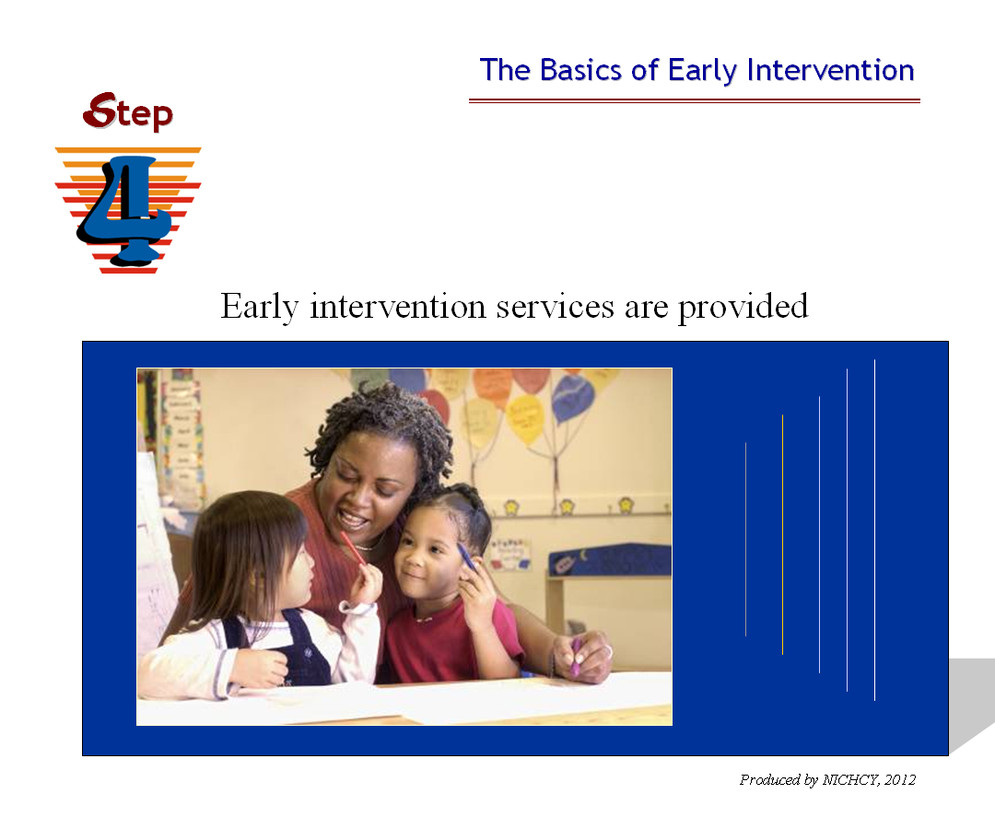
Text of slide………………………….
Step 4. Early intervention services are provided
End of slide…………………………

Slide operation: The slide loads automatically. No clicks are necessary except to advance to the next slide.

Pertinent Handouts
- Handout 3, Definition of Early Intervention Services
- Activity Sheet 1 (optional)

Once the IFSP is written, it is time to carry it out—in other words, to provide the infant or toddler (and family, as appropriate) with the early intervention services as listed in the IFSP. That’s what Step 4 is all about. There are two slides on this step.

This slide is quite short. It’s been purposefully abbreviated to allow you, as the trainer, to match the level of detail you offer about the provision of early intervention services to the roles, interests, and prior knowledge of your participants—and, of course, to juggle the constraints of limited training time.

The discussion below starts with a brief summary of Step 4 you can offer (for shorter trainings), and then delves into details (for more indepth training). Match the details you offer to your audience’s needs and the time available. Provide participants with Handout 3 as appropriate, where they’ll find the definition of early intervention services.
Summary Statements about Step 4

- Each early intervention service must be provided as soon as possible after the parent provides consent for that service. All States have included in their procedures timelines for the provision of EI services. Most have determined that early intervention services must begin no later than 30 days from when the parent consents to the services.

- Early intervention services are:

  - developmental services that are selected in collaboration with the parents (as part of writing the IFSP, see Step 3);

  - provided at no cost to the parents (except where the IDEA provides for a system of payments by families, including a schedule of sliding fees);

  - designed to meet the developmental needs of the eligible infant or toddler with a disability and the needs of the family to assist in the child’s development; and

  - provided by qualified personnel.

- Early intervention services are provided in the natural environment unless the IFSP team can justify that the EI services cannot be achieved satisfactorily in the natural environment. This decision is based on the unique needs of the child and not on what is convenient for the EI provider.

Note: Natural environments are “settings that are natural or typical for a same-aged infant or toddler without a disability” and may include the home or community settings. They are discussed on the next slide.

- Early intervention services are listed and defined in the Part C regulations at §303.13(b). These regulations appear on Handout 3. As participants should already know by now, the IFSP Team for a child determines what early intervention services are to be provided to the child and family, based on their unique needs and strengths. The team also determines (and documents in the IFSP) the length, duration, frequency, intensity, location, and method of delivering each early intervention service listed in the IFSP.

Types of services include, but aren’t limited to:

Assistive technology devices and services
Audiology
Family training, counseling, and home visits
Health services
Medical services (for diagnostic or evaluative purposes to help in determining the eligibility of the infant or toddler)
Nursing services
Nutrition services
Occupational therapy
Physical therapy
Psychological services
Service coordination services
Sign language and cued languages
Social work services
Special Instruction
Speech language pathology services
Transportation to access the other EI services and the related costs
Vision services
- Part C is a coordinated interagency system. Thus, EI services are to be coordinated across agencies. The federal Part C of IDEA funds are to be used as payor of last resort, so as not to replace existing funding that an infant or toddler with a disability and the family are entitled to. Therefore, when listing the EI services on the IFSP, the Part C regulations require that payment arrangements for each service be included on the IFSP.
Suggestions for Longer Training on EI Services
Perhaps you’d like to offer more detailed training on Step 4 to particular audiences. Here are a few suggestions for how to expand upon the summary statements just given.
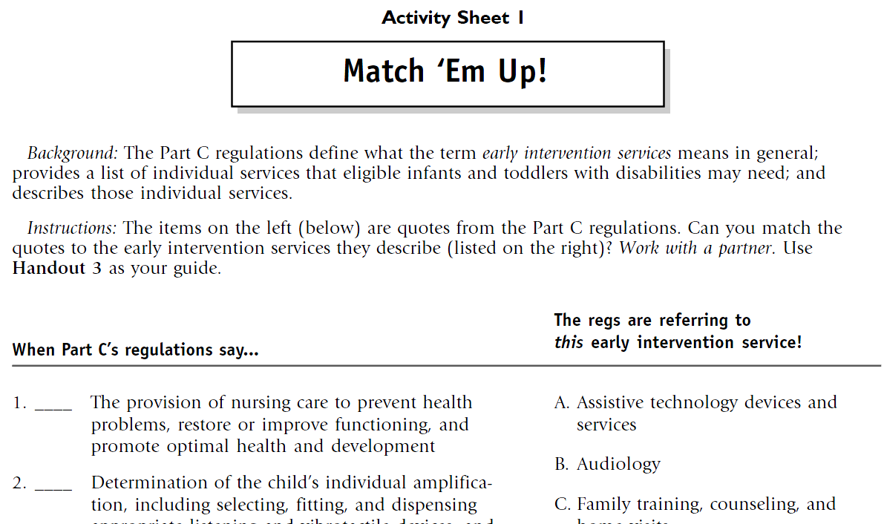
A—Engage the audience in an activity | Here’s a good spot to engage participants in an activity—either of your own devising or using Activity Sheet 1 that’s included in this module. Activities help participants blow off pent-up, sitting-too-long steam, and they promote greater learning through active engagement. Activity Sheet 1 asks participants to match quotes from the Part C regulations with the early intervention services they describe. Participants then check their work, using Handout 3 as their guide.
Note: Activity Sheet 1 is also used in the third slideshow in this module, which looks at key definitions in the Part C regulations. If you’re going to also provide this audience with training using that slideshow, you probably won’t want to do this activity now. But in the event that you do wish to use the activity now, here are the instructions—and the answers.
Instructions
1 | Refer participants to Activity Worksheet 1. Indicate that this is the activity sheet they have to complete, working with a partner and Handout 3.
2 | The worksheet has seven direct quotes from the definition of “early intervention services” at §303.13. Participants are to match each quote with the EI service it is describing, using the list of services in the right column. Indicate that participants will have 10 minuts to complete the worksheet.
3 | At the end of the time allotted, call the audience back to large-group focus.
4 | Take 5 minutes to go over their answers (answers are provided below) and their understanding of the scope and types of EI services specifically mentioned in the regulations. This is also a good opportunity to expand the discussion, highlighting specific EI services as you see fit, given the needs and interests of your audience.

Answers to Activity Worksheet
1 | F, nursing services
(The provision of nursing care to prevent health problems, restore or improve functioning, and promote optimal health and development)
2 | B, audiology services
(Determination of the child’s individual amplification, including selecting, fitting, and dispensing appropriate listening and vibrotactile devices, and evaluating the effectiveness of those devices)
3 | O, speech-language pathology services
(Provision of services for the habilitation, rehabilitation, or prevention of communication or language disorders and delays in development of communication skills)
4 | C, family training, counseling, and home visits
(Services provided, as appropriate, by social workers, psychologists, and other qualified personnel to assist the family of an infant or toddler with a disability in understanding the special needs of the child and enhancing the child’s development)
5 | K, service coordination services
(Assisting parents of infants and toddlers with disabilities in obtaining access to needed early intervention services and other services identified in the IFSP, including making referrals to providers for needed services and scheduling appointments for infants and toddlers with disabilities and their families)
6 | E, medical services
(Services provided by a licensed physician for diagnostic or evaluation purposes to determine a child's developmental status and need for early intervention services)
7 | D, health services
(Such services as clean intermittent catheterization, tracheostomy care, tube feeding, the changing of dressings or colostomy collection bags)
B—Go through the definition of “Early Intervention Services” | The Part C regulations provide a definition of early intervention services at at §303.13(b), and it’s substantial, with lots of areas to explore. Just consider the list of EI services given above. Look with participants at Handout 3 and go over how the individual services are, themselves, defined. Shape this scrutiny to any concerns or interests the audience might have that these Part C regulations address (e.g., addressing health care needs of an eligible infant or toddler).
C—Review how “service coordination services” are defined and what they include | The definition of service coordination services can be found on page 3 of Handout 3, at §303.34. For many audiences, especially parent audiences, this may be a topic of great relevance.

Slide 19 / Operation and Discussion: Step 4 (cont.) (Slide 2 of 2)
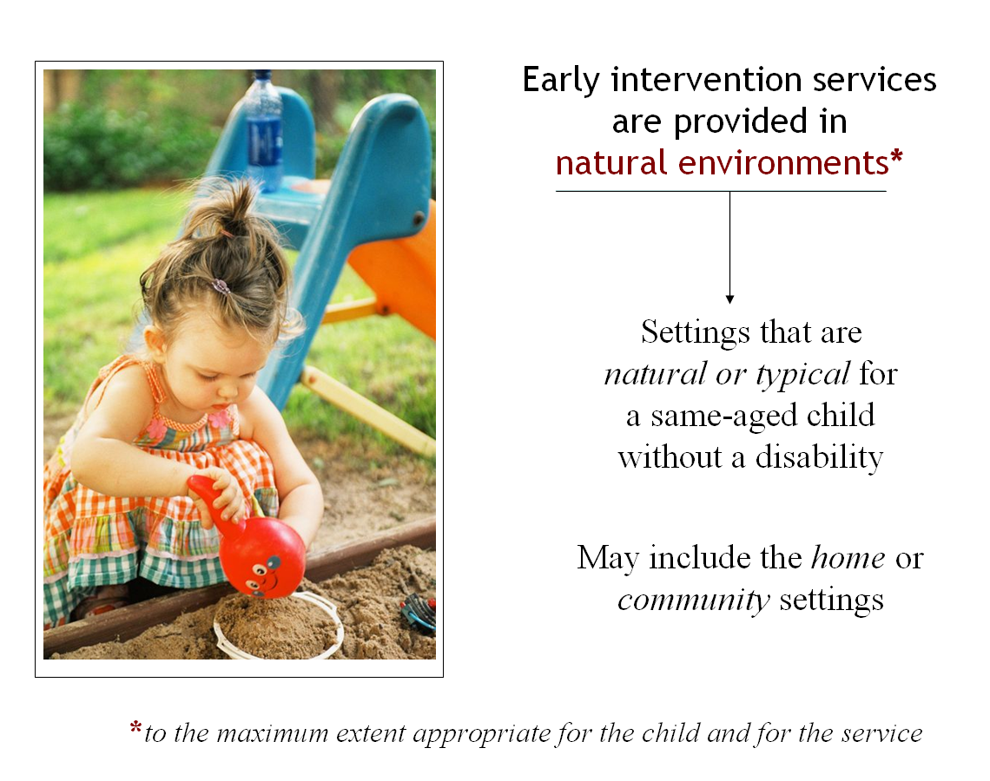
Text of slide…………………
Early intervention services are provided in
natural environments*

- Settings that are natural or typical for
a same-aged child without a disability

- May include the home or community settings

*to the maximum extent appropriate for the child and for the service
End of slide………………

Slide operation: The slide loads automatically. No clicks are necessary except to advance to the next slide.

Pertinent Handouts: none

It’s important to share with participants that early intervention services are to be provided in natural environments to the extent appropriate for the child and for the EI service itself. The meaning of “natural environments” is presented on the slide. Ask participants to name a few “natural environments” based on the meaning shown.
Related Points
While the slide can quickly be summarized, there are a few additional points to be made, as described below.
The individualized meaning of “natural environments” | The slide makes it clear that EI services are to be provided in natural environments—a term that must also be understood in light of what is natural for the child in question. An environment (setting) that’s natural for one child may not be typical or natural for another.
Who decides where? | The IFSP team determines the appropriate setting for providing EI services to a child or toddler. The determination that a service will not be provided in a natural environment may only be made “when early intervention services cannot be achieved satisfactorily in a natural environment.”
Based on what? | The IFSP team decides where each EI service will be provided based on the child’s outcomes that are identified by the team and listed in the IFSP.
Not in a natural environment? | If the IFSP Team determines that an early intervention service will be provided to a child in a setting that is not a natural environment, the team must include a justification as to why not in the child’s IFSP. Participants can see this for themselves on Handout 8—see page 3, at §303.344(d). The core of that provision requires that the IFSP must include:
…A statement that each early intervention service is provided in the natural environment for that child or service to the maximum extent appropriate … or… a justification as to why an early intervention service will not be provided in the natural environment.
An Interesting Analysis by the Department
We have to mention that we found the Department of Education’s discussion of natural environments in the Analysis of Comments and Changes very interesting—and illuminating. That’s why we’re sharing it with you below. While none of this may need to be shared with your audience of the moment, the Department’s comments may help you address questions or enrich discussion.
-----in a box------
On the Subject of Natural Environments
Observations from the U.S. Department of Education, 2011
On adding a list of community settings to the Part C regulations
It would not be appropriate or practicable to include a list of every setting that may be the natural environment for a particular child or those settings that may not be natural environments in these regulations. In some circumstances, a setting that is natural for one eligible child based on that child’s outcomes, family routines, or the nature of the service may not be natural for another child….[T]he decision about whether an environment is the natural environment is an individualized decision made by an infant’s or toddler’s IFSP Team, which includes the parent…
Are clinics, hospitals, or a service provider’s office “natural environments”?
We appreciate the commenters’ requests for clarification as to whether clinics, hospitals, or a service provider’s office may be considered the natural environment in cases when specialized instrumentation or equipment that cannot be transported to the home is needed.
Natural environments mean settings that are natural or typical for an infant or toddler without a disability….We do not believe that a clinic, hospital or service provider’s office is a natural environment for an infant or toddler without a disability; therefore, such a setting would not be natural for an infant or toddler with a disability.
However, §303.344(d)(1) requires that the identification of the early intervention service needed, as well as the appropriate setting for providing each service to an infant or toddler with a disability, be individualized decisions made by the IFSP Team based on that child’s unique needs, family routines, and developmental outcomes. If a determination is made by the IFSP Team that, based on a review of all relevant information regarding the unique needs of the child, the child cannot satisfactorily achieve the identified early intervention outcomes in natural environments, then services could be provided in another environment (e.g. clinic, hospital, service provider’s office). In such cases, a justification must be included in the IFSP…
----end box------
Slide 20 / Operation and Discussion: Step 5
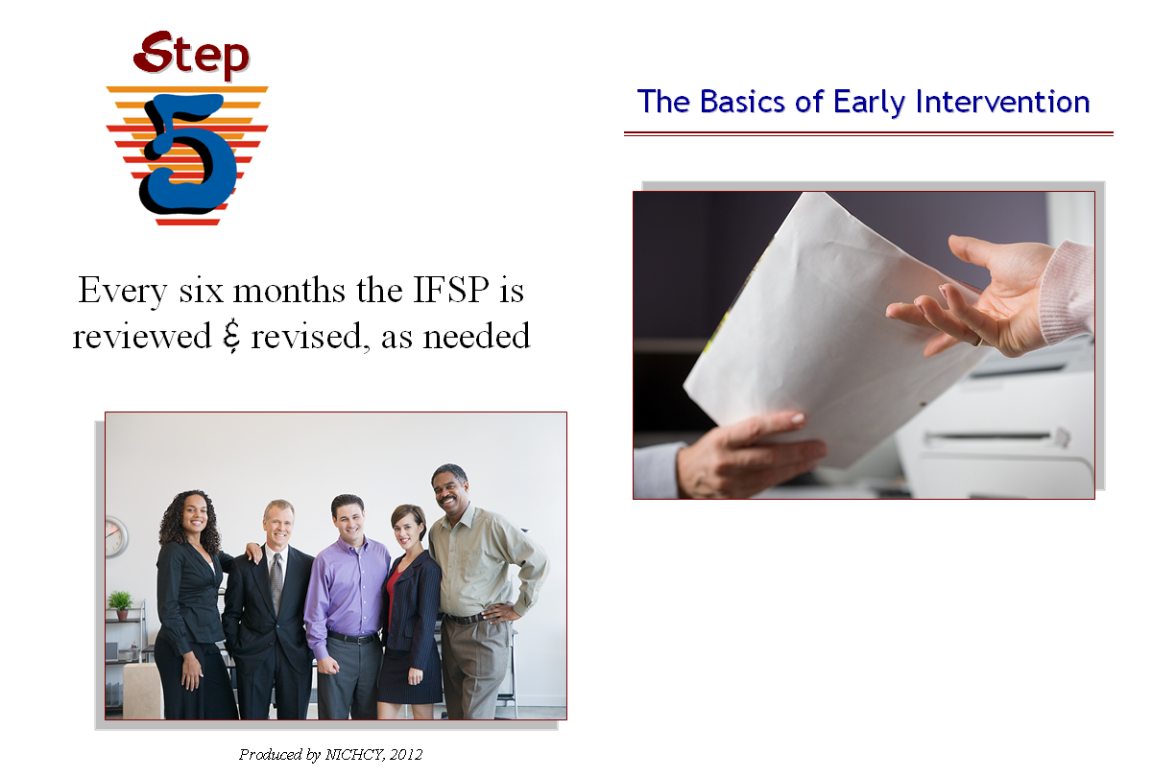
Text of slide……………………………
Step 5.
Every six months the IFSP is reviewed
& revised, as needed

End of slide………………………………

Slide operation: The slide loads automatically. No clicks are necessary except to advance to the next slide.

Pertinent Handouts: Handout 1, Basics of the Early Intervention Process under Part C of IDEA
Handout 8, The IFSP

Given how rapidly very young children can change and grow—and how critical the early years are to learning—it’s not surprising that IDEA would require a child’s IFSP to be reviewed at least every six months. IDEA calls this a “periodic review” and expressly permits that the IFSP can be reviewed more often if conditions warrant or if the family asks for such a review.
The relevant Part C regulations appear at §303.342(b) and on page 1 of Handout 8. They read:
(b) Periodic review. (1) A review of the IFSP for a child and the child’s family must be conducted every six months, or more frequently if conditions warrant, or if the family requests such a review. The purpose of the periodic review is to determine—
(i) The degree to which progress toward achieving the results or outcomes identified in the IFSP is being made; and
(ii) Whether modification or revision of the results, outcomes, or early intervention services identified in the IFSP is necessary.
(2) The review may be carried out by a meeting or by another means that is acceptable to the parents and other participants. [§303.342(b)]
Discussing the Slide
As with other slides, you can either state the obvious (what’s on the slide) and move on, or add details as you wish. The discussion below highlights additional points that can be made.
Who attends the periodic review? | According to the Part C regulations, the following individuals are part of the periodic IFSP review:
- the parent or parents of the child;
- other family members, as requested by the parent (if feasible);
- an advocate or person outside the family, if requested by the parent; and
- the service coordinator.
If conditions warrant, provisions must also be made for the participation of others on the IFSP Team—specifically, the person (or persons) directly involved in conducting the evaluations and assessments of the child and/or family, and people who are (or will be) providing EI services to the child or family.
Requirements for the meeting | As with the initial IFSP meeting (and the annual one, discussed on the next slide as Step 6), accessibility and convenience of the meeting are important. Key points here include the following:
- Meetings must be held in settings and at times that are convenient to the family.
- Meetings must also be held in the native language of the family (or other mode of communication used by the family), unless it’s clearly not feasible to do so.
- Prior written notice must be provided to the family and other participants early enough before the meeting to ensure that they will be able to attend.
Meeting by other means? | The regulations cited above indicate that the periodic IFSP review may be carried out by “another means that is acceptable to the parents and other participants.” What might that be? The regulations don’t say, at least with respect to the periodic review meeting. Speaking of the initial and annual meetings, the regulations require that, should one of the required participants in the meeting not be able to attend, arrangements must be made for the person’s involvement through other means, including one of the following:
- participating in a telephone conference call;
- having a knowledgeable authorized representative attend the meeting; or
- making pertinent records available at the meeting.

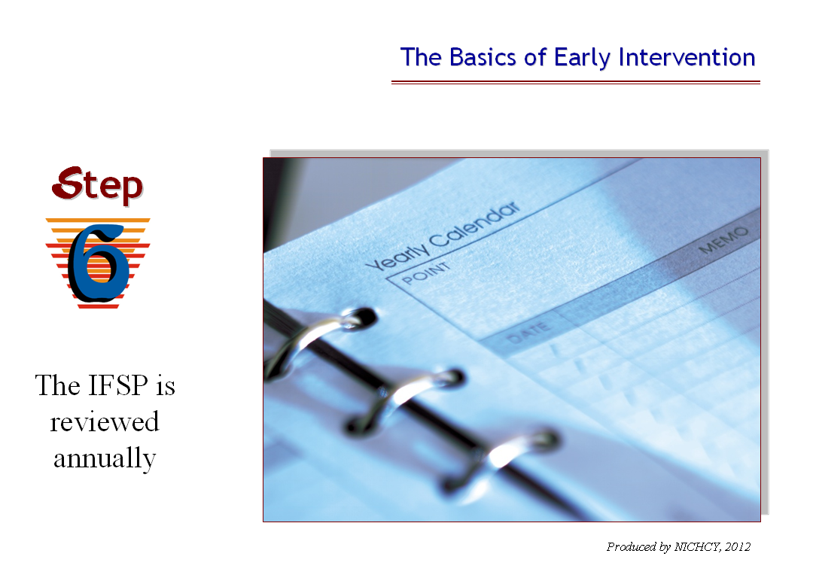
Slide 21 / Operation and Discussion: Step 6
Text of slide……………………………
Step 6.
The IFSP is reviewed annually

End of slide…………………………

Slide operation: The slide loads automatically.
No clicks are necessary except to advance to the next slide.

Pertinent Handouts:
- Handout 1, Basics of the Early Intervention Process under Part C of IDEA
- Handout 8, the IFSP

An annual review of the IFSP is also required. Children can change so quickly at this age that it’s critical to keep a close eye on a child’s progress and development—or lack thereof. Ongoing assessments of the infant or toddler would be conducted to determine how the child is progressing toward meeting the outcomes specified in the IFSP. The results of those assessments must be used in determining whether the IFSP needs to be revised and what early intervention services are needed and will be provided.
(c) Annual meeting to evaluate the IFSP. A meeting must be conducted on at least an annual basis to evaluate and revise, as appropriate, the IFSP for a child and the child’s family. The results of any current evaluations and other information available from the assessments of the child and family conducted under §303.321 must be used in determining the early intervention services that are needed and will be provided.
Similarities to the Initial IFSP Meeting and the Periodic Review Meeting
Not surprisingly, there are numerous requirements that are the same between the initial IFSP meeting, the periodic review meeting that occurs at six months (or as conditions warrant), and the annual review of the IFSP. You might ask participants to name a few requirements that they suspect would be the same between these meetings. Answers would include:
- required participants;
- accessibility and convenience of the meeting;
- prior written notice to parents;
- use of the parent’s native language or other mode of communication, unless it’s clearly not feasible to do so;
- ensuring that the IFSP is fully explained to parents;
- parental consent to implement the IFSP; and
- providing the EI services as soon as possible after the parent has provided consent.

Slide 22 / Operation and Discussion: Step 7 (Slide 1 of 3)
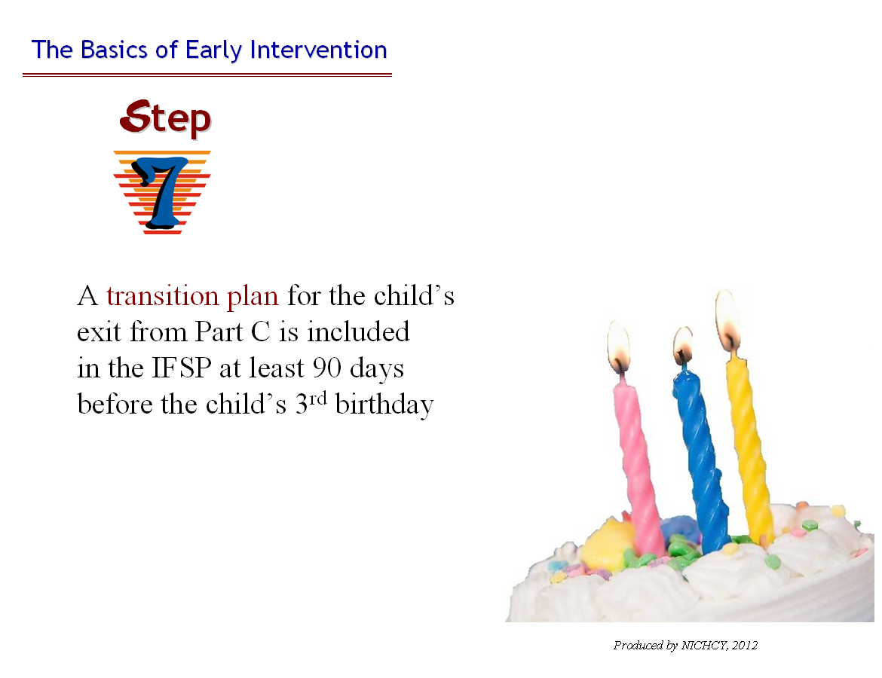
Text of slide………………………………………
Step 7.
A transition plan for the child’s exit from Part C is included in the IFSP at least 90 days before the child’s 3rd birthday
End of slide……………………………………

Slide operation: The slide loads automatically.
No clicks are necessary except to advance to the next slide.

Pertinent Handouts:
- Handout 1, Basics of the Early Intervention Process under Part C of IDEA
- Handout 8, the IFSP

Slide 22 introduces the topic of what’s commonly referred to as “transition planning” and the need to plan ahead for the child’s exit from Part C services to his or her next program. It’s the first of three slides on the topic. You’ll notice the birthday candles on the cake. How many? Three. As the child approaches his or her third birthday, the bell rings to begin making a concrete plan for that child’s transition.

Key Points of This Slide
The slide’s text shows that there are multiple aspects to transition planning that are noteworthy. For the purposes of this overview of early intervention, consider highlighting the following:

- Early intervention services under Part C typically end upon a child’s third birthday.
- It’s important that children make a smooth transition from Part C to their next program or setting. Research has certainly documented that transitions can be emotional and difficult for children and for families. The transition is easier and less chaotic when options have been considered ahead of time and planned for.
- As children approach their third birthday, transition planning must take place.
- A transition plan is developed and must be included in the child’s IFSP at least 90 days before the child turns three.
- The transition plan is part of the IFSP, not a separate document.
Details on the Fly
Part C’s transition requirements can be a bit tricky to summarize, because basically they divide out in three ways:
- what’s required for all exiting toddlers;
- what’s required for toddlers who are potentially eligible for preschool services under Part B of IDEA; and
- what’s required for toddlers who are not potentially eligible for Part B services.

Given that this module is an overview of early intervention, it’s probably not necessary to go into this level of detail with participants. The full story can be found in Modules 12 and 13, both of which address transition planning requirements. However, here are salient points for clarity (see the relevant regulations cited in the box below):

All toddlers | This slide refers to what’s required for all exiting toddlers, irrespective of their potential eligibility for preschool services under Part B. Each toddler about to exit Part C services must have a transition plan in the IFSP at least 90 days before the third birthday.

Transition planning may begin earlier | Transition planning for a child may begin up to 9 months before the child’s third birthday, at the discretion of all parties.

The family is involved in planning | The regulations are very clear on this point—families are to be involved in the writing of their child’s (and family’s) transition plan.

What’s included in the transition plan? | As appropriate to the child and family, the transition plan will include:
- steps for the toddler and family to exit from the Part C program;
- any transition services that the IFSP Team identifies as needed by the toddler and family.

Where does the child go next? | Part of transition planning includes reviewing program options for the child. To what program or setting will the child move next? This is the subject of the next slide.

Parental consent | Parental consent is needed before the lead agency may implement the transition plan.

----in a box-----
Relevant Transition Regulations

§303.209 Transition to preschool and other programs.
(a)…
(b)…
(c)…
(d) Transition plan. The State lead agency must ensure that for all toddlers with disabilities—
(1)(i) It reviews the program options for the toddler with a disability for the period from the toddler's third birthday through the remainder of the school year; and
(ii) Each family of a toddler with a disability who is served under this part is included in the development of the transition plan required under this section and §303.344(h);
(2) It establishes a transition plan in the IFSP not fewer than 90 days--and, at the discretion of all parties, not more than 9 months--before the toddler’s third birthday; and
(3) The transition plan in the IFSP includes, consistent with §303.344(h), as appropriate—
(i) Steps for the toddler with a disability and his or her family to exit from the Part C program; and
(ii) Any transition services that the IFSP Team identifies as needed by that toddler and his or her family.
(e) Transition conference and meeting to develop transition plan. Any conference conducted under paragraph (c) of this section or meeting to develop the transition plan under paragraph (d) of this section (which conference and meeting may be combined into one meeting) must meet the requirements in §§303.342(d) and (e) and 303.343(a).
(f) Applicability of transition requirements. (1) The transition requirements in paragraphs (b)(1)(i) and (b)(1)(ii), (c)(1), and (d) of this section apply to all toddlers with disabilities receiving services under this part before those toddlers turn age three, including any toddler with a disability under the age of three who is served by a State that offers services under §303.211.
----end box----
Slide 23 / Operation and Discussion: Step 7 (cont.) (Slide 2 of 3)
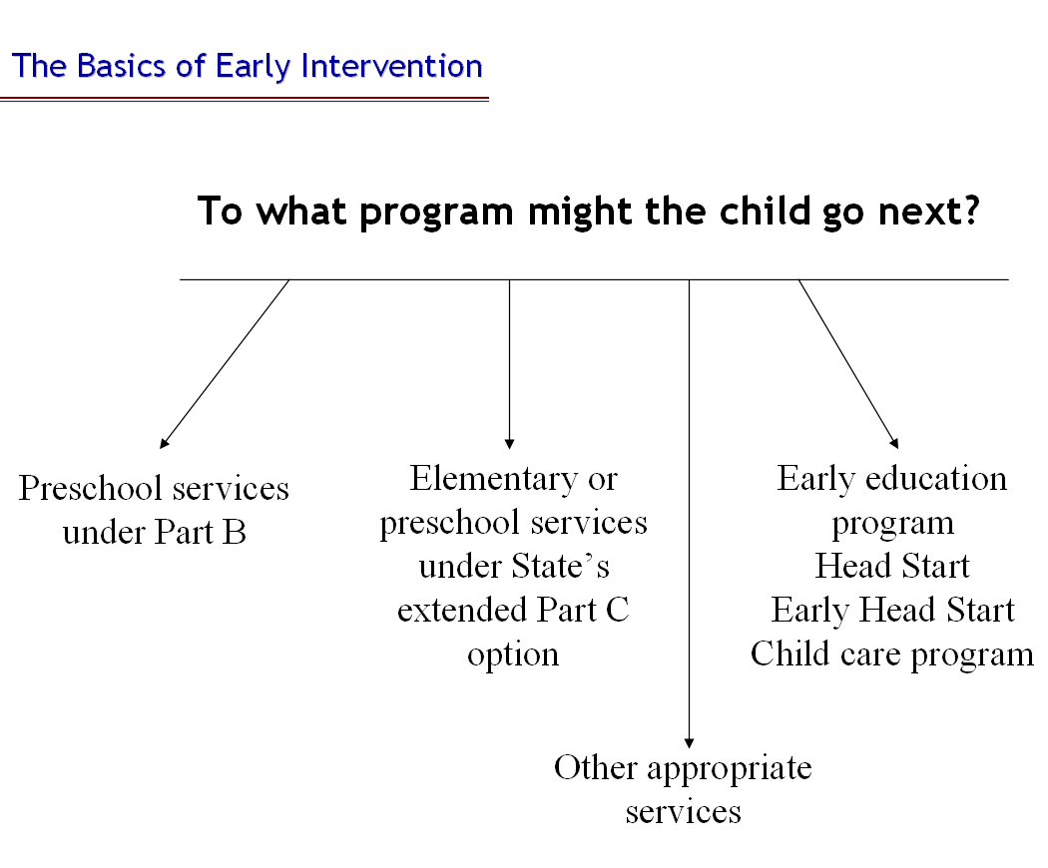
Text of slide…………………………
To what program might the child go next?

- Preschool services under Part B
- Elementary or preschool services under State’s extended Part C option
- Early education program, Head Start, Early Head Start, or child care program
- Other appropriate services

End of slide……………………………

Slide operation: The slide loads automatically. No clicks are necessary except to advance to the next slide.
Pertinent Handouts
- none

Slide 23 presents several program options to which a transitioning toddler might go upon exiting Part C. These include exiting to:

- preschool services under Part B of the Act (for children who are eligible for services under Part B);
- elementary school or preschool services for children participating under a State’s extended Part C option to provide early intervention services to children ages three and older;
- early education, Head Start, and Early Head Start or child care programs; or
- other appropriate services.

The IFSP must include steps to support the child’s transition to the program option selected by the child’s IFSP Team. As the Department notes, the transition steps appropriate for a given toddler with a disability will differ depending upon which program the IFSP Team selects.
The Extended Part C Option
States have the option to extend Part C services beyond children’s third birthday. Not all States offer this option. However, if a toddler lives in a State that does offer the Part C extension option, then the toddler could remain in Part C past age three—and, depending on the State’s policies regarding this option, through the age of entering kindergarten. Thus, staying in Part C becomes one of the program options available to the child and family, which is why it’s listed on the slide.

The extended Part C option and how it affects transition planning are beyond the scope of this introductory module. More information is available in Modules 12 and 13, which focus in detail on transition planning requirements.

---in a box----
Relevant Regulations

(h) Transition from Part C services. (1) The IFSP must include the steps and services to be taken to support the smooth transition of the child, in accordance with §§303.209 and 303.211(b)(6), from Part C services to—
(i) Preschool services under Part B of the Act, to the extent that those services are appropriate;
(ii) Part C services under §303.211; or
(iii) Other appropriate services.
(2) The steps required in paragraph (h)(1) of this section must include--
(i) Discussions with, and training of, parents, as appropriate, regarding future placements and other matters related to the child’s transition;
(ii) Procedures to prepare the child for changes in service delivery, including steps to help the child adjust to, and function in, a new setting;
(iii) …
(iv) Identification of transition services and other activities that the IFSP Team determines are necessary to support the transition of the child.
---end box----

Slide 24 / Operation and Discussion: Step 7 (cont.) (Slide 3 of 3)
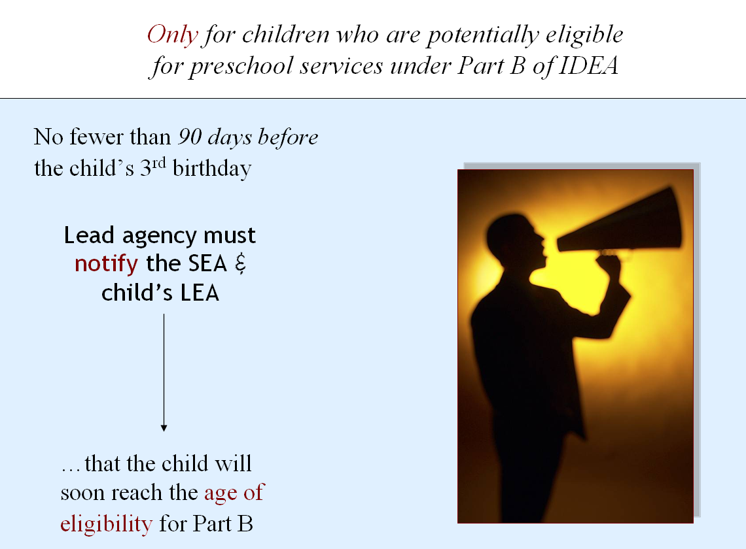
Text of slide……………………………………….
Only for children who are potentially eligible
for preschool services under Part B of IDEA

No fewer than 90 days before the child’s 3rd birthday
Lead agency must notify the SEA & child’s LEA

…that the child will soon reach the age of eligibility for Part B
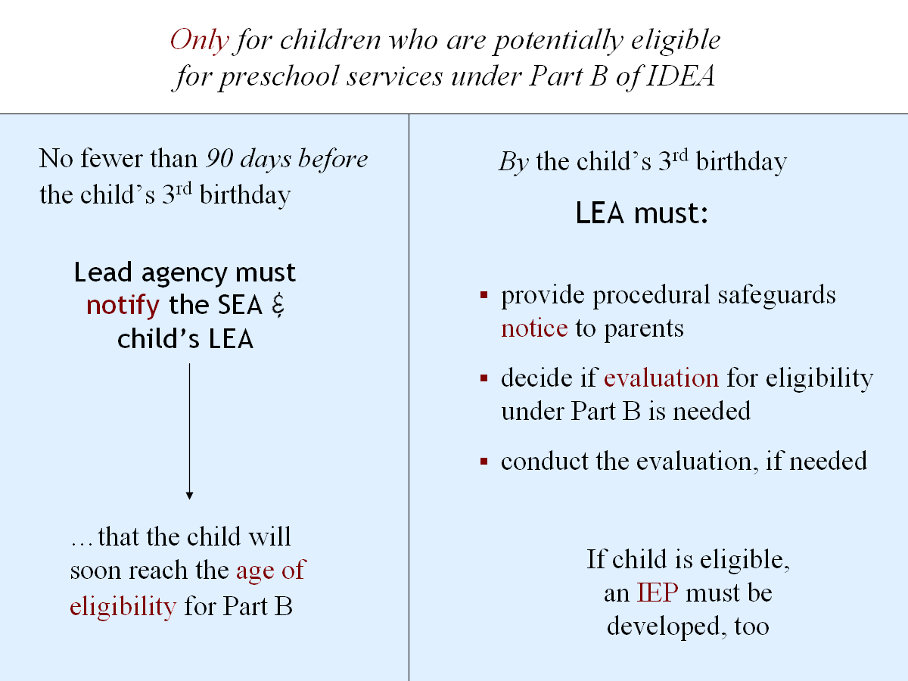
By the child’s 3rd birthday
LEA must:
- provide procedural safeguards notice to parents
- decide if evaluation for eligibility under Part B is needed
- conduct the evaluation, if it’s needed

If child is eligible, an IEP must be developed, too

End of slide……………………………

Slide operation: The slide loads with the view shown in the top screen shot. Click 1: The picture lifts away and the text beneath is displayed. Click again to advance to the next slide.

Pertinent Handouts
- none

Slide 24 takes up what happens, transition-planning-wise, for children who are potentially eligible for preschool services under Part B of IDEA. Specific additional steps are required for such toddlers about to leave Part C. You’ll find Part C’s relevant regulations in the box at the end of this slide.
Note that these steps do not apply to children who are not potentially eligible for Part B.

A Bit about Part B
Under Part B of IDEA, special education and related services are made available to address the unique needs of eligible children with disabilities. These include preschool services under Section 619 of IDEA for children ages 3-5.
Part B is typically administered at the State level by the State educational agency, or SEA. Local educational agencies (LEAs) are responsible for ensuring that special education and related services are made available to eligible children through the public school system in the area they serve. Where a child lives in the State determines which LEA is responsible for that child educationally.
How This Relates to Transition Planning
If a toddler about to exit Part C may be potentially eligible for preschool services under Part B, then the LEA serving the area where the child resides must become involved in the transition planning process for that child. The LEA has specific obligations and responsibilities, as shown on the slide and discussed further below.
How Does the LEA Know?
The slide also shows how the LEA finds out that a toddler in its jurisdiction will soon be exiting Part C and may be potentially eligible for Part B. In a nutshell, the State’s lead agency for early interventioni notifies the LEA. The notification also goes to the SEA, which is ultimately responsible throughout the State for the Part B program. The notification to the SEA and child’s LEA must occur not less than 90 days before the child’s third birthday.
What Information is Shared?
The notification the lead agency provides to the SEA and the child’s LEA indicates that the child will soon be reaching the age of eligibility for Part B services (age three) and that the child is potentially eligible for those services. The notification includes:
- the child’s name and date of birth,
- where the child resides, and
- parent contact information (including parents’ names, addresses, and telephone numbers).
The child’s IFSP must then include confirmation that this basic child find information about the child has been transmitted to the LEA. With parental consent (if required), additional information about the child may be transmitted to the LEA as well “to ensure continuity of services from the Part C program to the Part B program, including a copy of the most recent evaluation and assessments of the child and the family and most recent IFSP.”
How Does the LEA Respond?
In essence, the child has just been referred to the Part B program, which triggers specific obligations for the LEA. As the slide summarizes, primary among these are:
- participating in the transition conference the lead agency will hold (with family approval) to develop the child’s transition plan;
- providing parents with the procedural safeguards notice for Part B, which explains all of the safeguards available to the parents under Part B; and
- deciding whether or not the child needs to be evaluated to determine his or her eligibility for Part B services.
If the LEA decides that an evaluation of the child is needed, it must conduct that evaluation (parental consent required) and determine the child’s eligibility for Part B. If the child is found eligible, then the LEA must also ensure that an Individualized Education Program (IEP) is developed for the child.
All by the child’s third birthday.
Given the timelines associated with completing each of those tasks, it’s not surprising that the Department observes: “[T]he 90-day period prior to the toddler’s third birthday is the minimal time period necessary for an LEA to meet its responsibilities…” [emphasis added]. It’s also not surprising that in many States transition planning actually begins much earlier than 90 days before the toddler’s third birthday.
We’re done with Step 7. Let’s run to the last step!
----in a box----
Relevant Part C Regulations

§303.209 Transition to preschool and other programs.
(a)…
(b) Notification to the SEA and appropriate LEA. (1) The State lead agency must ensure that—
(i) Subject to paragraph (b)(2) of this section, not fewer than 90 days before the third birthday of the toddler with a disability if that toddler may be eligible for preschool services under Part B of the Act, the lead agency notifies the SEA and the LEA for the area in which the toddler resides that the toddler on his or her third birthday will reach the age of eligibility for services under Part B of the Act, as determined in accordance with State law…
(ii)…
(iii)…
(2) The State must ensure that the notification required under paragraphs (b)(1)(i) and (b)(1)(ii) of this section is consistent with any policy that the State has adopted, under §303.401(e), permitting a parent to object to disclosure of personally identifiable information.
----end box------
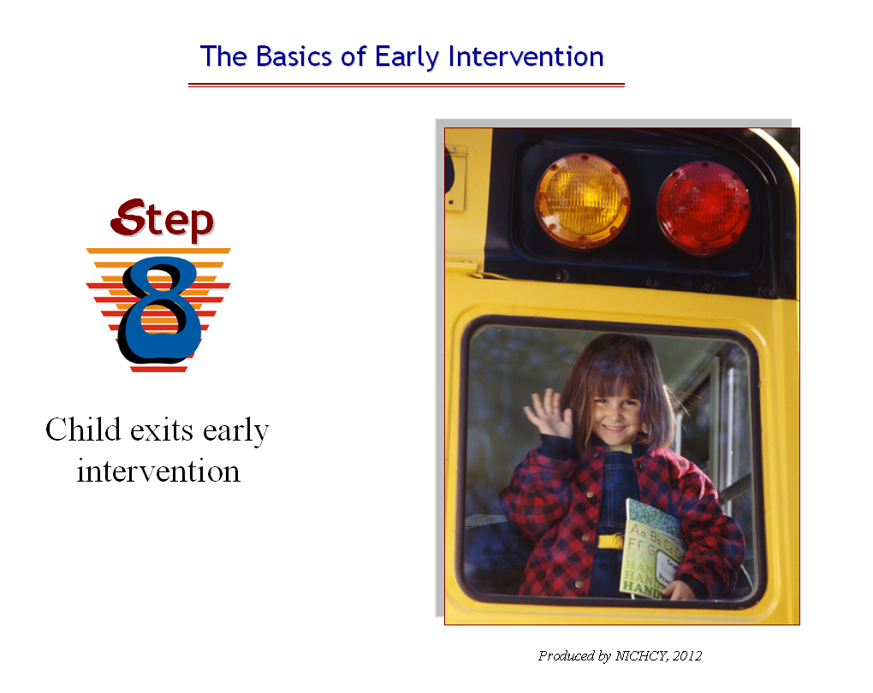
Slide 25 / Operation and Discussion: Step 8
Text of slide……………………………….
Step 8. Child exits early intervention

End of slide…………………

Slide operation: The slide loads automatically.
No clicks are necessary except to advance to the next slide.

Pertinent Handouts
- Handout 1, Basics of the Early Intervention Process under Part C of IDEA

Well, you’ve come to the last step, when the child leaves early intervention services and takes the big step into another program or setting. Hopefully, the child and family’s transition has been well planned, and the exit is a smooth one for all concerned.

Slide 26/ Operation and Discussion: Last Slide

Text of slide………………
Round-up Time!
End of slide………
Use this slide for a review and recap of your own devising, open the floor up for a question and answer period, or have participants complete Activity Sheet 2 (described below) and discuss in the large group afterwards. Emphasize the local or personal application of the information presented here.
Concluding Section 1 of Training Module
You’ve come to the end of Section 1 of the 8 basic steps in early intervention.
- Section 2 of this training module (in a separate slideshow and trainer’s guide) looks at seven EI acronyms everyone should know.
- Section 3 is for your hardiest of trainees, because it looks in depth at nine key definitions in early intervention. Section 3 is also addressed through a separate slideshow and trainer’s guide.
This module is designed in these three parts to give you flexibility in introducing early intervention to different audiences with different training needs.

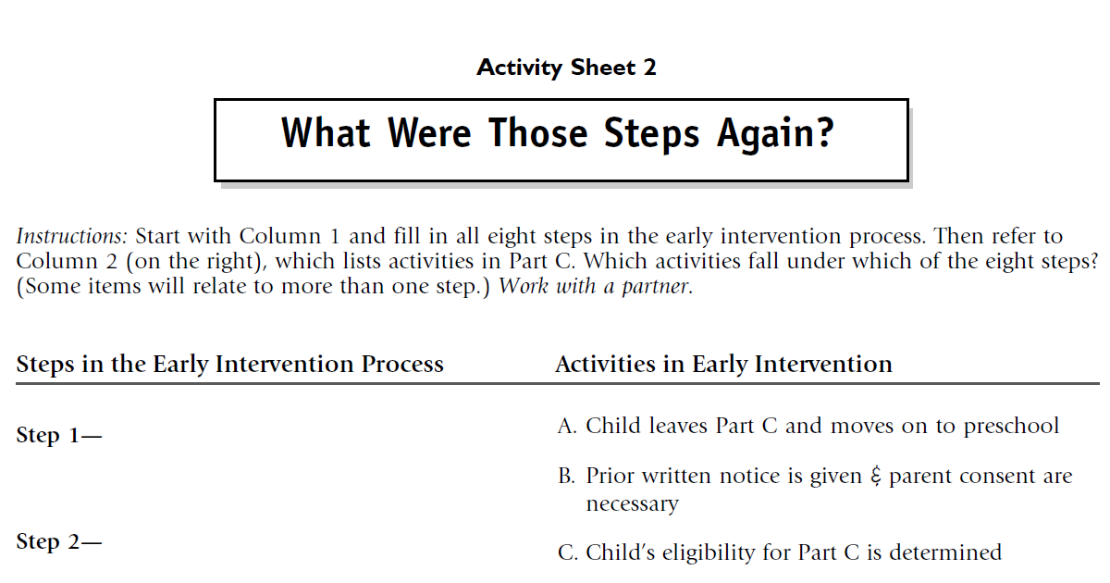
Closing Activity
Total Time Activity Takes: 10-15 minutes.
Group Size: Work in pairs.
Materials:
Activity Sheet 2
Instructions
Refer participants to Activity Sheet 2. Indicate that this is the activity sheet they have to complete. They will have 5 minutes to work with a partner.
Give the pairs 5-10 minutes to complete the activity sheet, then call the audience back to large-group focus.
Go through the steps on the left of the worksheet and have participants call out what items from the right they placed under the specific steps. You can use this time to clarify aspects of the training, should there be confusion. Suggested answers are given below.
Step 1 | An infant or toddler may have a developmental delay or disability. Concerned, someone refers child to Part C.
Suggested answers: D
D. Someone worries that an infant or toddler may have a delay and refers the child to the Part C system
Step 2 | The infant or toddler is evaluated to determine eligibility
Suggested answers: B, J
B. Prior written notice is given & parent consent must be obtained to evaluate the child.
J. Evaluation, assessment and initial IFSP meeting take place within 45 days.
Step 3 | Initial IFSP meeting is held, and the initial IFSP is written.
Suggested answers: E, H, J
E. IFSP Team, which includes the parent, meets to identify the needed EI services
H. IFSP meeting is held & IFSP is written by the IFSP Team, which includes the parent
J. Evaluation, assessment and initial IFSP meeting take place within 45 days
Step 4 | Early intervention services are provided.
Suggested answers: I. Early intervention services identified by the IFSP Team are provided
Step 5 | Every six months the IFSP is reviewed & revised, as needed.
Suggested answers: G
G. This happens every six months.
Step 6 | The IFSP is reviewed annually.
Suggested answers: E, H
E. IFSP Team, which includes the parent, meets to identify the needed EI services.
H. IFSP meeting is held & IFSP is written by the IFSP Team, which includes the parent.
Step 7 | A transition plan for the child’s exit from Part C is included in the IFSP at least 90 days before the child’s 3rd birthday.
Suggested answers: C, F, K, L
C. Lead agency may notify the SEA & child’s LEA as child approaches 3rd birthday.
F. The timeline is at least 90 days before the child’s 3rd birthday.
K. Transition plan is written.
L. A transition conference is held with the child’s LEA if the child is potentially eligible under Part B.
Step 8 | Child exits early intervention.
Suggested answers: A
A. Child leaves Part C and moves on to preschool, or other programs, as appropriate.

Update, February 2014: This training curriculum is designed and produced by NICHCY, the National Dissemination Center for Children with Disabilities, at the request of our funder, the Office of Special Education Programs (OSEP) at the U.S. Department of Education, and through Cooperative Agreement #H326N110002 between FHI 360 and OSEP.
NICHCY Lead: Lisa Küpper
OSEP Lead: Rhonda Spence
OGC Lead: Kala Surprenant
Although funding for NICHCY has officially ended except for completing the Part C training curriculum, its rich website (including these training materials) will remain online until September 30, 2014. Thereafter, all training materials in this Part C training curriculum will be made available at the website of the Center for Parent Information and Resources, at:
http://www.parentcenterhub.org/repository/legacy-partc/

U.S. Department of Education. (2011, September 28). Early intervention program for infants and toddlers with disabilities: Rules and regulations. Federal Register, 76(188), 60140- 60309. Washington, DC: Office of Special Education and Rehabilitative Services, Department of Education. Online at: http://www.gpo.gov/fdsys/pkg/FR-2011-09-28/pdf/2011-22783.pdf
Data Accountability Center. (2012, September). Number of infants and toddlers ages birth through 2 and 3 and older, and percentage of population, receiving early intervention services under IDEA, Part C, by age and state: Fall 2011 [Table C1-1]. Retrieved October 5, 2012, from: https://www.ideadata.org/TABLES35TH/C1-1.xls
National Dissemination Center for Children with Disabilities. (2011, September). Overview of early intervention. Washington, DC: Author. Online at: http://www.parentcenterhub.org/repository/ei-overview/
§303.13(b)(3) of the Part C regulations.
Findings of Congress as stated in Public Law 99-457 (1986). P.L 99-457 is the statute of the Education of the Handicapped Act Amendments of 1986, passed by Congress on October 8, 1986. Available online at: http://www.eric.ed.gov/PDFS/ED314927.pdf
Findings of Congress as stated in Public Law 108-446 (2004). P.L. 108-446 is the Individuals with Disabilities Education Improvement Act of 2004, passed by Congress on December 3, 2004. Available online at: http://www.parentcenterhub.org/wp-content/uploads/repo_items/PL108-446.pdf
National Early Childhood Technical Assistance Center. (n.d.). Overview to the Part C program under IDEA. Chapel Hill, NC: Author. Online at: http://www.nectac.org/partc/partc.asp#overview
National Early Childhood Technical Assistance Center. (n.d.). Overview to the Part C program under IDEA. Chapel Hill, NC: Author. Online at: http://www.nectac.org/partc/partc.asp#overview
? U.S. Department of Education. (2011). Department of Education fiscal year 2011 Congressional action. Washington, DC: Author. Online at: http://www2.ed.gov/about/overview/budget/budget11/11action.pdf
§303.13(a)(4)—Definition of early intervention services.
Centers for Disease Control and Prevention. (2011, October). Infant health. Atlanta, GA: Author. Online at: http://www.cdc.gov/nchs/fastats/infant_health.htm
Centers for Disease Control and Prevention. (2011, October). Infant health. Atlanta, GA: Author.
Centers for Disease Control and Prevention. (2011, August). Fetal alcohol spectrum disorders: Data and statistics in the United States. Atlanta, GA: Author. Online at: http://www.cdc.gov/ncbddd/fasd/data.html
Centers for Disease Control and Prevention. (2010, October). Facts about FASDs. Atlanta, GA: Author. Online at: http://www.cdc.gov/ncbddd/fasd/facts.html
Centers for Disease Control and Prevention. (2011, September). Birth defects: Data and statistics in the United States. Atlanta, GA: Author. Online at: http://www.cdc.gov/ncbddd/birthdefects/data.html
Data Accountability Center. (2012, September). Number of infants and toddlers ages birth through 2 and 3 and older, and percentage of population, receiving early intervention services under IDEA, Part C, by age and state: Fall 2011 [Table C1-1]. Retrieved October 5, 2012, from: https://www.ideadata.org/TABLES35TH/C1-1.xls
National Early Childhood Technical Assistance Center (NECTAC). (2011, July). The importance of early intervention for infants and toddlers with disabilities and their families. Chapel Hill, NC: Author. Online at: http://www.nectac.org/~pdfs/pubs/importanceofearlyintervention.pdf
Individuals with Disabilities Education Improvement Act of 2004, Pub. L. no. 108–446, 117 Stat 118 (2004). [Quotation is from Sec. 631(a)(1), Findings and policy.] Online at: http://www.parentcenterhub.org/wp-content/uploads/repo_items/PL108-446.pdf
“Diagnosed physical or mental conditions” include “genetic or congenital disorders; sensory impairments; inborn errors of metabolism; disorders reflecting disturbance of the development of the nervous system; congenital infections; severe attachment disorders; and disorders secondary to exposure to toxic substances, including fetal alcohol syndrome” [§303.21(a)(2)(ii)]
§303.301(b)—Public awareness program—information for parents: Information to be provided.
§303.302(b)(1)—Comprehensive child find system: Scope of child find.
See the Part C regulations at §303.301(a)(1)(ii).
§303.303(c)(3)—Referral procedures: Primary referral sources.
§303.421(a)—Prior written notice and procedural safeguards notice: General.
§303.421(b)—Prior written notice and procedural safeguards notice: Content of notice.
303.421(c)(1)—Prior written notice and procedural safeguards notice: Native language.
303.421(c)(2)—Prior written notice and procedural safeguards notice: Native language.
§303.320(a)(3)—Screening procedures (optional).
§303.21(a)(2)(i)—Infant or toddler with a disability.
The five developmental areas are: cognitive development; physical development, including vision and hearing; communication development; social or emotional development; and adaptive development.
§303.321(b)—Evaluation of the child and assessment of the child and family: Procedures for evaluation of the child.
§303.25(a)(2)—Native language. Also, §303.321(a)(4) and (5)—Evaluation of the child and assessment of the child and family: General.
§303.321(c)(2)—Evaluation of the child and assessment of the child and family: Procedures for assessment of the child and family.
§303.111—State definition of developmental delay.
See the Centers for Disease Control and Prevention (CDC) website pages called Developmental Milestones, which begin at: http://www.cdc.gov/ncbddd/actearly/milestones/index.html
Encyclopedia of Children’s Health. (). Development tests. Retrieved March 8, 2012 from: http://www.healthofchildren.com/D/Development-Tests.html
See the Centers for Disease Control and Prevention (CDC) website pages called Developmental Milestones, which begin at: http://www.cdc.gov/ncbddd/actearly/milestones/index.html
Parlakian, R., & Lerner, C. (2008). Your child’s development: 30 to 36 months. Washington, DC: Zero to Three. http://main.zerotothree.org/site/DocServer/30-36Handout.pdf?docID=6085
Zero to Three. (n.d.). Development of social-emotional skills. Retrieved March 8, 2012 from: http://www.zerotothree.org/child-development/social-emotional-development/social-emotional-development.html
See the Centers for Disease Control and Prevention (CDC) website pages called Developmental Milestones, which begin at: http://www.cdc.gov/ncbddd/actearly/milestones/index.html
Para-eLink. (n.d.). Development of adaptive behavior. Retrieved March 8, 2012 from the Para-eLink website: http://paraelink.org/eck1/eck1_6.html
§303.111—State definition of developmental delay.
Shackelford, J. (2006, July). State and jurisdictional eligibility definitions for infants and toddlers with disabilities under IDEA. NECTAC Notes, 21, 1-16. Available online at: http://www.nectac.org/~pdfs/pubs/nnotes21.pdf
Shackelford, J. (2006, July). State and jurisdictional eligibility definitions for infants and toddlers with disabilities under IDEA. NECTAC Notes, 21, 1-16. Quote from page 3.
Missouri Department of Elementary and Secondary Education. (2011, January). Missouri state plan for special education: Regulations implementing Part C of the Individuals with Disabilities Education Act First Steps program. Jefferson County, MO: Author. See page 16. Retrieved March 8, 2012 from: http://dese.mo.gov/schoollaw/rulesregs/documents/PartCStatePlan-Jan2011.pdf
§303.321(a)(3)(ii)—Evaluation of the child and assessment of the child and family: General.
76 Fed. Reg. at 60199.
§303.26 Natural environments.
§303.344(d)(1)(iv)—Content of an IFSP: Early intervention services.
See §303.126(b).
As stated at §303.344(d)(1)(ii)(B)(2).
Quotation from pages 60157-60158 of: U.S. Department of Education. (2011, September 28). Early intervention program for infants and toddlers with disabilities: Rules and regulations. Federal Register, 76(188), 60140- 60309. Washington, DC: Office of Special Education and Rehabilitative Services, Department of Education. Online at: http://www.gpo.gov/fdsys/pkg/FR-2011-09-28/pdf/2011-22783.pdf
The Department’s observations include the following footnote on page 60158: Lead agencies currently provide data on service settings under Information Collection 1820–0578. Examples of community settings identified in response to this information collection include: child care centers (including family day care), preschools, regular nursery schools, early childhood centers, libraries, grocery stores, parks, restaurants, and community centers (e.g., YMCA, Boys and Girls Clubs).
§303.343(b)—IFSP Team meeting and periodic review: Periodic review.
§303.342(d)—Procedures for IFSP development, review, and evaluation: Accessibility and convenience of meetings.
§303.343(a)(2)—IFSP Team meeting and periodic review: Initial and annual IFSP Team meeting.
§303.342(c)— Procedures for IFSP development, review, and evaluation: Annual meeting to review the IFSP.
Rosenkoetter, S., Schroeder, C., Rous, B., Hains, A., Shaw, J., & McCormick, K. (2009, March). A review of research in early childhood transition: Child and family studies (Technical Report #5). Lexington: University of Kentucky, Human Development Institute, National Early Childhood Transition Center. Available online at: http://www.hdi.uky.edu/SF/Libraries/NECTC_Papers_and_Reports/Technical_Report_5.sflb.ashx
§303.344(h)—Content of an IFSP: Transition from Part C services.
76 Fed. Reg. at 60176.
§303.209(b)—Transition to preschool and other programs: Notification to the SEA and appropriate LEA.
§303.401(d)—Confidentiality and opportunity to examine records: Disclosure of information.
§303.344(h)(2)(iii)—Content of an IFSP: Transition from Part C services.
§303.209(c) —Transition to preschool and other programs: Conference to discuss services.
76 Fed. Reg. at 60173
76 Fed. Reg. at 60174

