Slide 1

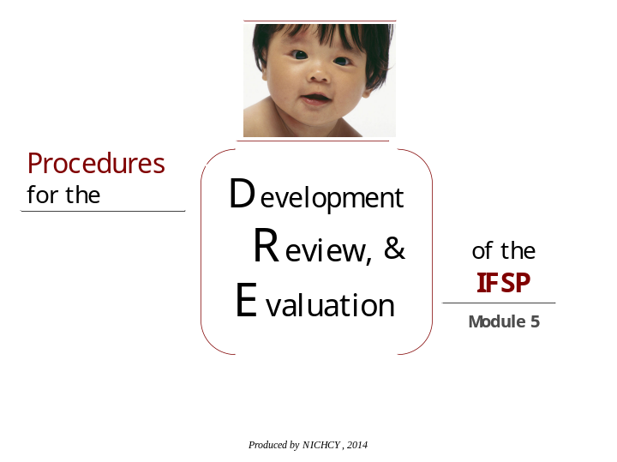

____________________________________________________________________________________________________________________________________________________________________________________________________________________________________________________________________________________________________________________________________________________________________________________________________________________________________________________________________________________________________________________________________________________________________________________________________________________________________________________________________________________________________________________________________________________________________________________________________________________________________________________________________________________________
Slide 2

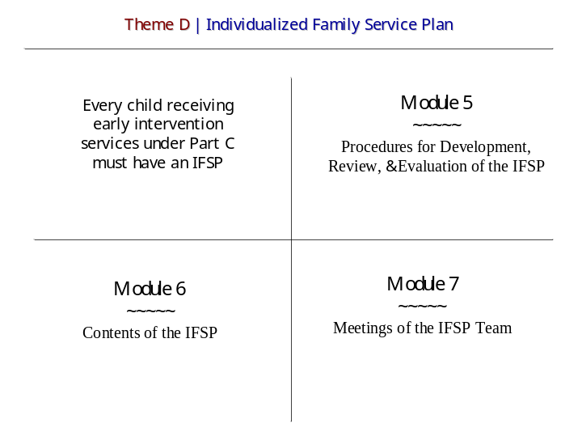

____________________________________________________________________________________________________________________________________________________________________________________________________________________________________________________________________________________________________________________________________________________________________________________________________________________________________________________________________________________________________________________________________________________________________________________________________________________________________________________________________________________________________________________________________________________________________________________________________________________________________________________________________________________________
Slide 3

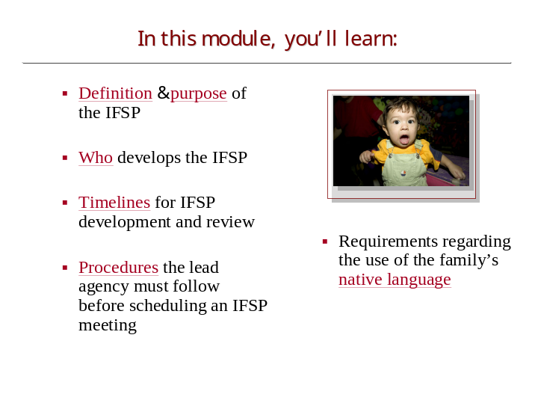

____________________________________________________________________________________________________________________________________________________________________________________________________________________________________________________________________________________________________________________________________________________________________________________________________________________________________________________________________________________________________________________________________________________________________________________________________________________________________________________________________________________________________________________________________________________________________________________________________________________________________________________________________________________________
Slide 4

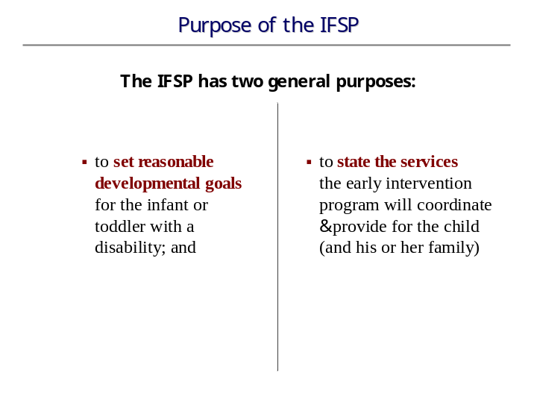

____________________________________________________________________________________________________________________________________________________________________________________________________________________________________________________________________________________________________________________________________________________________________________________________________________________________________________________________________________________________________________________________________________________________________________________________________________________________________________________________________________________________________________________________________________________________________________________________________________________________________________________________________________________________
Slide 5

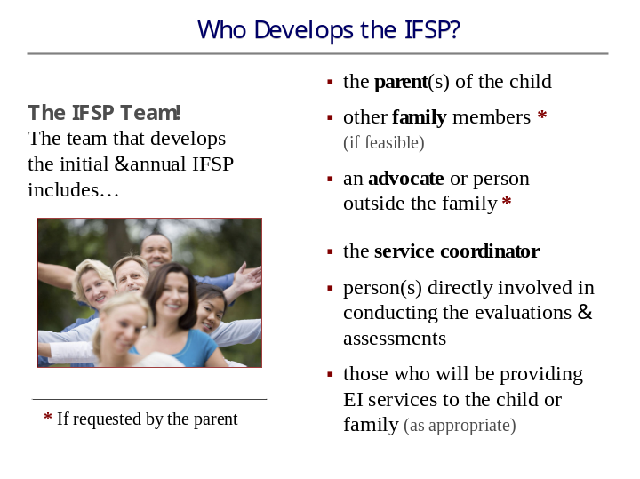

____________________________________________________________________________________________________________________________________________________________________________________________________________________________________________________________________________________________________________________________________________________________________________________________________________________________________________________________________________________________________________________________________________________________________________________________________________________________________________________________________________________________________________________________________________________________________________________________________________________________________________________________________________________________

Slide 6

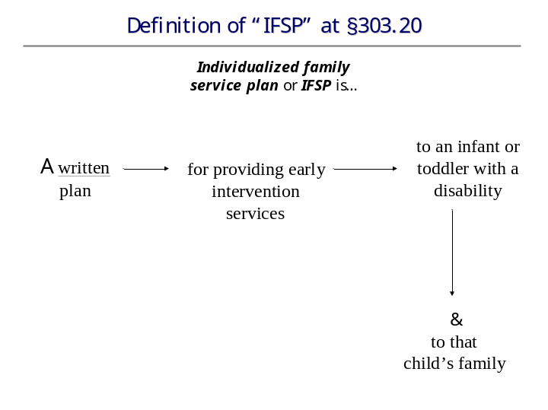

____________________________________________________________________________________________________________________________________________________________________________________________________________________________________________________________________________________________________________________________________________________________________________________________________________________________________________________________________________________________________________________________________________________________________________________________________________________________________________________________________________________________________________________________________________________________________________________________________________________________________________________________________________________________

Slide 7

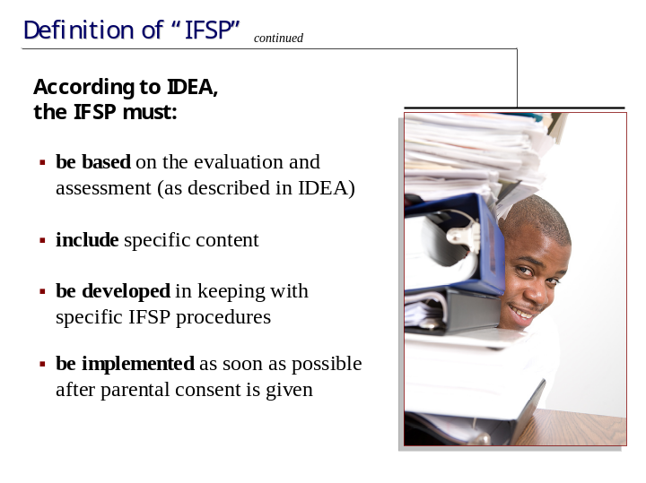

____________________________________________________________________________________________________________________________________________________________________________________________________________________________________________________________________________________________________________________________________________________________________________________________________________________________________________________________________________________________________________________________________________________________________________________________________________________________________________________________________________________________________________________________________________________________________________________________________________________________________________________________________________________________
Slide 8

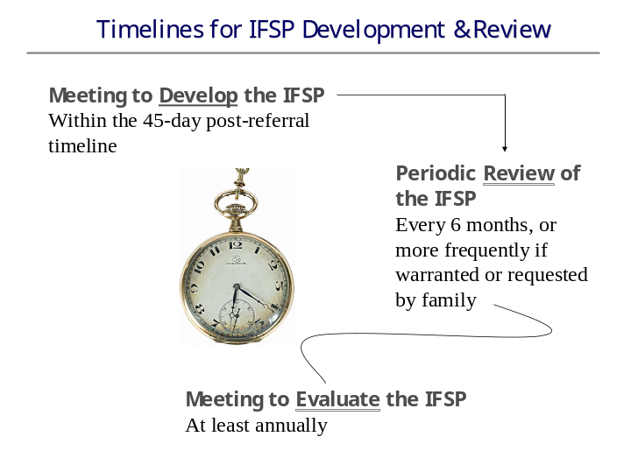

____________________________________________________________________________________________________________________________________________________________________________________________________________________________________________________________________________________________________________________________________________________________________________________________________________________________________________________________________________________________________________________________________________________________________________________________________________________________________________________________________________________________________________________________________________________________________________________________________________________________________________________________________________________________
Slide 9

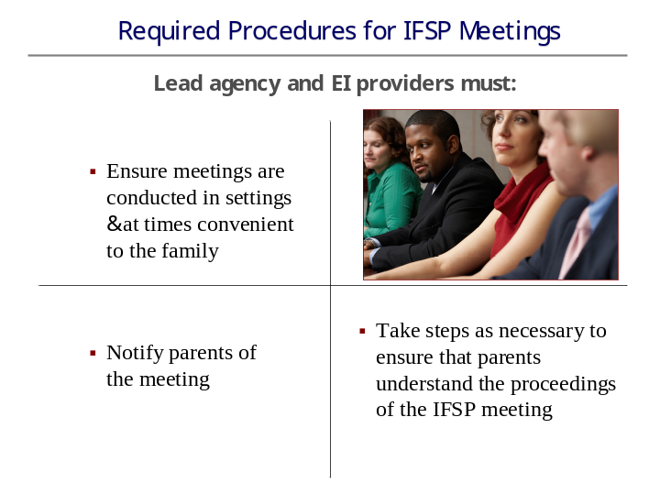

____________________________________________________________________________________________________________________________________________________________________________________________________________________________________________________________________________________________________________________________________________________________________________________________________________________________________________________________________________________________________________________________________________________________________________________________________________________________________________________________________________________________________________________________________________________________________________________________________________________________________________________________________________________________

Slide 10

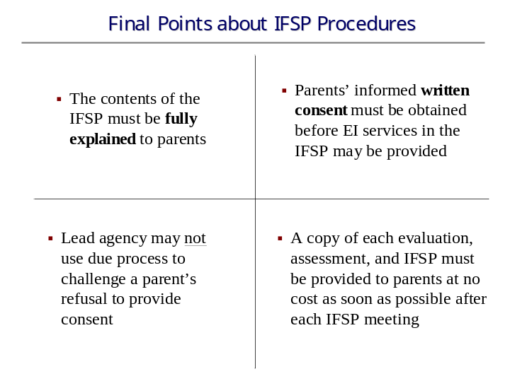

____________________________________________________________________________________________________________________________________________________________________________________________________________________________________________________________________________________________________________________________________________________________________________________________________________________________________________________________________________________________________________________________________________________________________________________________________________________________________________________________________________________________________________________________________________________________________________________________________________________________________________________________________________________________
Slide 11



____________________________________________________________________________________________________________________________________________________________________________________________________________________________________________________________________________________________________________________________________________________________________________________________________________________________________________________________________________________________________________________________________________________________________________________________________________________________________________________________________________________________________________________________________________________________________________________________________________________________________________________________________________________________

