Slide 1

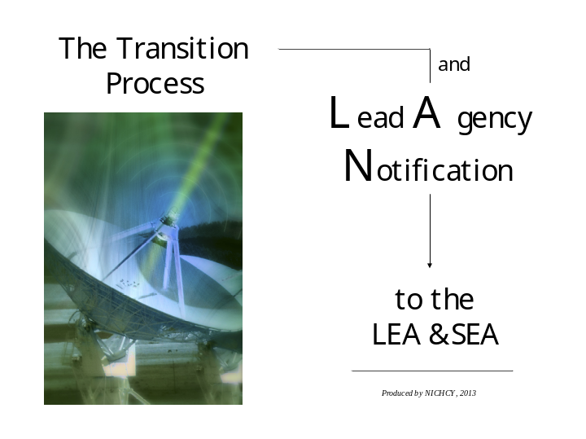

____________________________________________________________________________________________________________________________________________________________________________________________________________________________________________________________________________________________________________________________________________________________________________________________________________________________________________________________________________________________________________________________________________________________________________________________________________________________________________________________________________________________________________________________________________________________________________________________________________________________________________________________________________________________
Slide 2

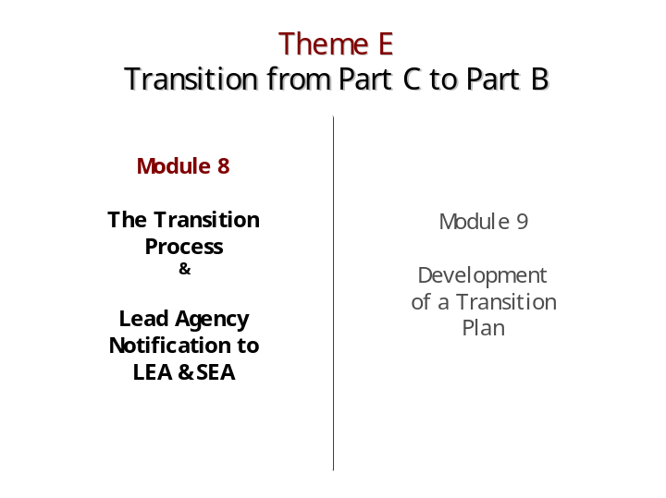

____________________________________________________________________________________________________________________________________________________________________________________________________________________________________________________________________________________________________________________________________________________________________________________________________________________________________________________________________________________________________________________________________________________________________________________________________________________________________________________________________________________________________________________________________________________________________________________________________________________________________________________________________________________________
Slide 3

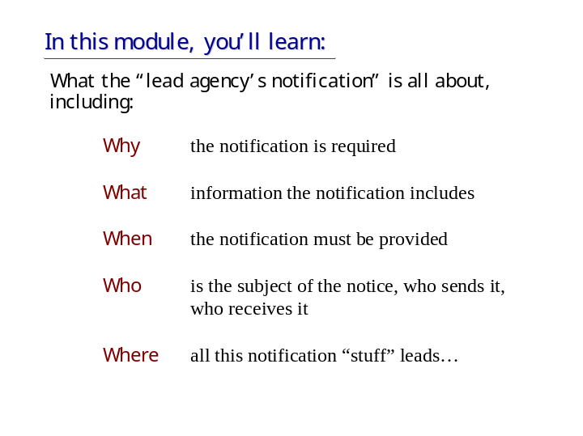

____________________________________________________________________________________________________________________________________________________________________________________________________________________________________________________________________________________________________________________________________________________________________________________________________________________________________________________________________________________________________________________________________________________________________________________________________________________________________________________________________________________________________________________________________________________________________________________________________________________________________________________________________________________________
Slide 4

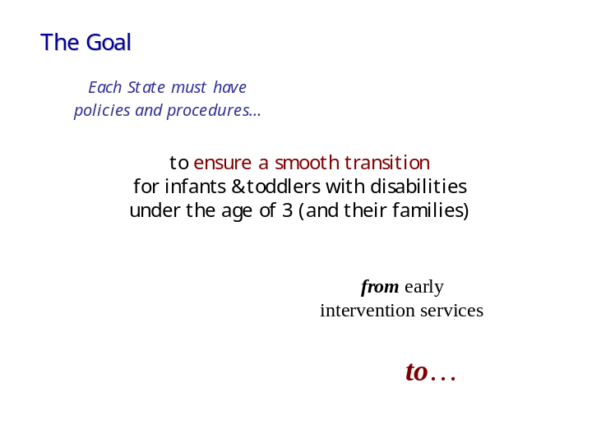

____________________________________________________________________________________________________________________________________________________________________________________________________________________________________________________________________________________________________________________________________________________________________________________________________________________________________________________________________________________________________________________________________________________________________________________________________________________________________________________________________________________________________________________________________________________________________________________________________________________________________________________________________________________________
Slide 5

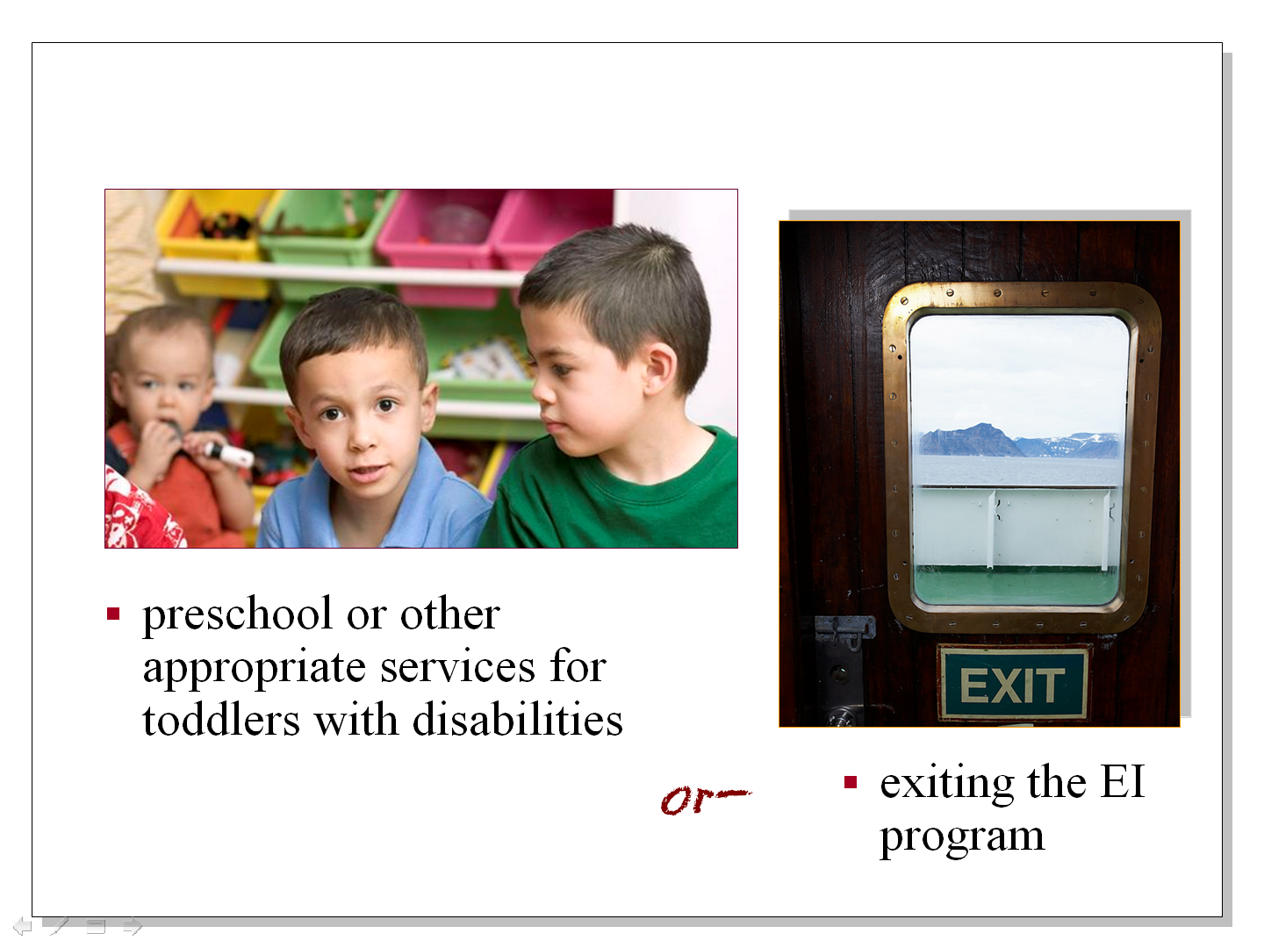

____________________________________________________________________________________________________________________________________________________________________________________________________________________________________________________________________________________________________________________________________________________________________________________________________________________________________________________________________________________________________________________________________________________________________________________________________________________________________________________________________________________________________________________________________________________________________________________________________________________________________________________________________________________________
Slide 6

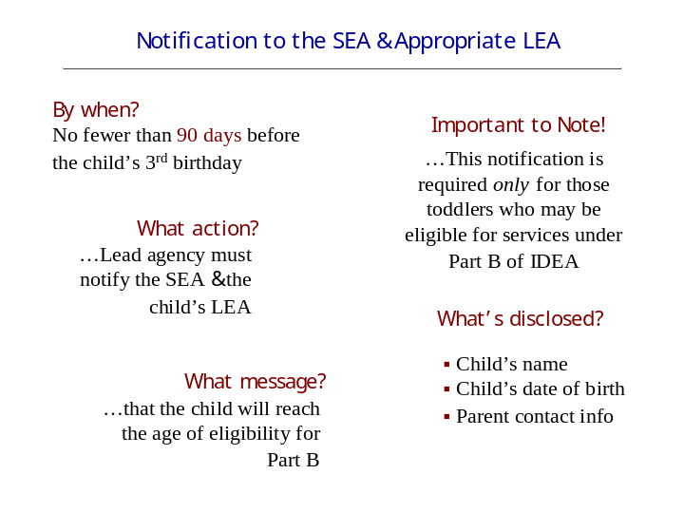

____________________________________________________________________________________________________________________________________________________________________________________________________________________________________________________________________________________________________________________________________________________________________________________________________________________________________________________________________________________________________________________________________________________________________________________________________________________________________________________________________________________________________________________________________________________________________________________________________________________________________________________________________________________________
Slide 7

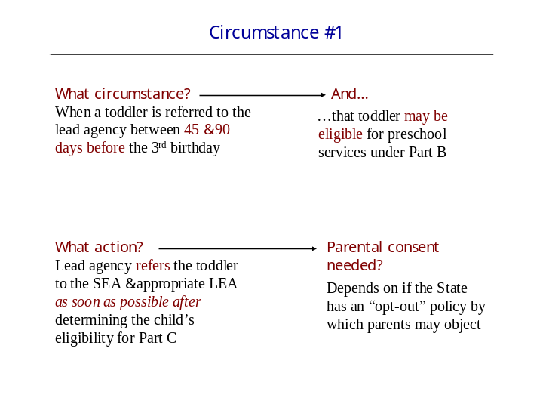

____________________________________________________________________________________________________________________________________________________________________________________________________________________________________________________________________________________________________________________________________________________________________________________________________________________________________________________________________________________________________________________________________________________________________________________________________________________________________________________________________________________________________________________________________________________________________________________________________________________________________________________________________________________________
Slide 8

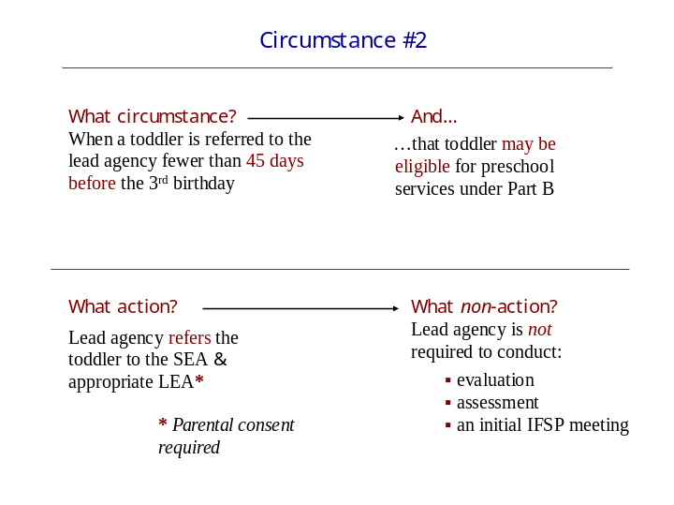

____________________________________________________________________________________________________________________________________________________________________________________________________________________________________________________________________________________________________________________________________________________________________________________________________________________________________________________________________________________________________________________________________________________________________________________________________________________________________________________________________________________________________________________________________________________________________________________________________________________________________________________________________________________________
Slide 9

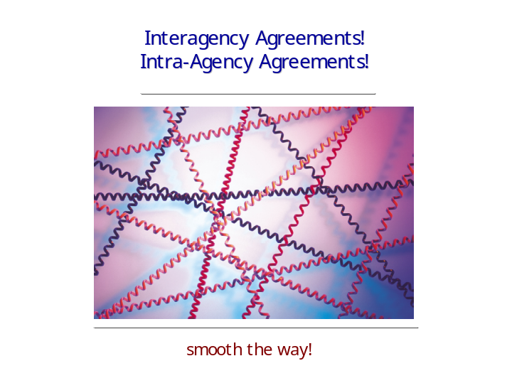

____________________________________________________________________________________________________________________________________________________________________________________________________________________________________________________________________________________________________________________________________________________________________________________________________________________________________________________________________________________________________________________________________________________________________________________________________________________________________________________________________________________________________________________________________________________________________________________________________________________________________________________________________________________________
Slide 10



____________________________________________________________________________________________________________________________________________________________________________________________________________________________________________________________________________________________________________________________________________________________________________________________________________________________________________________________________________________________________________________________________________________________________________________________________________________________________________________________________________________________________________________________________________________________________________________________________________________________________________________________________________________________
Slide 11

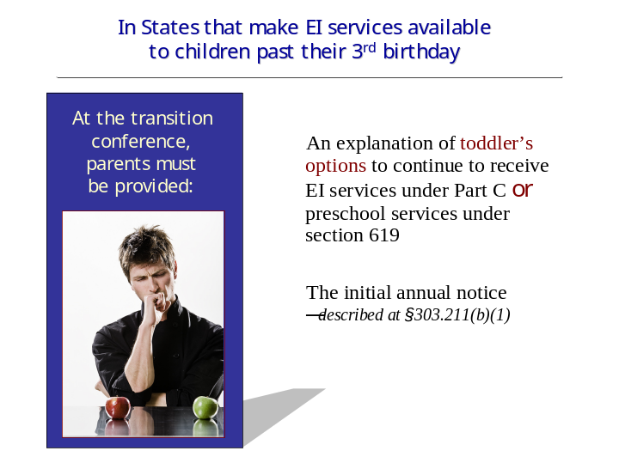

____________________________________________________________________________________________________________________________________________________________________________________________________________________________________________________________________________________________________________________________________________________________________________________________________________________________________________________________________________________________________________________________________________________________________________________________________________________________________________________________________________________________________________________________________________________________________________________________________________________________________________________________________________________________
Slide 12

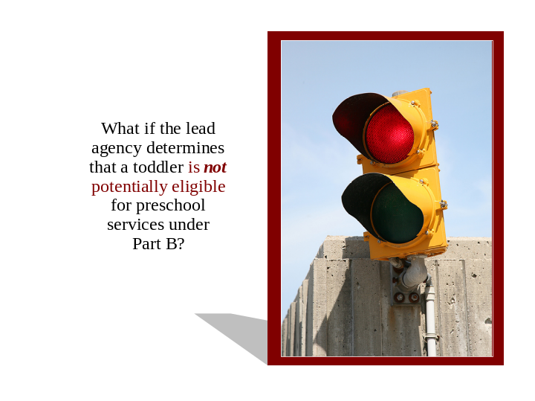

____________________________________________________________________________________________________________________________________________________________________________________________________________________________________________________________________________________________________________________________________________________________________________________________________________________________________________________________________________________________________________________________________________________________________________________________________________________________________________________________________________________________________________________________________________________________________________________________________________________________________________________________________________________________
Slide 13

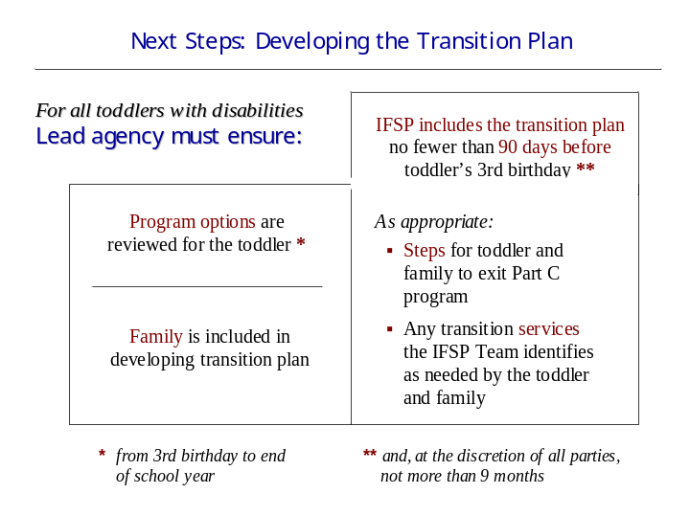

____________________________________________________________________________________________________________________________________________________________________________________________________________________________________________________________________________________________________________________________________________________________________________________________________________________________________________________________________________________________________________________________________________________________________________________________________________________________________________________________________________________________________________________________________________________________________________________________________________________________________________________________________________________________
Slide 14



____________________________________________________________________________________________________________________________________________________________________________________________________________________________________________________________________________________________________________________________________________________________________________________________________________________________________________________________________________________________________________________________________________________________________________________________________________________________________________________________________________________________________________________________________________________________________________________________________________________________________________________________________________________________

