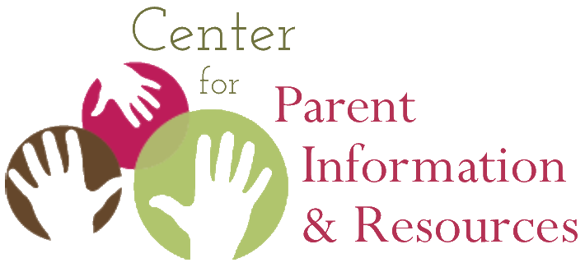
Instructions for Playing Native American Bingo
How to organize the activity, what players need, how to play

September 2020 | A publication of the Center for Parent Information and Resources
2nd edition developed by Joann Sebastian Morris and Rosie Rowe

Note: The game has been updated from the earlier version posted in Tier 1 of the Native American Resource Collection. This 2020 version poses questions related to the history, culture and lifeways of American Indians, Alaska Natives, and Native Hawaiians.
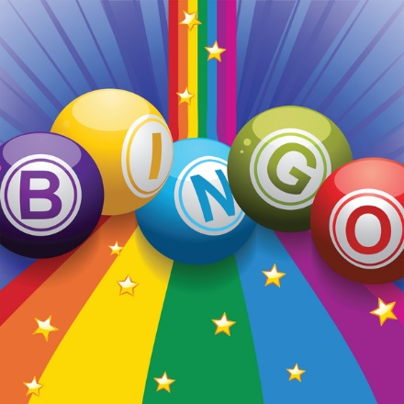
Often referred to as “People Bingo,” this activity is a great ice-breaker in staff meetings and other gatherings. Native American Bingo is an activity that Parent Center staff and others can play together to learn more about Native American history and culture. It gives all players an opportunity to see how much they already know (or don’t know) about Native American life.

It is also considered a fun get-acquainted activity. Native American Bingo will prove especially useful when conducting outreach to Native communities. In a training event or informational gathering of Native American parents, who may or may not know each other, they will enjoy this unique game and appreciate that you are using an activity focused on their cultures. Additionally, they will welcome learning new information about Native cultures distinct from their own.

Supplies Needed
The 2020 Native American Bingo Cards, pens, and the 2020 Native American Bingo Answer Sheets are all that’s needed, one of each for every participant.

Instructions
In advance, determine the amount of time you can allot to this activity, generally no more than 30 minutes.

Give each player a 2020 Native American Bingo card and a pen. The card is modeled on the traditional Bingo card, with its 5 x 5 design. The squares contain questions about Native American history, culture, and contemporary life. Ask each player to write her or his name in the center square. This makes that square “free”—meaning, answered. That is the only square that the individual card holder is allowed to “answer.”

Explain that the group has a time limit of X minutes to mingle, introduce themselves, and ask one person at a time if they can answer any question in a square. If the person answers the question, that person writes the answer in the square as well as their name.

Advise participants that they may answer only one question for fellow players. This causes the players to mingle more and get acquainted with a larger number of participants. However, if the group is small, participants may be allowed to answer two or more questions for fellow players.

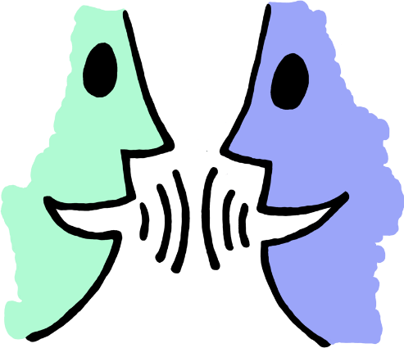
Explain that to “win” the game, players have to create a B-I-N-G-O. As in the traditional game, they’ve gotten a BINGO when they’ve filled in answers to questions that form a straight line down a column, across a row, or across the diagonal through the center square. When a player forms a BINGO, she or he calls out BINGO! To confirm the winner’s answers, ask him or her to read aloud the questions and answers one at a time for each square making up the BINGO. The game facilitator confirms if the answer is correct based on content in the 2020 Native American Bingo Answer Sheet. If all answers are correct, the winner is confirmed, cheers may ensue, and a prize may be given.

However, if the answer to any question is incorrect, the game resumes. In addition, if a confirmed BINGO happens too early in the game play, the other players may keep mingling and exchanging what they know until they’ve filled in more of their Bingo card or until time is called.

Debriefing
Afterwards, go through the questions one by one and answer them, not duplicating the questions already answered when confirming the Bingo winner. Allow for discussion. Close the activity by giving each player a copy of the 2020 Native American Bingo Answer Sheet for later reference.

A Final Note
Remember to have fun! This activity is designed to entertain and educate, while also allowing participants to relax, interact with each other in a new way, learn from each other, and open them to the information you have to share following the game.

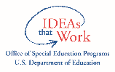
The CPIR is made possible through Cooperative Agreement Number H328R180005 between OSEP and the Statewide Parent Advocacy Network (SPAN). The contents of this document do not necessarily reflect the views or policies of the Department of Education, nor does mention of trade names, commercial products, or organizations imply endorsement by the U.S. Government.

- Native American Bingo Card

1. Who knows the preferred name of the people formerly called Eskimo? | 2. Who knows the 3 racial groups in the federal definition of Native American? | 3. Who knows the names of the 2 official languages in Hawai`i? | 4. Who knows how many federally recognized tribes & villages there are in the U.S.? | 5. Who can name 4 American Indian tribes, including one in or near your state?
6. Who can name the last monarch of the Kingdom of Hawai`i? | 7. Who knows how many indigenous groups make up the term Alaska Native? | 8. Who can offer 1 word to express the loss of homeland by Native Americans? | 9. Who knows which urban area has the largest American Indian population? | 10. Who knows the 2 meanings of the word Mahalo?
11. Who knows which tribe has the largest geographic reservation? | 12. Who knows the year in which the territory of Hawai`i gained statehood? | Put Your  Name Here | 13. Who knows what a potlatch is? | 14. Who has read a book by an American Indian, Alaska Native, or Native Hawaiian author?
15. Who knows which organization the initials NIEA stand for? | 16. Who knows when American Indians and Alaska Natives gained the right to vote? | 17. Who knows what “the supreme law of the land” refers to in the Constitution? | 18. Who knows when Native Hawaiians gained U.S. citizenship? | 19. Who knows which piece of legislation the initials ANCSA stand for?
20. Who can name the 7 major islands of Hawai`i? | 21. Who knows the percentage of Indian students in Bureau of Indian Education schools? | 22. Who knows what percent of Alaska’s population is Indian or Alaska Native? | 23. Who knows what Title VI of ESEA provides to all Native American students? | 24. Who can name the island where the capital of Hawai`i is located?
Developed by Joann Sebastian Morris and Rosie Rowe, for the Center for Parent Information and Resources

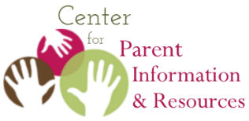
Answer Sheet for the
2020 Native American Bingo Activity

September 2020
A publication of the Center for Parent Information and Resources
Developed by Joann Sebastian Morris and Rosie Rowe
Find the instructions for this game and the BINGO game card at:
https://www.parentcenterhub.org/native-american-tier4-more-info/

- Inupiat is the term preferred by this large population of Alaska Natives. Inuit is another general term for “Eskimos,” used mostly in Canada.
- Since 1974, the Federal Government has included American Indians, Alaska Natives, and Native Hawaiians in its definition of Native Americans, particularly when stating eligibility for select federal grants.
- The two official languages in Hawaiʻi are English and Hawaiian. In 1978, the Hawaiian language was incorporated into the state constitution as one of its official languages. Hawaiʻi remains the only state to have two official languages.
- There are currently 574 tribes officially recognized by the Federal Government. This number includes 231 tribal entities and villages in Alaska alone.
- Answers will vary.
- The last monarch in Hawaiʻi, before her reign was overthrown, was Queen Lydia Liliʻuokalani, who even traveled to Washington, DC to petition President Cleveland to intervene on her nation’s behalf. His successor, President McKinley, signed the treaty annexing Hawaiʻi.
- In Alaska, there are 11 distinct indigenous peoples. About 50% are Cup’ik, Inupiaq, St. Lawrence Island Yup’ik, and Yup’ik; about a third are American Indians including the Athabascan (Dene) from the Interior, and Eyak, Haida, Tlingit, and Tsimshian of the Southeast; and about 15% are native to the Aleutian Islands including the Aleut and Alutiiq.
- Answers will vary.
- Per the 2010 US Census, New York City has the largest urban Indian population, followed by Los Angeles, Phoenix, Oklahoma City, and Anchorage.
- The Hawaiian word mahalo can mean thank you as well as good-bye.
- The Navajo Nation is the largest reservation, covering 17+ million acres, with land boundaries in AZ, NM, and UT. It is also the tribe with the largest population.
- Having changed from a sovereign kingdom to a republic, then to a territory of the U.S., Hawaiʻi became the 50th state in 1959.
- A potlatch is a gift-giving and wealth distribution feast celebrated by tribes in Southeastern Alaska and the Pacific Northwest. Honoring ancestors and the supernatural world are key elements of a potlatch. One’s stature as a potlatch host rises the more one gives to others.
- Answers will vary.
- NIEA is the National Indian Education Association, an advocacy organization founded in 1969. Based in Washington, DC, it supports and advances the educational interests of American Indians, Alaska Natives, and Native Hawaiians.
- In 1924 the Indian Citizenship Act was enacted granting full citizenship to American Indians, along with the right to vote. It passed, in part, to recognize the thousands of non-citizen Indians who’d served the country in World War I. Nonetheless, some states created provisions to prevent Indians from voting until as late as 1962.
- In the U.S. Constitution, treaties are referred to as “the supreme law of the land,” superseding federal, state, and local laws. This wording is significant to American Indians who, as sovereign nations, signed over 370 treaties ratified by the U.S.
- In 1898 Native Hawaiians gained U.S. citizenship if they were citizens of the post-overthrow Republic of Hawaiʻi, a short-lived nation-state whose sole goal was annexation by the U.S.
- ANCSA stands for the Alaska Native Claims Settlement Act of 1971, which settled all claims brought by Alaska Natives for lost land and revenue. Congress awarded land and a financial settlement but insisted that the land claims and money were to be divided among 12 regional corporations and 200 village corporations, a capitalist concept very foreign to those groups.
- The 7 main islands of the state of Hawai`i are: Hawaiʻi (aka Big Island), Maui, Molokai, Oʻahu, Lanai, Niihau, Kauai, and Kahoolawe.
- The percentage of American Indian students attending the federal Bureau of Indian Education school system is only 7% or approximately 49,000 students. This means the majority of K-12 Indian students attends public schools, contrary to popular belief.
- Per a 2014 Census, 18% of Alaska’s general population is American Indian or Alaska Native, the highest rate for this racial population of any state.
- In the Elementary & Secondary Education Act, Title VI funds programs and services to meet the “unique educational needs” of “Indians, Native Hawaiians, and Alaska Natives”. Some grants are disbursed automatically at the state and district level; others require an application.
- The capital of Hawaiʻi is located on the island of Oʻahu, the third largest island of the Hawaiian chain. Known as the “gathering place,” the majority of the state’s population resides on Oʻahu.

