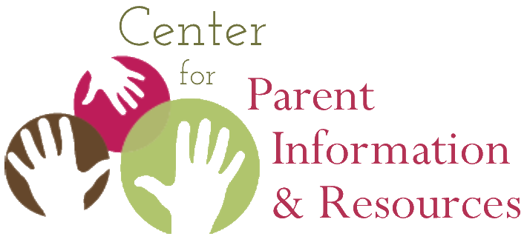
Instructions for Playing Native American Bingo
How to organize the activity, what players need, how to play

September 2020 | A publication of the Center for Parent Information and Resources
2nd edition developed by Joann Sebastian Morris and Rosie Rowe

Note: The game has been updated from the earlier version posted in Tier 1 of the Native American Resource Collection. This 2020 version poses questions related to the history, culture and lifeways of American Indians, Alaska Natives, and Native Hawaiians.
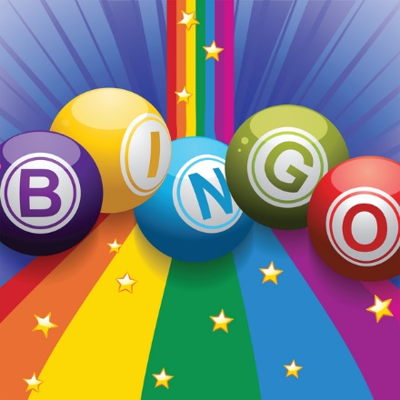
Often referred to as “People Bingo,” this activity is a great ice-breaker in staff meetings and other gatherings. Native American Bingo is an activity that Parent Center staff and others can play together to learn more about Native American history and culture. It gives all players an opportunity to see how much they already know (or don’t know) about Native American life.

It is also considered a fun get-acquainted activity. Native American Bingo will prove especially useful when conducting outreach to Native communities. In a training event or informational gathering of Native American parents, who may or may not know each other, they will enjoy this unique game and appreciate that you are using an activity focused on their cultures. Additionally, they will welcome learning new information about Native cultures distinct from their own.

Supplies Needed
The 2020 Native American Bingo Cards, pens, and the 2020 Native American Bingo Answer Sheets are all that’s needed, one of each for every participant.

Instructions
In advance, determine the amount of time you can allot to this activity, generally no more than 30 minutes.

Give each player a 2020 Native American Bingo card and a pen. The card is modeled on the traditional Bingo card, with its 5 x 5 design. The squares contain questions about Native American history, culture, and contemporary life. Ask each player to write her or his name in the center square. This makes that square “free”—meaning, answered. That is the only square that the individual card holder is allowed to “answer.”

Explain that the group has a time limit of X minutes to mingle, introduce themselves, and ask one person at a time if they can answer any question in a square. If the person answers the question, that person writes the answer in the square as well as their name.

Advise participants that they may answer only one question for fellow players. This causes the players to mingle more and get acquainted with a larger number of participants. However, if the group is small, participants may be allowed to answer two or more questions for fellow players.

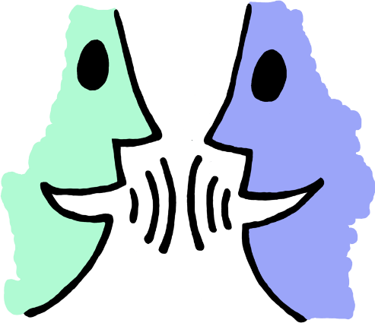
Explain that to “win” the game, players have to create a B-I-N-G-O. As in the traditional game, they’ve gotten a BINGO when they’ve filled in answers to questions that form a straight line down a column, across a row, or across the diagonal through the center square. When a player forms a BINGO, she or he calls out BINGO! To confirm the winner’s answers, ask him or her to read aloud the questions and answers one at a time for each square making up the BINGO. The game facilitator confirms if the answer is correct based on content in the 2020 Native American Bingo Answer Sheet. If all answers are correct, the winner is confirmed, cheers may ensue, and a prize may be given.

However, if the answer to any question is incorrect, the game resumes. In addition, if a confirmed BINGO happens too early in the game play, the other players may keep mingling and exchanging what they know until they’ve filled in more of their Bingo card or until time is called.

Debriefing
Afterwards, go through the questions one by one and answer them, not duplicating the questions already answered when confirming the Bingo winner. Allow for discussion. Close the activity by giving each player a copy of the 2020 Native American Bingo Answer Sheet for later reference.

A Final Note
Remember to have fun! This activity is designed to entertain and educate, while also allowing participants to relax, interact with each other in a new way, learn from each other, and open them to the information you have to share following the game.

The CPIR is made possible through Cooperative Agreement Number H328R180005 between OSEP and the Statewide Parent Advocacy Network (SPAN). The contents of this document do not necessarily reflect the views or policies of the Department of Education, nor does mention of trade names, commercial products, or organizations imply endorsement by the U.S. Government.

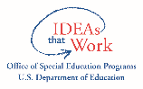

35 Halsey St, 4th Fl.
Newark, NJ 07102
parentcenterhub.org

