What Parent Centers Need to Know: Historical Perspectives for Working with Native American Parents

This document describes some of the historical factors impacting the participation of Native parents in the schooling of their children. These factors do not just impact special educators, but all educators working with Native students, whether they reside in reservation communities or live off-reservation and attend public schools.

T
here are many historical factors that impact the participation of Native parents in the schooling of their children. Because more than 75% of Native students attend public schools, these factors are important to know and consider.
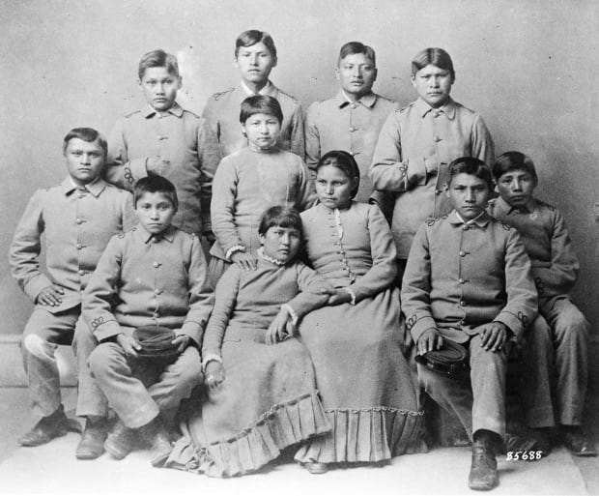
Many times attitudes of parents are rooted in their own experiences with schools. If parents have had negative experiences themselves, they may consciously, or even unconsciously transmit their negative feelings to their children. American Indian and Alaska Native (AI/AN) education clearly abounds with justification for parental fear, caution, and open hostility towards schools and educators.
The Impact of Boarding School Era
It has been well documented that the separation of Native children from their families—and sending them hundreds of miles from their homes to boarding schools—was the accepted strategy used to assimilate the Natives into society. When these children were removed from their families, whole generations lost access to Native parenting models, culture, language, and traditional values. Not only were the bonds between children and their fathers and mothers broken, but so were those with others who had parenting responsibilities as well. In many traditional Native communities, the extended family shared responsibilities for discipline, nurturing, guidance, and skill building.
As early as 1744, an Indian elder described tribal members who returned to tribal life from schools of the white man as unfit for tribal life, not able to speak the tribal language well, unfit to be counselors, and hence unable to make worthwhile contributions to the tribe. Following the 1871 conclusion of the treaty-signing period, boarding schools became the primary institution encouraging assimilation of AIAN youth and adhering to a regime that reflected the military fortifications in which schools were housed. Different conceptions of history were taught as part of a curriculum that was vastly different from tribal realities.
Numerous investigations have documented the imposition of education upon Native people—most notably, one in 1928 commonly called the Meriam Report and the other in 1969, entitled Indian Education: A National Tragedy, a National Challenge. The conclusions of these studies echoed that the federal government’s efforts to “educate” Native people had dramatically eroded the lifestyle and economic position of tribes and individuals. Historically, Native people have learned to fear schools and educators while at the same time understanding the necessity of their existence.
In the 1970s, Congress authorized funds for Indian education and cultural retention programs that required Native parental involvement. The Johnson O’Malley Programs began in 1934, were reauthorized in 1958, and in 1972 the Indian Education Act became part of the Elementary and Secondary Education Act (ESEA). The Indian Education programs still offer support to tribes, Bureau of Indian Education (BIE) schools, and public schools across the country.
While assimilationist practices are no longer the primary intent of educators, and public opinion has become more tolerant of cultural pluralism, Native education still carries the scars of this shameful legacy. These scars remain in the estrangement of Native parents from schools. They remain in the lack of accurate content about Native history, language, and community values and practices available in the school curriculum. They remain in the lack of parental outreach on the part of school staff. They remain in the attitudes of both Native parents and many non-native educators in Native schools. These attitudes are not likely to change without intervention.
Implications for Parent Centers
- Remember that Native parents do want to know what is going on, particularly when it affects their child, but they may not always know what to do in order to be supportive of what is being asked by the school. Non-judgmental, positive regard is required when working with Native parents. Native parents are concerned about their child’s education. If there is a problem, cooperative plans of action must be negotiated detailing the shared responsibility of schools and parents. Parent Center staff can provide assistance with these cooperative plans and processes.
- The inclusion of Native parents is critical, given the potential for success and the substantive impact Native parental participation could have on educational outcomes for students (e.g., attendance, achievement, attitudes toward school, self-esteem). Parent Centers can play a leadership role in helping Native parents to understand their role in the development of their student’s positive outcomes. Providing basic workshops that support a parent’s role in improving attendance, achievement, and having a positive attitude about school would be very helpful. Be aware that starting with workshops on special education laws and regulations will intimidate Native families, and they will be reluctant to attend similar workshops in the future.
- Researching the historical background of the specific tribe(s) in the Parent Center service area would be invaluable in building rapport with Native parents in each area.
- The process of rebuilding communities, nurturing and educating (or re-educating) Native parents will require tremendous time, energy, and commitment on the part of Parent Centers and tribal communities. Outreach to Native parents needs to be a priority and may need to include dedicating funds to cover the costs of outreach. Also, Parent Center staff may have to do a number of visits to Native communities before parent participation improves.
- The re-education process must begin or be strengthened and must be supportive, accepting, and participatory, allowing Native parents opportunities to learn and build skills necessary for themselves—skills that, in turn, they can pass on to their children. Skills could include supporting student self-esteem, attendance, and achievement.
- Additional training for school and Parent Center staff may be necessary in changing perceptions and abilities to work effectively with Native parents. Native people repeatedly express concern about school staff attitudes, behaviors, and lack of knowledge about the history, culture(s), and language(s) of tribes. High school staff turnover in some schools requires that this training be offered as a regular opportunity.

The content of this brief has been adapted from: Butterfield, R., & Pepper, F. (1991). Improving parental participation in elementary and secondary education for American Indian and Alaska Native students. In P. Cahape & C.B. Howley (Eds.), Indian nations at risk. Washington, DC: U.S. Department of Education. Available online at: https://files.eric.ed.gov/fulltext/ED343763.pdf

The brief was produced under U.S. Department of Education, Office of Special Education Programs No. H328R130012-14. The views expressed herein do not necessarily represent the positions or policies of the Department of Education. No official endorsement by the U.S. Department of Education of any product, commodity, service, or enterprise mentioned in this publication is intended or should be inferred. This product is in the public domain. Authorization to reproduce it in whole or in part is granted. While permission to reprint this publication is not necessary, the citation should be:
Butterfield, R. (2016). What parent centers need to know: Historical perspectives for working with Native American parents. Albuquerque, NM: Native American Parent Technical Assistance Center (NAPTAC). Online at: https://www.parentcenterhub.org/naptac-tier1-culture/

Nabokov, P. (Ed.). (1991). Native American testimony: A chronicle of Indian-white relations from prophecy to the present, 1492-1992. New York: Viking.

