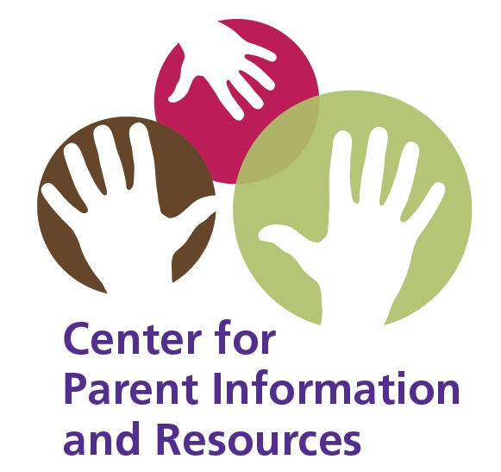
A Guide to Results-Driven Accountability for Parent Leaders and Advocates

A product of the CPIR
The Center for Parent Information and Resources
May 2014, Links updated January 2018

Read this publication if you’d like to know more about:
- results-driven accountability—what RDA is and why it’s important;
- the three phases that will frame States’ efforts to improve results for children with disabilities;
- the influential role that parents and advocates can play in the RDA process; and
- how to get involved in your State’s RDA planning.

The Current Context
The Office of Special Education Programs (OSEP) is currently revising how it holds States accountable for educating children with disabilities. To date, OSEP has focused most of its monitoring and enforcement on compliance-related requirements of the Individuals with Disabilities Education Act (IDEA).

Concerned that the achievement and graduation rates of students with disabilities have remained low for many years, OSEP is now refocusing its accountability system to emphasize achieving improved results for children with disabilities. This new approach is called results-driven accountability—RDA, for short.

We’ll talk more about RDA in a moment. First, though, here’s a bit of background.

Heard of the SPP, the APR, and OSEP’s List of Indicators?
IDEA requires that OSEP monitor how States implement their systems of early intervention (Part C) and special education (Part B). IDEA requires each State to submit to OSEP:

- a six-year State Performance Plan (known as the SPP), which identifies how the State will improve its implementation of IDEA; and

- an Annual Performance Report, or APR, in which the State reports its progress yearly to OSEP.

In their annual performance reports to OSEP, States are required to provide specific data for categories called indicators. Part C has different indicators from Part B, and States must report on both. In Part C, for example, States report by indicators such as the “settings in which infants and toddlers receive early intervention services” and “early child outcomes.” For Part B, States report on indicators such as graduation rates, dropout rates, and the percentage of the day that students with disabilities are served in regular classrooms or other settings.

Now, as OSEP and States move to a process that emphasizes improved results for children with disabilities, OSEP has included a new indicator for both Parts B and C. Each list now includes an indicator called the State Systemic Improvement Plan—the SSIP. The SSIP is an ambitious but achievable multi-year plan that each State must write describing how it will improve outcomes for children with disabilities served under IDEA. For Part C, Indicator 11 is now the SSIP. For Part B, it’s Indicator 17.

With a deadline of 2015 for the first part of the SSIP, States are beginning to write their SSIPs for Part B and Part C—and they’re using an RDA focus that’s required by OSEP.

Which brings us back to RDA! What is it?

The Basics of RDA
It’s easy to say what the letters of RDA stand for. But what does “results-driven accountability” actually mean? What does it involve? And why is it important to children with disabilities and their families? Why is it important to parent leaders and advocates? This guide is written to help answer these questions.

RDA begins with a premise—that the results we want to achieve need to drive the actions we take, not the other way around. Simply put, if we want to achieve X goal, what actions must we take to get there?

In applying the RDA approach to improving results for children with disabilities, each State must now ask itself:
- What improved results for children with disabilities do we want to achieve?
- What actions must we take to achieve those results?

When deciding on what improved results to target and what actions to take, each State must:
- identify the specific area (or areas) it will target for improvement, and
- plan in detail how it will achieve that improvement.

As we mentioned, this process is currently underway—and families, parent leaders, and advocates can be important stakeholders and informants in the process.

_________________________

The SSIP is central to the RDA process in your State.
It’s meant to be developed in partnership with stakeholders.

As stakeholders, parents and advocates have an important role to play in helping develop their State’s SSIP.
_________________________

RDA Principles
OSEP first announced its intention to move to a results-driven system of accountability in March of 2012. Since then, OSEP has worked with stakeholders to define what the RDA approach will involve. This has included defining its core principles as follows.

Core Principles of RDA
A system that:

- is developed in partnership with stakeholders
- is transparent and understandable
- drives improved outcomes
- ensures protection of individual rights
- provides differentiated incentives, supports, and interventions
- encourages States to direct their resources to where they can have the greatest positive impact
- is responsive to the needs and expectations of the ultimate consumers

Developing and Implementing the SSIP
States will develop and implement their individual SSIPs for Parts B and C in three phases. Each phase needs to involve significant stakeholder input—and States must describe in their SSIPs how they involve stakeholders in developing, implementing, and evaluating the SSIP. Here’s a brief description of what else is involved in each phase.

Phase 1: Analysis (Components to be submitted by 2015)
Phase I must include the following:

- Data Analysis: The SSIP must describe how the State identified and analyzed key data in order to (1) select the area or result to be improved for children with disabilities (called the State-identified Measurable Result for Children with Disabilities), and (2) identify root causes contributing to low performance. Key data to be analyzed include data from SPP/APR indicators, 618 data collections, and other available data (as applicable). This must be done for both Parts B and C.
State-identified Measurable Result for Children with Disabilities: What result(s) for infants and toddlers with disabilities does the State intend to improve in its Part C systems? What result(s) for students with disabilities will be improved under Part B? This information about the “State-identified measurable result for children with disabilities” must be stated in the SSIP the State submits to OSEP in Phase 1.

- Analysis of State Infrastructure to Support Improvement and Build Capacity: States will need a strong infrastructure to build the capacity of LEAs and EIS programs to implement, scale up, and sustain the use of evidence-based practices that improve results for children with disabilities. To that end, States must analyze their infrastructure to determine if improvements are needed in systems of governance, fiscal oversight, quality standards, professional development, data capacity, technical assistance, and accountability.
The SSIPs that each State submits to OSEP in Phase 1 must include a description of how the State analyzed the capacity of its infrastructure and the conclusions it drew regarding needed improvements.

- Selection of Coherent Improvement Strategies: What improvement strategies will the State use to achieve the desired result(s) for children with disabilities served under Part C or Part B? The SSIP must explain how the improvement strategies were selected; why they are sound, logical, and aligned; and how they will lead to measurable improvement in the State-identified result(s) for infants and toddlers in Part C and for students with disabilities under Part B.

- Theory of Action: The SSIP must include a graphic illustration of the State’s “theory of action” for the improvement strategies it has selected. In other words, it must explain in its SSIP why doing X (improvement strategies) will improve Y (the State’s capacity to lead meaningful change in LEAs and EIS programs and achieve improvement in the State-identified result for children with disabilities).

Phase 2 (Components to be submitted in 2016)
In Phase 2, each State fleshes out the details of the coherent improvement strategies identified in Phase 1 and makes each of its SSIPs (one for Part C and one for Part B) into actionable plans based on the State’s theory of action.

- How will the State improve infrastructure? Based on the data analysis of infrastructure conducted in Phase 1, the State can now identify what system improvements are needed to build the capacity of LEAs and EIS programs to use the evidence-based practices identified as key to achieving the State-identified measurable result(s) for children with disabilities. How does the State propose to make those system improvements?

- How will the State support local programs? How will the State support LEAs and EIS programs in using the evidence-based practices identified as key to achieving desired results for children with disabilities? Phase II of the SSIP needs to detail this information, including activities and timelines.

- How will the State evaluate implementation? Each State must also describe how it will evaluate the implementation of its SSIP for Part B and Part C and determine progress toward achieving the State’s desired results and improvements.

Phase 3 (to be completed by 2017)

- Evaluation!—The evaluation of SSIP implementation continues. So does the State’s reporting, including the extent to which its coherent improvement strategies were implemented in both Parts B and C.

- Results?—What progress has been made toward achieving the State-identified measurable result(s) for infants and toddlers with disabilities served under Part C? What progress, for students with disabilities served under Part B?

- Revisions to the SSIP—Based on data from the ongoing evaluation and with stakeholder involvement, the State may make revisions to its SSIP for Part B and/or Part C.

Coordination with Other Improvement Efforts
Throughout the three phases just described, the State’s improvement efforts need to be coordinated and aligned with the improvement work of other initiatives in the State.
And there can be quite a few of those! Examples include:
- College- and career-readiness standards
- Race to the Top and Race to the Top-Early Learning Challenge
- Elementary and Secondary Education Act Waiver
- Response to Intervention (RTI)
- Investing in Innovation (i3)
- School Turnaround
- Your own State’s initiatives

How Does RDA Affect Monitoring and Compliance?
Compliance with IDEA will always be an issue that States need to address. Procedural safeguards for children and families remain intact and unchanged.

Yes, OSEP will continue to monitor State performance—but now with a focus on helping States to improve results for children with disabilities. Technical assistance and support will be available to States from OSEP-funded TA projects. Differentiated levels of support will be provided based on State needs.

The Role of Parent Organizations in RDA
Clearly, there’s a great deal of data analysis, discussion, planning, writing, and action-taking that must occur in every State across the next three to six years. The remarkable thing is—improving results for children with disabilities is the singular focus of all the work to be done.

It’s also a focus that parent organizations strongly share, because children with disabilities are at the heart and soul of the work that parent leaders and advocates do every day. This makes them critical stakeholders in the RDA process unfolding in their State, including the development of the State’s SSIPs for Part B and Part C.

Moreover, OSEP expects each State to develop its SSIPs for Parts B and C with broad stakeholder input and public discussion. The door is open for parent organizations and advocates to contribute significantly to this process.

Connecting with Your State’s RDA Activities
Consider the many steps and stages that RDA will involve in your State—data analysis, deciding what the State-identified measurable result(s) will be for infants and toddlers with disabilities and for school-aged students with disabilities, selecting improvement strategies based on a coherent theory of action, building the State’s infrastructure to lead meaningful change at the local level... Any and all of these are appropriate points for family engagement.

How do you find out what’s going on in your State and get involved? This will vary depending on your State. Here are some suggestions for where to start.

- Contact your State Department of Special Education or the lead agency for early intervention services. These are the agencies responsible for developing the State’s plans for improvement on Parts B and C, respectively. Ask where the State is in the RDA process and its plans for developing the SSIP. Also ask how to be involved as a stakeholder and parent representative.

- Connect with your State’s Interagency Coordinating Council (ICC) for early intervention or the State Advisory Panel (SAP) for special education. These can be excellent points of connection to State-level activities and news.

- Visit your State’s website for early intervention or special education. This is where event calendars, public notices, and invitations for stakeholder involvement are often posted.

Share what you find out about your State’s point(s) of contact with other parents, parent organizations, and advocates. The parent voice is a very important one to have at the SSIP table!
Sources of Additional Information
Below we’ve listed two resources that will provide you with more information.

OSEP itself.
Visit OSEP’s RDA page and browse the documents and information there for the most authoritative voice on this subject.
https://www2.ed.gov/about/offices/list/osers/osep/rda/index.html

Sample Approaches for Using Assessment Data as Part of a Results-Driven Accountability System.
Available on OSEP’s RDA page, this document gives good examples of how States might analyze their student and program data.
https://www2.ed.gov/about/offices/list/osers/osep/rda/sample-approaches.pdf

Leading by Convening: A Blueprint for Authentic Engagement.
This book describes what’s called the “Partnership Way” and gives step-by-step guidance on how to use the strategy of partnership to build connections and foster authentic engagement with stakeholders. A product of the IDEA Partnership.
http://www.ideapartnership.org/building-connections/the-partnership-way.html

2014 SSIP Webinar series for Part C/Section 619.
For webinars and the latest news and available resources on RDA, visit the ECTA Center, at: http://ectacenter.org/~calls/2014/ssip/ssip.asp

Keep up to date at the ECTA Center as new resources emerge.
http://ectacenter.org/topics/ssip/

The Center for Parent Information and Resources will also be sure to post on its website additional information about RDA as it becomes available. Find us at: http://www.parentcenterhub.org

Stay tuned!

Questions? Concerns?
Contact:
Debra Jennings
CPIR Project Director
debra@parentcenterhub.org

We’d like to thank each of the regional Parent Technical Assistance Centers (PTACs) for their review of this guide in draft and for the many valuable suggestions and insights they shared. You’re the best!
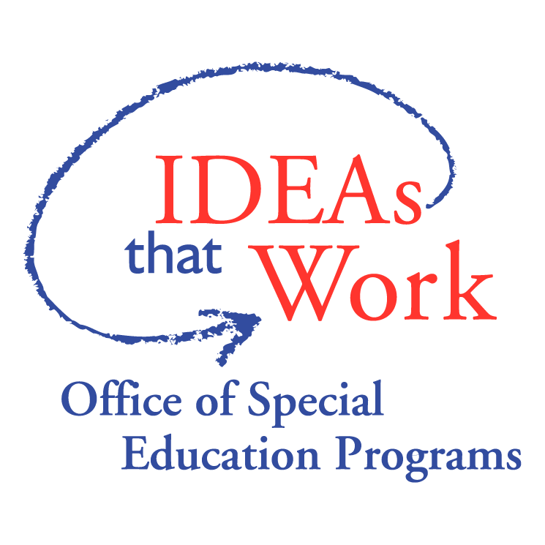
We’d also like to thank our Project Officer, Carmen Sánchez, at the Office of Special Education Programs (OSEP) of the U.S. Department of Education, for her support of Center for Parent Information and Resources.

The CPIR is made possible through Cooperative Agreement Number H328R130014 between OSEP and the Statewide Parent Advocacy Network (SPAN). The contents of this document do not necessarily reflect the views or policies of the Department of Education, nor does mention of trade names, commercial products, or organizations imply endorsement by the U.S. Government.

Need information for the parents
and families you serve?

Visit www.spanadvocacy.org
New Jersey’s Parent Training & Information Center
