Handout for Webinar 14
Where to Find Training Materials on IDEA at CPIR

At the Center for Parent Information and Resources (CPIR), you’ll find a lot of training materials on the IEP and on many other facets of IDEA, our nation’s special education law. But sometimes those materials are hard to locate if you don’t know where to look. So this is your handy-dandy, let’s-go-straight-to-the-target cheat sheet.

Training Modules on Part B of IDEA | Special Education for School-Aged Children with Disabilities
Main landing page for Building the Legacy Training Curriculum:
https://www.parentcenterhub.org/legacy/
Module 1: Top 10 Basics of Special Education (also available in Spanish)
http://www.parentcenterhub.org/partb-module1/

Module 9: Introduction to Evaluation under IDEA (also available in Spanish)
http://www.parentcenterhub.org/partb-module9/

Module 10: Initial Evaluation and Reevaluation (also available in Spanish)
http://www.parentcenterhub.org/partb-module10/

Module 12: The IEP Team: Who’s a Member? (2016 revised edition, also available in Spanish)
https://www.parentcenterhub.org/webinar-training-modules-on-iep-idea/#twelve

Module 13: Contents of the IEP (2016 revised edition, also available in Spanish)
https://www.parentcenterhub.org/webinar-training-modules-on-iep-idea/#thirteen

Module 14: Meetings of the IEP Team (2016 revised edition, also available in Spanish)
https://www.parentcenterhub.org/webinar-training-modules-on-iep-idea/#fourteen

Module 15: LRE Decision Making
http://www.parentcenterhub.org/partb-module15/

Module 17: Introduction to Procedural Safeguards (also available in Spanish)
http://www.parentcenterhub.org/partb-module17/

Module 18: Options for Dispute Resolution
http://www.parentcenterhub.org/partb-module18/

Module 19: Key Issues in Discipline
http://www.parentcenterhub.org/partb-module19/

Training Modules on Part C of IDEA | Early Intervention for Infants and Toddlers with Disabilities
Main landing page for Building the Legacy Training Curriculum on Part C:
http://www.parentcenterhub.org/legacy-partc/

Module 1: Basics of Early Intervention
http://www.parentcenterhub.org/partc-module1/

Module 3: Pre-Referral and Referral Activities
http://www.parentcenterhub.org/partc-module3/

Module 4: Screening, Evaluation, and Assessment Procedures
http://www.parentcenterhub.org/partc-module4/

Module 5: Procedures for IFSP Development, Review, and Evaluation
http://www.parentcenterhub.org/partc-module5/

Module 6: Content of the IFSP
http://www.parentcenterhub.org/partc-module6/

Module 8: The Transition Process and Lead Agency Notification
http://www.parentcenterhub.org/partc-module8/

Module 9: Development of the Transition Plan
http://www.parentcenterhub.org/partc-module9/

Module 10: Introduction to Procedural Safeguards
http://www.parentcenterhub.org/partc-module10/

Module 12: Access to and Examination of Records
http://www.parentcenterhub.org/partc-module12/

Module 14: System of Payments and Use of Funds in Part C
http://www.parentcenterhub.org/partc-module14/

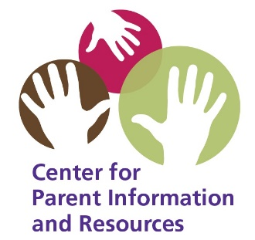

Updated 2019, September
Center for Parent Information and Resources
http://www.parentcenterhub.org

